


Fernwood Primary and Nursery School

English Intent & Implementation Overview

Our Reading Intent
Intent
At Fernwood Primary and Nursery School, we foster a love of language and reading; we attach great importance to enabling our children to become fluent readers. All staff at Fernwood Primary and Nursery school have a desire for children to be able to read fluently, confidently and with expression to achieve age-related expectation. We aspire to enthuse all children to read for pleasure – read to gain information, read to test out ideas, read to entertain, read to perform poetry, read to seek out new language and to have a love of books. Each year group has a carefully selected reading spine. This is the children’s entitlement for reading throughout the year and the texts are covered as part of shared reading, story time and English lessons.
Implementation
Phonics
Children are taught phonics from Nursery to Year 1 using the ‘Little Wandle Letters and Sounds revised' systematic synthetic programme. All children receive daily phonics lessons. Those children who require keep-up support are identified early and receive either small group or 1:1 interventions. At the beginning of Year 2, we review and consolidate, moving on to teaching the rules of spelling using phonetic knowledge. Children in Year 2 and KS2 who do not pass the phonics screener check remain on small group or 1:1 interventions, assessing their progress regularly.
Group Reading Sessions
Children in F2 and Year 1 receive two reading practice sessions per week, linked to the progression of the ‘Little Wandle Letters and Sounds Revised’ SSP. In Year 2, children receive a weekly guided reading session, focussing on fluency, prosody and comprehension. In KS2, children receive a small group (approximately 6 pupils) reading session, led by the teacher. During this time, children continue to build on their fluency and comprehension, discussing their reading choices.
Reading Lesson and Shared Reading
Children receive regular reading lessons based on quality fiction, non-fiction or poetry texts. These lessons focus on the teaching of the skills of reading including prediction, summarising, inference and vocabulary acquisition. In KS2, these lessons are weekly; a progression document for teaching the reading skills at KS2 can be found in Appendix 1 (KS2 Reading Lesson Progression). As part of reading lessons, shared reading takes place. This is when the teacher is reading the children a quality text to the whole class. During shared reading, discussions about genre, author’s approach and characterisation may take place.
Story Time
Story time takes place at the end of the day in all year groups; a teacher reads an age appropriate, high quality book or poem to the class. In KS1, story time takes place with the teacher reading a book to the children. In KS2, children and teachers share reading whole class reading of the same text. Each child has a copy of the text, led by the teacher. This models reading for pleasure and encourages children to engage with a wider range of books.

Reading for pleasure
We have many opportunities for reading for pleasure across the school. At the end of the school day, story time promotes reading for pleasure. Alongside this, a love of reading is fostered through World Book Day, reading/poetry competitions and reading sheds. To create a reciprocal reading community, children see school staff as readers with e.g. ‘Mrs Dorrington is reading…’ displayed outside all classrooms. Book talk between teachers and children enables discussions about book recommendations and behaviours. Many assemblies celebrate reading and poetry throughout the year. Annually, a group of Year 6 children are trained as Reading Buddies to listen to Year 3 and 4 children in KS2.
Reading books
In Nursery, children have a phonics reading book and choose a borrowed book to take home from the class library. In F2 and Year 1, children have a phonics reading book. Year 2 and 3 children have a banded book matched to their ability; some children will require a phonics reading book, if part of catch-up interventions. Children also choose a book from their class library to encourage reading for pleasure. Children in Year 4, 5 and 6 take home a borrowed book, monitored by their class teacher. Children in the lowest 20% are part of the Accelerated Reading Programme.
Reading Displays and Reading Areas
Reading displays in corridors celebrate the books on the reading spine of different year groups as well as work completed based on these books. Displays in the main entrance of both buildings celebrate the reading culture of Fernwood Primary and Nursery school and show the priority we give to reading. Welcoming reading areas in all classrooms reflect the children’s reading preferences and promote reading and its importance.
Our Writing Intent
The Writing Process
Children at Fernwood Primary and Nursery School develop their writing composition using following the writing process.
Hook
Engage and excite!

Read as a reader
Publishing
Children present their work for the target audience for another person to read or to be read aloud by themselves.
Editing & Improving
Children make changes to their writing, through self-evaluation and feedback given to ensure accurate spelling and grammar.
Drafting & Writing
Children follow their planning structure to write for their specific purpose and audience for writing.
Developing writing toolkit
Children learn the craft of writing for that purpose/audience.
Planning
Children identify audience and purpose of writing. Children use model texts to developing tool kits, generate ideas for writing and read as a writer.

Hook
Children are immersed into a writing unit using a hook (e.g. a crime scene, a letter from a character or an author visit). Children read as a reader to enjoy and familiarise themselves with the text. Story mapping is used as a tool to rehearse and embed the structure of a text and internalise vocabulary.
Planning
The use of a book-based writing curriculum allows children to engage with similar texts, look at and learn from their structures, presentation and vocabulary to help them gather ideas for their own writing. In KS1, children plan writing, focussing on sharing ideas orally and rehearsing sentences before writing using ‘think it, say it, write it, read it and check it’. In KS2, children plan their writing by discussing writing similar to which they are planning to learn from its structure and noting ideas for their writing. In Year 5 & 6, children draw on reading and research to help with the planning process. When planning writing, children write for four different purposes: writing to entertain (KS1 & KS2), writing to build a picture in the reader’s mind (KS1 & KS2), writing to inform (KS1 & KS2), writing to persuade (KS2) and writing to discuss (upper KS2). At the start of the planning process, collaboratively, a class will generate a writer’s tool kit using an expanded box plan.
Developing writing craft
Children are taught grammatical structures and writing crafts (e.g. show not tell character description) specific to the audience and purpose.
Drafting and Writing
When drafting and writing, children will compose and rehearse sentences, specific to the year group, described in the overview in this document.
Revising and Editing
In KS1, children begin to proof-read and check their writing with support from adults and peers. In Years 3 and 4, children edit and improve their writing, first by proof-reading for errors then developing the ability to assess the effectiveness of their own and others’ writing and suggesting improvements. In Year 5 and 6, children then develop the ability to ensure the consistent use of tenses throughout a piece of writing and propose changes to their writing that enhance effects and clarify meaning linked to the editing focus grid.
Publishing
Children perform their own compositions and read aloud their own writing as well as presenting writing to be read by others. In KS1, children begin by reading their writing aloud and develop the use of intonation to make the meaning of their writing clear. In Years 3 and 4, children also learn to control their tone and volume developing into using movement in Years 5 and 6. Children also present their work in written form, thinking specifically how to engage the audience that they are writing for.
Spelling
Children at KS1 follow the ‘Little Wandle Letters and Sounds Revised’ programme. Following from phonics, children at Fernwood Primary and Nursery School learn the spelling rules from the National Curriculum. See individual year group progression for the rules taught.
The Importance of Oracy
Oracy is the ability to articulate ideas, develop understanding and engage with others through spoken language. In school, oracy is a vital tool for learning; by teaching students to become more effective speakers and listeners we empower them to better understand themselves, each other and the world around them. At Fernwood Primary and Nursery School, we believe that it is important for children to learn to communicate effectively and creatively through spoken language to equip them with the skills to be lifelong learners. Purposeful talk is modelled and practised in the classroom to support and enhance learning to enable all learners to develop the skills needed to talk effectively and with confidence. We make use of sentence stems displayed in each classroom to support classroom discussion and promote a talk-rich environment.
Spoken Language
From Years 1 to 6, children are taught to:
- listen and respond appropriately to adults and their peers
- ask relevant questions to extend their understanding and knowledge
- use relevant strategies to build their vocabulary
- articulate and justify answers, arguments and opinions
- maintain attention and participate actively in collaborative conversations, staying on topic and initiating and responding to comments
- use spoken language to develop understanding through speculating, hypothesising, imagining and exploring ideas
- speak audibly and fluently with an increasing command of Standard English
- participate in discussions, presentations, performances, role play/improvisations and debates
- gain, maintain and monitor the interest of the listener(s)
- consider and evaluate different viewpoints, attending to and building on the contributions of others

Year 3 and 4 National Curriculum Objectives
Reading
National Curriculum – Word reading | - To apply growing knowledge of root words, prefixes and suffixes (etymology and morphology) as listed in English Appendix 1,  - To read aloud and to understand the meaning of new words they meet.  - To read further exception words, noting the unusual correspondences between spelling and sound, and where these occur in the word.
Year 3 National Curriculum - Reading comprehension | - To develop positive attitudes to reading and understanding of what they read by:  -listening to and discussing a wide range of fiction, poetry, plays, non-fiction and reference books or textbooks  - reading books that are structured in different ways and reading for a range of purposes  - using dictionaries to check the meaning of words that they have read  - increasing their familiarity with a wide range of books, including fairy stories, myths and legends, and retelling some of these orally  - identifying themes and conventions in a wide range of texts  - preparing poems and play scripts to read aloud and to perform, showing understanding through intonation, tone, volume and action  - discussing words and phrases that capture the reader’s interest and imagination  - recognising some different forms of poetry (for example, free verse, narrative poetry).  - understand what they read, in books they can read independently, by:  - checking that the text makes sense to them, discussing their understanding and explaining the meaning of words in context  - asking questions to improve their understanding of a text  - drawing inferences such as inferring characters’ feelings, thoughts and motives from their actions, and justifying inferences with evidence  - predicting what might happen from details stated and implied  - identifying main ideas drawn from more than one paragraph and summarising these  - identifying how language, structure, and presentation contribute to meaning  - retrieve and record information from non-fiction  - participate in discussion about both books that are read to them and those they can read for themselves, taking turns and listening to what others say.

Writing
National Curriculum – Transcription and Handwriting | Pupils are taught to:  - use further prefixes and suffixes and understand how to add them.  - spell further homophones.  - spell words that are often misspelt.  - place the possessive apostrophe accurately in words with regular plurals (e.g. girls’ and boys’) and in words with irregular plurals (e.g. children’s).  - use the first two or three letters of a word to check its spelling in a dictionary.  - write from memory simple sentences, dictated by the teacher, that include words and punctuation taught so far.  Pupils are taught to:  - use the diagonal and horizontal strokes that are needed to join letters and understand which letters, when adjacent to one another, are best left un-joined.  - increase the legibility, consistence and quality of their handwriting (for example, that the downstrokes of letters are parallel and equidistant; that lines of writing are spaced sufficiently so that the ascenders and descenders of letters do not touch.
National Curriculum – Composition | Pupils are taught to:  - plan their writing by:  - discussing writing similar to that which they are planning in order to learn from its structure, vocabulary and grammar  - discussing and recording ideas  - draft and write by:  - composing and rehearsing sentences orally (including dialogue), progressively building a varied and rich vocabulary and an increasing range of sentence structures.  - organising paragraphs around a theme.  - in narratives, creating settings, characters and plot.  - in non-narrative material, using simple organisational devices (for example, headings and sub-headings).  - evaluate and edit by:  - assessing the effectiveness of their own and others’ writing and suggesting improvements.  - proposing changes to grammar and vocabulary to improve consistency, including the accurate use of pronouns in a sentence.  - proof-read for spelling and punctuation errors.  - read aloud their own writing, to a group or the whole class, using appropriate intonation and controlling the tone and volume so that the meaning is clear.
National Curriculum – Vocabulary, grammar and punctuation | Pupils are taught to:  - develop their understanding of the concepts in English Appendix 2 by:  - extending the range of sentences it more than one clause by using a wider range of conjunctions (when, if, because, although)  - using the present perfect form of verbs in contrast to the past tense  - choosing nouns or pronouns appropriately for clarity and cohesion and to avoid repetition.  - use conjunctions, adverbs, and prepositions to expression time and cause.  - using fronted adverbials.  - indicate grammatical and other features by:  - using commas after fronted adverbials.  - indicating possession by using the possessive apostrophe with plural nouns.  - using and punctuating direct speech.  - use and understand the grammatical terminology in English Appendix accurately and appropriately when discussing their writing and reading.
English Appendix 2 | Year 3  - form nouns using a range of prefixes (e.g. super-, anti-, auto-)  - Use a or an correctly to introduce nouns.  - Identify word families based on common words.  - Express time, place and cause using conjunctions (when, before, after, while, so, because), adverbs (then, next, soon, therefore) or prepositions.  - Add subordinate clauses to sentences.  - Use the present perfect form of verbs.  - Introduce inverted commas to punctuate direct speech. | Year 4  - Know the difference between the plural and possessive -s.  - Use standard English forms of verb inflections (e.g. we were not we was)  - Punctuate fronted adverbials correctly  - Choose the correct pronoun or noun to create cohesion across sentences.  - To use apostrophes to mark plural possession.  - To identify and use a range of determiners.  - To identify and use possessive pronouns.

Year 3
Autumn 1
 | Week 1 and 2 |  | Week 3 and 4 |  | Week 5, 6 and 7
Stimulus for Writing | 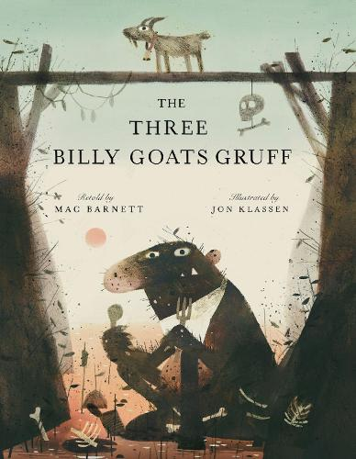  The Three Billy Goats Gruff by Mac Barnett and Jim Klassen |  |  |  | 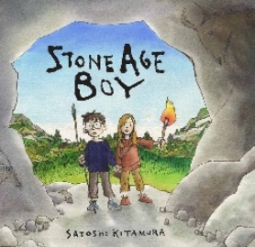  Stone Age Boy by Satoshi Kitamura
Writing purpose and genre | Writing to entertain  - Character description (the troll)  - Characterisation |  | Writing to entertain  - Re-telling a traditional tale  - Openings/endings |  | Writing to entertain  - Portal story  - Settings  - Dialogue  - Opening and endings
Writing Objectives  Grammar objectives | - To identify different types of nouns (proper and common nouns)  - To story map a traditional tale.  - To retell a traditional tale orally (fluency). | - To identify different types of nouns (concrete and abstract nouns).  - To explore the writing craft for character description.  - To use expanded noun phrases to describe (using adjectives).  - To write similes to describe.  - To use adverbs to describe how a character moves.  - To write a character description. | - To identify adjectives.  - To create a story map for my own alternate traditional tale.  - How do different Traditional tales end?  - To sequence sentences for cohesion.  - To use conjunctions to join two main clauses. | - To identify noun phrases.  - To plan a traditional tale with an alternative ending.  - To retell a story with an alternative ending.  - To retell a story with an alternative ending.  - To edit my writing by improving spelling and checking for fragments (EF1 teach). | - To identify fragments and main clauses.  - To explore the writing craft for a historical portal story.  - To use a range of conjunctions to use subordination (because, when, while and if) to extend sentences.  - INSET day | - To use a and an to correctly introduce nouns.  - To use adverbs as fronted adverbials.  - To explore bringing a setting to life (carefully chosen verbs and adverbs, using senses and the rule of three).  - To plan a portal story with a historical setting (using story mapping).  - HISTORY DAY | - To find conjunctions that join main clauses.  - To edit writing by checking for fragments (EF1 teach).  - To write a historical portal story (two/three days).  - To publish a portal story.
Reading Objectives | To explore the features of traditional tales (explore and compare). | No reading lesson | To use dictionaries to check the meaning of words. (Vocabulary) | To use a contents page and subheadings to locate information in a non-fiction text. (retrieval) | NTS testing (two lessons) | To summarise the key points in one paragraph (using the 5Ws).
Spelling objectives  Words from the Year 3 / 4 list | To spell common homophones correctly. (e.g. there/their/they’re, here/hear, quite/quiet)  accident, accidentally, address | To spell common homophones correctly (e.g. (to/too, be/bee blue/blue). answer, appear, arrive | To double consonants when adding the suffix -ing, -er or -ed (e.g. Forget, forgetting, forgotten, begin, beginner)  believe, bicycle | To spell words with the /i/ sound written as ‘y’ (e.g. myth, gym, Egypt, pyramid, mystery).  busy, business, calendar, caught, centre | To add the prefix dis- to root words to add a negative meaning (e.g. disappointment, disagree, disobey).  century, certain | To add the prefix in- to root words to add a negative meaning (e.g. inactive, incorrect, indecent, indefinite).  consider, continue

Autumn 2
 | Week 1, 2 and 3 |  |  | Week 4 and 5 |  |  | Week 6 and 7
Stimulus for Writing |   The Lion and the Mouse by Jerry Pinkey |  |  | 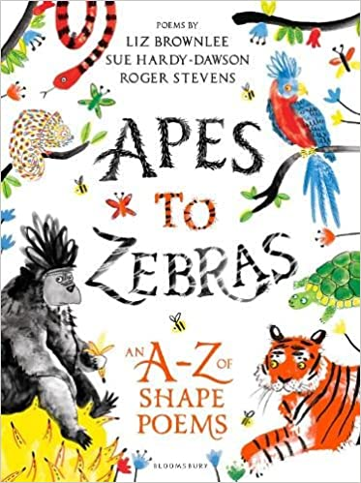 |  |  | 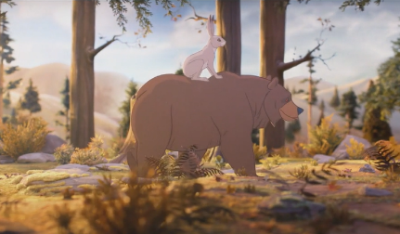  The bear and the hare animation
Writing purpose and genre | Writing to entertain  - A fable  - Characterisation  - Opening and endings  Set this out next year how we set out Egyptian Cinderella |  |  | Writing to entertain  - Poetry |  |  | Writing to entertain  - Dialogue
Writing Objectives  Grammar objectives | - To identify verbs.  - To explore the writing craft of a fable. (Read lots here e.g. Boy Who Cried Wolf, Hare and the Tortoise etc)  - To explore a fable picture book.  (Fill in box plan. Introduce the book)  - To create a story map for ‘The Lion and the Mouse’.  - CAREERS DAY | - To identify prepositions.  - To use prepositions and prepositions phrases to describe location.  - To describe two contrasting characters (use repetition to add description about a character, similes, verbs, adverbs and noun phrases).  - To use a varied sentence length to build suspense.  - To explore narrative openings by describing time and location. | - To identify prepositional phrases.  - To plan a fable.  - To write a fable (over two days).  - To publish a fable. | - To identify word families  - To explore language in animal poetry.  - To plan a calligram poem.  - To write a calligram poem.  - To perform a poem (poetry slam). |  | - To understand present and past tense for to be.  - To explore word families.  - To explore colour poetry.  - To plan a colour poem.  - To write a colour poem. | - To understand present and past tense for to have.  - To use speech bubble to show dialogue.  - To use inverted commas to show dialogue.  - To use synonyms for said.  - To write a short conversation. | - To perform a conversation (oracy).  - Christmas performance practise  - Christmas performance  - Staff Panto  - Toy day
Reading  Objectives | To infer characters thoughts and feelings from images (inference). | - To use dictionaries to check the meaning of words with more than one meaning (vocabulary). | - To make predictions about what will happen next using an image (prediction). Tunnel book. | - To explore the features of calligram poems (explore and compare). | - To perform a poem learned by heart (fluency). |  | - To infer characters’ thoughts and feelings from an animation (inference). |  | - To retrieve information from a non-fiction text (retrieval)
Spelling objectives  Words from the Year 3 / 4 list | To add the prefix im- to root words that start with m or p. (e.g. immature, immortal, impossible).  different, guard, notice, sentence | To spell words with split vowel digraphs. (e.g. hated, coped, cube, spine)  earth, eight | To use the prefix sub- to mean underneath or lower (e.g. subtract, subject, subside, subway).  eighth, heard, often | To add the prefix inter- to root words to mean between (e.g. interact, international, interval).  experience, ordinary, special | To add the prefix super- to root words to mean over and above (e.g. supervise, supersonic, supernatural).  height, peculiar, strange |  | To add the prefix ‘anti-‘, meaning against (e.g. anticlockwise, antibiotics).  famous, favourite, imagine, increase, popular, suppose

 | Spring 1
 | Week 1, 2 and 3 |  |  | Week 4 and 5 |  | Week 6
Stimulus for Writing | 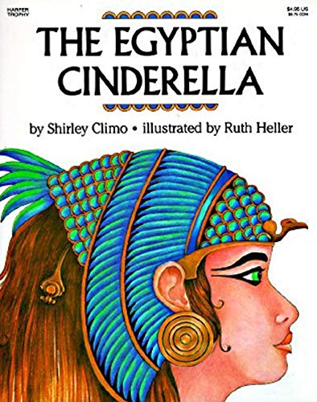  The Egyptian Cinderella by Shirley Climo |  |  | 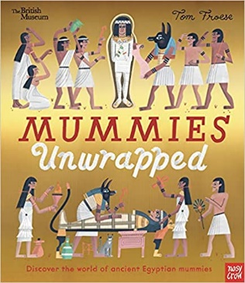  Mummies Unwrapped by Tom Froese
Writing purpose and genre | Writing to entertain  - Narrative (traditional tale from a different culture).  - Openings/endings  - Description  - Characterisation |  |  | Writing to inform  - Information text |  | Writing to inform  - Playscript documentary
Writing Objectives  Grammar objectives | - To form adjectives using suffixes (e.g. ful and less).  - To compare different versions of a traditional tale.  - To explore the writing craft of character description.  - To use comparative conjunctions to compare Rhodopsis and the slaves.  - To use show not tell to show character emotions. | - To identify features of setting and character description.  - To write a contrasting character description (paragraph about slaves and one about Rhodopsis).  - To choose expanded noun phrases for an Ancient Egyptian setting.  - To use similes and alliteration to build atmosphere for a setting.  - To use adverbs and prepositional phrases as fronted adverbials. | - To identify coordination and subordination within sentences.  - To improve writing, focussing on looking for fragments and run-ons (EF2 teach).  - To write a setting description.  - To publish a setting description.  - Pantomime | - To explore word families based on common words.  - To explore the writing craft of an information text.  - To explore organisational devices in a non-fiction text.  - To use subordination (when if that because, after and before). | - To identify fronted adverbials.  - To plan an information text about mummification.  - To write an information text about mummification (two days).  - To publish an information text about mummification for a museum. | - To identify nouns, adjectives, verbs, adverbs and conjunctions within a sentence.  - To explore the writing craft of a playscript.  - To role play a scene to plan a playscript.  - To write using the features of a playscript (group writing).  - Faith and Culture Day
Reading Objectives | - To create a story board to re-tell Egyptian Cinderella orally (summarising). | - To infer characters thoughts and feelings from their actions in the text. (inference) | - To learn the skill of ‘skim and scan’ to retrieve details from a fiction text. (retrieval) | - NTS testing (two days). | - To find the meaning of words using clues in the text (vocabulary). | - To perform a playscript. (fluency/explore and compare)
Spelling objectives  Words from the Year 3 / 4 list | To spell further homophones (e.g.  reign, material | To spell words ending with ‘gue’ (e.g. league, tongue, fatigue).  island library early | To spell words with the /s/ sound spelt ‘sc’ (e.g. science, scene, discipline).  build decide describe | To spell words with the /ai/ sound – ei, eigh or ey (e.g. they, sleigh, veil).  breath breathe | To spell words using the plural possessive apostrophe (e.g. girls’, boys’, babies’)  imagine history | To spell homophones and near homophones (e.g. ball/bawl, grown/groan).  February natural

 | Spring 2
 | Week 1, 2 and 3 |  |  | Week 4 and 5
Stimulus for Writing | 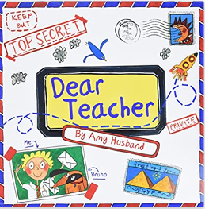  Dear Teacher by Amy Husband |  |  | 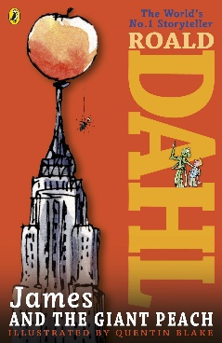  James and the Giant Peach by Roald Dahl
Writing purpose and genre | Writing to inform  - Informal letter | Writing to persuade  - Formal letter |  | Writing to inform  - Instruction writing
Writing Objectives  Grammar objectives | To identify personal and possessive pronouns.  - To explore the craft of informal letters.  - To explore informal language to plan an informal letter.  - To write an informal letter.  - INSET DAY | To identify conjunctions to link ideas.  - To explore the writing craft of a persuasive letter.  - To discuss persuasive arguments for a formal letter.  - To explore persuasive openers, formal language and rhetorical questions.  - To plan a persuasive letter. | To identify the present perfect tense.  - To write a formal persuasive letter(two days).  - To edit and improve my letter, focussing on improving vocabulary choices (use EF1-3 too).  - To publish a formal letter. | - To identify adverbs for time and cause (e.g. next, soon, then).  - To explore the writing craft of instructional writing.  - To use commas to indicate separate adjectives, or nouns, in a list.  - To explore vocabulary used in instruction writing.  - To explore sentence openers used in instruction writing | - To use commas in a list.  - To plan a set of instructions.  - To write a set of instructions using simple organisational devices (two days).  - EXPLORER DAY
Reading  Objectives | To find the meaning of words using a dictionary (vocabulary). | - World Book Day | - To read non-fiction books that are structured in different ways. (exploring and comparing) | - To predict the meaning of words using substitution in a sentence (vocabulary). | To use quotations from the text when retrieving information (retrieval).

Spelling objectives  Words from the Year 3 / 4 list | To spell homophones (e.g. here hear)  knowledge, learn, quarter, weigh, families | To spell homophones (e.g. missed and mist)  Experiment, medicine, disappear, tongue | Common misconception words.  Surprise, particular, confusion, mixture | g grapheme that sounds like /j/ (e.g. giant).  hought, various, incorrect, gym | Words with the /oo/ sound that are spelt ui (e.g. fruit)  regular, probably, heart, ascend, grey

 | Summer 1
 | Week 1 and 2 |  | Week 3 and 4 |  | Week 5 and 6
Stimulus for Writing | James and the Giant Peach by Roald Dahl |  |  |  | 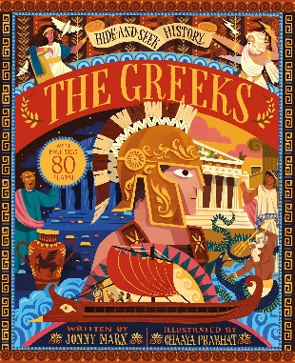  The Greeks by Jonny Marx
Writing purpose and genre | Writing to reflect  Recount (diary entry) |  | Writing to entertain  - Fantasy narrative (re-write section)  - Action (Dialogue) |  | Writing to persuade  • Persuasive writing – Visit Ancient Greece!
Writing Objectives  Grammar objectives | - To identify coordinating conjunctions (and, for, but, or and so).  - To explore the writing craft of a diary entry.  - To use the present perfect tense to describe past actions that still affect the present.  - To use fronted adverbials to indicate time for a diary entry.  - To explore informal language for a diary entry. | - To identify the present perfect tense.  - To plan a diary entry, organising paragraphs around a theme.  - To write a diary entry (two days).  - To edit and improve my writing, checking for improvements in punctuation (EF3 teach). | - To identify subordinating conjunctions (because, although, when and if).  - To story map a section of narrative.  - To use show not tell to describe a character and their emotions.  - To vary sentence length and use rhetorical questions to build tension.  - To use dialogue to show character’s feelings. | - To identify the features of direct speech.  - To plan and explore vocabulary choices to re-write a section of fantasy narrative.  - To re-write a section of narrative, including action and dialogue (two days).  - Bank holiday | - To use a or an correctly to introduce nouns.  - To explore the writing craft of a persuasive advert.  - To use conjunctions to explain a point (coordinating and subordinating).  - To use interesting adjectives to persuade.  - To identify word families. | - To use a or an correctly to introduce nouns.  - To plan a persuasive advert.  - To write a persuasive advert (two days)  - To present and publish a persuasive advert.
Reading  Objectives | - To distinguish between the important and less important detail in a text. (summarising) | - To infer a character’s motives from their actions in the text (inference). | - To infer characters thoughts and feelings using details from the text. (inference) | - To make predictions based on what is stated in a text (prediction). | - NTS assessment | - INSET day
Spelling objectives  Words from the Year 3 / 4 list | - To spell words using the prefix auto-, meaning self (e.g. autobiography, automatic, autograph)  forward, important, mention, position | - To spell words using the suffix -ation to turn verbs into nouns (e.g. prepare, preparation)  fruit, length | - To turn adjectives into averbs using the suffix -ly (e.g Sad, sadly, complete completely). | - To spell words ending in sure (e.g. measure, treasure, pleasure)r  group | - To spell words ending in ture (e.g. Creature, furniture, picture)  minute, possible | - To spell words using the -sion suffix to turn verbs into nouns (e.g, division, invasion, confusion)  island, potatoes, purpose, therefore

 | Summer 2
 | Week 1 and 2 |  | Week 3, 4 and 6 |  |  | Week 5 | Week 7
Stimulus for Writing | 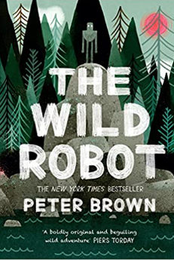  The Wild Robot by Peter Brown |  |  |  |  | BIG  ARTS  WEEK | 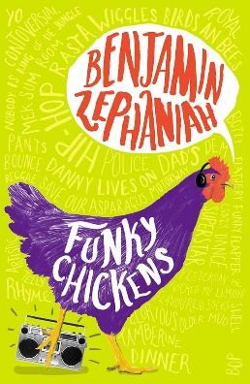  Funky Chickens by Benjamin Zephaniah
Writing purpose and genre | Writing to entertain  Setting Description (using chapter 1 and 2)  - Settings |  | Writing to entertain  Narrative with dialogue – climbing up the rocks |  |  | Writing to entertain  poetry
Writing Objectives  Grammar objectives | - To identify conjunctions.  - To explore the writing craft of a setting description.  - To choose vocabulary to describe using the senses. (include power of three)  - To write similes and alliteration to describe.  - To use when, where and how fronted adverbials. | - To identify conjunctions.  - To plan a setting description from a character’s perspective.  - To write a setting description (two days)  - To edit and improve my writing. | - To identify fronted adverbials.  - To explore the writing craft of narrative.  - To extend the range of sentences using a range of conjunctions (when, if, because, although).  - To use fronted adverbials to add cohesion to narrative.  - To use show not tell for a character’s emotions. | - To identify prepositions.  - To use repetition and rhetorical questions to build tension.  - To use varied sentence length to build tension.  - To plan a narrative from a character’s point of view. (use story mapping).  - To use inverted commas to punctuate dialogue, including action (WRITE THE BIT THEY WILL USE). | - To identify apostrophes for singular possession  - To write narrative building suspense and tension (three days).  - To publish a narrative scene. with illustrations. | - BIG ARTS WEEK x3  - INSET day | - Features of poetry.  - To explore performance poetry.  - To plan a poem.  - To write a free-verse poem.  - Transition morning
Reading  Objectives | - To justify predictions using evidence from the text (prediction). | - To justify inferences using evidence from the text. (inference) | - To discuss words and phrases that capture the reader’s interest and imagination (vocabulary) | - To retrieve and record information from a non-fiction text (retrieval). | - To summarise key findings from a text (summarising). |  | - Fernwood Festival
Spelling objectives  Words from the Year 3 / 4 list | Words with the /r/ sound that are spelt ‘wr; (e.g. write, wrapper).  through, history division, preferred | To spell homophones.  Here/hear, heel/heal/he’ll, knot/not  knowledge, learn, quarter | To spell homophones.  Missed/mist, peace/piece, plain/plane, scene/seen  experiment, medicine | To spell common exception words.  Because, improve, people, water, Christmas, beautiful, sure, clothes  surprise, particular | To spell words where the ‘g’ grapheme is used for the /j/ sound.  giant, ginger, genius, danger, emergency, imagine, intelligent, tragic  thought, various | To spell words using the ‘ui’ grapheme for the /oo/ sound.  juice, recruit, suitable, build, guide, fruit, suitcase regular, probably, heart | To spell words using the ‘wr’ grapheme for the /r/ sound. write wrapper, wreck, wrestle, wrinkle, wrong, wriggle, wrist  through, history

Year 4
Autumn 1
 | Week 1 and 2 |  | Week 3 and 4 |  |  | Week 5, 6 and 7
Stimulus for Writing | 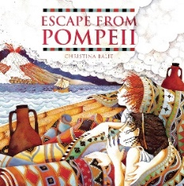  Escape from Pompeii by Christina Balit
Writing purpose and genre | Writing to paint a picture in the reader’s mind  - Settings (Pompeii – before eruption) |  | Writing to entertain  - Re-written section of historical suspense narrative, including dialogue |  |  | Writing to entertain  - Dialogue  - Suspense story (based on a different natural disaster)  - Openings/endings
Writing Objectives  Retrieval objectives | - To use the determiners a and an correctly to introduce nouns.  - To explore the writing craft of setting description. | - To identify prepositions and prepositional phrases.  - To explore vocabulary used to describe the Pompeii setting.  - To use expanded noun phrases with prepositional phrases to describe characters and settings.  - To bring a setting to life using personification and similes to create an atmosphere.  - To write a setting description. | - To understand the rules of punctuating direct speech.  - To explore the writing craft of suspense narrative with dialogue.  - To use direct speech to show how a character feels.  - To add on what the character is doing after a piece of dialogue to advance action.  - To use subordination in a sentence (because, when, before, after and while). | - To identify different types of adverbs (time, frequency and manner).  - To use coordination to join main clauses (and, but, so and yet).  - To choose verbs and adverbs effectively to show how a character is feeling.  - To write a section of narrative with dialogue (two days). |  | - To identify fronted adverbials.  - To research ideas for a natural disaster suspense story.  - To use adverbs and prepositional phrases as fronted adverbials.  - To build suspense in writing by using repetition, varied sentence length and rhetorical questions to make the reader worried.  - INSET DAY | - To identify similes and metaphors.  - To build suspense by moving the threat closer over a paragraph of writing and using vague vocabulary.  - To use personification and similes to create an atmosphere.  - To adapt and re-tell a story map for my suspense story.  - ROMAN DAY | - To identify personal and possessive pronouns.  - To recap editing focuses 1-3  - To explore different openings for my suspense story.  - To write a suspense story (over two days).  - To publish a short narrative.
Reading Objectives | - To create and re-tell a story orally using a story map (fluency). | - To use a dictionary to check the meaning of words, checking the correct word class and definition (vocabulary) | - To use skim and scan to retrieve information from a text (retrieval). | To highlight key information in a text and record it in diagrams (summarising) |  | - NTS testing | - HISTORY DAY | To infer a character’s feelings and thoughts using evidence from the text (inference).
Spelling objectives  Words from the Year 3 / 4 list | - To spell homophones (e.g. see/sea, bear/bare).  consider continue | - To use the il- prefix to have a negative meaning (e.g. illegal, illogical).  century certain position | - To add suffixes to words than begin with a vowel (e.g. garden gardener gardening).  breath breathe build |  | - To spell words with the /u/ sound spelt ‘ou’ (e.g. young).  busy calendar caught centre | - To spell words with the mis- prefix (e.g. misbehave, mislead)  believe bicycle | - To use the ir- prefix (e.g. irregular, irrelevant)  accident accidentally address

Autumn 2
 | Week 1 and 2 |  | Week 3, 4 and 5 |  |  | Week 6 and 7
Stimulus for Writing | 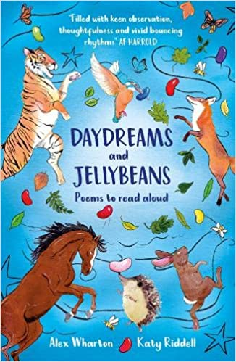  Daydreams and Jellybeans by Alex Wharton |  | 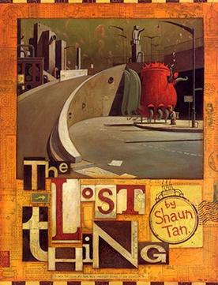  The Lost Thing by Shaun Tan |  |  | 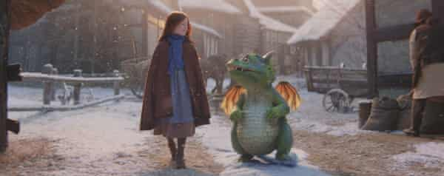  Edgar – video animation
Writing purpose and genre | Writing poetry |  | Writing to entertain  - Settings  - Characterisation |  |  | Writing to reflect  - Diary entry (recount)
Writing Objectives  Retrieval objectives | - To identify adjectives  - To explore a range of poetry.  - To explore the writing craft of free-verse poetry.  - To explore figurative language for poetry.  - Careers Fair | - To use precise nouns to describe (e.g. sparrow not brown bird).  - To write a free-verse poem, following a familiar structure.  - To write a free-verse poem (free writing).  - To perform a poem that I have written. | - To identify verbs and adverbs.  - To make inferences based on a picture.  - To explore the writing craft of a dystopian/science fiction narrative.  - To describe a character, showing their reactions to settings and other characters. (NARRATOR)  - To design and describe a dystopian character (CREATURE) | To use the present and past perfect form of verbs.  - To plan a first-person narrative as a story map  - To use dialogue to advance action. To edit and improve an action scene (EF4 teach).  - To write a first- person narrative. (1 lesson1) | To identify expanded noun phrases.  - To write a first- person narrative. (1 lesson1)  - To publish a first-person dystopian narrative (two days). | - To use coordinating conjunctions to join words, phrases and clauses.  - To explore the writing craft of a diary entry.  - To explore vocabulary to show facts, opinion and feelings in a diary entry.  - To use adverbials of time, duration and location as fronted adverbials.  - To explore the use of rhetorical questions and informal language. | - To use subordinating conjunctions to add a subordinate clause to a sentence.  - To plan a diary entry.  - To write a diary entry (two days).  - Toy day.
Reading Objectives | - To perform a poem learnt by heart (fluency). | - To use a thesaurus to find synonyms (vocabulary). | - To use prior knowledge and details from the text to make predictions (prediction). | - To infer characters’ motives using evidence from the text (inference). | - To write a brief summary of a story, using the main points. | - To use quotes to support answers to questions about the text (retrieval). | - Christmas performance.  - STAFF PANTO
Spelling objectives  Words from the Year 3 / 4 list | - To spell words using the re- prefix (e.g. redo, refresh).  early guide occasion occasionally separate | - To spell words, using split vowel digraphs (e.g. excuse, spite).  enough | - To use the prefix sub- (e.g. subheadings, submarine)  exercise heart opposite | - To use the prefix inter-, meaning between.  straight particular | - To use the prefix super-, meaning over and above (e.g. superficial, superimpose)  experiment extreme history perhaps strength | - To use the prefix anti-, meaning against (e.g. antifungal, antifreeze)  February surprise medicine

Spring 1
 | Week 1 and 2 |  | Week 3 | Week 4 and 5 |  |  | Week 6
Stimulus for Writing | 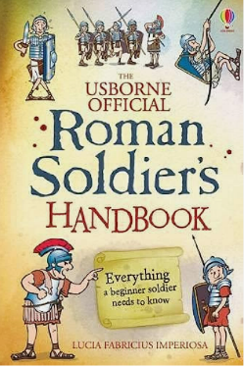  Roman Soldier’s Handbook by Lucia Fabricius Imperoisa |  | 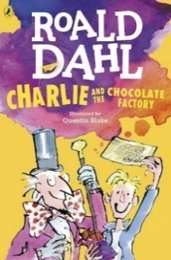  Charlie and the Chocolate Factory by Roald Dahl
Writing purpose and genre | Writing to inform  - Instruction writing (how to be a Roman soldier) |  | Writing to build a picture in the reader’s mind  - Character description (Charlie Bucket)  - Chapter 1 | Writing to persuade  - Persuasive letter (to Mr Willy Wonka)  - Chapter 3 and 4 |  | Writing to persuade Persuasive advert (sweet invention)
Writing Objectives  Retrieval objectives | - To identify imperative verbs and adverbs used to instruct.  - To explore the writing craft of instructional writing.  - To explore vocabulary to entertain the reader.  - To use fronted adverbials to create cohesion between instructions.  - To plan a set of instructions using a planning web. | - To identify determiners that quantify (three, many, some).  - To choose simple organisational devices in non-narrative material (captions, pictures and diagrams).  - To write a introduction to an instructional text.  - To write instructions ‘how to be a roman soldier’ (two days). | - To identify the present perfect form of verbs.  - To use verbs and adverbs to match your character’s personality.  - To use show not tell to describe a character’s emotions.  - To write a description of a character.  - Pantomime | - To understand and use the plural possessive apostrophe.  - To explore the writing craft of a persuasive letter.  - To use coordinating conjunctions to join words, phrases and clauses (and, but, so, or and yet) to link ideas.  - To explore appealing adjectives and compliments to persuade.  - To explore persuasive openers and rhetorical questions to persuade. | - To use coordinating conjunctions to join words, phrases and clauses (and, but, so, or and yet).  - To plan a persuasive letter.  - To edit to check for pronouns (EF5 teach)  - To write a persuasive letter (two lessons). | - To distinguish between adverbs of time, frequency and manner.  - To plan a persuasive advert.  - To write a persuasive advert (two days).  - To perform a persuasive advert.  - FAITH & CULTURE DAY
Reading Objectives | - To discuss how language, structure and presentation contribute to meaning in a non-fiction text (explore and compare). | To highlight key information in a text and record in bullet points (summarising). | - To use more than one piece of evidence from a text (inference). | - To find the meaning of new words using the context of a sentence (vocabulary). | - NTS testing | - To retrieve and record information in a fiction text (retrieval).
Spelling objectives  Words from the Year 3 / 4 list | - To spell words using the prefix dis-, meaning apart (e.g. disorder, disbelief)  learn recent | - To spell words using ation to change words from verbs into nouns (e.g. determine determination)  grammar library | - To spell using the suffix -ily to change adjectives into adverbs (e.g. happily angrily)  interest which | - To spell words with the /k/ sound spelt using ‘ch’ (e.g. scheme chorus)  natural quarter | - To spell words using the suffix -ture to turn verbs into nouns (e.g. signature departure)  possess possession

Spring 2
 | Week 1 and 2 |  | Week 3, 4 and 5
Stimulus for Writing | 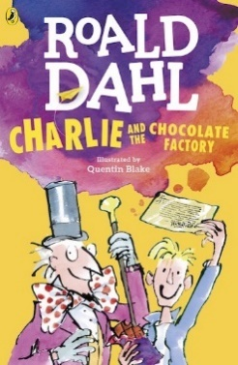  Charlie and the Chocolate Factory by Roald Dahl
Writing purpose and genre | Writing to entertain  - Re-writing part of narrative (travelling down the river – chapter 18)  - Dialogue  - Action |  | Writing to entertain  - Characterisation, settings, suspense and tension  - Wishing tale  Writing using a made-up character and their journey to get something that they really want.
Writing Objectives  Retrieval objectives | - To identify similes and personification used to create an atmosphere.  - To explore the writing craft of an action scene.  - To use conjunctions to add subordination to a sentence (because, when, before, after, although, if and while).  - To use inverted commas to punctuate direct speech, including using the reporting clause at the beginning.  - To use varied sentence length and repetition to build pace and tension. | - To use pronouns and to create cohesion across sentences.  - To show how a character is feeling through their actions and reactions to the setting or other characters (verbs).  - To edit and improve vocabulary choices (EF6 teach)  - To write an action scene, including dialogue. (over two lessons) | - York (x3 days)  - To explore a wishing tale. | - To use prepositional phrases, similes and adverbs as fronted adverbials.  - To build suspense and tension by showing the reader how my character is feeling rather than telling (actions and reactions).  - To build suspense and tension (short-burst writing).  - To create character, with a name to suggest something about them and reveal their desire or wish (short-burst writing).  - To plan a wishing tale. | - To identify features of character and setting descriptions.  - To write a wishing tale (three days).  - To publish my wishing tale and design a front cover.  - EXPLORER DAY
Reading Objectives | - To infer character’s feelings and thoughts using evidence from the text (inference). | - World Book Day | - To discuss why words have been chosen and their effect on the reader (vocabulary). | - To compare two characters, discussing author’s choice (explore and compare).
Spelling objectives  Words from the Year 3 / 4 list | - To spell words using the -ous suffix (our changes to or) e.g. humour humorous.  material regular | - To spell word with the ‘ous’ ending (e.g. curious hideous)  probably reign thought | - To spell words with the suffix -tion to change verbs into nouns (e.g. operate operation).  weight | - To spell words using the -ssion suffix (e.g. possess possession)  through various | To spell words using the suffix -sion when a verb ends in ‘de or se’ (e.g. collide collision).  accident accidentally

Summer 1
 | Week 1 | Week 2 and 3 |  | Week 4 | Week 5 and 6
Stimulus for Writing | Charlie and the Chocolate Factory by Roald Dahl | 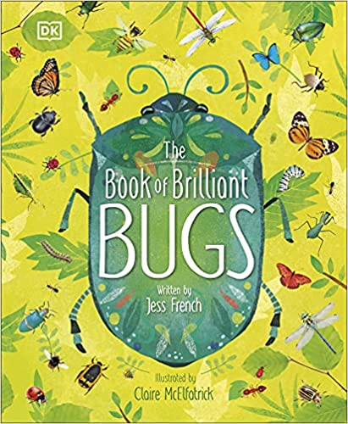  The Book of Brilliant Bugs by Jess French |  | 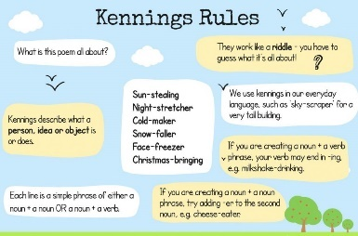  Kenning Poems | 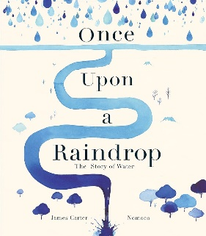  Once upon a raindrop by James Carter
Writing purpose and genre | Writing to build a picture in the reader’s mind  Setting description (the chocolate room chapter 15) | Writing to inform  - Information Text (minibeast) |  | Writing to entertain  - Poetry (Kenning) | Writing/Speaking to entertain – Oracy focus unit
Writing Objectives | - To use apostrophes to mark singular possession.  - To use adverbs, similes and prepositional phrases as fronted adverbials.  - To use powerful and precise vocabulary (nouns, adjectives, verbs and adverbs) to match the atmosphere.  - To show the setting through the character’s eyes.  - To write a setting description. | - To identify plural apostrophes.  - To explore the writing craft of information texts  - To research and make notes (focus on technical vocabulary).  - To explore literary devices in an information text.  - To use coordinating and subordinating conjunctions to link information. | To identify a variety of determiners.  - To plan the structure of an information text, including pictures/diagrams.  - To write an information text (two days)  - To publish an information text. | - To identify word families.  - To explore the writing craft of a Kenning poem.  - To explore technical vocabulary to plan a poem.  - To follow a similar structure to write poetry.  - To perform a poem, using intonation, volume and correct tone. | - To identify the difference between the plural and possessive ‘s’.  - To explore non-fiction as poetry.  - To perform poetry, creating a musical backing.  - To explore word families linked to water.  - To explore how a poet engages the reader (rq, alliteration, repetition). | - To identify possessive pronouns.  - To plan a story of water poem.  - To write a poem in groups.  - To perform a story of water poem.  - INSET day
Reading Objectives | - To make and justify predictions using evidence from the text (prediction). | - To discuss how language, structure and presentation contribute to meaning in a non-fiction text (explore and compare). | - To summarise information from a non-fiction text orally (summarising) | - Bank holiday | - NTS testing | - To explain how words and phrases capture the interest of the reader (vocabulary)..
Spelling objectives  Words from the Year 3 / 4 list | To spell homophones and near homophones (e.g. precede and proceed).  pressure | To spell words ending with the /k/ sound with the que grapheme (e.g. antique) with a French origin.  century group popular | To spell words with the /s/ sound using the sc grapheme (e.g. muscle) with a Latin origin.  bicycle famous favourite | To spell words using the /ey/ sound spelt using the graphemes ei eight or ey (e.g. neighbour).  heard peculiar | To spell words using the plural possessive apostrophe (e.g. parents’).  complete | To spell words using the /sh/ sound, spelt using the grapheme ch (e.g. chef).  answer appear arrive believe

Summer 2
 | Week 1 |  | Week 2 | Week 3 | Week 4 | Week 5, 6 and 7
Stimulus for Writing | 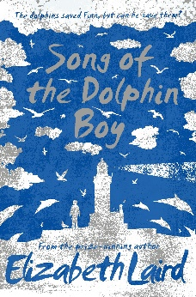  Song of the Dolphin Boy by Elizabeth Laird
Writing purpose and genre | Writing to entertain  - Settings | Writing to entertain  - Playscript |  | Oracy Focus Week | Writing to entertain  - Poetry | Writing to entertain  - Narrative with dialogue  - Characterisation  - Settings  - Openings/endings
Writing Objectives | - To identify fronted adverbials.  - To explore the writing craft of setting descriptions.  - To begin sentences with more than one fronted adverbial.  - To bring a setting to life using similes, metaphors and the senses to describe.  - To write a setting description of Finn’s cottage. | - To identify adverbs for describing location and manner.  - To explore the writing craft of a playscript.  - To orally re-tell a scene from a narrative book.  - To plan a short playscript.  - To write a playscript scene. |  | - To identify persuasive techniques  - To discuss my points of view.  - To collaborate with others to create a plan.  - To learn how to persuade through performance.  - To use drama to display emotion. | - To improve similes to describe  - To explore poetry linked to mythical creatures.  - To use abstract nouns in similes.  - To plan a poem based on a mythical creature.  - To write a poem based on a mythical creature. | - Transition morning  - INSET day  BIG ARTS WEEK | - To improve sentence openers.  - To plan a narrative setting and consider character  - To plan a narrative (story map).  - To write a narrative opening.  - To write a narrative. | - To identify word classes within sentences.  - To write a narrative  - To write the ending of a narrative.  - To improve my writing, looking for vocabulary and sentence openers.  - Transition morning
Reading Objectives | - To write a brief summary of the main point of a chapter, using important information (summarising). | - To perform a playscript (using own) |  | - To compare characters, discussing author choice (explore and compare). | - To make predictions by asking questions (prediction) | BIG ARTS WEEK | - To discuss and define new and unusual vocabulary (vocabulary). | - Fernwood Festival
Spelling objectives  Words from the Year 3 / 4 list | To spell homophones and near homophones (e.g. meet and meat).  ordinary consider | To spell homophones and near homophones (e.g. there their they’re).  eighth eleven |  | To spell words ending in -ar (e.g. familiar).  calendar | To spell words using cy at the start and end of words (e.g. cylinder accuracy).  imagine sentence | To spell words using the -cian suffix (e.g. beauty beautician).  accident address | To spell words using the oy and oi graphemes for the /oi/ sound.  woman women

Year 5 and 6 National Curriculum Objectives
Reading
Word Reading | - To apply their growing knowledge of root words, prefixes and suffixes (morphology and etymology), as listed in English Appendix 1, both to read aloud and to understand the meaning of new words that they meet.
Year 5 National Curriculum Statements - Reading comprehension | - To maintain positive attitudes to reading and understanding of what they read by:  - continuing to read and discuss an increasingly wide range of fiction, poetry, plays, non-fiction and reference books or textbooks  - reading books that are structured in different ways and reading for a range of purposes  - increasing their familiarity with a wide range of books, including myths, legends and traditional stories, modern fiction, fiction from our literary heritage, and books from other cultures and traditions  - recommending books that they have read to their peers, giving reasons for their choices  - identifying and discussing themes and conventions in and across a wide range of writing  - making comparisons within and across books  - learning a wider range of poetry by heart  - preparing poems and plays to read aloud and to perform, showing understanding through intonation, tone and volume so that the meaning is clear to an audience  - To understand what they read by:  - checking that the book makes sense to them, discussing their understanding and exploring the meaning of words in context  - asking questions to improve their understanding  - drawing inferences such as inferring characters’ feelings, thoughts and motives from their actions, and justifying inferences with evidence  - predicting what might happen from details stated and implied  - summarising the main ideas drawn from more than one paragraph, identifying key details that support the main ideas  - identifying how language, structure and presentation contribute to meaning  - discuss and evaluate how authors use language, including figurative language, considering the impact on the reader ♣ distinguish between statements of fact and opinion  - retrieve, record and present information from non-fiction  - participate in discussions about books that are read to them and those they can read for themselves, building on their own and others’ ideas and challenging views courteously  - explain and discuss their understanding of what they have read, including through formal presentations and debates, maintaining a focus on the topic and using notes where necessary  - provide reasoned justifications for their views.

Writing
National Curriculum – Transcription and Handwriting | Pupils should be taught to:  - use further prefixes and suffixes and understand guidance to add them.  - spell some words with ‘silent’ letters (for example knight, psalm and solemn).  - Continue to distinguish between homophones and other words which are often confused.  - use knowledge of morphology and etymology in spelling and understand that the spelling of some words ned to be learnt specifically, a listed in English Appendix 1.  - use dictionaries to check the spelling and meaning of words.  - use the first three or four letters of a word to check selling, meaning or both of these in a dictionary.  - use a thesaurus.  Pupils are taught to:  - write legibly, fluently and with increasing speed by:  - choosing which shape of a letter to use when give choices and deciding whether or not to specific letters  - choosing the writing implement that is best suited for a task.
National Curriculum – Composition | Pupils are taught to:  - plan their writing by:  - identifying the audience for and purpose of the writing, selecting the appropriate form and using other similar writing as models for their own.  - noting and developing initial ideas, drawing on reading and research where necessary.  - in writing narratives, considering how authors have developed characters and what pupils have read, listened to or seen performed.  - draft and write by:  - selecting appropriate grammar and vocabulary, understanding how such choices can change and enhance meaning.  - in narratives, describing settings, characters, and atmosphere and integrating dialogue to convey character and advance the action.  - précising longer passages.  - using a wide range of devices to build cohesion within and across paragraphs.  - using further organisational and presentational devices to structure text ad to guide the reader (for example headings, bullet points and underlining).  - evaluate and edit by:  - assessing the effectiveness of their own and others’ writing.  - proposing changes to vocabulary, grammar and punctuation to enhance effects and clarify meaning.  - ensuring the consistent and correct use of tense throughout a piece of writing.  - ensuring correct subject and verb agreement when sing singular and plural, distinguishing between the language of speech and choosing the appropriate register.  - proof-read for spelling and punctuation errors.  - perform their own compositions, using appropriate intonation, volume, and movement so that meaning is clear.
National Curriculum – Vocabulary, grammar and punctuation | Pupils are taught to:  - develop their understanding of the concepts in English Appendix 2 by:  - recognising vocabulary and structures that are appropriate for formal speech, and writing, including subjunctive forms.  - using passive verbs to affect the presentation of information in a sentence.  - using the perfect form of verbs to mark relationships of time and clause.  - use expanded noun phrases to convey complicated information concisely.  - using modal verbs and adverbs to indicate degrees of possibility.  - using relative clauses beginning with who, which, where, when, whose, that or an implied (i.e. omitted) relative pronoun.  - indicate grammatical and other features by:  - using commas to clarify meaning or avoid ambiguity in writing.  - using hyphens to avoid ambiguity.  - using brackets, dashes or commas to mark boundaries between independent clauses.  - using colons to introduce a list.  - punctuating bullet points consistently.  - use and understand the grammatical terminology in English Appendix accurately and appropriately when discussing their writing and reading.
English Appendix 2 | Year 5  - convert nouns or adjectives into verbs using suffixes (e.g. -ate, -ise, -ify)  - use prefixes for verbs (dis-, de-, mis-, over- and re-)  - use relative clauses beginning with who, which, where, when, whose and that.  - indicate degrees of possibility using adverbs or modal verbs.  - link ideas across paragraphs using adverbials of time, place, and manner.  - Use brackets, dashes or commas to indicate parenthesis.  - Use commas to clarify the meaning or avoid ambiguity. | Year 6  - know the difference between vocabulary for formal and informal.  - know how words are related by meaning as synonyms and antonyms.  - use the passive tense to affect the presentation of information in a sentence.  - use the subjunctive forms (e.g. ‘If I were…’)  - link ideas across paragraphs using a wider range of cohesive devise (repetition, adverbials, ellipsis)  - use semi-colons, colons and dashes to mark the boundary between independent clauses.  - to use colon to introduce lists and use semi-colons in lists.  - punctuate bullet point to list information.  - know how hyphens can be used to avoid ambiguity.

Year 5
 | Autumn 1
 | Week 1 and 2 |  | Week 3 | Week 4 and 5 |  |  | Week 6 and 7
Stimulus for Writing | 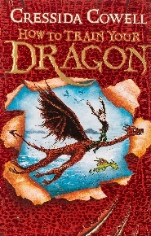  How to Train your Dragon by Cressida Cowell
Writing purpose and genre | Writing to paint a picture in the reader’s mind  - Characterisation (create a dragon) |  | Writing to paint a picture in the reader’s mind  - Settings (isle of Berk) | Writing to inform  - Instruction writing |  |  | Writing to entertain  - Dialogue  - Narrative
Writing Objectives  Retrieval objectives | - To identify and use adverbials of time, place and manner.  - To explore the writing craft of a character description.  - To develop and use expanded noun phrases and repetition to add detail about a character.  - To use appositive to add detail about a noun. | - To use a range of adverbs in writing to indicate manner (‘how’).  - To use figurative language techniques (similes, abstract similes and metaphors).  - To create a character.  - To write a character description.  - Editing focus teach: EF1 and EF2. | - To identify precise vocabulary that matches a setting.  - To begin sentences with more than one fronted adverbial to zoom in to or out of a setting. To use the appositive before or after a noun to describe detail.  - To plan a setting description, using the writing craft of description.  - To write a setting description.  - Editing focus teach: EF3 and 4 | - To identify coordinating conjunctions to join words, phrases and clauses.  - To explore the writing craft of instructions.  - To use modal verbs to indicate degrees of possibility.  - To use brackets to add parenthesis to a sentence.  - To use adverbials for time to create cohesion in writing. |  | - To identify adverbs and modal verbs that define possibility.  - To plan instructions for catching a dragon.  - To write a set of instructions (two days).  - To publish a set of instructions.  - INSET DAY | - To identify the rules of punctuating dialogue.  - To explore the writing craft of using dialogue to advance action in narrative.  - To punctuate dialogue, including split speech to advance the action and show character’s feelings.  - To use relative clauses to add subordination using who, which and whose.  - HISTORY DAY |  |  | - To identify relative clauses and relative pronoun within a sentence.  - To use adverbial clauses (when, although, whilst, if etc.) in narrative.  - To story map a section of text to re-tell.  - To write a section of narrative with dialogue.  - Editing focus teach: EF 5 and 6.
Reading Objectives |  | - To discuss and evaluate the author’s use of language, including figurative language, and the impact on the reader (explore and compare). | - To read a section of text before and after to retrieve information (retrieval). | - To explore the meaning of words in context, confidently using a dictionary (vocabulary). |  | - NTS testing | - To infer a character’s personality, using their behaviours as evidence (inference). | - To summarise the main ideas drawn from a section of test, identifying key details (summarising)
Spelling objectives  Year 5/6 words | To spell words /∫es/. If the root ends in -ce, then /∫/ sound is spelt as -c (e.g. gracious)  accommodate available cemetery familiar necessary | To spell words using -ant, -ance, -ancy and -ation (e.g. observant, observation).  according awkward | To turn adjectives ending in -able to abverbs ending in -ably (e.g. adorable and adorable).  sufficient aggressive  bruise community |  | To add suffixes beginning with vowels to words ending in -fer. (e.g. refer and referring)  ancient competition | To spell words using ‘ough’ (e.g. nought, enough).  appreciate conscious guarantee | To spell nouns ending in -ce and verbs ending is -se (e.g. practice and practise).  convenience hindrance occur

Autumn 2
 | Week 1, 2 and 3 |  |  | Week 4 and 5 |  | Week 6 and 7
Stimulus for Writing | 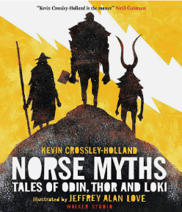  Norse myths |  |  | 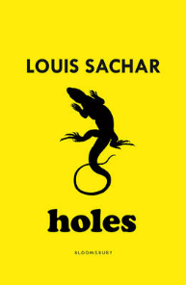  Holes by Louis Sachar
Writing purpose and genre | Writing to entertain  - Norse myth (quest/journey story)  - Characterisation  - Openings/endings  - Dialogue |  |  | Writing to persuade  - Formal letter |  | Writing to reflect and inform  - Informal letter
Writing Objectives  Retrieval objectives | - To identify commas for clarity.  - To explore the writing craft of a Norse myth.  - To create a story map for a Norse myth.  - To use -ed and -ing non-finite clauses to begin sentences to engage the reader.  - To explore vocabulary and descriptive techniques for my Norse myth. | - To identify different types of subordination (relative clause, non-finite clause and adverbial clause).  - To plan a Norse myth, following a structure.  - To explore characterisation, mirroring the character’s feelings to the atmosphere.  - To explore different openings for my Norse myth.  - To role play a section of dialogue that explores a character’s personality. | - To identify a range of fronted adverbials.  - To write a Norse myth (three days).  - To publish a Norse myth. | - To identify the present and past perfect tense.  - To explore the writing craft of a persuasive letter.  - To use a range of coordinating conjunctions to join words, phrases and clauses (and, but, so, or, yet, for and nor).  - To explore formal, persuasive and emotive vocabulary for effect.  - To use conjunctive adverbs and the rule of three for cohesion to persuade. | - To understand commas for clarity to clarify meaning.  - To plan a persuasive letter.  - To write a persuasive letter (two days).  - To publish a persuasive letter. | - To identify conjunctive adverbs.  - To explore the writing craft of informal letter writing.  - To use commas, brackets and dashes to add parenthesis to the end of a sentence (an afterthought).  - To explore informal language and punctuation choices (contractions, exclamations and question marks).  - To plan an informal letter. | - To identify adverbial clauses at the beginning and end of sentences.  - To write an informal letter (two days)  - To publish an informal letter.  - Christmas coffee morning  - Toy day
Reading Objectives | - To orally re-tell a norse myth (fluency) | - To explore themes in myth writing (explore and compare). | - To summarise the main ideas drawn from a whole text, identifying key details (summarising). | - To make predictions about details stated, using evidence from the text (prediction). | - To read around a word to explore its meaning n a section or paragraph of text (vocabulary). | - To infer a character’s feelings and thoughts from a text using their actions (inference).
Spelling objectives  Year 5/6 words | - To spell further homophones (e.g. guessed and guest).  critic criticise | - To spell adjectives with the suffix -able where the root word does not change. (e.g. comfort and comfortable).  curiosity lightning signature | - To spell adjectives with the -ible suffix and adverbs with the -ibly suffix. (e.g. possible and possibly).  develop parliament | - To spell words using the rule ‘I before e except afte c’ (e.g. friend).  embarrass interfere relevant symbol | - To spell words using the rule ‘I before e except afte c’ (e.g. receipt)  equip equipped equipment | - To spell homophones and near homophones (e.g. dessert and desert).  existence privilege thorough

 | Spring 1
 | Week 1, 2 and 3 |  |  |  | Week 4 and 5 |  | Week 6
Stimulus for Writing | Holes by Louis Sachar |  |  |  |  |  | William Shakespeare
Writing purpose and genre | Writing to inform  - Information text |  |  |  | Writing to entertain  - Characterisation  - Settings  - Flashback |  | Performing playscripts
Writing Objectives  Retrieval objectives | - To identify brackets used for parenthesis within a sentence.  - To explore the writing craft of an information text.  - To choose between using the appositive and relative clauses.  - To punctuate bullet points consistently |  | - To identify simple organisational devices (subheadings, headings and bullet points).  - To use hyphens to create compound adjectives.  - To begin sentences with adverbial clauses.  - To structure a topic themed paragraph.  - To plan an information text. | - To identify hyphenated compound adjectives.  - To write an information text (two days).  - To publish an information text.  - Pantomime | - To identify wide range of fronted adverbials, including more than one to begin a sentence.  - To explore the writing craft of narrative with a flashback.  - To explore characterisation, adding an embedded -ing or relative clause to suggest about the character.  - To ensure that word choices earn their place in description. | - To identify subordinate (adverbial, relative and non-finite) clauses embedded within a sentence.  - To plan a flashback narrative, mirroring the character’s feelings with the setting.  - To write a flashback narrative (two days).  - To publish a flashback narrative | - To understand an author from our literary heritage (William Shakespeare).  - FAITH & CULTURE DAY
Reading Objectives | - To investigate alternative word choices that could be made (vocabulary). |  | - To distinguish between fact and opinion in a text (explore and compare). | - To infer characters feelings, thoughts from a text and motives for their actions (inference). | - NTS papers | - To make predictions about details implied, using evidence from the text (prediction). | - To discuss themes and conventions from a chapter of text (summarising).  - To explore archaic language in a text.  - To prepare a play to perform, showing understanding through intonation, tone and volume so that the meaning is clear to an audience.  - To compare and discuss themes across two playscripts.
Spelling objectives  Year 5/6 words | - To spell further homophones and near homophones (e.g. accept and except).  explanation profession | - To spell words using split vowel (e.g. extreme).  leisure programme |  | - To turn adjectives to adverbs by adding -ly or -lly when the word end in an l. (e.g. wonderful wonderfully).  pronunciation restaurant | - To add the suffix -ly to words with more than one syllable (e.g. shabbily).  muscle | - To use -cial (after vowel) and -tial (after consonant) endings (e.g. partial and facial).  rhyme accompany definite guessed | - To use ‘ph’ digraph for the /f/ sound (e.g. paragraph).  achieve average

 | Spring 2
 | Week 1, 2 and 3 |  |  |  | Week 4 and 5
Stimulus for Writing |   A Galaxy of her own by Libby Jackson |  |  |  | 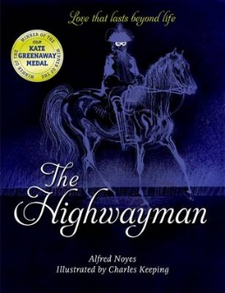  The Highwayman by Alfred Noyes
Writing purpose and genre | Writing to inform  - Biography (Helen Sharma). Children pick from four to write about. Ensure that |  |  |  | Writing to entertain  - Narrative poetry (from a character’s perspective)
Writing Objectives  Grammar l objectives | - To identify the perfect tense within a sentence.  - To explore a biography non-fiction text.  - To role play an interview with a famous astronaut.  - To write an interview as a playscript (choose one of the four).  - To understand how to write quotes and direct reported speech. | - To identify parenthesis embedded within a sentence.  - To explore the craft of biography writing.  - To explore adding detail to description using dashes, brackets commas to add parenthesis to sentences.  - To use semicolons to link two main clause.  - To research for a biography, making bullet point notes. |  | - To identify singular and plural apostrophes for possession.  - To plan a biography.  - To write a group paragraph in the style of a biography.  - To write a biography about a famous astronaut.  - To publish a biography. | - To identify adverbs for time, place and manner.  - To re-tell a narrative poem (story map).  - To practise using punctuation for parenthesis (commas and dashes)  - To use figurative language and sentence starters.  - To re-tell a narrative poem in the first person (one day). | - To identify different types of fronted adverbials.  - To re-tell a narrative poem in the first person (two days).  - To publish a narrative poem.  - EXPLORER DAY
Reading Objectives | - To make connections between information across a text to write a summary (summarising). | - World Book Day |  | - To retrieve information from a non-fiction text (retrieval). | - To discuss how the author’s choice of language impact the reader (vocabulary). | - To perform poetry with intonation (fluency).
Spelling objectives  Year 5/6 words | - To spell words with ‘xc’ (e.g. exceptional).  amateur neighbour nuisance |  | - To spell words ending in -ious (e.g. conscientious).  bargain category | - To spell words adjectives the prefix un- to demonstrate a negative meaning (e.g. uncomfortable).  apparent exaggerate | - To spell words ending in -ary (e.g. stationary).  committee frequently | - To spell words using the suffix -ible (e.g. sensible).  controversy foreign

Summer 1
 | Week 1, 2 and 3 |  |  |  | Week 4 | Week 5 and 6
Stimulus for Writing |   Alma video |  |  |  | 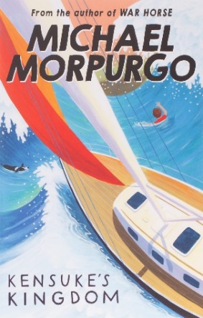  Kensuke’s Kingdom by Michael Morpurgo
Writing purpose and genre | Writing to entertain  - Narrative  - Settings  - Building suspense and action |  |  |  | Writing/Oracy to discuss  - Balanced argument | Writing to reflect  - Recount (ship’s log)
Writing Objectives | - To use commas and dashes to indicate parenthesis embedded in a sentence.  - To explore narrative that build suspense and tension.  - To create a story map for a short narrative.  - To choose figurative language techniques (similes, metaphors and personification) to bring a setting to life.  - To use a wide range of fronted adverbials to indicate when, where and how, including non-finite clauses. | - To identify relative clauses to add subordination using who, which, whose and that.  - To explore features to use punctuation to build tension (ellipsis, semicolon).  - To explore sentence structures to build tension (sentence of three with action, varied sentence length.  - To explore repetition to build tension (anadiplosis and beginning and end of sentence.  - To plan a narrative, building suspense. | - To identify hyphenated compound words.  - To write a narrative, building suspense (two days).  - To edit and improve, improving sentence openers and vocabulary choices.  - To publish a short narrative with a soundtrack. |  | - To identify word classes within sentences (nouns and adjectives).  - To explore the writing craft of a balanced argument.  - To choose modal verbs and formal vocabulary for discussion writing.  - To prepare arguments for a balanced argument (oracy lesson).  - To take part in a balanced argument. | - To identify word classes within sentences (determiners and pronouns).  - To explore the writing craft of diary/journal writing.  - To research ideas for writing.  - To explore the use of different tenses in journal writing.  - To plan a ship’s log (and begin writing). | - To identify word classes within sentences (conjunctions and prepositions).  - To write a ship’s log.  - To publish a ship’s log.  - INSET day
Reading Objectives | - To look at an author’s use of figurative language (vocabulary). | - To understand how figurative language can infer meaning (inference). | - To support predictions with more than one piece of evidence (prediction). |  | - Bank holiday | - NTS testing | - To draw evidence from more than one place in a text to make an inference (inferences).
Spelling objectives  Year 5/6 words | - To spell adjectives ending in -al (e.g. sensational).  government persuade. | - To spell adverbs using the -ally suffix (e.g. annually).  correspond dictionary desperate |  | - To spell adverbs using the suffix -fully (e.g. spitefully).  disastrous embarrass environment | - To spell nouns ending in the suffix -ment (e.g. encouragement).  excellent forty harass | - To spell progressive verbs with the suffix -ing where the l is doubled first (e.g. patrolling).  identity immediate immediately | - To spell simple past tense verbs ending in the suffix -ed when the l is doubled first (e.g. appalled).  individual rhythm suggest

Summer 2
 | Week 1 and 2 |  | Week 3 and 4 |  | Week 5 and 6 |  | Week 7 and 8
Stimulus for Writing | 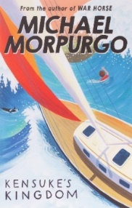  Kensuke’s Kingdom by Michael Morpurgo |  |  |  | 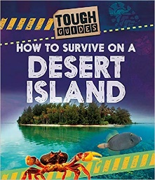  How to Survive on a Desert Island by Jim Pipe |  | 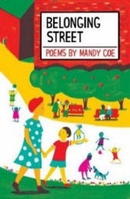  Belonging Street by Mandy Coe
Writing purpose and genre | Writing to entertain  - Characterisation and Settings  - Action and suspense  - Dialogue  - Openings/endings |  | Writing to entertain  - Setting description |  | Writing to inform  - Explanation (survival guide) |  | Writing to entertain  - Poetry
Writing Objectives  Grammar objectives | - To identify dashes, commas and brackets for parenthesis within a sentence.  - To explore the writing craft of narrative action scene, building tension.  - To use techniques to build tension (repetition and anadiplosis and power of three with clauses).  - To use semi colons to link two main clauses.  - To choose vocabulary to show the personality and emotions of the character. | - To identify relative pronouns and relative clauses within a sentence.  - To plan an action scene (allow children to have freedom to change something).  - To write an action scene, building suspense and tension (two days).  - To publish an action scene. | - To use semicolons to link two main clauses.  - To explore the writing craft of setting description.  - To develop language using a thesauru.  - To choose figurative language techniques.  - To use the rule of three and sentences with more than one fronted adverbial to describe. | - To improve sentence openers using fronted adverbials.  - To plan a setting description.  - To write a setting description (two days).  - To publish a setting description. | - To use modal verbs to indicate degrees of possibility.  - To explore the writing craft of an explanation text.  - To use relative clauses to add subordination using who, which, whose and that.  - INSET day | - To use colons to introduce lists.  - To use a variety of punctuation to develop different sentence structures (include bullet points)  - To plan a survival guide.  - To write a survival guide (two days)  - To publish a survival guide. | - To identify word classes within sentences.  - To explore figurative language in poetry.  - To write a colour poem  - Transition morning  - Fernwood Festival | - To publish a poem (red book and  perform).
Reading Objectives | - To identify themes across a wide range of writing (summarising). | - To find fact and opinion within a non-fiction text (retrieval). | - To draw evidence from more than one place in a text to make an inference (inference). | - To evaluate the author’s use of language (vocabulary). |  | No reading lesson – five writing this week. |  | - To begin to challenge others’ point of view (explore and compare).
Spelling objectives  Year 5/6 words | - To spell progressive verbs using the suffix -ing (e.g. accelerating).  communicate conscience temperature | - To spell adjectives using ‘ci’ for the /sh/ phoneme (e.g. suspicious).  determined mischievous twelfth | - To spell words with letters that are not stressed (e.g. business).  occupy physical variety | - To spell words using the dis- prefix to have a negative meaning (e.g. dishearten).  prejudice queue sincere | - To spell words using the prefix circum from the Latin ‘round’ (e.g. circumference). To spell words using the prefix hypo- from Greek ‘under’ (e.g. hypothesis). recognise recommend | - To spell words with the prefix audi-, from the Latin to har (e.g. audible

Year 6
Autumn 1
 | Week 1 and 2 |  |  | Week 3 and 4 |  | Week 5 | Week 6 and 7
Stimulus for Writing |   Black Powder by Ally Sherrick
Writing purpose and genre | Writing to entertain  - Dialogue  - Characterisation  Based on chapter 4. |  |  | Writing to reflect  - Diary entry  Based on chapter 11 |  |  | Writing to build a picture in the reader’s mind / to entertain  - Characterisation  - Settings
Writing Objectives  Grammar objectives | - To explore using the writing craft of using dialogue to convey character. | - To use pronouns and the appositive to avoid repetition.  - To use show not tell to convey character in dialogue.  - To use split speech and choose punctuation to convey character in dialogue.  - To write a section of dialogue, conveying character.  - To edit and improve a section of dialogue (Ef1-3).. |  | - To use modal verbs to indicate degrees of possibility.  - To explore the writing craft of a diary entry.  - To choose vocabulary for informal, reflective writing.  - To explore sentence openers for a diary entry.  - To use parenthesis to add thoughts and reflections. | - To identify a wide range of fronted adverbials.  - To plan a diary entry. To write a diary entry (three days).  - To publish a diary entry. | - NO OTHER LESSONS THIS WEEK – BIKEABILITY  - INSET day | - To identify noun phrases and expanded noun phrases in a sentence.  - To explore the writing craft of character description.  - To use the rule of three to describe  - To use figurative language techniques to describe.  - Spine writing: Falcon description. | To identify synonyms.  - To explore the writing craft of setting description  - To use personification to bring a setting to life.  - To use repetition to make a setting seem mysterious.  - Spine writing: London setting.
Reading Objectives | To make predictions and explore  vocabulary in fiction text (prediction and vocabulary)  To make inferences to help compare characters in a text (inference). | - To summarise the main ideas from a text, identifying key details (summarising). |  | - To read around a word to explore its meaning of words in context (vocabulary). | - To read around a word to explore its meaning In context (vocabulary). | - SATs paper testing | - History day – to retrieve information from a non-fiction text. | - To discuss and evaluate the author’s use of language, including figurative language, and the impact on the reader (explore and compare).
Spelling objectives  Year 5/6 words | - To spell words /∫es/ ending it -tious (e.g. infectious).  accompany average committee foreign neighbour stomach |  | - To spell words ending in -ent, -ence and -ency (e.g. decent decency).  achieve bargain communicate forty nuisance | - To turn adjectives ending in -ible to adverbs ending in -ibly (e.g. forcible and forcibly).  amateur category frequently | - To spell words using hyphens, joining prefixes to words beginning with a vowel (e.g. co-ordinate).  apparent conscience government occupy suggest | - To spell words with silent letters, where the letters used to be pronounced historically (e.g. thistle).  attached controversy harass | - To spell homophones and near homophones (e.g. effect and affect).  correspond identity opportunity

Autumn 2
 | Week 1 and 2 |  | Week 3, 4 and 5 |  |  |  | Week 6 and 7
Stimulus for Writing | Black Powder by Ally Sherrick |  | 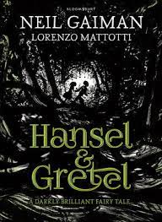  Hansel and Gretel by Neil Gaiman |  |  |  | 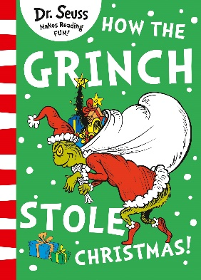  The Grinch by Dr. Seuss
Writing purpose and genre | Writing to inform  - Explanation text  - How were criminals treated through the ages? |  | Writing to entertain  - Fairy tale narrative  - Characterisation  - Dialogue  - Action and suspense |  |  |  | Writing to instruct
Writing Objectives  Grammar objectives | - To identify relative pronouns and relative clauses.  - To explore the writing craft of an explanation text.  - To use brackets, dashes and commas to add factual detail to sentences using parenthesis.  - To use a range of conjunctions to introduce a subordinate clause at the beginning, middle or end of a sentence.  - To use colons (lists) and bullet points to present information. | - To identify adverbs to indicate manner, time and frequency and place.  - To plan an explanation text.  - To write an explanation text (two days).  - To publish an explanation text. | - To identify conjunctions used to introduce a subordinate clause.  - To explore the writing craft of a fairy tale narrative that uses suspense and dialogue.  - To precis the main events in a story using story mapping.  - To use repetition in a variety of ways to build tension.  - To explore openings to engage the reader. |  | - To identify hyphenated adjectives.  - To plan a version of a traditional tale.  - To explore character description, using precise vocabulary and embedded clauses.  - To describe two contrasting settings using figurative language.  - To explore the use dialogue within narrative to advance the action. | - To identify coordinating conjunctions.  - To write a fairy tale narrative (two days).  - To publish a fairy tale narrative.  - SPaG paper in pairs and as a class | - To identify antonyms.  - To explore a text identifying instructional features.  - To use semicolons to join two main clauses.  - To plan and structure an instructional text.  - To use a variety of sentence openers. | - To identify a range of pre-fixes.  - To write an instruction text on how to steal Christmas (2 days)  - To publish an instructional text.
Reading Objectives | - To use more than one piece of evidence to support an inference made about a character’s thoughts, feelings or motive (inference). | - To explore and compare character’s motives in a text (Falcon vs. Hunt) (explore and compare). | - To discuss how an author has used language and its impact on the reader – create an atmosphere (vocabulary). |  | - To make predictions from details stated and implied, using evidence from the text (prediction). | - Reading assessment | - To summarise an event as a storyboard (summarising) | - Christmas sing
Spelling objectives  Year 5/6 words | - To spell homophones and near homophones (e.g. morning and mourning).  dictionary individual secretary | - To spell words with a + double consonant (e.g. assembly , anniversary).  desperate language rhythm | - To spell words endng in -ance, -an and -ation using root words (e.g. expectant expectation).  determined temperature | - To spell adjectives ending in -able (e.g. reasonable).  especially marvellous interrupt persuade |  | - To spell adverbs ending in -ably (e.g. believably).  definite environment | - To use the rule ‘I’ before ‘e’ except after ‘c’ and some exceptions (e.g. conceit).  excellent prejudice system

Spring 1
 | Week 1 and 2 |  | Week 3 | Week 4, 5 and 6
Stimulus for Writing | Pet Peeves Blog Entries |  | 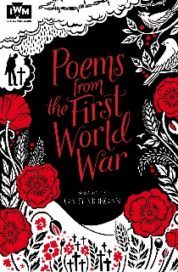  Poems from the first World War | Gas Mask! Portal Story  Lee Enfield rifle from the WW1 history box as a hook
Writing purpose and genre | Writing to inform/entertain  - Blog entry writing |  | Writing to paint a picture in the reader’s mind  - Settings | Writing to entertain  - Portal narrative  - Settings  - Characterisation  - Openings/endings
Writing Objectives  Grammar  objectives | - To identify modal verbs to indicate degrees of possibility.  - To explore the writing craft of a blog entry.  - To explore formal and informal language.  - To understand how to use semicolons in a list. | - To identify nouns and noun phrases.  - To use the active and passive voice.  - To plan a blog entry  - To write a blog entry (two days)  - To publish a blog entry. | - To identify different types of figurative language  - To explore vocabulary in war time poetry.  - To write figurative language for poetry.  - To write and perform a wartime poem.  - Pantomime | - To identify semicolons.  - To explore the writing craft of a portal story.  - To practise using a range of sentence lengths in narrative.  - To begin to plan a portal story  - To develop characters using a range of techniques | - To identify the subject and object of a sentence.  - To develop two contrasting settings.  - To explore different ways to begin a narrative.  - To use colons to add an explanation to a sentence.  - SPaG paper | - To identify a range of fronted adverbials.  - To write a portal story (three days).  - To publish a portal story.
Reading Objectives | - To explore the meaning of words in context (vocabulary). |  | - To compare poems (explore and compare) | - To make impressions about characters using evidence from the text (inference). | - Reading paper | - TO summarise a text by ordering its main plot points (summarising)
Spelling objectives  Year 5/6 words | - To spell words using the ‘ough’ letter string (e.g. afterthought).  aggressive necessary leisure | - To turn adjectives to adverbs by using the -ly suffix to words ending with a consonant (e.g. vivid vividly).  queue variety | - To turn adjectives to adverbs by using the -ly suffix to words ending with -ble, -ple, -tle, -gle (e.g. reasonable reasonably).  sacrifice | - To spell words part of word families, showing words related in meaning (e.g. vary, variety, variation, variable).  soldier vegetable  - To add suffixes beginning with vowel letters to words ending in -fer (e.g. confer conferred).  recognise recommend vehicle |  | - To spell words with the /s/ phoneme spelt with the c grapheme (e.g. cemetery).  yacht accommodate community

Spring 2
 | Week 1 and 2 |  |  | Week 3 and 4 |  |  | Week 5
Stimulus for Writing | 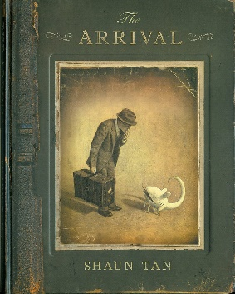  The Arrival by Shaun Tan
Writing purpose and genre | Writing to entertain  Writing narrative (characterisation, setting) |  |  | Writing to reflect  Diary entry (recount) |  |  | Writing to inform  - Information text based on a made-up animal
Writing Objectives  Grammar objectives | - Revise grammar you think children need.  - To predict and infer from illustrations (reading).  - To explore symbolism in The Arrival.  - To use figurative language.  - To explore punctuation choices.  - To explore sentence openers. |  | - Revise grammar you think children need.  - To practise techniques to build tension.  - To write a narrative, building suspense (two days).  - To publish a narrative.  - World Book Day | - Revise grammar you think children need.  - To explore the writing craft of diary writing.  - To plan a diary entry.  - To write a diary entry.  - To plan a diary entry. |  | - Revise grammar you think children need.  - To write a diary entry.  - To plan a contrasting diary entry.  - To write a diary entry.  - To publish diary entries. | Revise grammar you think children need.  - Reading paper  - SPaG paper  - To explore the writing craft of an information text.  - To write in a formal tone.  - To plan an information text/.
Reading Objectives | Application of reading skills to practise and develop skills in comprehension questions involving retrieval, inference, prediction, summarising and exploring and comparing short extracts of text.
Spelling objectives  Year 5/6 words | To spell words using the ending in -cial (e.g. artificial).  according ancient appreciate available | To spell words ending in -tial (e.g. potential).  bruise awkward cemetery |  | To spell words with the long ‘o’ sound using the graphemes ou and ow. (e.g. smoulder).  competition convenience curiosity conscious | To spell words that can be used as nouns and verbs (e.g. challenge).  develop existence explanation |  | To spell words part of word families (e.g. accrue , accomplish).  muscle signature | To spell words part of word families (e.g. assign assignment).  relevant restaurant

Summer 1
 | Week 1 | Week 2 and 3 |  | Week 4 and 5 | Week 6
Stimulus for Writing | The Arrival by Shaun Tan | 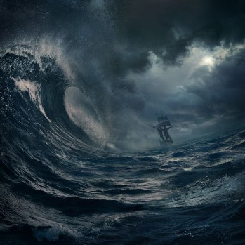  Sea storm description |  | SATS revision and KS2 SATs tests | WW2 historical sources  (more lessons this week due to SATs being finished)
Writing purpose and genre | Writing to inform  Information text based on a made-up animal | Writing to entertain  - Setting description  - Dialogue |  |  | Writing to reflect/inform  - Letter from an evacuee
Writing Objectives | - Revise grammar you think children need.  - To plan an information text.  - To write and publish an information text (three lessons). | - To identify the progressive tense.  - To explore the writing craft of sea storm narrative  - To choose vocabulary for a sea storm setting.  - To use dialogue to advance the action. | - Revise grammar you think children need.  - To plan a sea storm description.  - To write a sea storm description (two days). |  | - To identify parenthesis  - To identify conjunctions  - To explore the writing craft of an informal letter.  - To explore emotional language to use in an informal letter.  - To plan an informal letter.  - To write an informal letter.  - To publish an informal letter  - INSET day
Reading Objectives | Application of reading skills to practise and develop skills in comprehension questions involving retrieval, inference, prediction, summarising and exploring and comparing short extracts of text.
Spelling objectives  Year 5/6 words | To spell words part of word families (e.g. telegram hologram).  occur parliament privilege profession | To spell words part of word families (e.g. digest congestion).  thorough symbol rhyme pronunciation

Summer 2
 | Week 1 and 2 |  | Week 3 | Week 4 and 5 | Week 6 and 7
Stimulus for Writing | Range of advertisements for hotels |  |  | 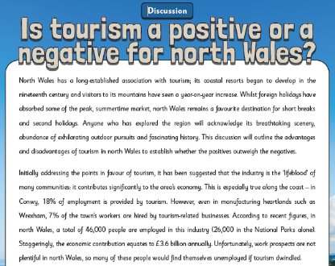 |   Research using fernwoodprimary.co.uk
Writing purpose and genre | Writing to persuade  Hotel advert |  |  | Writing/Speaking to discuss (oracy focus week)  - Should tourism be allowed in North Wales? | Writing to reflect  - Newsletter all about Fernwood Primary School  - Leavers memory poems
Writing Objectives | - To identify persuasive devices.  - To explore the writing craft of a persuasive advert. To use the subjunctive form to persuade.  - To explore language for a persuasive hotel advert. | - To plan a persuasive advert.  - To write a persuasive advert (two days).  To publish a persuasive advert. |  | - To explore the craft of a discussion text.  - To consider what makes a good orator.  - To speak from bullet points.  - To present views on an important topic.  - Week 5 – BIG ARTS WEEK | - To use the passive voice.  - To interview to find record quotes.  - To plan a newsletter.  - To write a newsletter.  - Transition morning
Reading Objectives | - To discuss and compare inferences made with peers and justify my views (inference). | - To make give recommendations to my peers, giving reasons for my choices (explore and compare). |  | - To speak fluently to discuss my ideas. | - To ask my own questions, following a line of enquiry (retrieval).
Spelling objectives  Year 5/6 words | - To spell words that can be used as nouns and verbs (e.g. produce).  criticise identity  - To spell words that are synonyms and antonyms (e.g. elated forlorn).  embarrass  - To spell words that are synonyms and antonyms (e.g. ambled sauntered).  interfere

