


Fernwood Primary and Nursery School

Curriculum Intent

Subject Progression 2026 - 27

Contents

 | Page
Our Curriculum Vision | 3
Science | 4
History | 18
Geography | 27
RE | 37
Computing | 52
PD | 68
Music | 76
DT | 88
Art | 98
MFL (French) | 110
PE | 116
Fernwood Days | 132
Visits and Residentials | 136

Our Curriculum
At Fernwood Primary and Nursery School, our curriculum is designed to foster a lifelong love of learning, igniting curiosity, creativity, and a passion for discovery in every child. We believe in building a strong foundation of knowledge and skills that progressively develop throughout each stage of a child’s education. From the earliest years through to Key Stage 2, our curriculum is carefully sequenced to ensure that every learner not only acquires essential knowledge but also develops the critical thinking and problem-solving skills needed to navigate a rapidly changing world.
We aspire to create a vibrant and inclusive learning environment where children are encouraged to explore, ask questions, and make connections across subjects. Through a rich and diverse curriculum, we aim to nurture a deep understanding of the world around them, preparing them to become confident, responsible, and compassionate individuals who are equipped to thrive in the future.
Our approach is rooted in the belief that learning is a lifelong journey, and we are committed to providing our pupils with the tools and mindset to continue their learning beyond the classroom. A skilled and experienced team support all children to grow and develop in many ways. Our values of Friendship, Respect, Inclusion, Enthusiasm, Nurture and Determination are lived out by children and staff so that we can meet our ambitious aims of excellence for all. We aim to inspire a sense of wonder and possibility, ensuring that all children, regardless of their starting point, leave our school with the skills, knowledge, and ambition to reach their full potential.

FPNS Science Curriculum Intent Progression Document

Science Vision Statement
We know that children learn best through an exciting and engaging curriculum that both supports and stretches every child and gives them the potential to build on their learning over time. Every child’s learning journey begins in the Early Years Foundation Stage where we Plant new ideas and concepts; these ideas then Grow over their time with us, giving all children the chance to Flourish and love learning. The values of a ‘Fernwood Friend’ are woven throughout the Curriculum; children are well-rounded individuals who take greater responsibility for their learning.

Intent
We teach Science to inspire curiosity, fascination and understanding of the world in which we live. Our pupils are given many opportunities to work scientifically. We support them to ask questions and find answers through predictions, investigation, observation and discussion. They learn to record their findings in a range of different ways (using diagrams, tables, charts and graphs) and they draw conclusions based on their own practical experiences. At Fernwood, we want our pupils to view themselves as scientists and potentially be inspired to pursue an interest in STEM careers in the future. As part of our Science provision, our pupils enjoy working outdoors and in the local environment to observe and record life around them. Cross-curricular links are used whenever possible to make their learning interesting and relevant.
Implementation
‘It is important to view knowledge as sort of a semantic tree – make sure you understand the fundamental principles, i.e. the trunk and big branches, before you get into the leaves/details or there is nothing for them to hang on to.’ Elon Musk
Teachers create a positive attitude to science learning within their classrooms and reinforce an expectation that all children are capable of achieving high standards in science. At Fernwood Primary and Nursery School, Science is taught every half-term as all pupils should be taught essential aspects of the knowledge, methods, processes and uses of science in a consistent and thorough unit. Science at Fernwood follows the objectives of the national curriculum (Understanding of the World – EYFS) and the units taught are carefully designed to build on curriculum knowledge throughout the year, the whole school science progression map is used to support this. For each unit, the key knowledge, skills and vocabulary have been identified to ensure a progression of learning and to help lay the foundations for more abstract concepts.
In the planning of science, problem solving opportunities are used in investigative enquiries that allow children to use the working scientifically skills outlined in the national curriculum. Children are encouraged to develop their own questions and this curiosity is valued and celebrated. Planning involves teachers creating engaging lessons, making use of resources to aid knowledge and provide hooks in learning. Teachers use precise questioning in lessons to assess understanding and to stretch and challenge.
Science Day is also a chance for children to expand on their working scientifically skills and to help them see themselves as a Scientist. We have used the CREST awards to engage and motivate parents at home to continue an enjoyment of scientific enquiry.

Impact
Our high-quality Science curriculum provides our children with the foundations for understanding the world through the specific disciplines of biology, chemistry and physics, which they are able to build upon in their secondary education. The progressive nature of the Science curriculum allows them to make links between new knowledge and their existing scientific understanding. The work in the children’s Science books provides evidence of the engaging Science curriculum we offer and showcases their developing knowledge and skills.

Nursery
Topic areas:
Autumn 1 –
Autumn 2 – Autumn and Woodland Animals
Spring 1 – Winter
Spring 2 – Materials and Life Cycles
Summer 1 – Spring and Animals
Summer 2 – Seaside and Summer

To comment and ask questions about aspects of their familiar world such as the place where they live or the natural world. (UTW-TNW)

To talk about why things happen and how things work. (UTW-TNW)

To show care and concern for living things and the environment. (UTW-TNW)

Vocabulary:

Foundation F2
Topic areas:
Autumn 1 –
Autumn 2 – Autumn
Spring 1 – Winter
Spring 2 – Spring
Summer 1 – Plants
Summer 2 – Farm and Summer

To explore the natural world around them, making observations and drawing pictures of animals and plants. (UTW-TNW)

To know some similarities and differences between the natural world around them and contrasting environments, drawing on their experiences and what has been read in class. (UTW-TNW)

To understand some important processes and changes in the natural world around them, including the seasons and changing states of matter. (UTW-TNW)

Vocabulary:

Year 1

Knowledge

Plants (Biology)
To identify and name some common wild and garden plants, including deciduous and evergreen trees.
To identify and describe the structure of a variety of flowering plants, including trees.

Animals including humans (Biology)
To identify and name some common animals including fish, amphibians, reptiles, birds and mammals.
To identify and name a variety of common animals that are carnivores, herbivores and omnivores.
To describe and compare the structure of a variety of common animals (fish, amphibians, reptiles, birds and mammals, including pets).
To identify, name, draw and label the basic parts of the human body and say which
part of the body is associated with each sense.

Materials (Chemistry)
To distinguish between an object and the material from which it is made.
To identify and name a variety of everyday materials, including wood, plastic, glass, metal, water, and rock.
To describe the simple physical properties of a variety of everyday materials.
To compare and group together a variety of everyday materials on the basis of their simple physical properties.

The seasons (Biology)
To observe changes across the four seasons.
To observe and describe weather associated with the seasons and how day length varies.

Working Scientifically

Asking simple questions and recognising they can be answered in different ways
Talk about what they can see and do. Does a tree always look the same? What material should we build a model house with? What is the weather like?

Observing closely and using simple equipment
Magnifying glasses, QR codes, iPads.

Performing simple tests
Test ideas suggested to them. Grow cress, tests related to the 5 senses—feely bag, smelly socks, tasting different flavours, testing materials—strength, waterproof, absorbency.

Identifying and Classifying
Plants (Wollaton Park Plant Hunt), Animals, Materials.
Begin to compare some living things.
Make simple comparisons and groupings.

Using observations and ideas to suggest answers to questions
What is the weather like? Which animals make good pets? Why?
Cinderella needs a mop. Which material would be best? How could we find out?

Gathering and recording data to help answer questions
Use simple charts/ICT/simple writing/labelling to communicate findings. Weather chart.
Writing What I did... and what happened?
Drawing ideas and simple pictures.
Recording classification of animals for display/in a chart.

Vocabulary:

Year 2
Knowledge

Plants (Biology)
To observe and describe how seeds and bulbs grow into mature plants.
To experiment and describe how plants need water, light and a suitable temperature to grow and stay healthy.

Animals including humans (Biology)
To know that animals, including humans, have offspring which grow into adults.
To describe the basic needs of animals, including humans, for survival (water, food and air).
To describe the importance for humans of exercise, eating the right amounts of different types of food, and hygiene.

Living things and their habitats—chicks/the pond and the farm (Biology)
To explore and compare the differences between things that are living, dead, and things that have never been alive.
To identify that most living things live in habitats to which they are suited and describe how different habitats provide for the basic needs of different kinds of animals and plants, and how they depend on each other.
To identify and name a variety of plants and animals in their habitats, including micro-habitats.
To describe how animals, obtain their food from plants and other animals, using the idea of a simple food chain, and identify and name different sources of food.

Materials (Chemistry)
To identify and compare the suitability of a variety of everyday materials, including wood, metal, plastic, glass, brick, rock, paper and cardboard for particular uses.
To find out how the shapes of solid objects made from some materials can be changed by squashing, bending, twisting and stretching.

Working Scientifically

Asking simple questions and recognising that they can be answered in different ways
Describe observations using some scientific vocabulary. What does a plant need to grow? How could we make a test to find out? I wonder where a frog lives? Why is that a good place for a frog to live? What do animals need to survive?

Observing closely and using simple equipment
Timer, ruler (cms).

To perform simple tests
Grow a bean/Testing materials—changes including twist, bend and stretch.
Begin to recognise when a test is fair.

Identifying and Classifying
Plants (grown from bulbs and seed). Animals (matched to their habitats). Materials (matched to particular uses).

Using observations and ideas to suggest answers to questions
What happens to these seeds if we leave them in the dark?
What happens to my body when I exercise? Why is that important?
What is a food chain? Can we describe one?

Gathering and recording data to help answer questions
Writing ‘What I did...’ in more detail.
Suggesting ‘What might happen…?’ Writing ‘What happened?’
Experiments which require measurement/observations over time including growing experiment.

Vocabulary:

Year 3
Knowledge

Plants (Biology)
To know about the functions of different parts of flowering plants: roots, stem/trunk, leaves and flowers.
To explore the requirements of plants for life and growth (air, light, water, nutrients from soil, and room to grow) and how they vary from plant to plant.
To investigate the way in which water is transported within plants.
To know the part that flowers play in the life cycle of flowering plants—pollination, seed formation and dispersal.

Animals, including humans (Biology)
To know that animals, including humans, need the right types and amount of nutrition, and that they cannot make their own food; they get nutrition from what they eat.
To know that humans and some other animals have skeletons and muscles for support, protection and movement.

Rocks (Chemistry)
To compare and group together different kinds of rocks on the basis of their appearance and simple physical properties.
To describe in simple terms how fossils are formed when things that have lived are trapped within rock.
To know that soils are made from rocks and organic matter.

Light (Physics)
To know light is needed in order to see things and that dark is the absence of light.
To know that light is reflected from surfaces.
To know that light from the sun can be dangerous and that there are ways to protect our eyes.
To know that shadows are formed when the light from a light source is blocked by an opaque object.
To find patterns in the way that the size of shadows change.

Forces and magnets (Physics)
To compare how things move on different surfaces.
To know that some forces need contact between two objects, but magnetic forces can act at a distance.
To observe how magnets attract or repel each other and attract some materials and not others.
To compare and group together a variety of everyday materials on the basis of whether they are attracted to a magnet, and identify some magnetic materials.
To describe magnets as having two poles.
To predict whether two magnets will attract or repel each other, depending on which ways the poles are facing.

Working Scientifically

Asking relevant questions/use different types of science enquiries to answer them.
What do you know about magnets? How do things move on different surfaces?

Setting up simple practical enquiries, comparative and fair tests.
Carry out a fair test with support. Friction investigation (same ramp height etc).

Making systematic and careful observations/accurate measurements using standard units/equipment.
Measure shadows (metre rulers/cms). How does friction affect distance of travel?

Gathering, recording, classifying and presenting data in a variety of ways to help answer questions
Body measurements and ability investigation. Permeability and strength of rocks.

Recording findings using simple language, drawings, labelled diagrams, keys, bar charts and tables.
Keys to classify leaves/create a bar chart from findings. Conditions for seed growth.

Reporting on findings—oral and written, displays or presentations of results and conclusions.
Oral and written presentation on rock findings. Record investigations in charts and graphs.

Using results to draw simple conclusions, making predictions for new values, suggesting improvements and raising further questions
Bigger/smaller magnet investigation. Shadow investigation.

Identifying differences/similarities/changes related to simple scientific ideas and processes
Animals including humans—compare teeth of carnivores, herbivores and omnivores.

Using straightforward scientific evidence to answer questions or to support findings
Shadow investigation/Light investigation.

Vocabulary:

Year 4
Knowledge

Living things and their habitats (Biology)
To recognise that living things can be grouped in a variety of ways.
To explore and use classification keys to help group, identify and name a variety of living things in their local and wider environment.
To recognise that environments can change and that this can sometimes pose dangers to living things.

Animals, including humans (Biology)
To describe the simple functions of the basic parts of the digestive system in humans.
To identify the different types of teeth in humans and their simple functions.
To construct and interpret a variety of food chains, identifying producers, predators and prey.

States of Matter (Chemistry)
To compare and group materials together, according to whether they are solids, liquids or gases.
To observe some materials that change state when they are heated or cooled, and measure or research the temperature at which this happens in degrees Celsius (°C).
To understand the part played by evaporation and condensation in the water cycle and associate the rate of evaporation with temperature.

Electricity (Physics)
To identify common appliances that run on electricity.
To construct a simple series electrical circuit, identifying and naming its basic parts, including cells, wires, bulbs, switches and buzzers.
To know whether or not a lamp will light in a simple series circuit, based on whether or not the lamp is part of a complete loop with a battery.
To recognise that a switch opens and closes a circuit and associate this with whether or not a lamp lights in a simple series circuit.
To recognise some common conductors and insulators, and associate metals with being good conductors.

Sound (Physics)
To identify how sounds are made, associating some of them with something vibrating.
To recognise that vibrations from sounds travel through a medium to the ear.
To find patterns between the pitch of a sound and features of the object that produced it.
To find patterns between the volume of a sound and the strength of the vibrations that produced it.
To recognise that sounds get fainter as the distance from the sound source increases.

Working Scientifically

Asking relevant questions/using different types of science enquiries to answer them
Why and how does the volume and pitch change when playing different lengths of tube?

Setting up simple practical enquiries, comparative and fair tests
Plan and carry out fair tests e.g. which insulator works best for ear protection?

Making systematic and careful observations/accurate measurements using standard units/equipment
How does volume decrease as you move further from the source? Data loggers.

Gathering, recording, classifying and presenting data in a variety if ways to help answer questions
How quickly does a material melt, and at what temperature. Charts, graphs.

Recording findings using simple language, drawings, labelled diagrams, keys, bar charts and tables
Which organs make up the human digestive system? Labelled and annotated diagrams.

Reporting on findings—oral and written, displays or presentations of results and conclusions
Demonstrate how the water cycle works by creating a ‘water cycle bag’.

Using results to draw simple conclusions, making predictions for new values, suggest improvements and raise further questions
How can we make wet clothes dry faster? How can we improve our findings?

Identifying differences/similarities/changes related to simple scientific ideas and processes
When have you seen this in real life? Condensation. Make it rain investigation.

Using straightforward scientific evidence to answer questions or to support findings.
Solids, liquids, gases investigations.

Vocabulary:

Year 5
Knowledge

Living things and their habitats (Biology)
To describe the differences in the life cycles of a mammal, an amphibian, an insect and a bird.
To describe the life process of reproduction in some plants and animals.

Animals including humans (Biology)
To describe the changes as humans develop to old age.

Properties and changes of materials (Chemistry)
To compare and group together everyday materials on the basis of their properties, including their hardness, solubility, transparency, conductivity (electrical and thermal), and response to magnets.
To know that some materials will dissolve in liquid to form a solution, and describe how to recover a substance from a solution.
To use knowledge of solids, liquids and gases to decide how mixtures might be separated, including through filtering, sieving and evaporating.
To give reasons, based on evidence from comparative and fair tests, for the particular uses of everyday materials, including metals, wood and plastic.
To demonstrate that dissolving, mixing and changes of state are reversible changes
To explain that some changes result in the formation of new materials, and that this kind of change is not usually reversible, including changes associated with burning and the action of acid on bicarbonate of soda.

Earth and Space (Physics)
To describe the movement of the Earth and other planets relative to the sun in the solar system.
To describe the movement of the moon relative to the Earth.
To describe the sun, Earth and moon as approximately spherical bodies.
To use the idea of the Earth’s rotation to explain day and night and the apparent movement of the sun across the sky.

Forces (Physics)
To explain that unsupported objects fall towards the Earth because of the force of gravity acting between the Earth and the falling object.
To identify the effects of air resistance, water resistance and friction, that act between moving surfaces.
To recognise that some mechanisms including levers, pulleys and gears allow a smaller force to have a greater effect.

Working Scientifically

Planning different types of scientific enquiries to answer questions, including recognising and controlling variables where necessary.
Materials investigation/dissolving in a liquid to create a solution/recover a substance.

Taking measurements, using a range of scientific equipment, with increasing accuracy and precision, taking repeat readings when appropriate.
Materials investigation (mms) indentation into plasticine, timers linked to air resistance, measuring with a Newton Metre (linked to work on forces)

Recording data and results of increasing complexity using scientific diagrams and labels, tables, scatter graphs and bar graphs.
Testing strength of materials (bar graph). Analysis of babies’ growth (comparing pie/bar/line graph).

Using test results to make predictions to set up further comparative and fair tests.
Predicting which materials dissolve/separate, air resistance/water resistance.

Reporting and presenting findings from enquiries, including conclusions, causal relationships and explanations of and degree of trust in results, in oral and written forms such as displays and other presentations.
Writing up experiments, feedback to class, diagrams/models.

Investigating scientific evidence that has been used to support or refute ideas or arguments.
Discussions/presentation e.g. Geocentric and heliocentric solar systems.

Vocabulary:

Year 6
Knowledge

Living things and their habitats (Biology)
To describe how living things are classified into broad groups according to common observable characteristics and based on similarities and differences, including microorganisms, plants and animals.
To give reasons for classifying plants and animals based on specific characteristics.

Animals Including Humans (Biology)
To identify and name the main parts of the human circulatory system, and describe the functions of the heart, blood vessels and blood.
To recognise the impact of diet, exercise, drugs and lifestyle on the way bodies function.
To describe the ways in which nutrients and water are transported within animals, including humans.

Evolution and Inheritance (Biology)
To recognise that living things have changed over time and that fossils provide information about living things that inhabited the Earth millions of years ago.
To recognise that living things produce offspring of the same kind, but normally offspring vary and are not identical to their parents.
To identify how animals and plants are adapted to suit their environment in different ways and that adaptation may lead to evolution.

Light (Physics)
To recognise that light appears to travel in straight lines.
To use the idea that light travels in straight lines to explain that objects are seen because they give out or reflect light into the eye.
To explain that we see things because light travels from light sources to our eyes or from light sources to objects and then to our eyes.
To use the idea that light travels in straight lines to explain why shadows have the same shape as the objects that cast them.

Electricity (Physics)
To associate the brightness of a lamp or the volume of a buzzer with the number and voltage of cells used in the circuit.
To compare and give reasons for variations in how components function, including the brightness of bulbs, the loudness of buzzers and the on/off position of switches.
To use recognised symbols when representing a simple circuit in a diagram.

Working Scientifically

Planning different types of scientific enquiries to answer questions, including recognising and controlling variables where necessary.
Investigating what can affect the brightness of a bulb, shapes of shadows

Taking measurements, using a range of scientific equipment, with increasing accuracy and precision, taking repeat readings when appropriate.
Rulers, data logger to measure light levels, investigating body measurements, stopwatches to measure heart rate.

Recording data and results of increasing complexity using scientific diagrams and labels, classification keys, tables, scatter graphs, bar and line graphs.
Heart rate, circuits (tables) bar chart (shadow) classification key (evolution)

Using test results to make predictions to set up further comparative and fair tests.
Child led investigation linked to body knowledge.

Reporting and presenting findings from enquiries, including conclusions, causal relationships and explanations of and degree of trust in results, in oral and written forms such as displays and other presentations.
Conclusions when writing experiments (bulb brightness) ‘Light’ oral presentation, presenting own conclusions following inherited characteristics, evolution theories.

Identifying scientific evidence that has been used to support or refute ideas or arguments.
Discussion and presentations on different evolutionary theories

Vocabulary:

FPNS History Curriculum Intent Progression Document

History Vision Statement
We know that children learn best through an exciting and engaging curriculum that both supports and stretches every child and gives them the potential to build on their learning over time. Every child’s learning journey begins in the Early Years Foundation Stage where we Plant new ideas and concepts; these ideas then Grow over their time with us, giving all children the chance to Flourish and love learning. The values of a ‘Fernwood Friend’ are woven throughout the Curriculum; children are well-rounded individuals who take greater responsibility for their learning.
Intent
At Fernwood Primary and Nursery School, we believe history provokes and answers questions about British history and history around the world. It is a focus within the curriculum for developing cultural awareness, understanding historical periods and recognising the impact these periods have on us today. Through the history taught at Fernwood Primary, we seek to inspire pupils’ curiosity about the past to inform their understanding of the present.
Implementation
History at Fernwood Primary and Nursery School follows the National Curriculum objectives and is taught in units throughout the year, so that children can achieve depth in their learning. For each unit, teachers have identified the key knowledge, skills and vocabulary which will be covered. Units have been carefully planned using the whole school history progression map to ensure children build on prior learning and make links between units. A short narrative of how each unit builds on prior learning is shown in the whole school history overview. History at Fernwood Primary and Nursery School is organised under four main categories known as substantive knowledge. These include: Society and Community, Exploration and Invasion, Power and Conflict and Disaster. Within each topic, our lessons link to one of the second order concepts which inform the skills and knowledge covered. These include: Cause and Consequence, Change and Continuity, Similarity and Difference, Historical Significance, Evidence and Interpretation and Chronology. These threads of knowledge run throughout our curriculum and allow children to make links and recognise the implications of history with increasing sophistication.
As a school, we value the importance of developing children’s chronological knowledge. Each class has visual learning aids to refer to throughout the year to embed children’s understanding of chronology. At EYFS and KS1, children can order events and artefacts using the terms ‘past’ and ‘present’ and ‘old’ and ‘modern’. In KS2, children embed their understanding of chronology by referring to a timeline which sequences the historical periods taught in this key stage. They can apply their knowledge of chronology to create their own timelines identifying key events. Children have access to a wide range of artefacts as well as primary and secondary sources to develop their enquiry skills. Children are encouraged to examine and ask questions about these artefacts to deepen their knowledge of the past and the people of that time.
At Fernwood Primary and Nursery School, we endeavour to make links in learning across the National Curriculum subjects. Where possible, history units are taught alongside high-quality texts. For example, in Year 1, when studying the history of Nottingham, children will read ‘Robin Hood and the Silver Arrow’ by Tony Bradman and in Year 6, when studying Crime and Punishment, children will read ‘Black Powder’ by Ally Sherrick. This enables children to make connections both in their historical learning and in the wider curriculum.
Impact
Through the history curriculum, children develop the historical knowledge and skills to help them explore, enquire and understand the past and present. Children’s knowledge and skills develop intrinsically as they progress through the school, not only enabling them to meet the requirements of the National Curriculum but to prepare them to become competent historians in secondary education. The work in children’s history books evidences the broad and balanced history curriculum we deliver and demonstrates their acquisition of key knowledge and skills.

Nursery
Topic areas:
Autumn 1 – (History Day)
Autumn 2 –
Spring 1 – Old and New buses
Spring 2 –
Summer 1 –
Summer 2 – Seaside, fossils and dinosaurs

To remember and talk about significant events in their own experience.

To begin to explore the past through books and storytelling. (UTW-P&P)

Vocabulary: today, yesterday, parent, grandparent, week, tomorrow, old, new, bus

Foundation F2
Topic areas:
Autumn 1 – Jobs in the community
Autumn 2 – Past through settings, events and people
Spring 1 –
Spring 2 –
Summer 1 – Old and New
Summer 2 –

To talk about the lives of the people around them and their roles in society. (jobs)
To know some similarities and differences between things in the past and now, drawing on their experiences and what has been read in class. (vehicles) (UTW-P&P)
To understand the past through settings, characters and events encountered in books read in class and storytelling. (UTW-P&P)

Skills
Chronology
To talk about past and present.

Causality and Interpretation
To decide whether objects are from the past or present.
Vocabulary: same, different, job, now, then, the past, remember, old, new

Year 1
Knowledge

How things have changed
To know about changes within living memory (my life).
To know about changes within living memory (last 70 years).

Transport (bikes and trains)
To know about changes within living memory.
To know about events beyond living memory that are significant nationally (George Stephenson and the Rocket Locomotive).
To know about the lives of significant individuals in the past who have contributed to national achievements (George Stephenson)

Famous People from Nottingham
To know some facts about significant historical events, people and places in Nottingham (Robin Hood).
To know about events beyond living memory.

Skills
Chronology
To sort objects into old and modern.
To use vocabulary—old, new, modern, a long time ago.
To know about my changes since birth.

Causality and Interpretation
To talk about why Robin Hood is famous.
To identify some similarities and differences between old/modern objects.
To identify some objects from the past (household objects).
To make observations about old/modern objects using artefacts.

Enquiry
To ask and answer questions using artefact/photograph provided.

Vocabulary: same, different, old, modern (new), years, timeline, invention, artefact, technology, influence

Year 2
Knowledge
Black History
To know about the lives of significant individuals in the past who have contributed to international achievements.
To compare aspects of life in different periods (Martin Luther King and another famous black achiever such as Rosa Parks, Barak Obama or Nelson Mandela.)

The Great Fire of London
To know about events beyond living memory that are significant nationally.

History of the School and Willoughby Family
To know about significant historical events, people and places in Wollaton.

Skills

Chronology
To use phrases and words like: ‘before’, ‘after’, ‘past’, ‘present’, ‘then’ and ‘now’.
To sequence a set of events in chronological order and give reasons for the order.

Causality and Interpretation
To recount some interesting facts from an historical event (Great Fire of London).
To explain how a historical figure shaped the world we live in (Nelson Mandela, Rosa Parks).
To identify similarities and differences between Wollaton in the past and present.

Enquiry
To ask historical questions using a source of evidence (eg MLK speech, digimaps)
To research the life of a historical figure (eg Willoughby family, Rosa Parks, etc).

Vocabulary: resistance, laws, similarity, difference, achievements, disaster, black history, significant, past, present, legacy, architecture

Year 3
Knowledge

The Stone Age to Iron Age
To use artefacts to ask questions about what happened in the past.
To compare similarities and differences from the stone age and now.
To order events chronologically from the stone age to iron age using dates on a timeline.
To know about the changes from the stone age to iron age.
To know why there were changes from the stone age to the iron age.
To investigate why historians believes the stone, bronze and iron ages are significant to us.

The Ancient Egyptians
To know about where and when the first civilisations appeared.
To order events chronologically using dates on a timeline and explain changes.
To compare the similarities and differences between ancient Egypt and today using a secondary resource.
To know why the pyramids are an achievement for Ancient Egyptians.
To understand what Ancient Egyptians know about life and after death.

Ancient Greece
To know who the Ancient Greeks were using evidence.
To arrange events from Ancient Greece in chronological order.
To investigate Greek inventions and compare to them to today.
To explain why the first Olympic games are significant.
To research Greek gods and goddesses.
To know what impact ancient Greece has on the world.

Skills
Chronology
To order events chronologically from the Stone Age to Iron Age using dates on a timeline.

Causality and Interpretation
To explain why things changed within a period of time.
To identify a similarity and difference between a historical period and Britain today.
To explain how an event from the past is significant to us now.

Enquiry
To ask questions to understand more about what happened in the past.
To use primary and secondary sources of evidence to answer questions.
To research a specific event from the past.

Vocabulary: civilisation, settlement, religion, government, democracy, influence, architecture, legacy, technology, art, travel, trade
Year 4

Knowledge

Roman Empire
To understand the chronological position of the Romans on a timeline.
To know the extent of the Roman Empire and the people that lived there (diversity)
To compare and contrast the Romans to the Ancient Greeks (eg gods and goddesses)
To know why the Romans invaded Britain (Caesar and Claudius)
To investigate Leicester as a Roman town, comparing similarities and differences (digimaps)
To analyse the impact of the Romans on Celtic life
To explain the significance of Boudicca and reasons for her revolt.
To ask questions about Roman life using artefacts
To understand how the Romans were significant to us today
To know why the Romans left Britain and the fall of the Roman Empire.

Britain’s settlement by the Anglo-Saxons and Scots
To review the Roman withdrawal from England and the fall of the Roman Empire
To ask questions about why the Anglo Saxons invaded and where they settled
To understand the significance of Sutton Hoo using primary and secondary resources
To compare daily life of an Anglo Saxon to my own

Skills
Chronology
To order events chronologically across periods of time.

Causality and Interpretation
To explain why things changed within a period of time and the consequences for it.
To identify a similarity and difference between 2 historical periods.
To explain how events from the past have helped shape our lives.

Enquiry
To ask historically valid questions to understand more about what happened in the past.
To compare the validity of primary and secondary sources of evidence.
To research a specific event from the past, selecting and organising relevant information

Vocabulary: civilisation, empire, conflict, power, government, democracy, invasion, influence, technology, religion, resistance, legacy

Year 5

Knowledge

The Vikings
To know about the Viking and Anglo-Saxon struggle for the Kingdom of England to the time of Edward the Confessor.
To understand the power of the Vikings and the significance their raids and invasions (Lindisfarne)
To compare Anglo Saxon rulers
To know about Anglo-Saxon laws and justice.

A Local History Study
To study an aspect of local history dating from a period beyond 1066 that is significant and reflected in the locality.
To study a site (Nottingham Castle) dating from a period beyond 1066 that is significant in the locality.
To link Nottingham Castle to significant historical events, people and places in Nottingham (links to Year 2)

The Mayans
To conduct a study on a non-European society/civilisation that provides contrasts with British history.
To understand the significance of the Maya civilisation
To compare aspects of Maya civilisation to others in the world (Anglo Saxons)

Skills
Chronology
To identify and articulate the chronology of world history.

Causality and Interpretation
To make comparisons within and between historical periods.
To explain how people or events from the past have positively or negatively shaped our lives.

Enquiry
To ask historically valid questions and investigate the outcome to understand more about what happened in the past.
To decide which type of primary or secondary source of evidence will help in answering our questions.
To select and organise relevant information to share what you know.

Vocabulary: civilisation, power, resistance, government, democracy, invasion, influence, religion, conflict, trade, inventions, settlement, empire, crime and punishment, legacy, monarchy

Year 6
Knowledge

Crime and Punishment
To study a theme in British history that extends pupils’ chronological knowledge beyond 1066.
To understand the chronology of crime and punishment in Britain.
To compare crime and punishment in Britain across different periods (Tudors, Stuarts, Victorians)
To analyse the causes and consequences of the Gunpowder Plot.
World War One
To study and have an in-depth knowledge about an aspect or theme in British history that extends pupils’ chronological knowledge beyond 1066.
To analyse the causes of significant events in British history: World War One and the Battle of Britain.
To understand the impact of these events on people’s lives.

World War Two
To study and have an in-depth knowledge about an aspect or theme in British history that extends pupils’ chronological knowledge beyond 1066.
To analyse the causes of significant events in British history: World War Two and the Battle of Britain.
To understand the impact of these events on people’s lives.

Skills
Chronology
To identify and articulate the chronology of British history.
To say where a period of history fits on a timeline in decades (WWI and WW2).
To understand the chronology of some British monarchs.

Causality and Interpretation
To make informed connections between a specific time in history and its impact on wider history.
To make connections between famous people and historical events.
To explain with evidence how people and events from the past have positively or negatively shaped our lives.

Enquiry
To devise historically valid questions to obtain and challenge historical data.
To analyse and challenge historical sources while using them to argue or support ideas.

Vocabulary: resistance, government, democracy, invasion, influence, technology, religion, conflict, inventions, settlement, empire, crime and punishment, monarchy, legacy

FPNS Geography Curriculum Intent Progression Document

Geography Vision Statement
We know that children learn best through an exciting and engaging curriculum that both supports and stretches every child and gives them the potential to build on their learning over time. Every child’s learning journey begins in the Early Years Foundation Stage where we introduce new ideas and concepts; these ideas then develop over their time with us, giving all children the chance to foster a love of learning. The values of a ‘Fernwood Friend’ are woven throughout the Curriculum; children are well-rounded individuals who take greater responsibility for their learning.
Intent
At Fernwood Primary and Nursery School, we strongly believe that geography provokes and answers questions about both the natural and human worlds. It is a focus within the curriculum for developing cultural awareness, understanding and resolving issues about the environment and recognising the importance of sustainable development. Through the geography taught at Fernwood Primary, we seek to inspire children to think about their own place in the world, their values, and their rights and responsibilities to other people and the environment.
Implementation
Geography at Fernwood Primary and Nursery School follows the National Curriculum objectives and is taught in units throughout the year, so that children can achieve depth in their learning. For each unit, teachers have identified the key knowledge, skills and vocabulary which will be covered. Units have been carefully planned using the whole school geography progression map, to ensure children build on prior learning and make links between units.
As a school, we value the importance of developing children’s locational knowledge. Each class has a map area and uses this throughout the year to embed children’s locational knowledge. At KS1 and Year 3, locational knowledge is taught through the specific units. From Year 4 onwards, locational knowledge is the focus for a unit at the beginning of the year and then developed through the year.
Children experience a range of fieldtrips to develop their geographical skills and fieldwork. Children use the digital mapping programme digimaps for schools, to develop their map work skills and to engage them in map work. We use the teaching of geography to develop place knowledge through carefully chosen contrasting localities for study. Children undertake field work, whilst in Conwy, to study both the physical and human impact of tourism on the area.
At Fernwood Primary and Nursery School, we endeavour to make links in learning across the National Curriculum subjects. Where possible, geography units are taught alongside high-quality texts. For example, in Year 4, when studying South America, the children will read ‘Charlie and the chocolate factory.’ By Roald Dahl.
Also, whilst studying India in year 1, the children read ‘Pattan’s Pumpkin Patch.’ By Chitra Soundar. This enables children to make connections both in their geographical learning and in the wider curriculum.
Impact
Through the geography curriculum, children develop the geographical knowledge and skills to help them explore, navigate and understand the world around them and their place in it. Children’s knowledge and skills develop progressively as they move through the school, not only to enable them to meet the requirements of the National Curriculum but to prepare them to become competent geographers in secondary education. The work in children’s topic books evidences the broad and balanced geography curriculum we deliver and demonstrates their acquisition of key knowledge and skills.

Nursery
Topic areas:
Autumn 1 –
Autumn 2 – Autumn in our immediate environment
Spring 1 – Winter in our immediate environment, The Poles and Our Community
Spring 2 – Our School environment
Summer 1 – Spring in our immediate environment and Animals around the world
Summer 2 – Summer in our immediate environment

To talk about where they live. (UTW-PCC)

Vocabulary:

Foundation F2
Topic areas:
Autumn 1 – Our immediate environment
Autumn 2 – Autumn
Spring 1 – Winter and cold places
Spring 2 – Local area/vehicles
Summer 1 –
Summer 2 – Maps and Summer and hot places

To describe their immediate environment using knowledge from observation, discussion, stories, non-fiction texts and maps. (UTW-PCC)

To explain some similarities and differences between life in this country and life in other countries, drawing on knowledge from stories, non-fiction texts and when appropriate—maps. (UTW-PCC)

Vocabulary:
The highlighted words are National Curriculum requirements
F2
house | farm | tree
Road | Wollaton | street
Fernwood Primary and Nursery School |  | bungalow
church | zebra crossing | bridge
forwards | backwards | map

Year 1

Knowledge
The UK – Capitals and Seas
To name, locate and identify characteristics of the four countries and capital cities of the United Kingdom and its surrounding seas.
To understand and begin to use basic geographical vocabulary—physical features (beach, cliff, coast, forest, hill, mountain, sea, river, soil, season and weather) and human features (city, house, harbour and shop)

London and New Delhi
To understand geographical similarities and differences through studying the human and physical geography of a small area of the United Kingdom (London), and of a small area in a contrasting non-European country (Delhi) (landmarks, rivers, transport, flag, currency).
To locate the hot and cold areas of the world in relation to the Equator and the North and South Poles.

Weather Reporters!
To identify seasonal and daily weather patterns in the United Kingdom.

Skills
Geographical Enquiry
To answer teacher led enquiry/simple questions: ‘What is it like to live in this place?’
To use NF books/pictures and sources of information.
To communicate in different ways e.g. pictures/simple maps/sketches/labelled diagrams

Fieldwork
To explore and talk about the school and its grounds.
To experience walks within the local area including St Leonard’s and Wollaton Park.

Map work
To follow directions (up down, left right).
To draw/make imaginary map (from stories).
To create symbols for an imaginary map.
Look at atlas/globe and with support to locate 4 countries and capital cities of the UK, London, France, Paris, India, New Delhi Arctic and Antarctic.

Vocabulary:
Year 1-build on F2 plus,
weather | seasons | village
valley | aerial view | plan view
side view | building | globe
Nottingham | London | Edinburgh
Cardiff | Belfast | Dublin
capital city | country | England
Scotland | Wales | Northern Ireland
The South Pole | The North Pole | equator
Irish Sea | North Sea | English Channel
Atlantic Ocean

Year 2

Knowledge

Aliens Arrive
To name and locate the worlds 7 continents and 5 oceans and to use globes, atlases and maps to locate these places.
To understand and use basic geographical vocabulary—physical features (consolidate Y1 vocabulary and valley, vegetation and ocean) and human features (consolidate Y1 vocabulary and town, village, factory, farm, office and port,)

Nottingham
To understand geographical similarities and differences through studying the human and physical geography of a small area of the UK

Around the World
To name and locate the worlds 7 continents and 5 oceans. To use globes, atlases and maps to locate these places.

To look at atlas/globe and with support locate different places (continents, seas, revise UK, capitals and Nottingham).
Skills

Geographical Enquiry
To ask simple questions.
To use NF books/pictures/internet as sources of information.
To investigate surroundings e.g. the school and its grounds and the key human and physical features of its surrounding environment.
To make simple comparisons between features of different places.

Fieldwork
To use simple fieldwork and observational skills to study the geography of the school and its grounds and the key human and physical features of its surrounding environment.
To make labelled field sketches (add colour and detail, observed in environment).

Map work
To use aerial photographs and plan perspectives to recognise landmarks and basic human and physical features.
To devise a simple map.
To use and construct basic symbols in a key.
To use simple compass directions (North, South, East and West) and locational and directional language (for example, near and far; left and right), to describe the location of features and routes on a map
To draw a map of a real place.
To begin to create a simple key.
To look at atlas/globe and with support locate different places (continents, seas, revise UK, capitals and Nottingham, China and Beijing).
To continue to identify countries by their shape.

Vocabulary:
Year 2 – build on F2 & Year1 plus,
city | beach | sea
soil | port | forest
shop | cliff | hill
river | vegetation | harbour
ocean | coast | mountain
factory | forest | shop
town | office | North
South | East | West
compass | Europe | South America
North America | Africa | Asia
Oceania/Australasia | Antarctica | Pacific Ocean
Indian Ocean | Arctic Ocean | Atlantic Ocean
Southern Ocean

Year 3

Knowledge
Europe (UK and Greece)
To locate the world’s countries, using maps to focus on Europe—their environmental regions, key physical and human characteristics.
To understand geographical similarities and differences through the study of human and physical geography of a region in a European country (Greece).
To understand the four points of a compass.

Wollaton and Wollaton Park (Local Study)
To build on geographical knowledge from KS1 to recognise human and physical characteristics of the local area.
To use maps to identify and discuss land use/geographical changes over time in the local environment (Martins Pond/Wollaton Park).
To map land use and identify human features on Arleston Drive.

Volcanoes and Earthquakes
To describe and understand key aspects of Volcanoes and earthquakes

Skills
Geographical Enquiry
To use NF books/pictures/internet /atlases as sources of information.
To analyse evidence and begin to draw conclusions e.g. make comparisons between two locations using photos/ pictures, temperatures in different locations.

Fieldwork
To make labelled field sketches (Add colour, texture and detail to own field sketches/Add title and descriptive labels with help) – Wollaton Park.
To take a photo.
To use fieldwork to observe, measure, record and present the human and physical features of Wollaton Park/Arleston Drive.

Map work
To use maps, atlases, globes and digital computer mapping to locate countries and begin to describe features studied.
To use 4 compass points to follow/give directions.
To use letter/no. co-ordinates to find features on a map.
To begin to identify places on maps.
To use maps, globes and digital mapping to identify and name cities and countries of places studied: Greece (Athens/other cities).
Further identify countries by their shape including Italy (the boot), Norway, Sweden, Finland (3 fingers).

Vocabulary:
Human features, physical features, points of interest, land use, settlement, mountain, compass (North, East, South, West), crater, volcano, magma, larva, mantle, core, crust, earthquake, epicentre, population, Greece, currency,

Year 4

Knowledge

South America
To know the location of South America.
To know the environmental regions of North and South America.
To know the key human and physical characteristics of a region in North and South America (Brazil).
To locate some countries and major cities in North and South America.

York
Through a detailed study on the River Ouse, deepen understanding of human and physical characteristics of a region in the UK (York)

The UK—Counties and Cities
To know the location of major rivers in the UK including the River Trent, Ouse, Avon and Thames.
To name and locate some counties and cities of the United Kingdom and begin to be familiar with geographical regions and their identifying human and physical characteristics.
To locate some key topographical features (including hills, mountains, coasts and rivers), and land-use patterns and begin to understand how some of these aspects have changed over time.

Skills

Geographical Enquiry
To ask and respond to questions and offer their own ideas, e.g. What is this landscape like? What will it be like in the future? (Rainforests).
To use satellite images and aerial photographs as sources of information.
To collect and record evidence (questionnaires/charts/colour coded maps).
To identify explain different views of people including themselves (farmers/conservationists/tribes).
To analyse evidence and draw conclusions

Fieldwork
To pick out the key lines/features of a view in the field using a view finder to help.
To annotate sketches with descriptive and explanatory labels.

Map work
To use 8 compass points to follow/give directions.
To use letter/no. co-ordinates to locate features on a map confidently.
To confidently identify places and environments identified in KS2 so far.

Vocabulary:
Cocoa farming, intensive farming, arable farming, hydroponics, import, export grid reference, sustainability, weathering/erosion, ox bow lake, meander, source, river mouth, river features, trade, grid reference, coastal, compass points, topographical features,

Year 5

Knowledge
Biomes
To locate many of the world’s countries and major cities
To identify the position and significance of latitude, longitude, Equator, Northern Hemisphere, Southern Hemisphere, the Tropics of Cancer and Capricorn, Arctic and Antarctic Circle, the Prime/Greenwich Meridian and time zones (including day and night).
To understand key aspects of climate zones, biomes and vegetation belts.

Eastern Europe focus (Russia)
To continue to locate the world’s countries, using maps to focus on Europe (including the location of Russia) concentrating on environmental regions, key physical and human characteristics, countries, and major cities.

North America
To know the location of North America.
To know the environmental regions of North America.
To know the key human and physical characteristics of a region in North America.
To locate some countries and major cities in North America.

Skills
Geographical Enquiry
To collect and record evidence unaided.
To analyse evidence and draw conclusions e.g. compare historical maps of varying scales e.g. temperature of various locations - influence on people/everyday life.

Fieldwork
To evaluate own sketch against criteria and improve it.
To use sketches as evidence in an investigation.
To select and use a range of measuring instruments in investigations.
To include contour lines on own field map.

Map work
To use four-figure co-ordinates to locate features on a map.
To use/recognise OS map symbols.
To confidently identify places and environments identified in KS2 so far.
To have a confident knowledge of many countries in the world.
To locate regions linked to knowledge learned in Year 5.
To use maps, atlases, globes and digital/computer mapping to locate countries and describe features studied.
To build on map reading skills—continuing to use four-figure grid references, symbols and key (including the use of Ordnance Survey maps) including contour lines.

Vocabulary:

climate/ weather, grid reference, grid reference, continent, landscape, population, time zones, latitude, longitude, hemisphere, tropics, Cancer/Capricorn, GMT (Greenwich Meridian time), biomes, North America, Human feature, physical feature, computer mapping, state, province

Year 6

Knowledge
Environment
To know how our species is affecting the planet and what we can personally do to help (global warming, pollution, recycling, deforestation, population).

Conwy
To explain different types of settlement and land use, economic activity including trade links and the distribution of natural resources including energy, food, minerals and water.
To describe and understand key aspects of physical geography, including mountains (and their location).

Our World
To know the geographical features of countries studied using digital mapping, maps, atlases and globes.
To build knowledge of the UK and the wider world.

Skills
Geographical Enquiry
To use primary and secondary sources of evidence in investigations.
To identify & explain different viewpoints e.g. Do the people of North Wales always welcome tourists?

Fieldwork
To select field sketching from a range of techniques
To annotate sketches to describe and explain geographical processes and patterns.
To select and use a range of measuring instruments in investigations.
To design own census, pilot and evaluate it.
To use fieldwork to observe, measure, record and present the human features in the local area using a range of methods, including sketch maps, plans and graphs, (Martins Reach) and digital technologies.

Map work
To confidently use maps, atlases, globes and digital/computer mapping to locate countries and describe features studied.
To confidently use the eight points of a compass, four and six-figure grid references, symbols and key (including the use of Ordnance Survey maps) to locate features.
To begin to draw a variety of thematic maps.
To confidently identify places and environments identified in KS2 so far.
To have confident OS knowledge of Conwy and surrounding geographical features,

Vocabulary:
Thematic map, global warming, plastic pollution, deforestation, global warming, sustainability, renewable, natural resources, geographical features, plains, plateaus, mountain ranges, Ordinance Survey map, grid reference, urban, rural, map symbols, key, settlement, land use

FPNS RE Curriculum Intent
Progression Document

Religious Education Vision Statement
We know that children learn best through an exciting and engaging curriculum that both supports and stretches every child and gives them the potential to build on their learning over time. Every child’s learning journey begins in the Early Years Foundation Stage where we plant new ideas and concepts; these ideas then grow over their time with us, giving all children the chance to flourish and love learning. The personal knowledge of pupils is key in giving context to their RE learning. The values of a ‘Fernwood Friend’ are woven throughout the Curriculum; children are well-rounded individuals who take greater responsibility for their learning.
Intent
At Fernwood Primary and Nursery School, we believe RE provokes interesting questions and answers about the world we live in today. It is a focus within the curriculum for developing cultural awareness, understanding different religious and non-religious world views and the impact these have on us. Through the RE taught at Fernwood Primary, we seek to inspire children to think about their own place in the world, their beliefs and values, and their rights and responsibilities to other people and environments.
Implementation
RE at Fernwood Primary and Nursery School follows the Nottinghamshire and Nottingham City Agreed Syllabus for RE and is taught in units throughout the year, so that children can achieve depth in their learning. For each unit, the key knowledge, skills and vocabulary to be covered has been identified. Units have been carefully planned using the Agreed Syllabus to ensure children build on prior learning and make links between units. A short narrative of each unit can be seen in the whole school RE curriculum map.
As a school, we value the importance of developing children’s understanding of religious and non-religious world views. We aim to represent our school community and local community. In KS1, children will focus on learning about Christianity and Islam, with Humanism threaded throughout the curriculum at all points. In KS2, children will build upon this knowledge and expand their learning to focus on Christianity, Islam and Sikhism. Again, Humanism will be a featuring thread throughout the curriculum.
Children experience a wide range of visits to religious places of worship to develop their understanding and knowledge of different religious world views. We have strong links with the local Mosque, Church and Gurdwara, which children will visit multiple times throughout their journey at Fernwood. There is also the inclusion of the use of artefacts to engage them in their learning and development of substantive knowledge and their ways of knowing.
At Fernwood Primary and Nursery School, we endeavour to expose the children to all of the main religions of the world through our assemblies and Faith and Culture Day. This will allow children to explore various cultural celebrations and faith celebrations.
Impact
Through the RE curriculum, children develop the RE knowledge and skills to help them explore, navigate and understand the world around them and their place in it. Children’s knowledge and skills develop progressively as they move through the school, not only to enable them to meet the requirements of the National Curriculum and Agreed Syllabus but to prepare them to become competent in the further study of RE throughout secondary education. The work in children’s topic, humanities and floor books evidences the broad and balanced RE curriculum we deliver and demonstrates their acquisition of key knowledge and skills.

Nursery

Topic areas:
Autumn 1 – Me and my family
Autumn 2 – Diwali and Christmas
Spring 1 – Lunar New Year (Faith and Culture Day)
Spring 2 – Easter
Summer 1 – (Green Day)
Summer 2 –

Knowledge

To know some of the things that make them unique, and can talk about some of the similarities and differences in relation to friends or family. (UTW-PCC)

Skills
To show interest in the lives of people who are familiar to them. (UTW-PCC)
To enjoy joining in with different religious and cultural celebrations. (UTW-PCC)

Vocabulary:

Foundation F2
Topic areas:
Autumn 1 – What makes me special?
Autumn 2 – Diwali and Christmas
Spring 1 – Lunar New Year
Spring 2 – Easter
Summer 1 – How can we care for the planet?
Summer 2 – Noah’s Ark

Knowledge
To know some similarities and differences between different religious and cultural communities in this country, drawing on their experiences and what has been read in class (UTW-PCC)
Skills
To respect and show interest in cultures and beliefs of other people.
Vocabulary:

Year 1

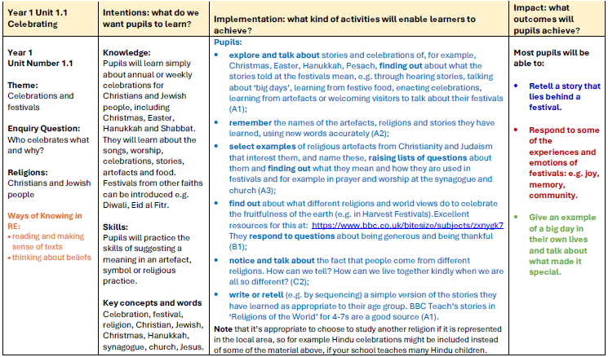

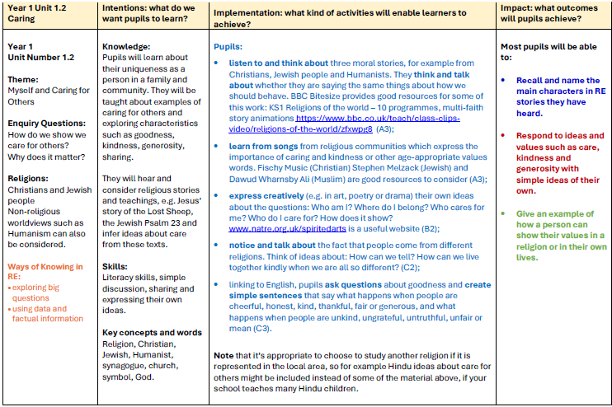

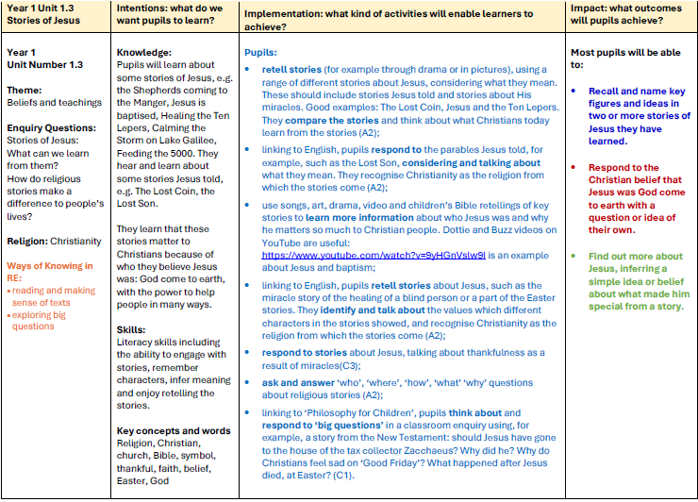

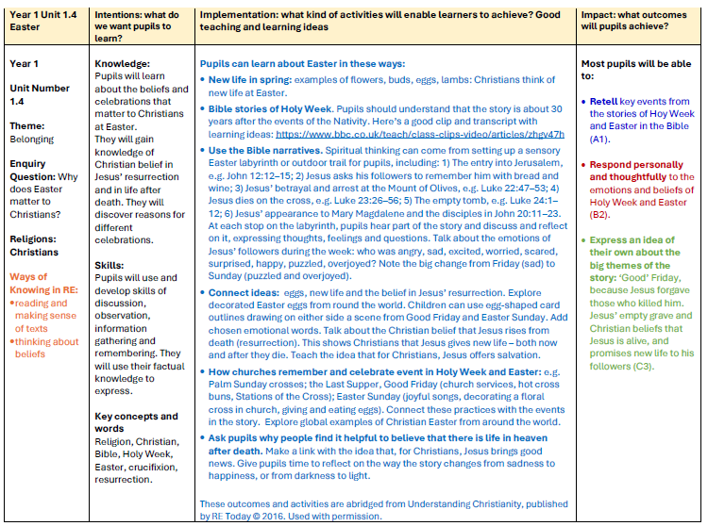
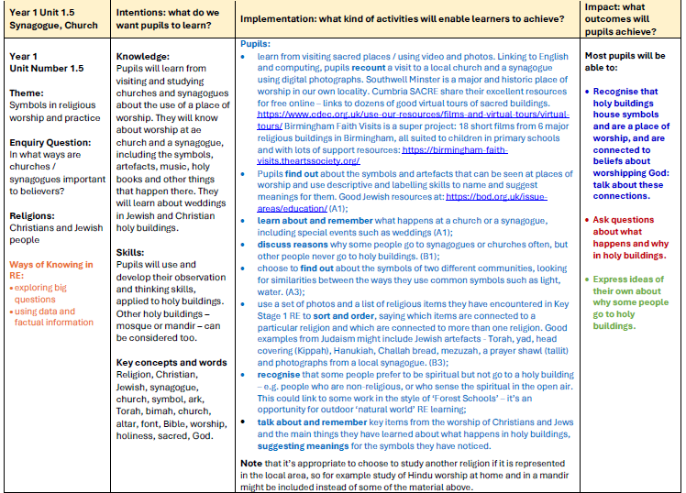

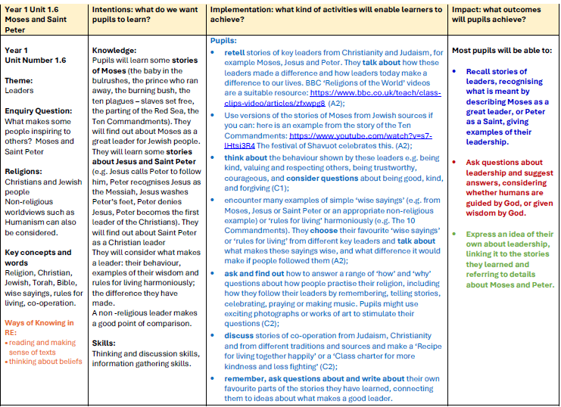

Advent
To know the signs that Christmas is coming
To know how Christian families, prepare for Christmas

Year 2

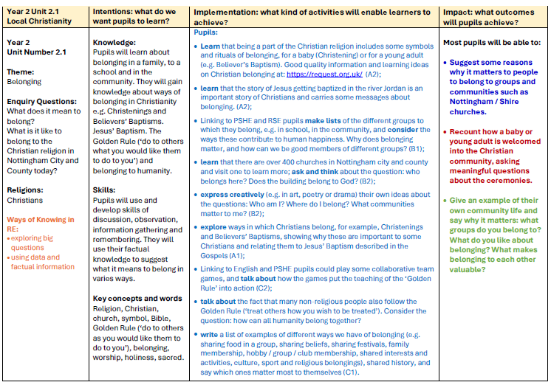

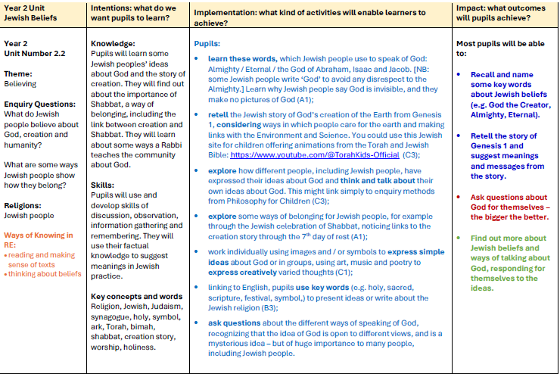

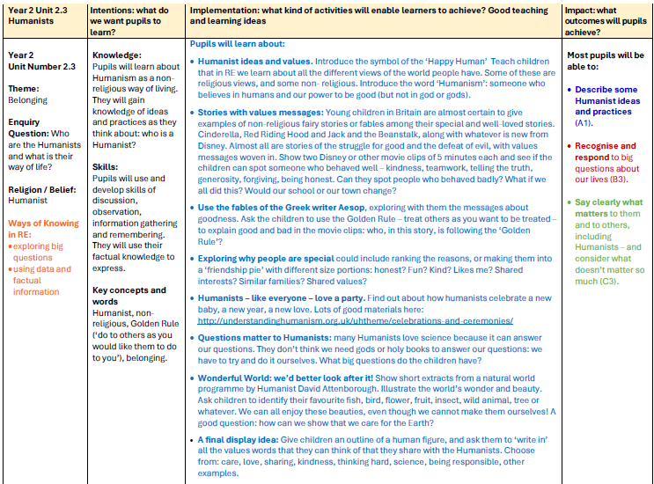

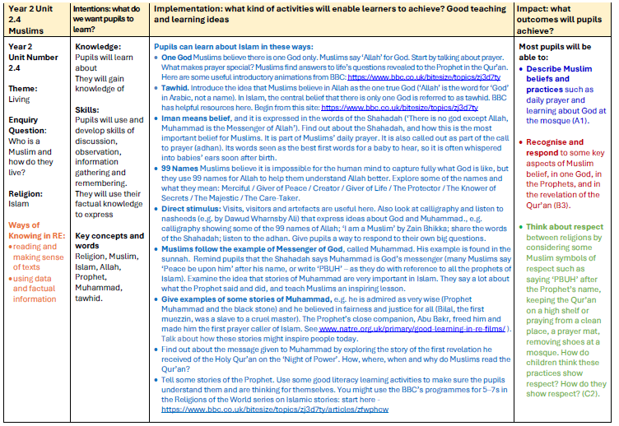

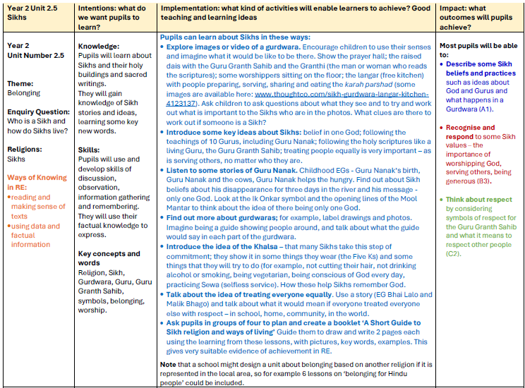

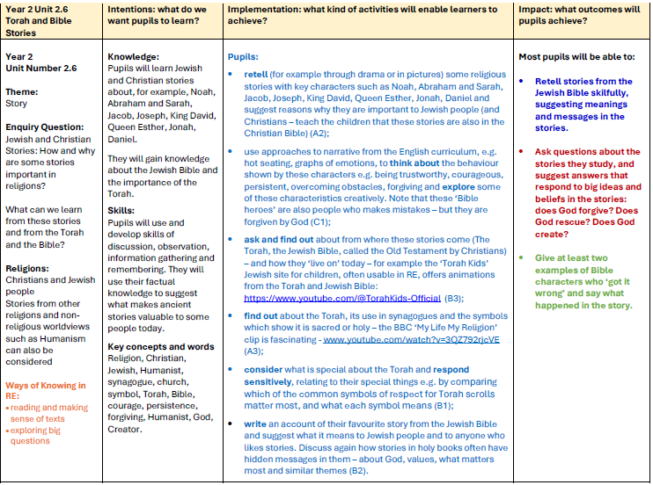

Gift Bringers
To know the significance of the shepherds and the wise men

Year 3

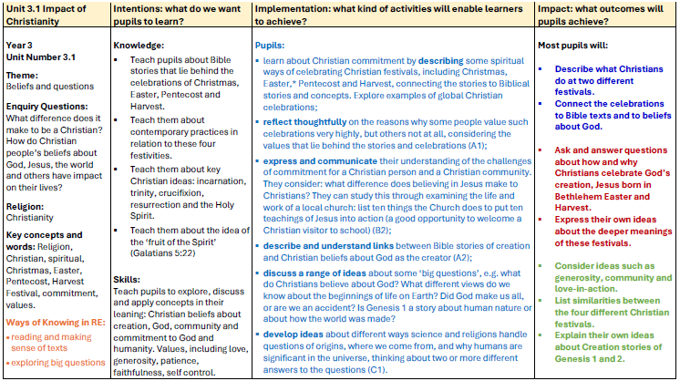

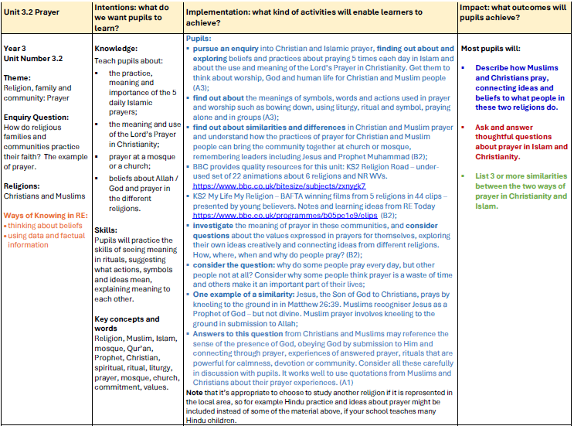

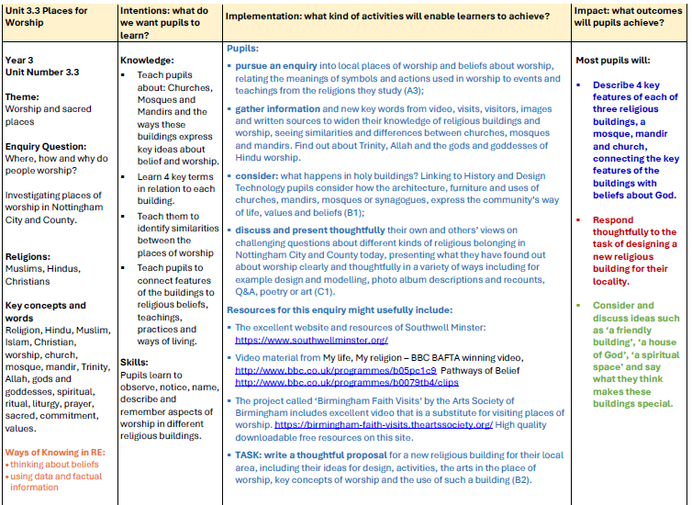

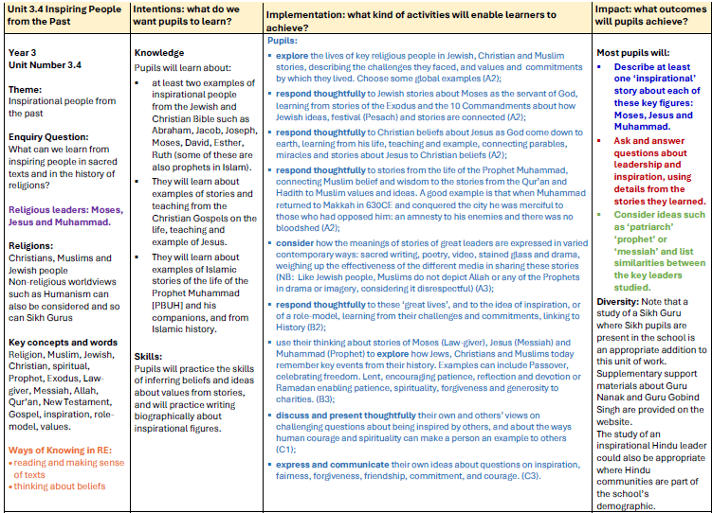

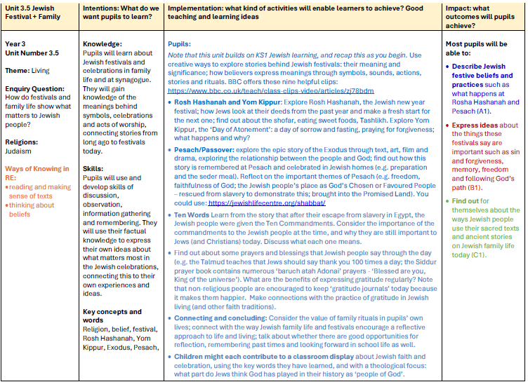

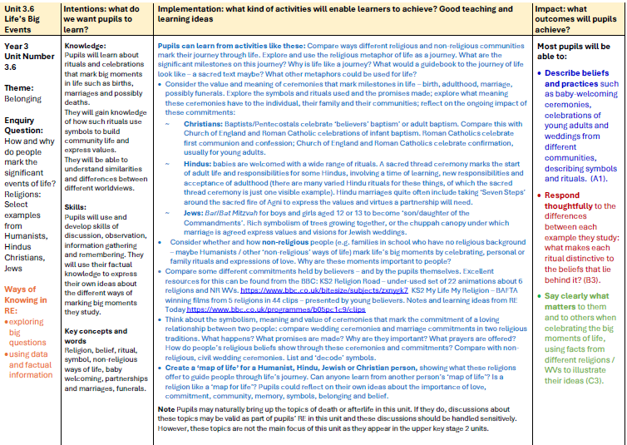

Mary
To know the significance of Mary in the Christmas Story

Year 4

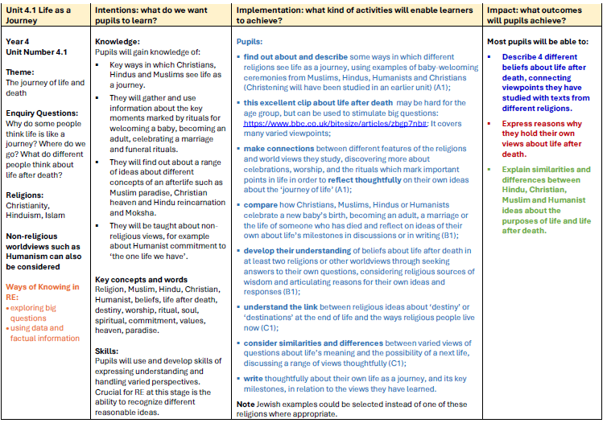

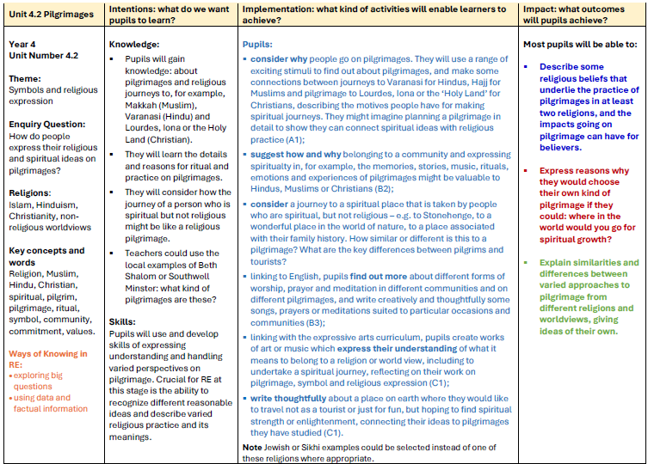

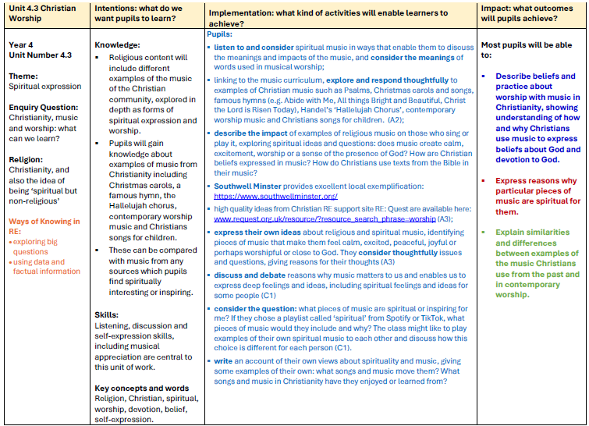

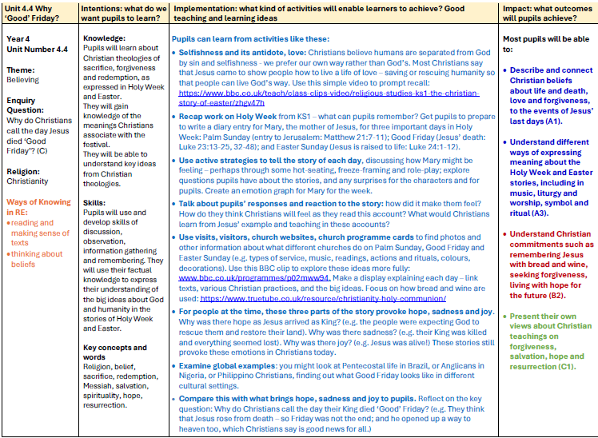

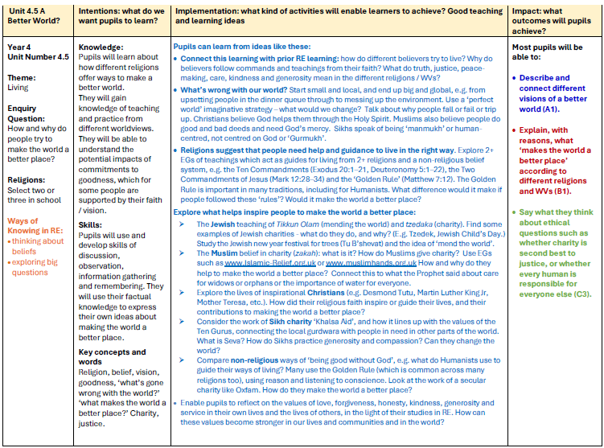

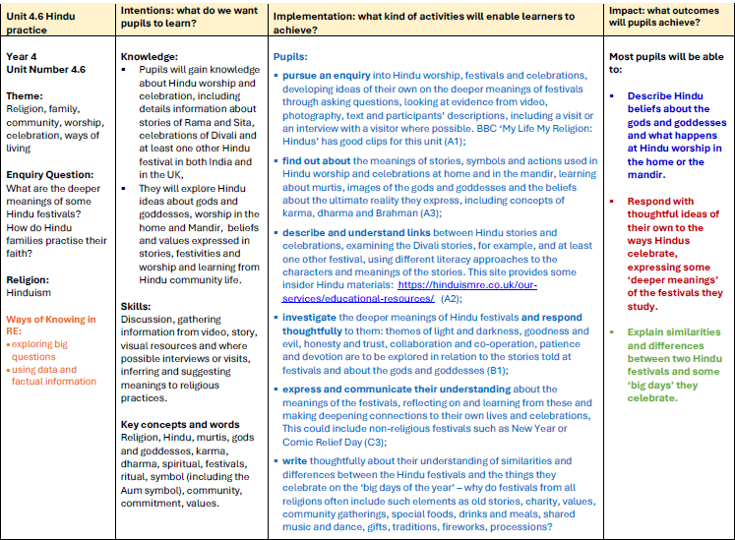

Light
To know the significance of Light in the Christmas Story

Year 5

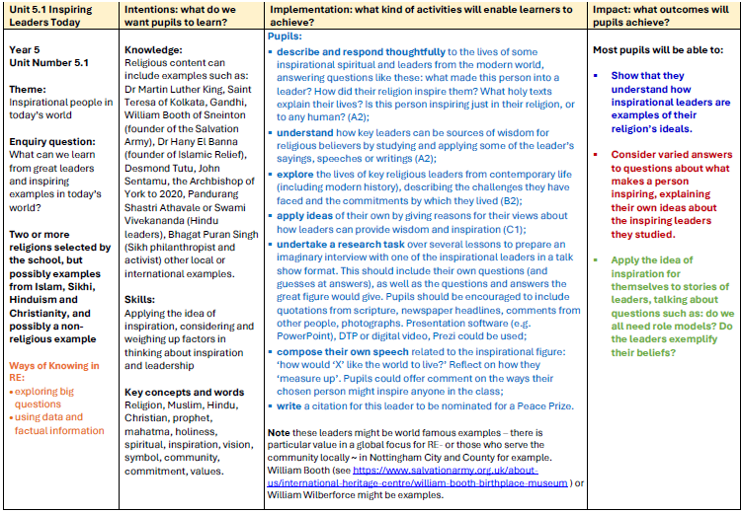

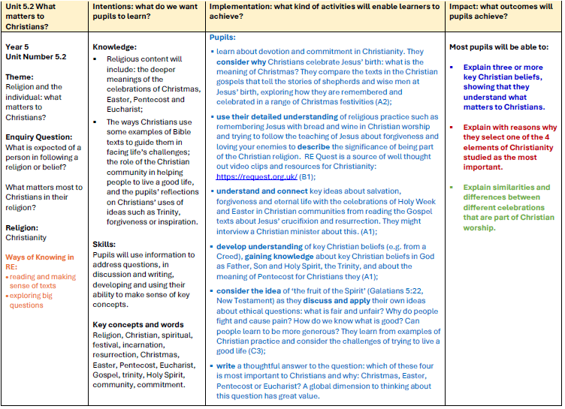

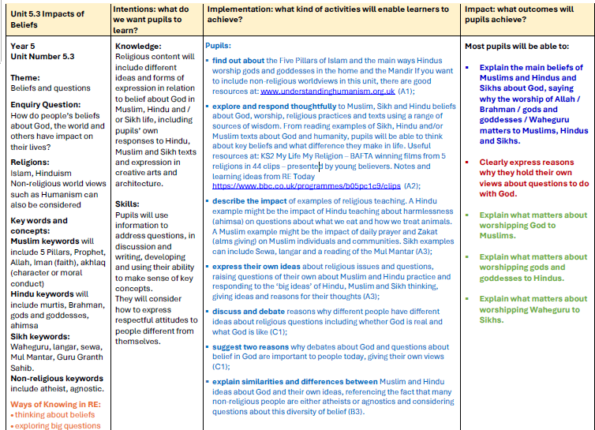

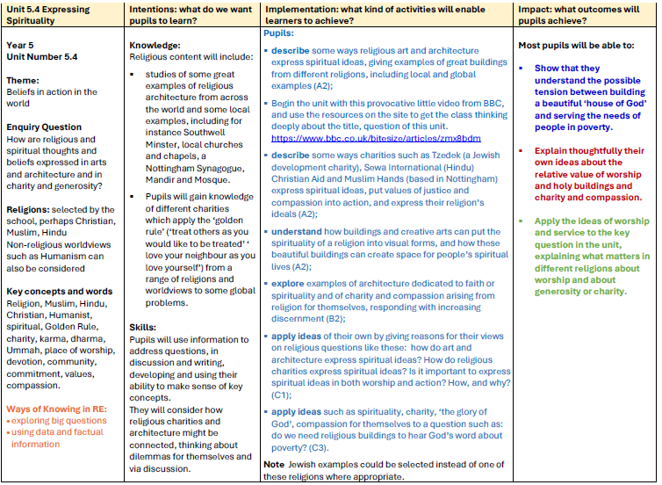

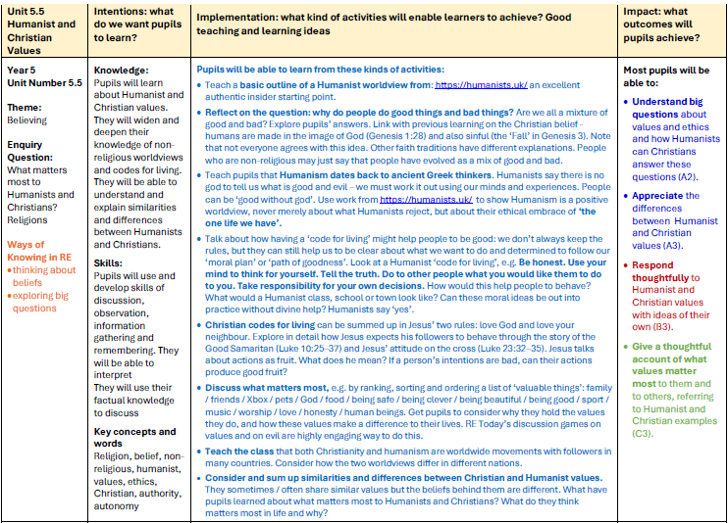
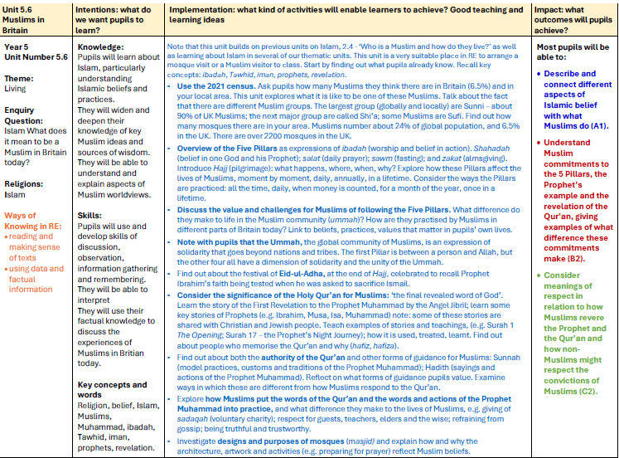

The Prince of Peace
To identify what peace is and how it is associated with the Christmas Story

Year 6

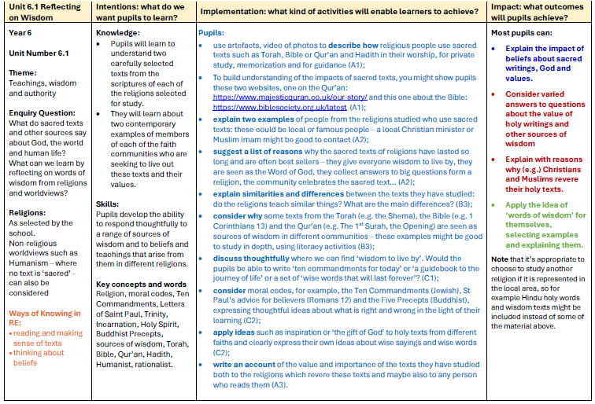

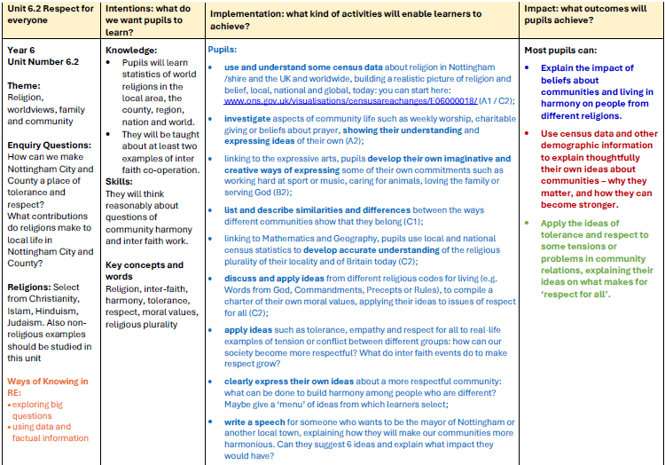

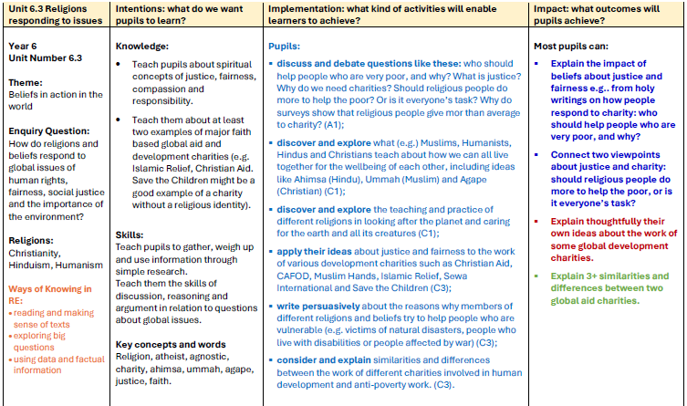

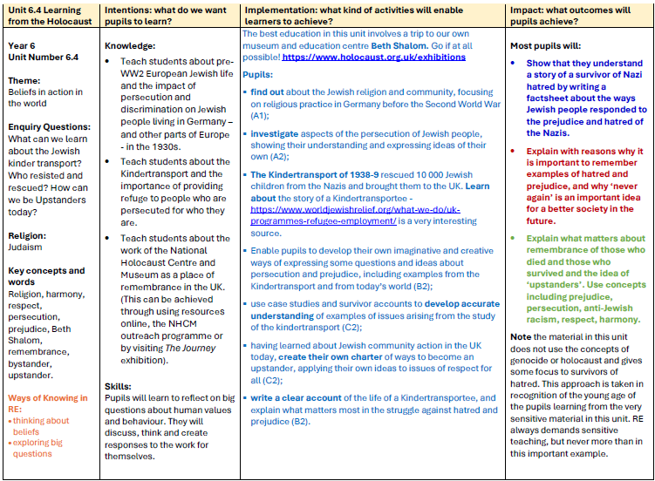

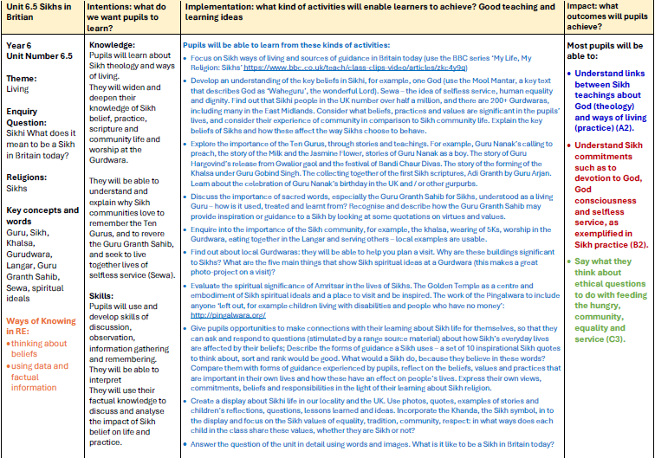

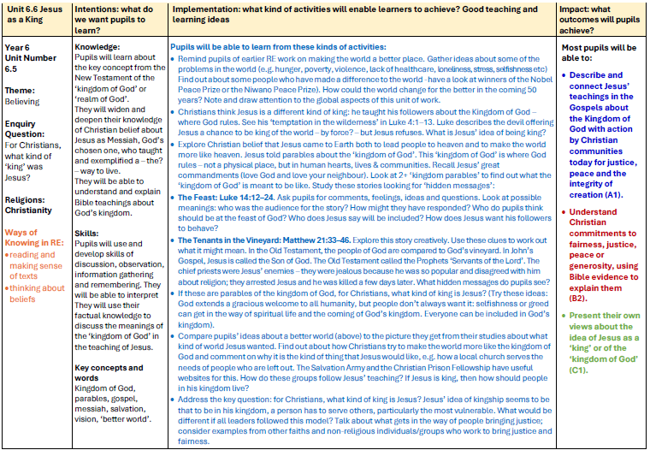

Religious Christmas: Secular Christmas
To understand the significance of Christmas from different perspectives
FPNS Computing Curriculum Intent Progression Document

Computing Vision Statement
We know that children learn best through an exciting and engaging curriculum that both supports and stretches every child and gives them the potential to build on their learning over time. Every child’s learning journey begins in the Early Years Foundation Stage where we Plant new ideas and concepts; these ideas then Grow over their time with us, giving all children the chance to Flourish and love learning. The values of a ‘Fernwood Friend’ are woven throughout the Curriculum; children are well-rounded individuals who take greater responsibility for their learning.
Intent
At Fernwood Primary and Nursery School, we believe that over the early years and two key stages Fernwood children use computational thinking and creativity to understand and change the world. Children develop their understanding of computation, digital systems and programming, building on the knowledge throughout their time at Fernwood. The lessons provided also ensure that pupils become digitally literate; able to use and express themselves safely and responsibly through information and communications technology, ready to be an active participant in a digital world.
Implementation
Computing at Fernwood Primary and Nursery School adheres to the National Curriculum and the Teach Computing objectives. We teach Computing in sequenced blocks throughout the year, ensuring a coherent pedagogy that supports students’ learning progression. This structured approach is designed to build a deep understanding of coding, programming, networks whilst focusing on children’s safety and security.
As a school we encourage children to think about technology around us, looking at how computers are connected and how information is shared. We discuss impact and methods of inter communication; begin website creation; look at variables in games; have an introduction to spreadsheets; explore 3D modelling and understand different ways a computer senses. Throughout the curriculum e-safety is threaded through each strand of learning.
We have a class set of laptops in KS1 and 2 and a class iPad to ensure that all year groups have the opportunity to use a range of devices and programs for many purposes across the wider curriculum, as well as in discrete computing lessons. In EYFS there are class tablets that children can access independently with educational games.
Internet safety is a high priority at Fernwood and is embedded within our curriculum. We have an e-Safety Policy that provides guidance for teachers and children about how to use the internet safely. Each year group participates in an aspect of e-safety in the beginning of each lesson, so children understand how to stay safe when using technology and the Internet. We also have esafety assemblies and regular contact with parents and carers about how to support e-safety at home.
Impact
Through our comprehensive Computing curriculum, we develop a deep understanding and appreciation for the subject. As children progress through the school, their knowledge and skills develop systematically, ensuring they not only meet the National Curriculum requirements but also become confident computer literate individuals ready for secondary education who are adaptable in an ever-changing world.

Nursery and Foundation
Topic areas:
Autumn 1 –
Autumn 2 – E-safety
Spring 1 – Digital Literacy
Spring 2 –
Summer 1 –
Summer 2 – Coding

To know the basics of how to stay safe when using technology
To create simple and basic, 2 function programs

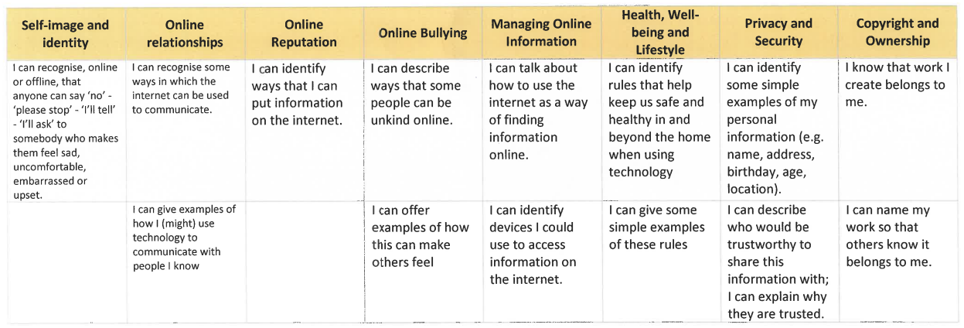

Year 1

Technology Around us
To identify technology
To identify a computer and its main parts
To use a mouse in different ways
To use a keyboard to type on a computer
To use the keyboard to edit text
To create rules for using technology responsibly

Digital Painting
To describe what different freehand tools do
To use the shape tool and the line tools
To make careful choices when painting a digital picture
To explain why I chose the tools I used
To use a computer on my own to paint a picture
To compare painting a picture on a computer and on paper

Digital Writing
To use a computer to write
To add and remove text on a computer
To identify that the look of text can be changed on a computer
To explain why I used the tools that I chose
To compare typing on a computer to writing on paper

Grouping Data
To label objects
To identify that objects can be counted
To describe objects in different ways
To count objects with the same properties
To compare groups of objects
To answer questions about groups of objects

Moving a Robot
To explain what a given command will do
To act out a given word
To combine ‘forwards’ and ‘backwards’ commands to make a sequence
To combine four direction commands to make sequences
To plan a simple program
To find more than one solution to a problem

Programming Animations
To choose a command for a given purpose
To show that a series of commands can be joined together
To identify the effect of changing a value
To explain that each sprite has its own instructions
To design the parts of a project
To use my algorithm to create a program

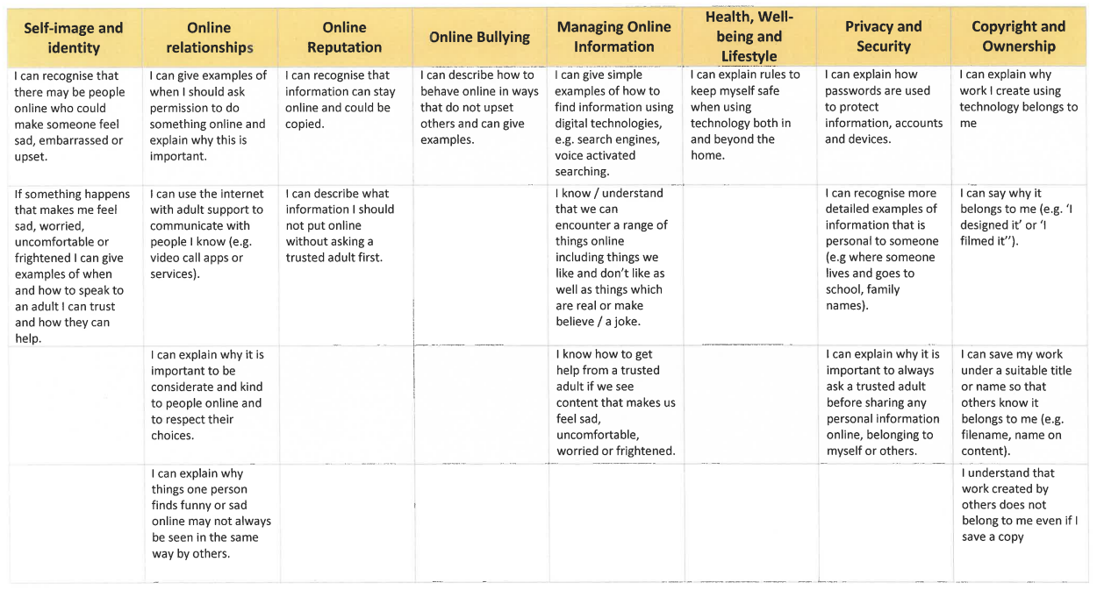

Year 2

Information Technology Around Us
To recognise the uses and features of information technology
To identify the uses of information technology in the school
To identify information technology beyond school
To explain how information technology helps us
To explain how to use information technology safely
To recognise that choices are made when using information technology

Digital Photography
To use a digital device to take a photograph
To make choices when taking a photograph
To describe what makes a good photograph
To decide how photographs can be improved
To use tools to change an image
To recognise that photos can be changed

Making Music
To say how music can make us feel
To identify that there are patterns in music
To experiment with sound using a computer
To use a computer to create a musical pattern
To create music for a purpose
To review and refine our computer work

Pictograms
To recognise that we can count and compare objects using tally charts
To recognise that objects can be represented as pictures
To create a pictogram
To select objects by attribute and make comparisons
To recognise that people can be described by attributes
To explain that we can present information using a computer

Robot Algorithm
To describe a series of instructions as a sequence
To explain what happens when we change the order of instructions,
To use logical reasoning to predict the outcome of a program
To explain that programming projects can have code and artwork
To design an algorithm
To create and debug a program that I have written

Programming Quizzes
To explain that a sequence of commands has a start
To explain that a sequence of commands has an outcome
To create a program using a given design
To change a given design
To create a program using my own design
To decide how my project can be improved

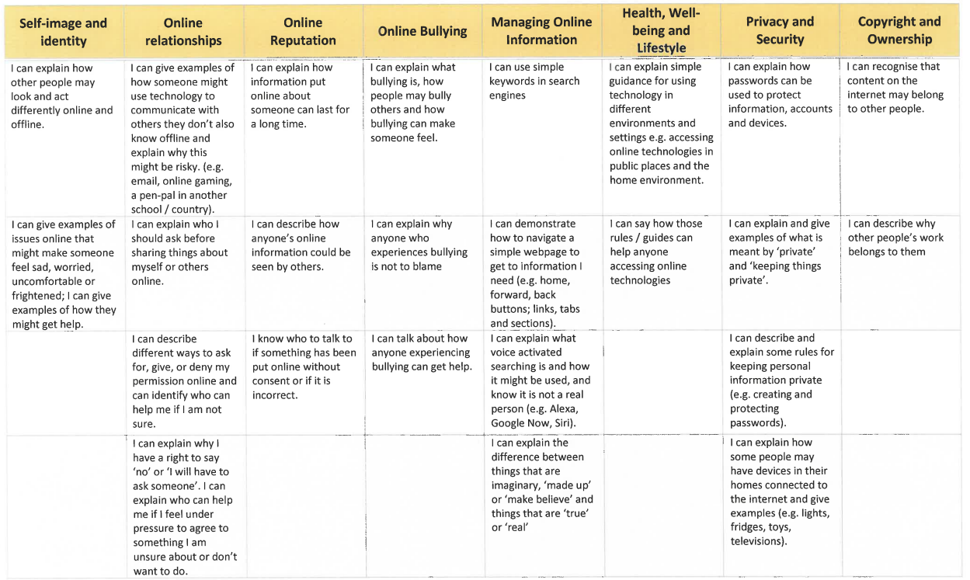

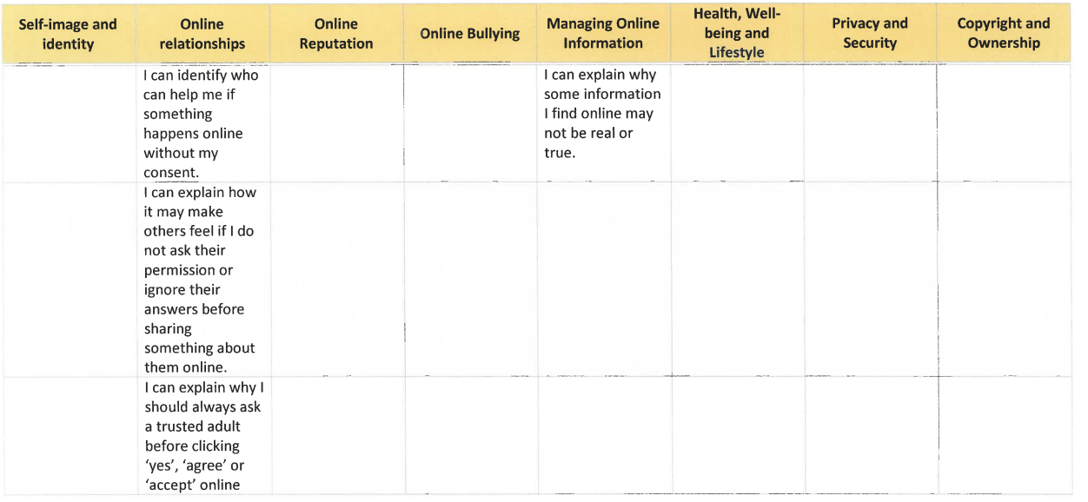

Year 3

Connecting Computers
To explain how digital devices function
To identify input and output devices
To recognise how digital devices can change the way that we work
To explain how a computer network can be used to share information
To explore how digital devices can be connected
To recognise the physical components of a network

Stop-frame Animation
To explain that animation is a sequence of drawings or photographs
To relate animated movement with a sequence of images

To plan an animation
To identify the need to work consistently and carefully
To review and improve an animation

To evaluate the impact of adding other media to an animation

Desktop Publishing
To recognise how text and images convey information
To recognise that text and layout can be edited
To choose appropriate page settings
To add content to a desktop publishing publication
To consider how different layouts can suit different purposes
To consider the benefits of desktop publishing

Branching Databases
To create questions with yes/no answers
To identify the attributes needed to collect data about an object
To create a branching database
To explain why it is helpful for a database to be well structured
To plan the structure of a branching database
To independently create an identification tool

Sequencing Sounds
To explore a new programming environment
To identify that commands have an outcome
To explain that a program has a start
To recognise that a sequence of commands can have an order
To change the appearance of my project
To create a project from a task description

Events and Actions in Programs
To explain how a sprite moves in an existing project
To create a program to move a sprite in four directions
To adapt a program to a new context
To develop my program by adding features
To identify and fix bugs in a program
To design and create a maze-based challenge

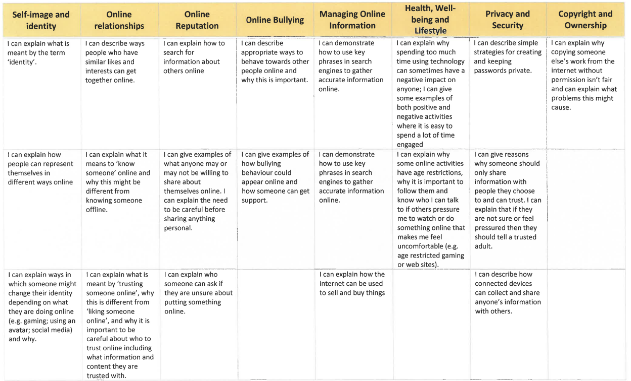

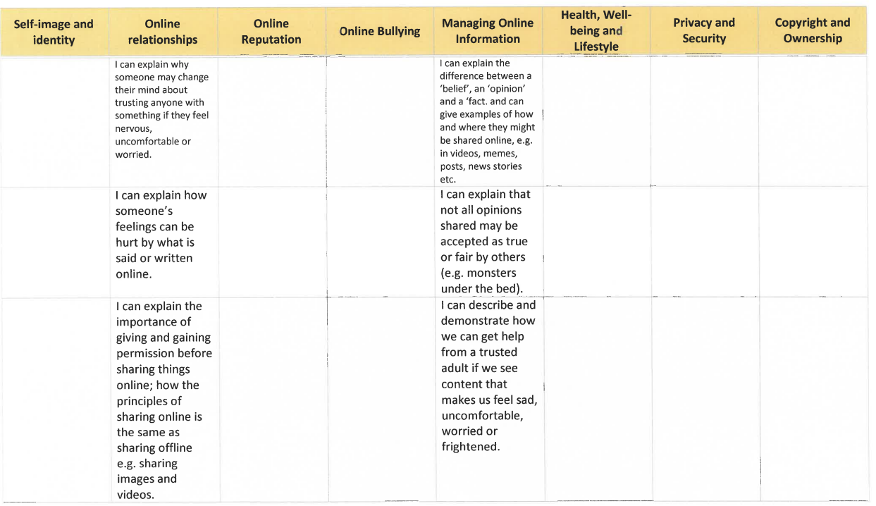

Year 4

The Internet
To describe how networks physically connect to other networks
To recognise how networked devices make up the internet
To outline how websites can be shared via the World Wide Web (WWW)
To describe how content can be added and accessed on the World Wide Web (WWW)
To recognise how the content of the WWW is created by people
To evaluate the consequences of unreliable content

Audio Production
To identify that sound can be recorded
To explain that audio recordings can be edited
To recognise the different parts of creating a podcast project
To apply audio editing skills independently
To combine audio to enhance my podcast project
To evaluate the effective use of audio

Photo Editing
To explain that the composition of digital images can be changed
To explain that colours can be changed in digital images
To explain how cloning can be used in photo editing
To explain that images can be combined
To combine images for a purpose
To evaluate how changes can improve an image

Data Logging
To explain that data gathered over time can be used to answer questions
To use a digital device to collect data automatically
To explain that a data logger collects ‘data points’ from sensors over time
To recognise how a computer can help us analyse data
To identify the data needed to answer questions
To use data from sensors to answer questions

Repetition in Shapes
To identify that accuracy in programming is important
To create a program in a text-based language
To explain what ‘repeat’ means
To modify a count-controlled loop to produce a given outcome
To decompose a task into small steps
To create a program that uses count-controlled loops to produce a given outcome

Repetition in Games
To develop the use of count-controlled loops in a different programming environment
To explain that in programming there are infinite loops and count-controlled loops
To develop a design that includes two or more loops which run at the same time
To modify an infinite loop in a given program
To design a project that includes repetition
To create a project that includes repetition

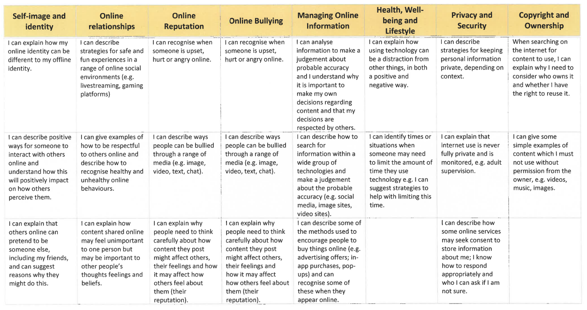

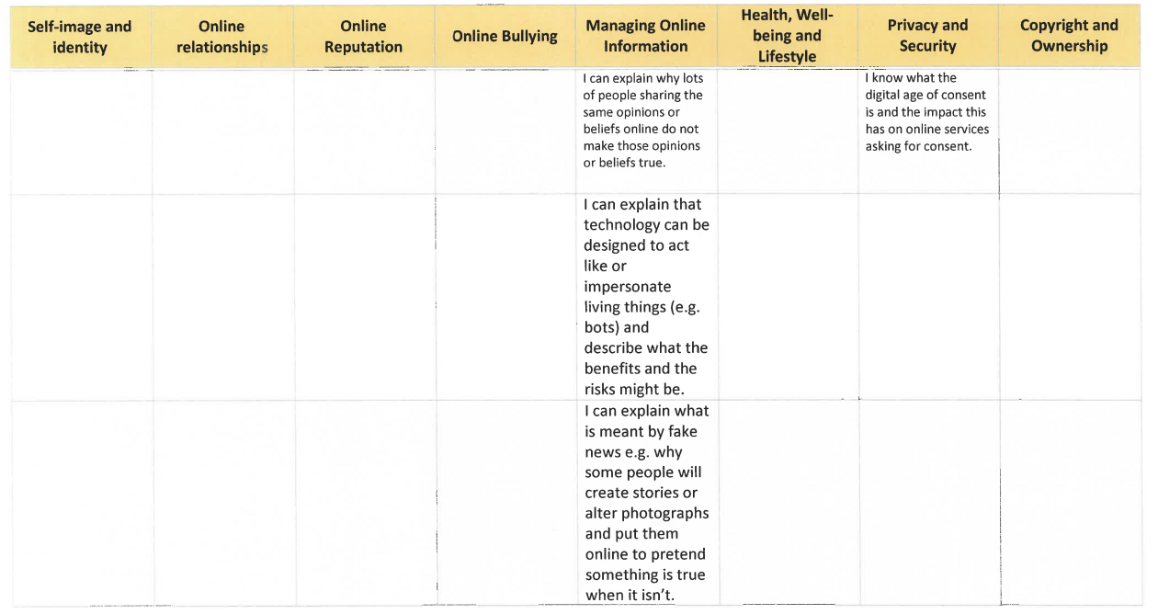

Year 5
Systems and Searching
To explain that computers can be connected together to form systems
To recognise the role of computer systems in our lives
To identify how to use a search engine
To describe how search engines select results
To explain how search results are ranked
To recognise why the order of results is important, and to whom

Vector Drawing
To identify that drawing tools can be used to produce different outcomes
To create a vector drawing by combining shapes
To use tools to achieve a desired effect
To recognise that vector drawings, consist of layers
To group objects to make them easier to work with
To apply what I have learned about vector drawings

Video Production
To explain what makes a video effective
To use a digital device to record video
To capture video using a range of techniques
To create a storyboard
To identify that video can be improved through reshooting and editing
To consider the impact of the choices made when making and sharing a video

Flat-file Database
To use a form to record information
To compare paper and computer-based databases
To outline how you can answer questions by grouping and then sorting data
To explain that tools can be used to select specific data
To explain that computer programs can be used to compare data visually
To use a real-world database to answer questions

Selection in Physical Computing
To control a simple circuit connected to a computer
To write a program that includes count-controlled loops
To explain that a loop can stop when a condition is met
To explain that a loop can be used to repeatedly check whether a condition has been met
To design a physical project that includes selection
To create a program that controls a physical computing project

Selection in Quizzes
To explain how selection is used in computer programs
To relate that a conditional statement connects a condition to an outcome
To explain how selection directs the flow of a program
To design a program that uses selection
To create a program that uses selection
To evaluate my program

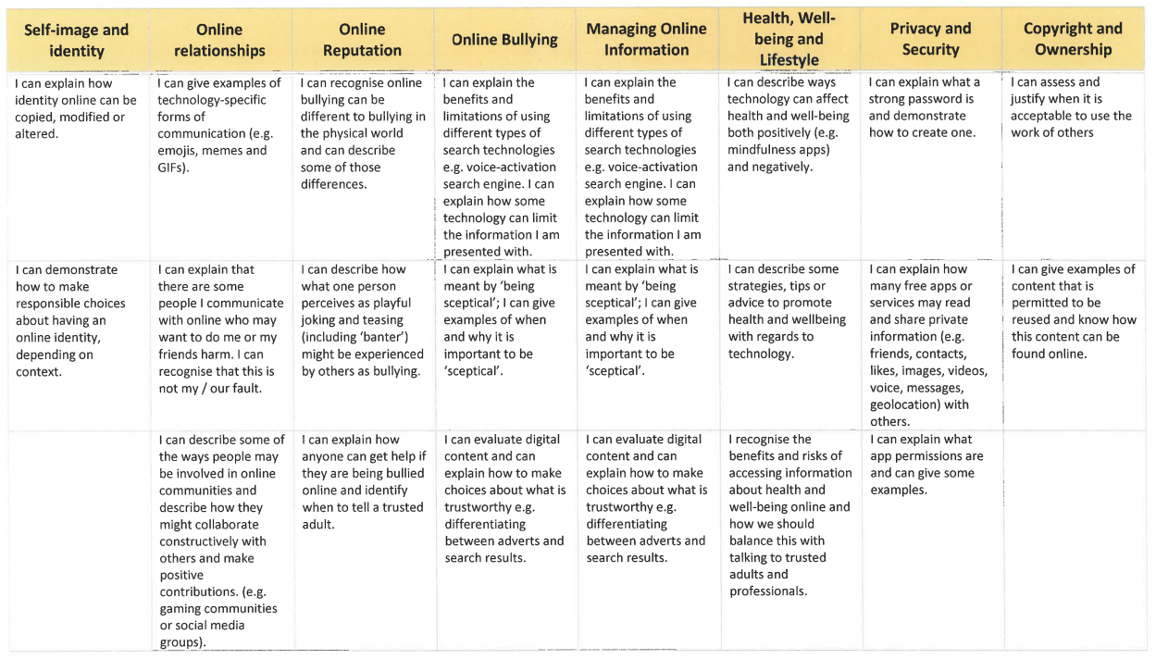

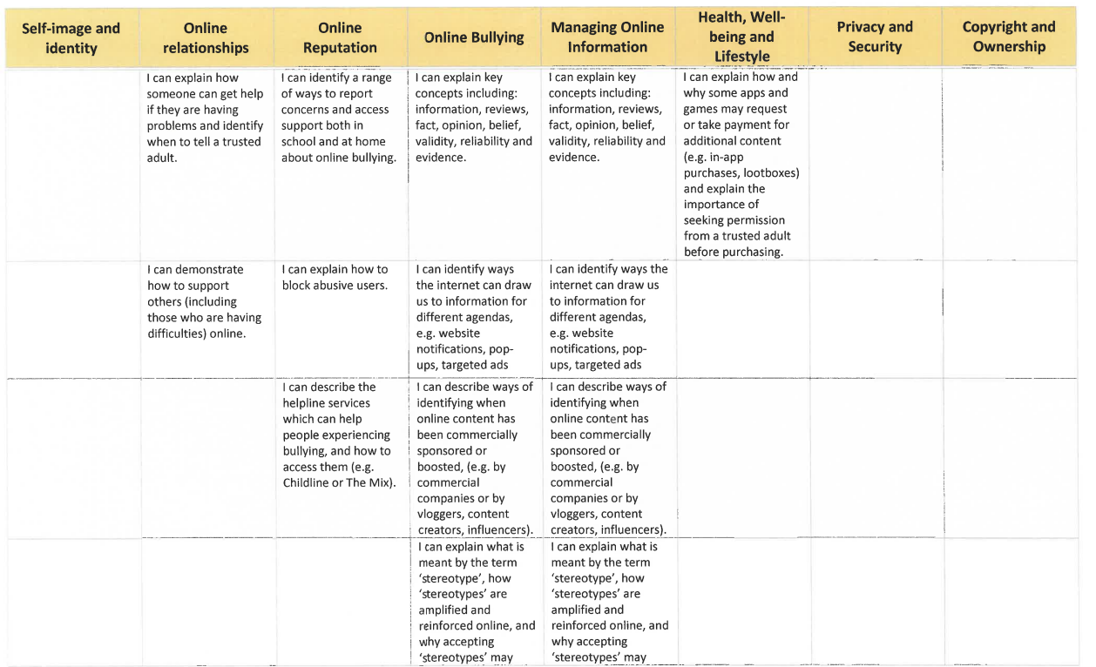

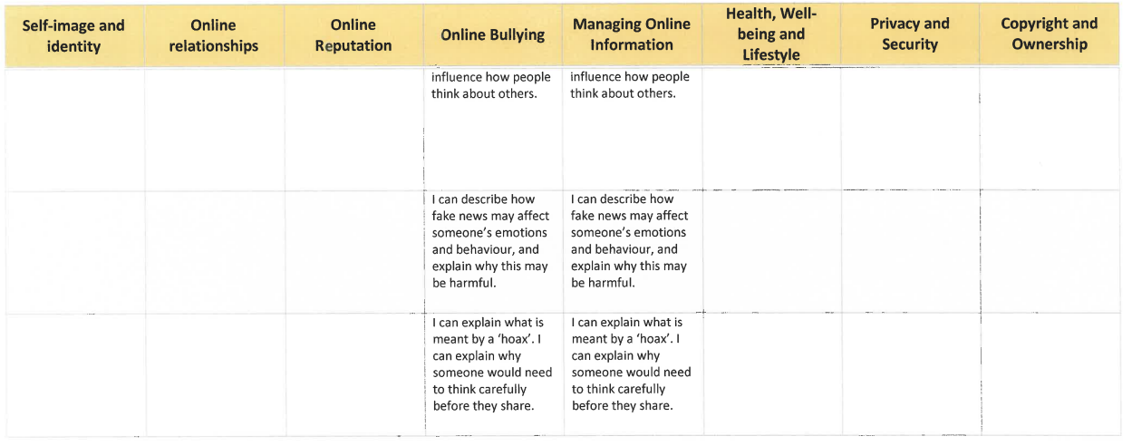

Year 6

Communication and Collaboration
To explain the importance of internet addresses
To recognise how data is transferred across the internet
To explain how sharing information online can help people to work together
To evaluate different ways of working together online
To recognise how we communicate using technology
To evaluate different methods of online communication

3D Modelling
To recognise that you can work in three dimensions on a computer
To identify that digital 3D objects can be modified
To recognise that objects can be combined in a 3D model
To create a 3D model for a given purpose
To plan my own 3D model
To create my own digital 3D model

Web page Creation
To review an existing website and consider its structure
To plan the features of a web page
To consider the ownership and use of images (copyright)
To recognise the need to preview pages
To outline the need for a navigation path
To recognise the implications of linking to content owned by other people

Introduction to Spreadsheets
To create a data set in a spreadsheet
To build a data set in a spreadsheet
To explain that formulas can be used to produce calculated data
To apply formulas to data
To create a spreadsheet to plan an event
To choose suitable ways to present data

Variables in Games
To define a ‘variable’ as something that is changeable
To explain why a variable is used in a program
To choose how to improve a game by using variables
To design a project that builds on a given example
To use my design to create a project
To evaluate my project

Sensing
To create a program to run on a controllable device
To explain that selection can control the flow of a program
To update a variable with a user input
To use an conditional statement to compare a variable to a value
To design a project that uses inputs and outputs on a controllable device
To develop a program to use inputs and outputs on a controllable device

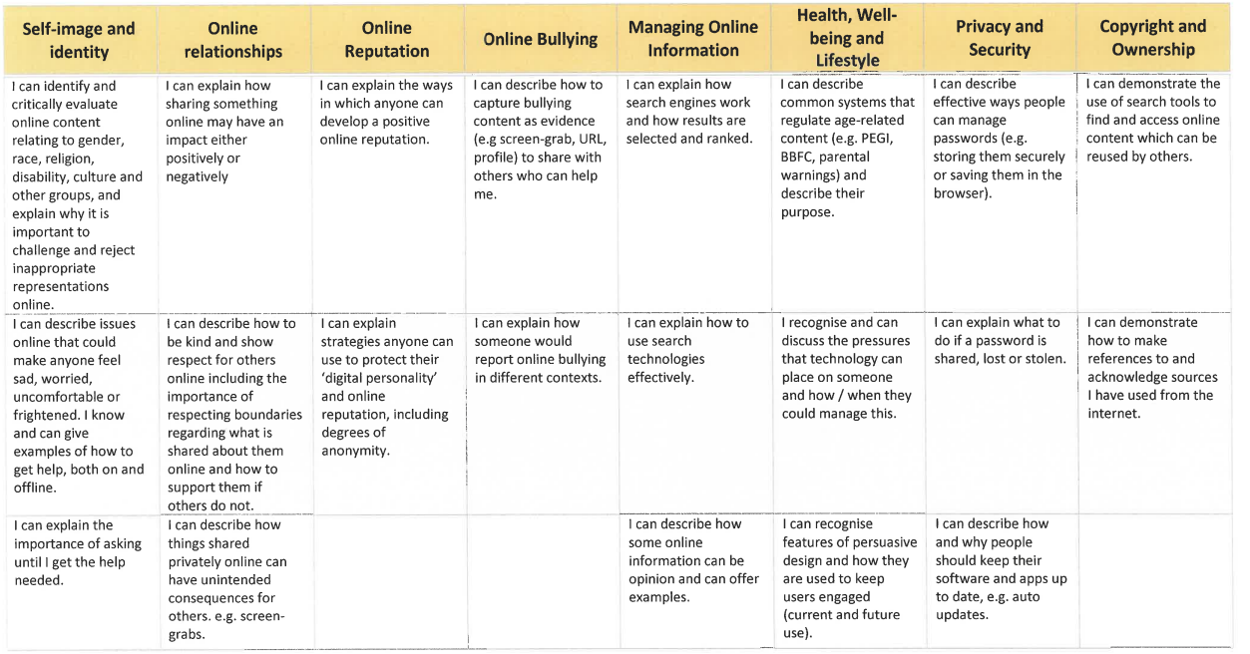

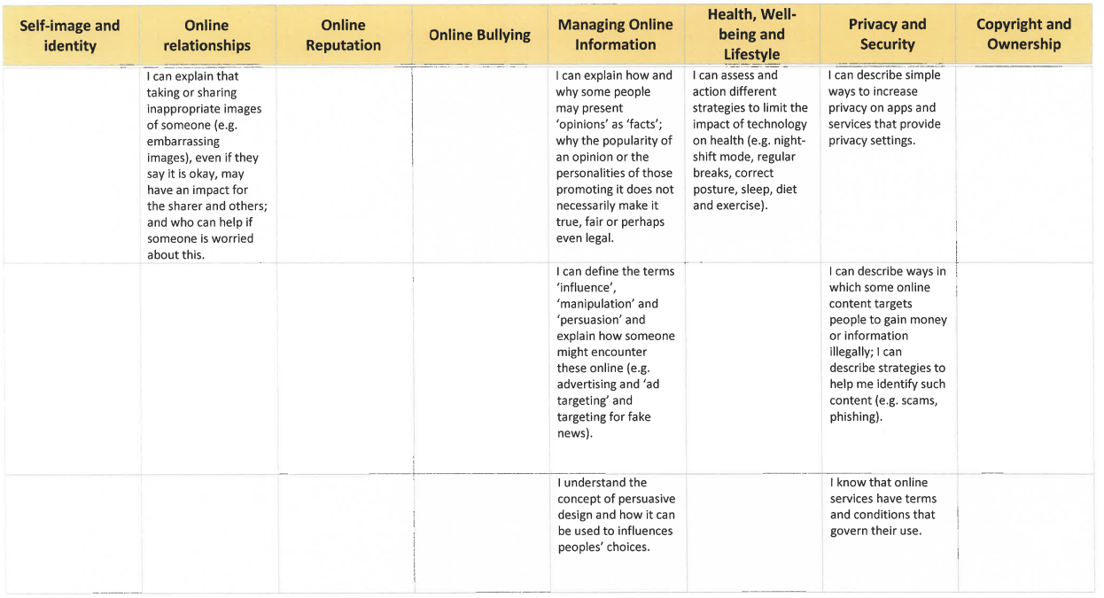

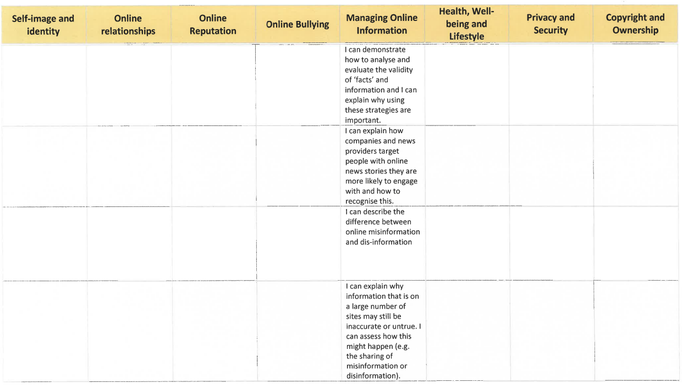

FPNS Personal Development Curriculum Intent Progression Document

PD Vision Statement
We know that children learn best through an exciting and engaging curriculum that both supports and stretches every child and gives them the potential to build on their learning over time. Every child’s learning journey begins in the Early Years Foundation Stage where we Plant new ideas and concepts; these ideas then Grow over their time with us, giving all children the chance to Flourish and love learning. The values of a ‘Fernwood Friend’ are woven throughout the Curriculum; children are well-rounded individuals who take greater responsibility for their learning.
Intent
At Fernwood Primary and Nursery School, we strongly believe Personal Development prepares our children for the wider world and how to be a good citizen in it. Through the PD lessons taught, we seek to allow children to develop their own character, be safe (online and in the real world), be healthy, be knowledgeable about other cultures and religions, show a good level of understanding of healthy relationships and find their own place in our world.
Implementation
PD at Fernwood Primary and Nursery School covers a wide range of topics and is taught continuously throughout the school year, in every year group. The topics are:
- Keeping Safe and Managing Risk,
- Physical Health and Wellbeing,
- Drug, Alcohol and Tobacco Education,
- Identify, Society and Equality,
- Mental health and emotional Wellbeing
- Careers, financial Capability and economic Wellbeing.
- Sex and relationships Education (SRE)

For each unit, teachers have identified the key knowledge and vocabulary which will be covered. Units have been carefully planned using the ‘You, Me, PSHE,’, ‘The Cambridge Scheme’ and ‘The Christopher Winters project’. The whole school PD progression map ensures children build on prior learning and make links between units.
As a school, we value the importance of developing children as individuals, celebrating our differences and healthy relationships. For example, in Nursery, the topic of friendships is taught, and repeated in Year 2 but with a focus on playground games, moving to Year 3 and having a sense of belonging which is revisited in Year 5 with the GREAT Project teaching about Healthy relationships.
Keeping our children safe in all areas of life is main priority for us at Fernwood Primary and Nursery School. We teach about sun safety, online safety, basic first aid skills, fire safety, drugs education and how to stay safe in our local area. Our lessons empower our children to make the correct choices in life and give them the tools to help them make a positive impact in the world around them
At Fernwood Primary and Nursery School, we endeavour to make links in learning across the National Curriculum subjects. Where possible, PD units build on the teaching from other subjects e.g. diversity link to Year 5 Prejudice and Discrimination lessons, F2 teach about why exercise is good for us (PE link), E-safety links to Year 4’s topic of having healthy gaming habits online, and further links can be seen in Year 1 and 4 about special food being associated with different religions (RE link). British Values is also embedded in our Personal Development curriculum.
Impact
Through the PD curriculum, children develop the knowledge and skills to help them navigate life throughout and after primary school. Children’s understanding of key concepts are age and stage appropriate and develop progressively as they move through the school which enables them to build on and develop their prior knowledge. The work in children’s books evidences the broad and balanced curriculum we deliver and demonstrates their understanding of the different topics covered.

Nursery

Topic areas:
Autumn 1 – Settling into Nursery/All about me
Autumn 2 – Feelings
Spring 1 – Following the rules
Spring 2 – Friendships
Summer 1 – Independence and wellbeing
Summer 2 – Sun safety/transition

To try new activities with increasing independence. (PSED-MS)
To follow Nursery routines and expectations. (PSED-MS)
To begin to manage their own basic hygiene and personal needs, including going to the toilet. (PSED-MS)
To enjoy healthy drinks and snacks. (PSED-MS)
To begin to work and play cooperatively and take turns with others. (PSED-BR)
To form positive attachments to adults and particular friendships with other children. (PSED-BR)
To begin to show sensitivity to their own and to others’ needs. (PSED-BR)
To begin to regulate own behaviour. (PSED-SR)
To begin to wait for what they want and control their immediate impulses when appropriate. (PSED-SR)
To begin to listen to what the teacher says and respond appropriately. (PSED-SR)

Vocabulary:

Foundation F2

Topic areas:
Autumn 1 – Me and my family/Rules and Routines
Autumn 2 – Good friends
Spring 1 – Feelings
Spring 2 – Healthy Lifestyles
Summer 1 – Setting Goals
Summer 2 – SRE/Transition

To be confident to try new activities and show independence, resilience and perseverance in the face of challenge. (PSED-MS)
To explain the reasons for rules, know right from wrong and try to behave accordingly. (PSED-MS)
To manage their own basic hygiene and personal needs, including dressing, going to the toilet and understanding the importance of healthy food choices. (PSED-MS)
To work and play cooperatively and take turns with others. (PSED-BR)
To form positive attachments to adults and friendships with peers. (PSED-BR)
To show sensitivity to their own and to others’ needs. (PSED-BR)
To show an understanding of their own feelings and those of others, and begin to regulate their behaviour accordingly. (PSED-SR)
To set and work towards simple goals, being able to wait for what they want and control their immediate impulses when appropriate. (PSED-SR)
To give focussed attention to what the teacher says, responding appropriately even when engaged in activity, and show an ability to follow instructions involving several ideas of actions. (PSED-SR)

Vocabulary:

Year 1

Autumn 1 – Exercise and play
Autumn 2 – Keeping safe
Spring 1 – Our bodies
Spring 2 – Roles and responsibilities
Summer 1 – Managing feelings
Summer 2 – Care for my body

To talk about how exercise and play makes us feel.
To know about own roles and responsibilities at home and school.
To know who to trust at school and home and who to talk to about feeling unsafe, worried or scared.
To identify, talk about and manage feelings.
To know ways to keep safe.
To know about what is safe on and in own body.
To know about growing and how to care for own body.

Vocabulary:

Year 2
Autumn 1 – Friendships
Autumn 2 – Money
Spring 1 – Keeping Safe and managing Risk
Spring 2 – Medicines
Summer 1 – Food safety and hygiene
Summer 2 – Relationships

To know about healthy eating, the importance of exercise, getting good sleep and basic hygiene.
To know about spending, where money comes from, keeping money safe and work.
To know about friendships and ways to solve problems that might arise.
To know about keeping safe inside and outside the home.
To know about road safety.
To know why medicines are taken and how to keep safe round medicines.
To know the biological differences between male and female children.
To know a male and a female is needed in life cycles

Vocabulary:

Year 3
Autumn 1 – Mental Health/Drugs and Smoking
Autumn 2 – Anti-Bullying
Spring 1 – Celebrating Achievements
Spring 2 – Belonging
Summer 1 – Healthy Food
Summer 2 – Sex and Relationships

To know what drugs are and how they can be harmful to humans.
To know about the effects of smoking.
To know about asthma medication.
To know about bullying—see it, say it, stop it.
To continue to develop good mental health—celebrating achievements, setting goals and dealing with setbacks.
To know about community and belonging to groups.
To know about different careers and work. To know about differences between male/female; personal space and dealing with unwanted touch and family differences.

Vocabulary:

Year 4
Autumn 1 – Democracy
Autumn 2 – Careers
Spring 1 – Food and Sleep
Spring 2 – Keeping Safe/First Aid
Summer 1 – Drugs and Alcohol
Summer 2 – Puberty

To know Britain is a democratic society, about how laws are made and about the local council.
To know that there are drugs (including alcohol, nicotine and narcotics) that are common in everyday life, why people choose to use them, changes in behaviour linked to drugs and how to make good choices.
To know why people might choose not to eat certain foods.
To know about the importance of sleep.
To know about keeping safe—near roads, rail, water, building sites/with computer gaming.
To know some basic first aid.
To know about how we grow and change including physical and emotional changes at puberty.
To know about differences between male/female; personal space and dealing with unwanted touch and family differences.

Vocabulary:
Year 5
Autumn 1 – The Media
Autumn 2 – Online Safety
Spring 1 – Emotions and feelings in times of grief and change
Spring 2 – Drugs, smoking and alcohol
Summer 1 – The GREAT project
Summer 2 – Puberty and physical hygiene

To know about how the media can manipulate images and that these images may not reflect reality.
To know about keeping safe online.
To know that violence within relationships is not acceptable (Great Project).
To know about a wide range of emotions and feelings and how these are experienced in the body including times of change and grief.
To know about stereotyping, including gender stereotyping.
To know about prejudice and discrimination and how this can make people feel.
To know about changes in puberty and the importance of physical hygiene.
To know about strategies to resist peer pressure regarding drugs, smoking and alcohol.

Vocabulary:

Year 6
Autumn 1 – How drugs affect our body
Autumn 2 – Radicalisation and British Values
Spring 1 – Mental Health
Spring 2 – Careers, Financial Capability and economic wellbeing
Summer 1 – Rights of the child, refugees and homelessness
Summer 2 – Safety in our local area/Human reproduction

To understand the dangers of addictive drugs and how they can affect our bodies.
To understand the Human Rights Act and the UN Convention on the Rights of the Child/the experience of being a refugee/homeless.
To know about the importance of mental health and ways to look after oneself.
To know about being safe ‘out and about’ in the local area and recognising and respond well to peer pressure.
To understand about careers, financial capability and economic wellbeing.
To understand issues such as homophobia, radicalization and gender fluidity and FGM.
To know what constitutes a healthy relationship and about human reproduction.

Vocabulary:

FPNS Music Curriculum Intent Progression Document

Music Vision Statement
We know that children learn best through an exciting and engaging curriculum that both supports and stretches every child and gives them the potential to build on their learning over time. Every child’s learning journey begins in the Early Years Foundation Stage where we Plant new ideas and concepts; these ideas then Grow over their time with us, giving all children the chance to Flourish and love learning. The values of a ‘Fernwood Friend’ are woven throughout the Curriculum; children are well-rounded individuals who take greater responsibility for their learning.
Intent
At Fernwood Primary and Nursery School, we believe that all children should be taught to sing, play an instrument and create music together. They should have the opportunity to progress their musical interests and talents. The Model Music Curriculum states that:
Music connects us through people and places in our ever-changing world. It is creative, collaborative, celebratory and challenging. In our schools, music can bring communities together through the shared endeavour of whole-school singing, ensemble playing, experimenting with the creative process and, through the love of listening to friends and fellow pupils, performing. The sheer joy of music making can feed the soul of a school community, enriching each student while strengthening the shared bonds of support and trust which make a great school.
Through the music taught at Fernwood Primary we aim to provide an inclusive curriculum which identifies the landmarks of music understanding and allows children to experience music from a range of styles and traditions.
Implementation
Music at Fernwood Primary and Nursery School follows the National Curriculum objectives and is taught in half termly units throughout the year using the Charanga scheme, so that children can achieve depth in their learning. For each unit, music leaders have identified the key knowledge, skills and vocabulary which will be covered. Units have been carefully selected to ensure children build on prior learning and make links between units. As a school, we value the importance of developing children’s musical knowledge. We aim to provide an integrated, practical, exploratory and child-led approach to musical learning. Charanga uses a spiral curriculum built around the Interrelated Dimensions of Music: pulse, rhythm, pitch, tempo, dynamics, timbre, texture, structure and notation. These dimensions are at the centre of all the learning. We will focus on different musical skills in each term – playing in autumn, improvising in spring and composing in summer. As a school, we will use glockenspiels in every year group (chime bars in EYFS) to ensure progression. In Year 4, children will access specialist music provision through the Nottingham Music Hub. They will participate in Whole Class Ensemble teaching using violins.

Children will also be regularly exposed to a range of musical styles in assemblies using the Charanga listening calendar. We will also endeavour to provide a range of live music performances throughout the year. Children will have the opportunity to pursue their musical interests beyond their classroom lessons through instrumental lessons, choirs, clubs and also ensembles led by the Nottingham Music Hub.
Impact
Through the music curriculum, we will nurture fundamental musical techniques while building musical knowledge and understanding. Through a rich and varied music framework we will lay the foundations of aural skills, improvisation and composition which allow children to be confident musicians when they enter secondary school.

Music will be taught using the Charanga Musical School scheme of work. Music will be taught for 6 lessons per half term, 3 half terms per year (with the exception of Year 4).
Year groups will follow the units below from Charanga:
 | Autumn | Spring | Summer
Nursery | Units 1-8 | Units 9-16 | Units 17-24
Foundation F2 | Me!  Nursery Rhymes  Pat-a-cake  1,2,3,4,5  Five little ducks  Name Song  Things for fingers | Everyone!  Nursery Rhymes  Wind the bobbin up  Rock a bye baby  Five little monkeys  Happy and you know it  Twinkle, Twinkle  Heads, shoulders, knees, toes | Our World  Nursery Rhymes  Old Macdonald  Wheels on the bus  Incy Wincy Spider  Row, row, row your boat  Hokey Cokey
Year 1 | Hey You! | In The Groove | Your Imagination
Year 2 | Hands, Feet, Heart | I Wanna Play In A Band | Zootime
Year 3 | The Dragon Song | Lean On Me | Blackbird
Year 4 | Strings | Strings | Strings
Year 5 | Livin’ On A Prayer | The Fresh Prince of Bel-Air | Dancing In The Street
Year 6 | You’ve Got A Friend | Classroom Jazz 2 | YuStudio Hip Hop

In Year 4, from September 2024 onwards, music will be taught by the Nottingham Music Hub through their weekly whole class strings lessons over the entire year. In Year 6, due to SATs, Conwy, the production and Leavers’ Assemblies, children will complete the Music Technology project independently when time allows.
Music will cover knowledge and skills in the six following strands (with slight changes in Reception):
- Listening and appraising
- Singing
- Playing instruments
- Improvising
- Composing
- Performing

Nursery
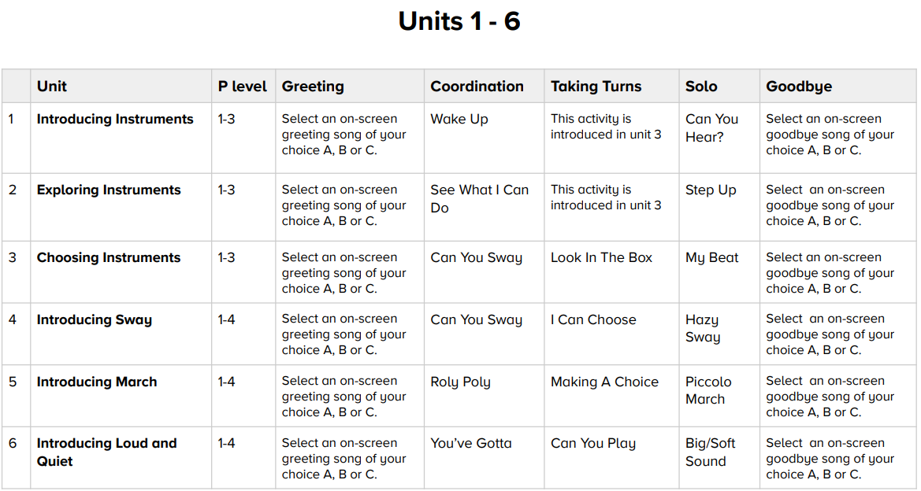
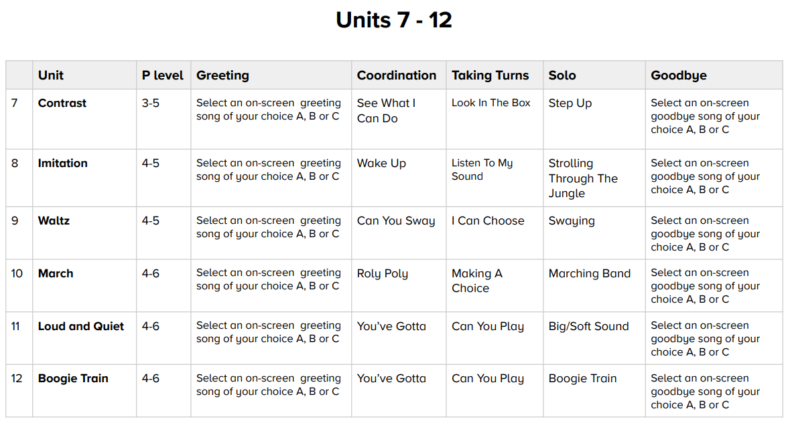
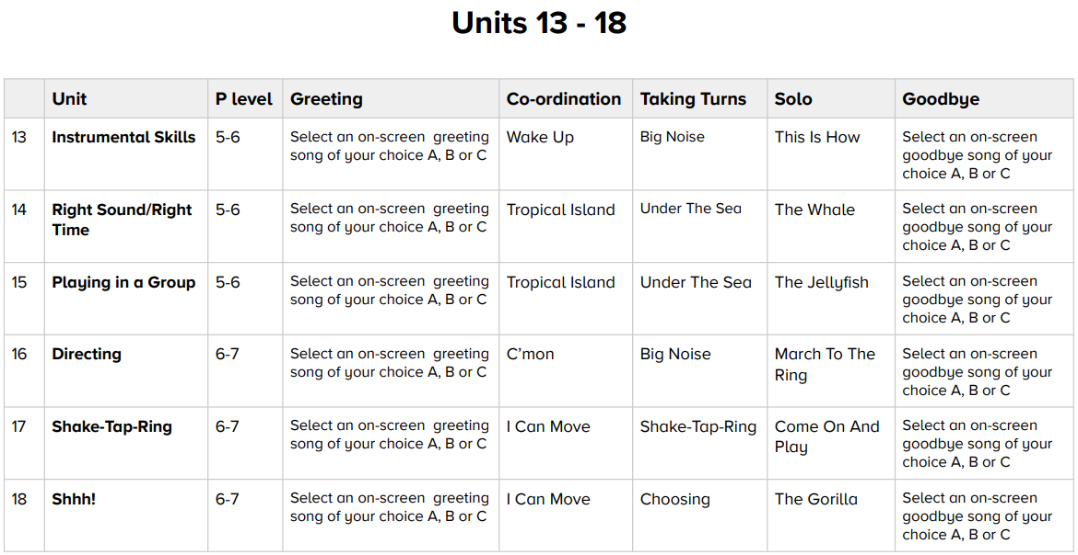

Foundation F2
Listening and Responding
To know some nursery rhymes off by heart
To enjoy moving to music by dancing, marching or acting

Exploring and Creating
To know that we can move with the pulse of the music
To know that song words can tell stories
To find the pulse of a nursery rhyme
To copy basic rhythm patterns
To explore high and low sounds using voices

Singing
To sing or rap nursery rhymes and simple songs from memory
To know songs have sections (e.g. verses and choruses)
To sing along with a pre-recorded song or backing track, adding actions
Sharing and Performing
To know that a performance is sharing music
To perform any nursery rhyme by singing, dancing or adding actions
To record the performance to talk about it

Year 1
Listening and Appraising
To know 5 songs off by heart and know what they are about
To know and recognise the sound and names of some untuned percussion that they use
To know that music has a steady pulse like a heartbeat
To know that we can create rhythms from familiar words and our names
To clap back a rhythm and create a rhythm for others to copy
To use voices to copy singing to ‘la’

Singing
To confidently sing or rap 5 songs from memory in unison
To sing notes of different pitches (high and low)
To learn to start and stop singing when following a leader

Playing
To learn the name of the instrument that they are playing
To treat instruments carefully and with respect

Improvising
To know that improvisation is making up our own tune on the spot
To improvise answers using simple rhythms and tunes using one or two notes

Composing
To know that composing is like writing a story with music
To help create a simple melody using up to 3 notes

Performing
To know a performance is sharing music with an audience
To perform a song they have learnt
To record the performance and say how they feel about it

Year 2
Listening and Appraising
To know that some songs have a chorus or response part
To learn how songs tell a story or describe an idea
To know that rhythms are different from the steady pulse
To create rhythms for others to copy

Singing
To confidently know and sing 5 songs from memory
To know that unison is everyone singing at the same time
To make different types of sound using their voices (e.g. rapping)
To know why we need to warm up our voices

Playing
To learn to play a tuned instrumental part
To know the names of some of the notes from their instrumental parts
To play in time with the steady pulse
To listen to and follow musical instructions from a leader

Improvising
To use voices and instruments to listen and clap/sing back and then answer using their own pattern

Composing
To help create simple melodies using up to 5 notes

Performing
To know that a performance can be for a special occasion
To record a performance and say how they feel about it

Year 3
Listening and Appraising
To know 5 songs and who sung them or wrote them
To be able to talk in detail about one song (including tempo, dynamics, rhythm and pitch)
To confidently identify and move to the pulse

Singing
To know that songs can make you feel different things (e.g. happy, energetic or sad)
To sing in unison and in two simple parts
To sing with an awareness of being ‘in tune’
To listen to the group when singing

Playing
To play different parts on a glockenspiel
To rehearse and perform their part within the unit song

Improvising
To know that if you improvise using the notes you are given you cannot make a mistake
To use a glockenspiel to listen and play an answer using one or two different notes

Composing
To plan and create a section of music that can be performed within the context of the unit song
To listen to and reflect upon the developing composition and make musical decisions
To record the composition in an appropriate way

Performing
To perform with clear articulation
To record a performance and be able to talk about it

Year 4
WSCE Teaching (Nottingham Music Hub)
To play a stringed instrument (whole class ensemble) basic bowing technique/playing a range of notes accurately.

Year 5
Listening and Appraising
To know up to 5 songs from memory and their origins and historical context
To identify the main sections of a song (including introduction, bridge, chorus, verse etc.)
To know the names of some instrument they can hear
To compare two songs in the same style
To create musical ideas for the group to copy or respond to
To copy one note riffs using simple and syncopated rhythm patterns

Singing
To know and explain the importance of warming up your voice
To sing in unison and to sing backing vocals
To listen to each other and be aware of how you fit into a singing group

Playing
To know that notes can be recorded on a 5 line stave
To play a glockenspiel with the correct technique

Improvising
To know of 3 well known improvising musicians (e.g. Miles Davis)
To question and answer using a glockenspiel and up to 3 notes

Composing
To recognise the connection between sounds and symbols
To explain the key note or home note and structure of a melody

Performing
To know that a performance involves communicating ideas, thoughts and feelings though the music
To record a performance and discuss what went well

Year 6
Listening and Appraising
To discuss the style of songs using musical characteristics
To know and talk about having their own musical identity
To listen carefully and respectfully to other people’s thoughts about the music
To compare two songs in the same style, talking about what stands out musically
To create musical ideas for the group to copy or respond to
To copy back two note riffs by ear and with notation

Singing
To sing in tune and to be aware of how you fit into the group
To talk about the meaning of the lyrics in a song

Playing
To know and talk about instruments that might be played in an orchestra or band
To read musical notation from a 5 line stave, playing the notes on a glockenspiel

Composing
To create simple melodies using up to 5 different notes and simple rhythms
To record the composition in a way that recognises the connection between sound and symbol

Performing
To sing, rap or play clearly and with confidence
To record a performance to discuss and talk musically about what went well and what could be improved

FPNS DT Curriculum Intent Progression Document

DT Vision Statement
We know that children learn best through an exciting and engaging curriculum that both supports and stretches every child and gives them the potential to build on their learning over time. Every child’s learning journey begins in the Early Years Foundation Stage where we Plant new ideas and concepts; these ideas then Grow over their time with us, giving all children the chance to Flourish and love learning. The values of a ‘Fernwood Friend’ are woven throughout the Curriculum; children are well-rounded individuals who take greater responsibility for their learning.
Intent
At Fernwood Primary and Nursery School, we believe that DT should allow children to be creative and imaginative whilst designing products that solve real and relevant problems. We feel it is vital to nurture creativity and innovation through design and by exploring the designed and made world in which we all live and work. Children are taught to use appropriate tools safely and effectively to make a product. In all areas of DT the children are encouraged to consider the effectiveness of their designs and requirements of the product. FPNS offers all children the opportunity to develop their understanding, experience and application in a wide variety of situations.
Implementation
DT at Fernwood Primary and Nursery School follows the National Curriculum objectives and is taught in half termly units.
During their time at FPNS children will design and make projects within the areas of:
- Electrical Systems
- Mechanical Systems
- Structures
- Textiles
- Food.

Each project begins with evaluating existing products, completing focused practical tasks and designing, making and evaluating a quality product with a clear user and purpose. We want children to understand that they are designing something for someone for a purpose, and believe in the authenticity of their product. Building on their knowledge from KS1 To KS2, we have developed a DT curriculum which shows a clear progression of skills.
For each project, teachers have identified the key knowledge and vocabulary which will be covered. As DT subject leaders, we feel it is important to inspire the children by looking at existing products and inventors/ designers. Children need to think about what the products they are designing are used for and the needs of those who use them. We want children to become confident using a variety of tools in a safe and secure environment.
Through the Design and Technology Association, we are able to deliver a creative, practical and challenging DT education. This provides a range of resources that support teachers in delivering the DT curriculum whilst helping the teaching of other subjects in a fun and inspiring manner.
Impact
We want all children at FPNS to be confident at taking risks and therefore become more resourceful, innovative and enterprising. Students develop a critical understanding of the impact of DT in life and the wider world. As children progress through the school, they will build a repertoire of knowledge, understanding and skills in order to design and make high-quality prototypes and products for a wide range of users.

Nursery

Topic areas:
Autumn 1 – Exploring our Workshop and Food
Autumn 2 –
Spring 1 –
Spring 2 – Exploring materials and Baking
Summer 1 –
Summer 2 – Exploring Box Modelling

To handle tools, objects, construction and malleable materials safely and with increasing control and intention. (PD-FMS)

To make, paint, draw and create with increasing independence. (EAD-CWM)

To use various construction materials, e.g. joining pieces, stacking vertically and horizontally, balancing, making enclosures and creating spaces. (EAD-CWM)

Vocabulary: tools, picture, build, shape, make, join, stack, vertical, horizontal, final,

Foundation F2

Topic areas:
Autumn 1 – Our Workshop and Food
Autumn 2 – Cutting skills
Spring 1 – Joining skills
Spring 2 –
Summer 1 –
Summer 2 – Box Modelling

To safely use and explore a variety of materials, tools and techniques, experimenting with colour, design, texture, form and function. (EAD-CWM)

To share their creations, explaining the process they have used. (EAD-CWM)

To use a range of small tools, including scissors, paintbrushes and cutlery. (PD-FMS)

Vocabulary: use, ideas, draw, experiment, change, materials, complete, cut,

Year 1

Developing, planning and communicating ideas.
To design (talk about, draw and list my ideas) with a purpose/audience in mind.
To draw on own experience to help generate ideas.
To suggest ideas/explain what they are going to do.
To model ideas in card and paper.
To research to develop design ideas.

Working with tools, equipment, materials and components.
To make a model with increasing independence.
To select from and use a wide range of materials and components, including ingredients, according to their characteristics.
To measure, mark out, cut (accurately) and shape a range of materials with support
To use tools e.g. scissors and a hole punch safely.
To assemble, join and combine materials/components together using a variety of temporary methods (including different glues, taping and split pin)
To use basic food handling and hygiene routines.
To use simple finishing techniques to improve the appearance of product.

Evaluating procedures and products.
To say what I like about my product and make suggestions for improvement.
To evaluate a product by discussing how well it works.
To evaluate products as they are developed, identifying strengths and possible changes.

Projects
- Sliding pictures - Mechanisms
- Playground structures (Barnaby Bear) - Structures
- Salad – Food – Jamie Oliver

Vocabulary:

Year 2

Developing, planning and communicating ideas
To explore and evaluate a range of existing products.
To design purposeful, functional, appealing products for themselves and other users
To generate, develop, model and communicate their ideas through talking, drawing and mocks ups.
To identify a purpose for product.
To identify simple design criteria.
To make simple drawings and label parts.

Working with tools, equipment, materials and components.
To build structures, exploring how they can be made stronger, stiffer and more stable.
To select from and use accurately a range of tools to join, cut, shape and finish.
To measure and cut with some accuracy.
To use hand tools safely and appropriately.
To assemble, join and combine materials in order to make product.
To use basic sewing techniques.
To follow safe procedures for food safety and hygiene.
To choose and use appropriate finishing techniques.
To use mechanisms in models.

Evaluating procedures and products.
To evaluate against design criteria.
To evaluate products as they are developed, identifying strengths and possible changes they might make.
To talk about their ideas, saying what they like and dislike.

Projects
- Space Buggy – Mechanisms – NASA engineers, the Mars Rover.
- Gingerbread - Food
- Bookmark – Textiles

Vocabulary:

Year 3

Developing, planning and communicating ideas.
To design (talk about, draw and list my ideas) with a purpose/audience in mind.
To use research, investigate and analyse a range of existing products.
To consider purpose and identify the user/s when designing.
To establish criteria for a successful product.
To plan the order of their work before starting.
To explore, develop and communicate design proposals by modelling ideas.
To make drawings with labels when designing.

Working with tools, equipment, materials and components.
To make models/products with increasing independence and accuracy.
To begin to understand and use mechanical systems.
To select from and use a wide range of tools, techniques, materials and components, including ingredients, according to their characteristics.
Measure, mark out, cut, score and assemble components with some accuracy
Demonstrate hygienic food preparation and storage.
Use finishing techniques to strengthen and improve the appearance of their product using a range of equipment, including ICT.

Evaluating procedures and products.
To evaluate ideas and products against own design criteria and make suggestions for improvement.
To be willing to change things if this helps improve work.

Projects

- Healthy sandwich - Food
- Gift Box - Structures
- Pop up books – Mechanisms – Voitech Kubasta (engineered and illustrated pop up books)

Vocabulary:

Year 4

Developing, planning and communicating ideas.
To understand how key events in design and technology have helped shape the world.
To consider purposes for which they are designing.
To make labelled drawings from different views showing specific features.
To develop a clear idea of what has to be done, planning how to use materials, equipment and processes, and suggesting alternative methods of making.
To investigate and analyse a range of existing products.

Working with tools, equipment, materials and components.
To select the correct tools (use accurately and safely) and materials (according to functional properties and aesthetic qualities), components and techniques to make a successful model from a wide range of choice
Construct products using permanent joining techniques.
Pin, sew and stitch materials together.
To understand and use electrical systems in products (series circuits incorporating switches, bulbs).
To prepare a salad demonstrating safe chopping and cutting.
To select appropriate tools and techniques.
To measure, mark out, cut and shape a range of materials, using appropriate tools, equipment and techniques.
To join and combine materials and components accurately in temporary and permanent ways.

Evaluating procedures and products.
To evaluate ideas and products against design criteria.
To evaluate work both during and at the end of the assignment.
To evaluate products carrying out appropriate tests.

Projects
- Textiles – Pencil Cases
- Electrical systems – Torch - Thomas Edison and David Misell
- Layered Salad – Food

Vocabulary:

Year 5

Developing, planning and communicating ideas.
To research and develop design criteria to inform the design of innovative, functional, appealing products that are fit for purpose.
To generate, develop, model (with prototypes) and communicate their ideas through discussion and annotated sketches.
To investigate and analyse a range of existing products.
To Brainstorm and identify a purpose for the product.
Develop a clear idea of what has to be done, planning how to use materials, equipment and processes, and suggesting alternative methods of making if the first attempts fail.
Use results of investigations, information sources, including ICT when developing design ideas.

Working with tools, equipment, materials and components.
To understand and use mechanical systems in products.
To continue to develop the principles behind a healthy and varied diet.
To prepare and cook a savoury dish using different cooking techniques.
Select appropriate materials, tools and techniques and use safely.
Weigh and measure accurately (time, dry ingredients, liquids).
Apply the rules for basic food hygiene and other safe practices e.g. hazards relating to the use of ovens.
Cut and join wood with accuracy to ensure a good quality finish.

Evaluating procedures and products.
To evaluate ideas and products against design criteria and consider the views of others to improve own work.
Evaluate product against the original design specification.
Evaluate personally and seek evaluation from others.

Projects
- Bird Boxes – Structures – Charles Waterton
- Cams toys - Mechanisms
- Chilli - Food

Vocabulary:

Year 6

Developing, planning and communicating ideas.
To research and develop design criteria to inform the design of an innovative, functional, appealing products.
To develop, model and communicate ideas through discussion, annotated sketches, cross-sectional and exploded diagrams and prototypes.
To understand how key events and individuals in D&T have helped shape the world.
Develop a design specification.
Explore, develop and communicate aspects of design proposals by modelling ideas in a variety of ways.
Plan the order of own work, choosing appropriate materials, tools and techniques.

Working with tools, equipment, materials and components.
To select the correct tools (use accurately and safely) and materials (according to functional properties and aesthetic qualities), components and techniques to make a successful model from a wide range of choice
To apply their understanding of computing to program, monitor and control their products.
Assemble components make working models.
Construct products using permanent joining techniques.
Pin, sew and stitch materials together.

Evaluating procedures and products.
To evaluate ideas and products against own design criteria and consider the views of others to improve work.
Evaluate products identifying strengths and areas for development, and carrying out appropriate tests.
Record evaluations using drawings with labels.
Evaluate against original criteria.

Projects
- Toy car – Electrical systems
- Bags – Textiles - Walter H. Deubner (reinforced paper bag)
- Cup cakes – Food – Nadiya Hussain

Vocabulary:

FPNS Art Curriculum Intent Progression Document

Art Vision Statement
We know that children learn best through an exciting and engaging curriculum that both supports and stretches every child and gives them the potential to build on their learning over time. Every child’s learning journey begins in the Early Years Foundation Stage where we Plant new ideas and concepts; these ideas then Grow over their time with us, giving all children the chance to Flourish and love learning. The values of a ‘Fernwood Friend’ are woven throughout the Curriculum; children are well-rounded individuals who take greater responsibility for their learning.
Intent
At Fernwood Primary and Nursery School, we believe that Art should be aspirational yet accessible for all children. Every child is entitled to develop their critical and creative thinking skills and to build their knowledge and understanding of materials and techniques. Through the art taught at Fernwood Primary, we seek to enable creativity through encouraging exploratory journeys. We, as teachers, feel it is our role to facilitate this journey. It is our aim that by the time every child leaves Fernwood Primary School, they can feel as if they have found an area of art that is relevant and engaging to them.
Implementation
Art at Fernwood Primary and Nursery School follows the National Curriculum objectives and is taught in half termly units using the Access Arts scheme so that children can achieve depth in their learning. Access Art offers a range of CPD opportunities, which we feel will help teachers teach art with increased confidence. For each unit, Art leaders have identified the key knowledge, skills and vocabulary which will be covered. Units have been carefully selected to ensure children build on prior learning and make links between units.
As a school, we feel it is extremely important to develop children’s artistic skills and their creative flair. In EYFS, there is a focus on exploratory learning which enables an open-ended, playful exploration of materials, processes and ideas, which in turn nurture dexterity skills and begin to build the child’s confidence. Building on from this into KS1 and KS2, we have selected units which show a clear progression a range of skills including drawing, painting, sculpture, printing and collage. Alongside these skills, the children will study a variety of diverse artists. We promote the use of sketchbooks which provide the children with the opportunity to develop their journeying skills (exploration, testing, reflecting, understanding). Sketchbooks provide a space for children to play, explore, try and wonder and we use sketchbooks from Year 1 to Year 6.
Through Access Art, we are able to deliver a really exciting, rich and forward-thinking art education. The Access Art curriculum is designed to give more freedom to the children and it nurtures creative thinking skills and helps to ensure that the children learn through art.
At Fernwood Primary and Nursery School, we endeavour to celebrate the children and their art. Through table top galleries, Big Arts Week and links with The Fernwood School, we have been able to share with the wider community. Children will have the opportunity to pursue their artistic interests through internal and external clubs.
Impact
Through the art curriculum, children develop the artistic knowledge and skills to help them become creative individuals. They also develop a love of art and the arts. Children’s knowledge and skills develop progressively as they move through the school, not only to enable them to meet the requirements of the National Curriculum but to prepare them to become competent artists in secondary education. The work in children’s sketchbooks evidences the broad and balanced art curriculum we deliver and demonstrates their acquisition of key knowledge and skills.

Nursery

Topic areas:
Autumn 1 – Exploring Art
Autumn 2 – Exploring Materials
Spring 1 – Exploring Collaging
Spring 2 – Exploring Patterns
Summer 1 – Exploring Techniques
Summer 2 – Making and Creating

To handle tools, objects, construction and malleable materials safely and with increasing control and intention. (PD-FMS)
To make, paint, draw and create with increasing independence. (EAD-CWM)

Vocabulary:

Foundation F2

Topic areas:
Autumn 1 – Painting
Autumn 2 – Patterns
Spring 1 – Colours
Spring 2 – Artists
Summer 1 – Drawing
Summer 2 – Make and Create

To safely use and explore a variety of materials, tools and techniques, experimenting with colour, design, texture, form and function. (EAD-CWM)
To share their creations, explaining the process they have used. (EAD-CWM)
To begin to show accuracy and care when drawing. (PD-FMS)
To use a range of small tools, including scissors, paintbrushes and cutlery. (PD-FMS)

Vocabulary:

Year 1

Pathway: Spirals (Autumn 1)

Disciplines: Drawing, Collage, Sketchbooks

Key Concepts:

That drawing is a physical and emotional activity. That when we draw, we can move our whole body.

That we can control the lines we make by being aware of how we hold a drawing tool, how much pressure we apply, and how fast or slow we move.

That we can draw from observation or imagination.

That we can use colour to help our drawings engage others.

Pathway: Playful Making (Spring 1)

Disciplines: Sculpture, Drawing, Collage

Key Concepts:

That there is a relationship between drawing & making – we can transform 2d to 3d.

That we can use observational drawing and experimental mark-making together to make art.

That we can work from similar stimulus or starting point but end up with very different individual results.

That the individual results can then be brought together to make a whole artwork.

Pathway: Simple Printmaking (Summer 1)

Discipline: Printmaking, Collage, Drawing

Key Concepts:

That we can make a “plate” from which to “print”

That there is a relationship between plate and print: e.g. negative / positive.

That we can use print to create “multiples”

That we can explore line, shape, colour and texture to explore pattern, sequence, symmetry and intention.

Vocabulary:

Year 2

Pathway: Exploring the World through Mono Print (Autumn 1)

Disciplines: Printmaking (Mono Print), Drawing, Collage

Key Concepts:

When we make mono prints we use mark making to create one off prints.

When we make mono prints we create an impression of a drawing.

That we can generate playful narratives and inventions through drawing.

That we understand that using a range of marks will generate different effects when creating mono prints.

That we can create creative responses to different stimuli and make the work our own.

Pathway: Expressive Painting (Spring 1)

Disciplines: Painting, Sketchbooks

Key Concepts:

That artists sometimes use loose, gestural brush marks to create expressive painting.

Expressive painting can be representational or more abstract.

Artists use impasto and sgraffito to give texture to the painting.

Artists sometimes use colour intuitively and in an exploratory manner.

That we can enjoy, and respond to, the way paint and colour exist on the page.

Pathway: Stick Transformation Project (Summer 1)

Disciplines: Making, Drawing, Sketchbooks

Key Concepts:

That artists use their creativity to look at the world in new ways, and use their hands to transform materials into new things.

That making art can be playful and fun. That we can create things for other people to enjoy/use.

That we can use our imagination to help us shape the world.

Vocabulary:

Year 3

Pathway: Cloth, Thread and Paint (Autumn 1)

Disciplines: Painting, Sewing, Drawing, Sketchbooks

Key Concepts:

That artists can combine art and craft using painting and sewing together to make art.

That when we use two media together such as paint and thread, we can use their unique qualities in different ways to build an image.

That the skills we learn in one medium such as mark making in drawing, can be used in another such as sewing.

That we don’t have to use materials in traditional ways – it is up to us to reinvent how we use materials and techniques to make art.

Pathway: Making Animated Drawings (Spring 1)

Disciplines: Drawing, Animation, Sketchbooks

Key Concepts:

That artists can make animations by creating drawings which move in a sequence.

That we can use all our mark making skills and imagination to make our drawings visually engaging.

That we can use our moving drawings to share narratives.

Pathway: Telling stories through drawing and making (Summer 1)

Disciplines: Drawing, Sculpture, Sketchbooks

Key Concepts:

That we can take inspiration from other artforms such as film and literature and make work in 3 dimensions in response.

That through making work in another medium we can make the work our own, re-interpreting and re-inventing.

That we can explore character, narrative and context and create objects (sculptures) which convey these qualities through their form, texture, material, construction and colour.

Vocabulary:

Year 4

Pathway: The Art of Display (Autumn 1)

Disciplines: Sculpture, Creative Thinking Sketchbooks

Key Concepts:

That artists think carefully not just about what they make, but also how they present what they make.

That when we view sculpture (or other art), the context (way it is presented) affects how we react to it.

That how something will be seen can help us shape what is made.

That we can give thought to how we display the art we make, to help us understand how people will view our work.

Pathway: Exploring Still Life (Spring 1)

Disciplines: Painting, Drawing, Collage, Sketchbooks, Relief

Key Concepts:

That when artists make work in response to static objects around them it is called still life.

That still life has been a genre for many hundreds of years, and is it still relevant today.

That when artists work with still life, they bring their own comments and meaning to the objects they portray.

That we can make a still life creative response in many media: drawing, painting, collage, relief…

That we can use line, shape, colour, texture, and form to help us give meaning to our work, and explore composition, foreground, background, and negative space.

Pathway: Festival Feasts (Summer 1)

Disciplines: Sculpture, Painting, Drawing, Collage, Sketchbooks

Key Concepts:

That we can respond to a creative stimulus through lots of different media (paper, pen, paint, modelling materials and fabric) to work towards drawing, painting, collage, and sculpture.

That we can use our knowledge and curiosity of line, shape, colour and form to make playful and inventive art.

That we can make an individual artwork which contributes to a larger shared piece, or we can work on a shared artwork.

That making art can be fun and joyful, and that we can find subject matter which inspires us all and brings us together.

Vocabulary:

Year 5

Pathway: making Monotypes (Autumn 1)

Disciplines: Printmaking (Monotype), Drawing, Painting, Collage, Sketchbooks

Key Concepts:

That Monotype is a process where we make images by transferring ink from one surface to another to make a single print.

That we can use the “distance” that monotype gives us between mark making and outcome to make images with texture and a sense of history/process.

That we can combine monotype with other disciplines such as painting and collage.

That we can make art by expressing our own personal response to literature or film.

Pathway: Set Design (Autumn 2)

Disciplines: Set Design, Making, Drawing, Sketchbooks

Key Concepts:

That designers and makers design “sets” which form the backdrop/props to give context to drama (theatre, film or animation).

That we can use many disciplines including painting, making, drawing to create sets, as well as thinking about lighting, scale, perspective, composition, and sound.

That we can create our own “sets” to create models for theatre design, or backgrounds for an animation.

That we can take our inspiration from the sources of literature or music to inform our creative response and to capture the essence of the drama.

Pathway: Fashion Design (Summer 1)

Disciplines: Fashion, Painting, Collage, Sketchbooks

Key Concepts:

That designers bring their own culture, experiences and passions into their designs, for other people.

That as individuals we can grow our experience of the world by experiencing (seeing, listening, taking the time to understand) the creativity expressed by other people.

That we can use colour, pattern, line, shape, form, material, texture to express our creativity.

That when we design fashion, we can understand what it might feel like to wear the clothes. How would they change the person wearing or seeing them?

That when we design clothes, we can build an awareness of how 2d shapes might become 3d forms.

Vocabulary:

Year 6

Pathway: 2D Drawing to 3D Making (Autumn 1)

Disciplines: Drawing, Sculpture, Graphic Design, Collage, Sketchbooks

Key Concepts:

That drawing and making have a close relationship.

That drawing can be used to transform a two dimensional surface, which can be manipulated to make a three dimensional object.

That when we transform two dimensional surfaces we can use line, mark making, value, shape, colour, pattern and composition to help us create our artwork.

That we can use methods such as the grid method and looking at negative space to help us draw.

That there is a challenge involved in bringing two dimensions to 3 dimensions which we can solve with a combination of invention and logic.

Pathway: Shadow Puppets (Spring 1)

Disciplines: Making, Drawing, Sketchbooks

Key Concepts:

That there are many traditions of using intricate cutouts as shadow puppets to narrate archetypal stories.

That artists and craftspeople adapt the traditions they inherit to make them their own, and to reflect the culture they live in.

That we can take inspiration from other artists and cultures and make the processes and techniques our own by using materials, tools and narratives which are important to us.

That we can work in collaboration with others to make a shared experience.

Pathway: Exploring Identity (Summer 1)

Disciplines: Collage, Drawing, Painting, Sketchbooks

Key Concepts:

That artists embrace the things which make them who they are: their culture, background, experiences, passions – and use these in their work to help them create work which others can relate to.

That people are the sum of lots of different experiences, and that through art we can explore our identity.

That we can use techniques such as working with layers to help create imagery which reflects the complex nature of our identities.

That as viewers we can then “read” imagery made by other people, unpicking imagery, line, shape, colour to help us understand the experience of the artist.

Vocabulary:

FPNS MFL (French) Curriculum Intent Progression Document

French Vision Statement
We know that children learn best through an exciting and engaging curriculum that both supports and stretches every child and gives them the potential to build on their learning over time. Every child’s learning journey begins in the Early Years Foundation Stage where we Plant new ideas and concepts; these ideas then Grow over their time with us, giving all children the chance to Flourish and love learning. The values of a ‘Fernwood Friend’ are woven throughout the Curriculum; children are well-rounded individuals who take greater responsibility for their learning.
Intent
Our aim is to create passionate language learners, to add to the cultural diversity of our school community by giving them a solid foundation for learning a modern foreign language. We want our children to be excited and enthusiastic about their role as global citizens. Our goal is for children to be competent language users who are prepared for learning languages in KS3 and beyond.
Implementation
French at Fernwood Primary and Nursery School follows the National Curriculum objectives and is taught in half termly units throughout the year using the Language Angels scheme, so that children can experience a variety of French language. The use of language angels is an excellent scaffold to develop language acquisition due to correct pronunciation and language structure modelled by the interactive resources and teachers.
For each unit, French leaders have identified the key knowledge, skills and vocabulary which will be covered. Units have been carefully selected to ensure children build on prior learning and make links between units. As a school, we value the importance of developing children’s language learning skills: listening, speaking reading and writing.
All classes will have access to a high-quality foreign languages curriculum using the Language Angels scheme of work and resources. This will progressively develop pupil skills in foreign languages through regularly taught and well-planned weekly lessons during alternate half terms in KS2. Within foundation and KS1 children are exposed to basic French vocabulary throughout the year.

Children will progressively acquire, use and apply a growing bank of vocabulary, language skills and grammatical knowledge organised around age-appropriate topics and themes.

Impact
Our French curriculum is progressive. Pupils will continuously build on their previous knowledge as they progress in their foreign language learning journey through the primary phase. Previous language will be recycled, revised, recalled and consolidated whenever possible and appropriate. This ensures that children are ready to commence their KS3 language learning.
Foundation

To know how to say hello, goodbye and hi in French (Ongoing throughout the year, for example in the register). See language angels salutations slideshow.

Year 1

To know how to say hello, goodbye and hi in French (Ongoing throughout the year, for example in the register). See language angels salutations slideshow.

To know how to count to 10 in French.

To know where France is on the map.

Year 2

To know how to say hello, goodbye and hi in French (Ongoing throughout the year, for example in the register). See language angels salutations slideshow.

To know how to count to 10.

To know how to say, ‘my name is…’.

To be able to say how I feel.

Year 3

To learn about France. (Autumn 2)
To be able to say how I feel. (Autumn 2)
To be able to ask, ‘what is your name?’ and reply. (Autumn 2)
To know numbers 1-10. (Autumn 2)
To know some colours. (Autumn 2)
To look up French vocabulary in a dictionary. (Autumn 2)
To learn the days of the week. (Spring 2)
To learn the months of the year. (Spring 2)
To learn numbers 11-20. (Spring 2)
To know some colours. (Spring 2)
To learn numbers. 21 – 31. (Spring 2)
To be able to name five fruits. (Summer 2)
To be able to name five more fruits. (Summer 2).
To be able to talk about ‘one’ and ‘more than one’ fruit. (Summer 2)
To say which fruits I like. (Summer 2)
To understand key words from a story. (Summer 2)

Year 4

To be able to say 5 things I can do. (Autumn 2)
To be able to say 5 more things I can do. (Autumn 2)
To be able to say things I can do. (Autumn 2)
To say, I am able to…. (Autumn 2)
To say, I am able to/not able to…. (Autumn 2 )
To write a conversation between two people. (Spring 2)
To show I can count confidently to ten. (Spring 2)
To say how old I am. (Spring 2)
To say where I live and what nationality I am. (Spring 2)
To learn the 10s in French up to 100. (Spring 2)
To learn seven classroom objects. (Summer 2)
To learn five more classroom objects. (Summer 2)
To be able to say what is in my pencil case. (Summer 2)
To learn the different ways of saying ‘my’. (Summer 2)
To learn how to say what is not in my pencil case. (Summer 2)
To look up French vocabulary in a French dictionary. (Summer 2)

Year 5

I can say how old I am. (Autumn 2)
To understand a person presenting themselves. (Autumn 2)
To learn the names of family members. (Autumn 2)
To learn how to say ‘my’ family member. (Autumn 2)
To say if I have brother and/or sisters. (Autumn 2)
To learn how to introduce my family members (Autumn 2)
To learn the four seasons. (Spring 2)
To learn vocabulary about winter. (Spring 2)
To learn vocabulary about spring. (Spring 2)
To learn vocabulary about summer. (Spring 2)
To look up French vocabulary in a French dictionary. (Spring 2)
To learn some food and drinks. (Summer 2)
To continue to learn some food and drinks. (Summer 2)
To be able to order food and drinks. (Summer 2)
To be able to order more than one item in a café. (Summer 2)
To present to an audience. (Summer 2)

Year 6
To know the days of the week. (Autumn 2)
To know the months of the year. (Autumn 2)
To recap date vocabulary. (Autumn 2)
To be able to read and say the date. (Autumn 2)
To say when my birthday is. (Autumn 2)
To learn the numbers 21-30. (Autumn 2)
To learn some names of items of clothing. (Spring 2)
To learn some more names of items of clothing. (Spring 2)
To be able to say what I wear. (Spring 2)
To describe clothing using colours. (Spring 2)
To use the possessive adjective ‘my’. (Spring 2)
To say where I live. (Summer 2)
To say some rooms in a home. (Summer 2)
To name more rooms in a home. (Summer 2)
To say what is and isn’t in my home. (Summer 2)
To look up French vocabulary in a dictionary. (Summer 2)

PE Curriculum Intent Progression Document

PE Vision Statement
We know that children learn best through an exciting and engaging curriculum that both supports and stretches every child and gives them the potential to build on their learning over time. Every child’s learning journey begins in the Early Years Foundation Stage where we Plant new ideas and concepts; these ideas then Grow over their time with us, giving all children the chance to Flourish and love learning. The values of a ‘Fernwood Friend’ are woven throughout the Curriculum; children are well-rounded individuals who take greater responsibility for their learning.
Intent
At Fernwood Primary and Nursery School, we believe in ‘Sana mens in corpore sano’: a healthy mind in a healthy body. It is a focus within the curriculum that activity matters and PE lessons are not optional. Our aim is to enable pupils of all abilities to have the opportunity to practice a variety of sports whilst building their skills upon prior knowledge showing progression year on year, extending both physical and intellectual demands on pupils. Importantly, we aim to develop PE expertise in all children giving them the skills they require to improve, rather than merely giving them a whistle-stop tour. Our focus is depth rather than breadth when promoting progression whilst also ensuring children understand the importance of healthy lifestyle choices and how they impact their fitness and wellbeing.
Implementation
PE at Fernwood Primary and Nursery School follows the National Curriculum objectives and is taught in units throughout the year, so that children can achieve depth in their learning. For each unit, teachers have identified the key knowledge, skills and vocabulary which will be covered. Units have been carefully planned using the whole school PE progression map to ensure children build on prior learning and make links between units. A short narrative of how each unit builds on prior learning is shown in the whole school PE overview.
As a school, we value the importance of developing children’s knowledge throughout their time here. Our implementation is set out so that children build upon prior knowledge whilst learning new skills year on year. Children will complete new learning of invasion games, net and wall games, striking and fielding and athletics. By structuring the curriculum in this way, it ensures that children learn transferable skills that are useful in a range of many different sports and also are not requirement to repeat the same sport every year. We reason this to be more productive for children’s learning as varied practice is shown to get better results. It also enables the children to see and understand how their progression is led by their prior learning.

Primary pupils are expected to be able to use running, jumping, throwing and catching in isolation and in combination. They are required to play competitive games, modified where appropriate in a range of sports all covered within our curriculum. Children will also learn how to apply basic principles suitable for attacking and defending; develop flexibility, strength, technique, control and balance. We enable children to perform dances using a range of movement patterns; take part in outdoor and adventurous challenges both individually and within a team, whilst also comparing and evaluating their performances with previous attempts as well as that of their peers. Pupils are expected to be given upmost opportunity to swim 25 metres before they leave. Booster classes have been implemented to ensure we have done all we can to help in this vein. All pupils should be able to demonstrate and recognise the improvements they have made.
At Fernwood Primary and Nursery School, we endeavour to make links in learning across the National Curriculum subjects. Where possible, PE units are linked to other subjects. For example, the outdoor and adventurous studies augment and build upon Geography knowledge of maps and cartography, while fitness and the choices that impact that links to RHSE units of learning on healthy eating.
Impact
Through the PE curriculum, children develop the knowledge and skills to help them explore, navigate and understand their existing sporting abilities as well as their routes of progression linking to their prior learning. Children’s knowledge and skills develop progressively as they move through the school, not only to enable them to meet the requirements of the National Curriculum but to prepare them to become competent in secondary education and healthy inside and outside of school. The feedback from children in pupil voice and performance in competition evidences the broad and balanced PE curriculum we deliver and demonstrates their acquisition of key knowledge and skills.

Nursery
Autumn 1 | Spring 1 | Summer 5
PD- GM  Outdoor - Multi Skills  To practice, rolling, catching, kicking, jumping and moving in different ways.  EAD- BIE  Gymnastics  To practise balance skills. | PD- GM  Outdoor - Multi Skills  To practice, rolling, catching, kicking, jumping and moving in different ways.  EAD- BIE  Gymnastics  To practise movement skills. | PD- GM  Outdoor - Multi Skills  To join in with different Sports Day games- getting ready for Sports Day.  EAD- BIE  Gymnastics  To practise balance & movement skills.
Autumn 2 | Spring 2 | Summer 2
PD- GM  Outdoor - Multi Skills  To practice, rolling, catching, kicking, jumping and moving in different ways.  EAD- BIE  Dance  To move our bodies in a variety of ways to music. | PD- GM  Outdoor - Athletics  To practice, rolling, catching, kicking, jumping and moving in different ways.  EAD- BIE  Dance  To move our bodies in a variety of ways to music. | PD- GM  Outdoor - Athletics  To join in with different Sports Day games- getting ready for Sports Day.  EAD- BIE  Dance  To move our bodies in a variety of ways to music.

Reception
Autumn 1 | Spring 1 | Summer 1
Outdoor – Rugby  To move with control and awareness.  - Move safely in different directions and to start and stop on demand.  - To explore different ways of controlling a ball (roll, carry, place)  - To run with a rugby ball  - To roll and receive a ball  - To avoid defenders in simple games  - To understand basic game rules.  Indoor - Gymnastics  To negotiate space and obstacles safely, with consideration for themselves and others.  - To move my body around a large space in different ways (2 lessons) (Gymnastics)  To move energetically, such as running, jumping, dancing, hopping, skipping and climbing.  - To travel in different ways (walk and skip). (Gymnastics)  - To move in different ways (Hop and jump). (Gymnastics)  - To move in different ways (leap, bounce). (2 lessons) (Gymnastics) | PD (GM)  Outdoor – Football  To move energetically, such as running, jumping, dancing, hopping, skipping and climbing.  - To kick a ball with either foot (Outdoor PE- football)  To demonstrate strength, balance and coordination when playing. (Outdoor PE- football)  - To control and stop a ball with either foot. (2 lessons)  - To kick a ball to a partner (Outdoor PE- football)  - To kick a ball into a target area/goal (2 lessons) (Outdoor PE- football)  Indoor – Gymnastics  To demonstrate strength, balance and coordination when playing.  - To explore different ways of travelling (running, jumping, skipping, sideways)  - To explore different shapes and balances (balance on 1 leg, v balance (on bottom), on a bench  - To explore different ways of jumping (2 foot, 1 foot, 2 to 1 foot, star jump, tuck jump)  - To explore different ways of rolling (pencil and egg)  - To explore linking previously learnt skills in a performance (1 jump/ 1 move) | PD (GM)  Outdoor – Athletics  To move energetically, such as running, jumping, dancing, hopping, skipping and climbing.  1.To use a good starting position to run faster  To negotiate space and obstacles safely, with consideration for themselves and others.  2. To move my arms to run faster  3. To pass a baton to a team mate  To move energetically, such as running, jumping, dancing, hopping, skipping and climbing.  4. To run and jump over hurdles.  To demonstrate strength, balance and coordination when playing.  5. To throw a bean bag overarm  To negotiate space and obstacles safely, with consideration for themselves and others.  6. To throw a javelin overarm  Indoor – Skipping Skills  To move energetically, such as running, jumping, dancing, hopping, skipping and climbing.  - To jump in a range of patterns (1 to 2 feet, 2 feet to 1 foot etc)  - To complete a range of jumps (tuck, straddle, skip)  - To jump over a low-level rope.  - To step over a turned rope & to jump over a turned rope  - To jump as part of a group over a turned rope.
Autumn 2 | Spring 2 | Summer 2
Outdoor – Hockey  To explore movement and ball skills in hockey  - To move safely in different directions  - To hold a hockey stick safely  - To begin to dribble a ball with a hockey stick  - To hit (push) a hockey ball towards a target  - To dribble the hockey ball around obstacles  - To play simple movement games in hockey  EAD- BEI  Indoor – Dance Imoves- Nursery rhymes (3 lessons)  PD (GM) To move energetically, such as running, jumping, dancing, hopping, skipping and climbing.  - To be able to perform basic movements to music, and to build a simple themed dance focusing on Nursery Rhymes. | Outdoor – Netball  To throw and kick a ball in a variety of ways  - To pass a ball using a chest pass  To track balls sent to them moving in line with the ball to receive it  - To know how to find space safely (attacking)  - To apply simple rules for defending. (2 weeks  - To move with a ball in and out of cones  - To play simple attacking and defending games of Netball.  EAD- BEI  Indoor –  Dance Imoves-weather (3 lessons)  Dance Imoves-minibeasts (3 lessons)  To move energetically, such as running, jumping, dancing, hopping, skipping and climbing.  - To be able to perform basic movements to music, and to build a simple themed dance focusing on Weather/ Minibeasts | PD (GM)  Indoor & Outdoor Athletics  To demonstrate strength, balance and coordination when playing.  - To push a shot put (soft shot put)  To move energetically, such as running, jumping, dancing, hopping, skipping and climbing.  - To perform a stationary two footed forwards jump  To demonstrate strength, balance and coordination when playing.  - SPORTS DAY PREPARATION x 3  - To know how to race as part of a team.  - SPORTS DAY  - To participate in team races  PD (GM)  Outdoor – Tennis  To demonstrate strength, balance and coordination when playing.  - To control a tennis ball on a racket (Outdoor PE – tennis)  - To hit a stationary ball (Outdoor PE – tennis)  - To hit a dropped ball. (Outdoor PE – tennis)  - To hit a fed ball. (Outdoor PE – tennis)  - To begin to return a ball into a target area (2 lessons) (Outdoor PE – tennis)

Y1
Autumn 1 | Spring 1 | Summer 1
Outdoor - Rugby  To carry the ball, pass and show simple attacking and defending skills in rugby  - To carry the rugby ball effectively  - To pass the rugby ball  - To dodge and evade in rugby (change direction to avoid opponents and to recognise available space)  - To remove a tag safely  - To apply passing and running into a game situation  - To score a try/point in a game of rugby.  Indoor - Gymnastics  High and low movements with and without apparatus.  - I can move and balance in a variety of ways that are high and low (L1 and 3 ONA)  - I can perform a range of high jumps with good control (L2 ONA)  - I can move on, off and around the apparatus and balance in a variety of high and low ways (L4 and 5 ONA)  - I can create ways to move and balance in low ways over and under apparatus. (L6 ONA)  Linking a variety of movements.  - I can create movements that are wide and narrow on the floor and apparatus. (L7 and 9 ONA)  - I can demonstrate movements and balances in wide, narrow and curled ways. (L9 and 10 ONA)  Transitions and linking movements into a final piece  - I can transition between a variety of movements and link two movements together to apply quality gymnastics to a performance (L11 and 12 ONA) | Outdoor - Football  - To move safely in different directions around a space.  - To travel with a ball using their feet.  - To stop a ball using control and balance.  - To change direction while moving with a ball.  - To work with others and take turns during activities and games.  - To take part in simple football games with confidence and enjoyment.  Indoor – dodgeball  To send an object using a hand or a bat to a partner or target space  - To throw and kick a ball in a variety of ways  - To send a ball using a hand to a partner or target space  - To move towards a ball to return it with hand or bat  - To track balls sent to them moving in line with the ball to receive it  - To know how to find and use space  To score a point against an opponent over a line or small net  - To know how to score points in simple modified games of dodgeball | Outdoor - Cricket  1. To move safely in different directions around a space.  - To roll and stop a ball with control.  - To throw a ball towards a target using an underarm action.  - To catch and collect a ball using two hands.  - To strike a ball using a bat or racket with increasing confidence.  - To work with others by taking turns and playing simple cricket games.  Indoor – Outdoor and Adventurous  - To move safely from one place to another along a simple path (2 lessons)  - To locate signs and clues within a known environment  - To create a simple map of a known environment  - To follow a simple map of a known environment (2 lessons)
Autumn 2 | Spring 2 | Summer 2
Outdoor – Hockey  To move with a ball in and out of cones  - To begin to apply basic movements in a range of activities – controlling and dribbling in hockey.  - To begin to apply basic movements in a range of activities – To move with the hockey ball in and out of cones  To track balls sent to them moving in line with the ball to receive it  - To track balls sent to them moving in line with the ball to receive it – stopping the hockey ball with the stick.  - To apply basic skills for attacking (2 lessons)  - To apply basic skills for defending  - To shoot the hockey ball towards an open goal.  Indoor – Dance  - To perform basic body actions and move with control (Explore combining skills such as travelling on different levels.)  - To perform basic body actions and move with control (Explore combining skills such as jumping and turning on different levels.)  - To remember and repeat body actions in a simple pattern (Link 2 or more movements together to form a sequence individually.)  - To remember and repeat body actions in a simple pattern (Link 2 or more movements together to form a sequence as part of a group.)  - To remember and repeat body actions in a simple pattern (Work with a partner or small group to copy or create a formation for the movements.) (2 lessons)  To describe basic body actions  - To say what I like about my performance | Outdoor – Basketball  To throw and catch a ball with a team member  - To throw a ball in a variety of ways (chest, bounce, overhead). (passing basketball) (2 lessons)  - To intercept a ball using hands and/or feet  To play simple attacking and defending games  - To dribble a ball using one hand  - To shoot the basketball into the net. (2 lessons)  Indoor – Bench Ball  - To throw and kick a ball in a variety of ways  - To throw and catch a ball with a partner  - To track balls sent to them moving in line with the ball to receive it  - To track the path of a ball to either attack or defend. (2 weeks)  - To move with a ball in and out of cones | Outdoor – Athletics  To develop fundamental skills of hopping, skipping, jumping, throwing, running, jogging  - To practise throwing techniques (javelin and chest push).  - To practise jumping techniques – bend knees, swing arms, look forward (speed bounce, long jump).  To travel quickly and slowly  - To practise running techniques and apply these to races and relays (2 weeks)  - To apply running techniques to participate in long distance running. (2 weeks)  - To evaluate their performance using time  Outdoor – Tennis  To send an object using a hand or a bat to a partner or target space  - To control a tennis ball using hands  - To control a tennis ball using a tennis racket  - To return a ball back to a feeder  To move towards a ball to return it with hand or bat  - To hit a forehand shot  To score a point against an opponent over a line or small net  - To begin to have a rally  - To understand how to serve in tennis.  .

Y2
Autumn 1 | Spring 1 | Summer 1
Outdoor – Rugby  To throw and catch a ball with a team member  - To hold the rugby ball with the correct hand positions.  - To throw and catch a rugby ball with a team member. (any direction)  - To intercept a ball using hands  - To play simple attacking and defending games  - To run with a rugby ball  - To score a try  - To follow the rules to a modified game of rugby  Indoor – Gymnastics  Linking movements and balances on and off apparatus.  - I can link two movements or a movement and a balance together with flow on and off apparatus (L1 and 2 ONA)  Jumping and rolling  - I can create a sequence that flows in a pattern, including jumps, rolls and balances on and off apparatus. (L3 and 4 ONA)  Creation and completion of sequences.  - I can create, evaluate and improve a sequence on apparatus with flow. (L5 and 6 ONA)  Zigzag and curved pathways  - I can create a sequence of movements following a zigzag pathway on and off apparatus. (L7 and 8 ONA)  - I can create a sequence of movements following a curved pathway on and off apparatus. (L9 and 10 ONA)  Creation and completion of sequences and performances.  - I can select, evaluate and improve my own pathway incorporating flow using apparatus. (L11 and 12) | Outdoor – Football  To throw and catch a ball with a team member  - To pass the ball to a teammate using the instep (2 lessons).  - To intercept a ball using hands and/or feet (2 lessons)  - To dribble the football around cones.  - To play simple attacking and defending games (x2)  Indoor – Dodgeball  - To track the path of a ball over a line or net and move towards it  - To throw and catch a ball with a partner  - To dodge a ball  To play a modified game by sending and returning a ball over a line or small net  - To play a modified game by sending and returning a ball over a line. (2 lessons)  - To follow the rules to a modified game of dodgeball | Outdoor – Cricket  To perform basic skills of rolling and striking with more confidence during a range of simple games  - To hit a ball from a batting tee into a set area (pull shot)  - To follow the rules to a modified game of cricket  - To throw a ball towards a given target accurately  - To throw balls using an overarm throw.  - To catch different sized balls with more consistency  Outdoor and Adventurous  - To know which way a map is orientated  - To create a bird’s eye view map  - To follow a short trail with support  - To locate signs and clues within a known environment  - To solve a problem using the environment to help them  - To move safely from one place to another along a simple path
Autumn 2 | Spring 2 | Summer 2
Outdoor - Hockey  - To dribble and change direction  - To pass and receive a hockey ball  (push pass)  - To shoot at a target  - To understand basic defending skills in hockey  - To create space  - To follow the rules of a hockey game.  Indoor – Dance  - To choose and perform different body actions that express an idea, mood or feeling  - To perform a short dance with control and coordination that link body actions (2 lessons)  - To create a dance that links body movements in groups (2 lessons)  - To perform a dance as part of a group  To describe how dancing affects their body  - To evaluate my own successes | Outdoor - Netball  - To pass a ball accurately to a partner  - To receive and control a ball accurately  - To move into space  - To use the footwork rule by landing, pivoting and stopping safely with the ball.  - To mark an opponent using basic defending skills  - To apply passing, moving and defending skills in small-sided netball games.  Indoor – Bench ball  To throw and catch a ball with a team member  - To throw ball, two handed, to a team member accurately  - To catch a ball with 2 hands with increasing accuracy.  - To intercept a ball using hands and/or feet  To play simple attacking and defending games  - To follow the rules to a modified game of bench ball | Indoor and Outdoor – Athletics  To develop fundamental skills to access a broad range of activities to enhance their agility, balance and coordination  - To use an appropriate technique for running short distance (2 lessons)  - To pass a baton to a team mate in a relay (2 lessons)  - To perform 2:2, 2:1, 1:2, 1:1 jumps and land with control (Long and triple jump) (3 lessons)  - To attempt a range of throwing techniques to improve accuracy (Javelin, Shot put)  Outdoor – Tennis  To hit a ball with both hands or a racquet with some consistency  - To hold a tennis racket correctly and use it control a tennis ball  - To hit a ball with a forehand stroke over a modified net  - To track the path of a ball over a line or net and move towards it  - To move towards a ball to return it with a racquet (x2)  - To play a modified game by sending and returning a ball over a line or small net  - To score a point against an opponent over a line or small net (x2)

Y3
Autumn 1 | Spring 1 | Summer 1
Outdoor - Rugby  To build on passing and receiving skills implementing movement and creating space.  - To pass and receive the ball accurately to help keep possession.  - To pass and move the ball accurately, creating space in order to help my team keep possession.  - To work with my team to maintain possession and score tries by making effective decisions.  To keep track and score points using previous skills.  - To use previous skills of passing and creating space in order to score tries and points.  To build on the concept of defending and marking to prevent the opposing team from scoring points.  - To follow the movements of an attacker and stay close in order to mark and force an error when defending.  To play small sided games.  - To use and apply understanding of attacking and defending as part of a team in order to gain positive results in games.  Indoor (Gymnastics)  Balances in pairs adding in sequences  - I can create a variety of quality balances on my own and with a partner on and off apparatus. (L1 and 2 ONA)  - I can create quality movements to travel over and under apparatus including movements and balances individually and as a pair. (L3 and 4 ONA)  Changes in level and direction.  - I can create a flowing sequence that incorporates change in level on and off the apparatus. (L5 and 6 ONA)  - I can create a flowing sequence that incorporates changes in direction on and off the apparatus. (L7 and 8 ONA)  Combining balances and movements to finalise sequences.  - I can perform a sequence including movement and changes in level and direction. (L9 and 10 ONA)  - I can evaluate and improve another group’s performance responding to peer feedback. (L11 and 12 ONA) | Outdoor - Football  To build on passing and receiving skills implementing movement and creating space.  - To pass and receive the ball accurately to help keep possession.  - To pass and move the ball accurately, creating space in order to help my team keep possession.  - To work with my team to maintain possession and score points by making effective decisions.  To keep track and score points using previous skills.  - To use previous skills of passing and creating space in order to score goals.  To build on the concept of defending and marking to prevent the opposing team from scoring points.  - To follow the movements of an attacker and stay close in order to mark and force an error when defending.  To play small sided games.  - To use and apply understanding of attacking and defending as part of a team in order to gain positive results in games.  Indoor (Dodgeball)  To play a continuous game by throwing, catching and simple hitting.  To move forward to return a ball over a net and into a boundary.  - Throw with greater accuracy at stationary and moving targets.  - Catch balls at different heights and speeds.  - Apply dodging skills in small-sided games.  - Begin to use simple tactics (aiming for space, avoiding players).  - Communicate with teammates during play.  - Follow rules and show fair play consistently. | Outdoor – Cricket  Understanding the concept of the game  - I can understand and explain the concept of batting and fielding in games.  Technique of throwing the ball.  - I can throw the ball accurately using the correct underarm throwing technique.  - I can understand how, when and why to throw a ball overarm with power and distance.  - I can used both underarm and overarm throws in a game to prevent the opposition from scoring runs.  Batting and fielding  - I can strike the ball with intent away from the fielders to score runs.  - I can understand the difference between my role when batting and fielding in a game situation.  Indoor (Outdoor and adventurous)  - To identify where they are using a plan.  - To identify where they are using a plan within their environment.  - To follow a short trail with support.  - To follow a short trail using a simple plan.  - To respond positively to a problem they are set a challenge.  - To respond positively to a problem they are set a challenge (more complex challenges).
Autumn 2 | Spring 2 | Summer 2
Outdoor (Hockey)  - To score goals using the appropriate technique  - To pass and dribble with control without an opponent  - To keep possession of a ball by passing with an opponent  Indoor (Dance)  - To improvise freely from a given stimulus (3 lessons)  - To create and share a dance phrase independently or with a partner/group (3 lessons)  - To suggest improvements to their own and other’s dances | Outdoor (Basketball)  To score goals using the appropriate technique  - To score baskets using the appropriate technique.  To pass and dribble with control without an opponent  - To push pass with control without an opponent.  - To dribble using either hand with control without an opponent.  To keep possession of a ball by throwing and catching  - To keep possession of a ball by passing and dribbling (2 lessons)  - To use learned skills in a modified game of basketball  Indoor (Table Tennis)  To begin a game by using a simple serve  - To begin a game by using a single bounce serve  - To begin a game by using a double bounce serve  To play a continuous game by throwing, catching and simple hitting  - To hit a forehand shot over the net  - To play a continuous rally with simple hitting (2 lessons)  To move forward to return a ball over a net and into a boundary  - To move around the table to return a ball over a net and into a boundary. | Outdoor and Indoor (Athletics)  To run at fast, medium and slow speeds  - To run at a fast speed using powerful arms  - To run at a fast speed using long strides (2 lessons)  - To pace my running for longer distances (2 lessons)  - To throw objects using a range of techniques (discus, javelin) (2 lessons)  Outdoor (Tennis)  - To begin a game by using a simple serve (underarm)  To play a continuous game by throwing, catching and simple hitting  - To play a mini rally with simple hitting.  - To play a continuous game with simple hitting. (2 lessons)  - To move forward to return a ball over a net and into a boundary (2 lessons)  - To jump from a stationary position and land correctly

Y4
Autumn 1 | Spring 1 | Summer 1
Outdoor (Rugby)  Combining passing and receiving  - I can apply passing and moving skills to keep possession and create opportunities to score tries.  - I can pass and move the ball accurately and create simple tactics for creating space and keeping possession.  - I can combine passing, moving and shooting to create an attack.  - I can combine passing, moving and shooting skills to score tries against another team.  Defensive tactics.  - I can defend in a game, as part of a team by applying pressure to prevent attacking opportunities and stop the opposition from scoring.  Game application of attack and defence.  - I can compete in a game using the required skills for attacking and defending as possession in the game.  Indoor (Gymnastics)  Symmetry, Asymmetry and applications on apparatus.  - I can create a variety of quality movements and balances in an asymmetric and symmetric way. (L1 and 2 ONA)  - I can create a sequence of quality symmetrical and asymmetrical balances with a partner on apparatus. (L3 and 4 ONA)  Sequences utilising canon and unison balances and movements.  - I can create a sequence in unison or canon using a range of movements and balance that flow. (L5 and 6 ONA)  - I can create a sequence in unison or canon on apparatus using a range of movements and balance that flow. (L7 and 8 ONA)  Pair and group work.  - I can work as part of a group to design a sequence that includes symmetrical and asymmetrical movements. (L9 and 10 ONA)  - I can develop, evaluate and perform a group sequence. (L11 and 12 ONA) | Outdoor (Football)  Combining passing and receiving  - I can apply passing and moving skills to keep possession and create opportunities to score.  - I can pass and move the ball accurately and create simple tactics for creating space and keeping possession.  - I can combine passing, moving and shooting to create an attack.  - I can combine passing, moving and shooting skills to score against another team.  Defensive tactics.  - I can defend in a game, as part of a team by applying pressure to prevent attacking opportunities and stop the opposition from scoring.  Game application of attack and defence.  - I can compete in a game using the required skills for attacking and defending as possession in the game.  Indoor - Dodgeball  - Demonstrate controlled throwing (speed and direction).  - Catch under pressure in game situations.  - Use movement strategies (dodging, positioning) effectively.  - Make decisions about when to throw or hold the ball.  - Begin to anticipate opponents’ actions.  - Support teammates through communication and positioning. | Outdoor (Cricket)  To field a ball by stopping it or catching it using the correct technique.  - To field a ball by catching it using the correct technique.  - To field a ball by stopping it using a long barrier  - To field a moving ball and returning with a throw  To strike a ball and run to distance.  - To strike a ball and run to a target.  To throw a ball over arm accurately at a short-distanced target  - To throw a ball over arm accurately to a wicket keeper  - To throw a ball over arm accurately at the stumps  Indoor (Outdoor and Adventurous)  1. To use maps and diagrams to orientate themselves (x2)  2. To travel around a simple course using a map. (x2)  3. To plan a simple physical challenge with a partner or group. (x2)
Autumn 2 | Spring 2 | Summer 2
Outdoor – Hockey  Combining passing and receiving  - I can apply passing and moving skills to keep possession and create opportunities to score.  - I can pass and move the ball accurately and create simple tactics for creating space and keeping possession.  - I can combine passing, moving and shooting to create an attack.  - I can combine passing, moving and shooting skills to score tries against another team.  Defensive tactics.  - I can defend in a game, as part of a team by applying pressure to prevent attacking opportunities and stop the opposition from scoring.  Game application of attack and defence.  - I can compete in a game using the required skills for attacking and defending as possession in the game.  Indoor (Dance)  To use simple movement patterns to create dance phrases independently, with a partner or in a small group.  - To be able to perform basic movements to music, and to build a simple themed dance focusing on Disco independently.  - To be able to perform basic movements to music, and to build a simple themed dance focusing on Disco in a group.  - To use dynamic, rhythmic and expressive qualities whilst performing dance phrases and dances.  - To describe and interpret a dance performance. | Outdoor (Netball)  To use appropriate tactics to keep possession and help their team to score  - To move around the court and pass the ball to keep possession and score (2 lessons)  To pass and dribble with control under pressure  - To pass a ball using a bounce pass  - To move into position to score  - To use an overhead shot to score  To play games using a range of throwing and catching techniques  - To play modified games using chest and bounce passes  Indoor (Table Tennis)  To return a served ball using either side of the body  - To return a served ball using forehand.  - To return a served ball using backhand.  To choose ways to send a ball to make it difficult for an opponent to return  - To increase the pace of a return to make it difficult for an opponent  - To return the ball on the opposite side to make it difficult for an opponent  To use defensive tactics to defend the court, moving into different positions  - To lift the ball to make it easier to defend  - To move around the table to make it easier to return a ball | Outdoor and Indoor (Athletics)  To combine running and jumping activities with control.  - To use the correct technique to run and land when long jumping  - To use the correct technique to run and land when triple jumping  To throw a variety of objects, changing their throwing action for distance and accuracy.  - To throw a javelin using an appropriate technique for distance (2 lessons)  - To throw a discus using an appropriate technique for distance (2 lessons)  - To take part in relays over a range of distances remembering when to run.  - To perform a changeover successfully, using a relevant technique.  Outdoor (Tennis)  To return a served ball using either side of the body  1. To return a served ball using a forehand.  2. To return a served ball using a backhand.  3. To choose ways to send a ball to make it difficult for an opponent to return  4. To lob a ball over an opponent  5. To use defensive tactics to defend the court, moving into different positions  .

Y5
Autumn 1 | Spring 1 | Summer 1
Outdoor - Rugby  To run into space, creating attacks and maintaining possession.  - I can run into space, changing direction with control in order to keep possession of the ball.  - I can run into space to create an attack.  - I can combine running and passing skills in a game to create an attack that results in scoring opportunities.  Denying space  - I can deny the opposition space by guarding space.  Transitioning from defence to attack with different focuses.  - I can react quickly when my team loses possession of the ball to prevent the opposition from scoring.  - I can create, apply and adapt attacking and defensive tactics in games to help my team.  Indoor (Swimming)  - To swim 25m on front unaided  - To swim 25m on back unaided  - To develop strokes for travelling in water, on front and back with and without support  - To swim for distance, at an appropriate pace, being able to travel further  Indoor (Gymnastics)  Counter balance and counter tension  - I can create a variety of quality counter balances with a partner.  - I can create a variety of quality counter balances with a partner on apparatus.  - I can create a counter balance sequence incorporating flow accurate timing.  - I can create a variety of counter tension balances with a partner on apparatus.  - I can create a sequence on apparatus starting with counter balance and ending with counter tension using movements that flow.  - I can perform, evaluate and improve my own and others’ sequences. | Outdoor - Football  To dribble into space, creating attacks and maintaining possession.  - I can dribble into space, changing direction with control in order to keep possession of the ball.  - I can dribble into space to create an attack.  - I can combine dribbling and passing skills in a game to create an attack that results in scoring opportunities.  Denying space  - I can deny the opposition space by guarding areas.  Transitioning from defence to attack with different focuses.  - I can react quickly when my team loses possession of the ball to prevent the opposition from scoring.  - I can create, apply and adapt attacking and defensive tactics in games to help my team.  Indoor (Swimming)  - To swim 25m on front unaided  - To swim 25m on back unaided  - To develop strokes for travelling in water, on front and back with and without support  - To swim for distance, at an appropriate pace, being able to travel further.  Indoor (Dodgeball)  - Use a range of throwing techniques (fast, lob, aimed throws).  - Catch consistently in competitive situations.  - Apply tactical awareness (spacing, targeting weaker areas).  - Work effectively as part of a team to plan play.  - React quickly to changing game situations.  - Demonstrate teamwork and communicational skills in a game scenario. | Outdoor – Cricket (L1-3 ONA)  The concept of cricket.  - I can demonstrate a good understanding of batting and fielding in a game of cricket.  Bowling with appropriate technique  - I can begin to bowl overarm accurately and with control from a standing position.  Fielding skills.  - I can demonstrate good fielding skills by stopping and returning the ball quickly and accurately in a game of cricket.  Striking the ball.  - I can strike the ball at different angles and speeds to score runs in a game of cricket.  Tactics and game-play  - I can apply tactics when fielding to prevent the batter from scoring runs and understand umpiring.  - I can create basic tactics when batting to help my team score more runs in a game.  Indoor (Swimming)  - To swim 25m on front unaided  - To swim 25m on back unaided  - To develop strokes for travelling in water, on front and back with and without support  - To swim for distance, at an appropriate pace, being able to travel further
Autumn 2 | Spring 2 | Summer 2
Outdoor (Hockey)  Dribbling and Control  - I can use my dribbling skills in order to keep control and possession of the ball.  Accurately dribbling, passing and receiving  - I can pass and receive the ball with accuracy.  - I can use my passing, receiving and dribbling skills to create successful scoring opportunities.  Denying Space  - I can deny my opponents space and understand how to defend.  Shooting  - I can use the correct technique to shoot with accuracy and control.  Attack v defence  - I can quickly and effectively switch from attacking to defending to help my team when playing hockey.  Indoor (Swimming)  - To swim 25m on front unaided  - To swim 25m on back unaided  - To develop strokes for travelling in water, on front and back with and without support  - To swim for distance, at an appropriate pace, being able to travel further  Indoor (Dance - Charleston)  - To adapt and refine the way you use weight, space and rhythm in dance. (3 lessons)  - To express yourself in the style of dance being performed. (3 lessons)  - To recognise and comment on dances showing an understanding of style. | Outdoor (Basketball)  - To mark opponents and help each other whilst defending  - To intercept the ball when defending  - To use tactics to help their team keep the ball including passing and dribbling  - To use tactics to help your team keep the ball including movement around the court.  - To use tactics to create scoring opportunities and shoot with control during games (2 games)  Indoor (Table Tennis)  - To play a range of shots on both sides of the body, moving feet to hit the ball. (2 lessons)  - To apply control when returning a ball including foot placement, shot selection and aim. (2 lessons)  - To play modified sending and returning games with others, keeping track of their own scores. (2 lessons)  Indoor (Swimming)  - To swim 25m on front unaided  - To swim 25m on back unaided  - To develop strokes for travelling in water, on front and back with and without support  - To swim for distance, at an appropriate pace, being able to travel further | Outdoor and Indoor (Athletics)  - To throw with accuracy and power into a target area. (Javelin)  - To push throw with accuracy and power into a target area. (shot put)  - To perform a variety of jumps using the correct technique. (Long jump, triple jump, standing vertical jump) (3 lessons)  - To perform a variety of jumps using the correct technique with a short run up. (long jump and triple jump) (2 lessons)  - To run over long distances for sustained periods of time.  - To pace myself to run a long distance race  Indoor (Swimming)  - To swim 25m on front unaided  - To swim 25m on back unaided  - To develop strokes for travelling in water, on front and back with and without support  - To swim for distance, at an appropriate pace, being able to travel further  Outdoor (Tennis)  To play a range of shots on both sides of the body, moving feet to hit the ball.  - To play a forehand and backhand volley  - To play a volley drop shot  - To play a shot whilst on the move  - To apply control when returning a ball including foot placement, shot selection and aim (2 lessons)  - To play modified sending and returning games with others, keeping track of their own scores

Y6
Autumn 1 | Spring 1 | Summer 1
Outdoor (Rugby)  To develop passing and movement  - I can pass and move to create attacking opportunities to help my team score a try,  To develop defensive and attacking tactics in games  - I can understand and apply defensive tactics in a game situation to prevent attacking opportunities for my opponents.  - I can create, apply basic tactics in order to prevent my opponents from scoring a try.  - I can apply attacking tactics in a game situation to create an attack  - I can think tactically and use a variety of skills in different game situations.  To apply skills in a mini game  - I can effectively switch from attacking to defending in a game of tag rugby.  Indoor (Gymnastics)  Matching  - I can create a sequence of three movements that are matching with flow, extension and control.  - I can create a sequence of three movements that are matching with flow, extension and control on apparatus  Mirroring  - I can create a sequence of three mirrored movements that flow with extension and control.  - I can create a sequence of three mirrored movements that flow with extension and control on a variety of apparatus  Matching and mirroring  - I can create a sequence with a partner that includes quality matching and mirroring movements on apparatus ensuring flow and accurate timing.  - I can make final enhancements to my sequence performing with fluidity and timing throughout. | Outdoor (Football)  To develop understanding of different scenarios  - I can apply a range of attacking skills at the right time.  - I can apply a range of defensive skills at the right time.  To develop defensive and attacking tactics in games  - I can create, apply and adapt tactics in order to beat my opponents and execute successful attacks.  - I can create, apply and adapt tactics in order to prevent my opponents from executing successful attacks to win possession.  To apply powers into game play to challenge play to challenge tactical thinking.  - I can think tactically in games to give my team and advantage.  - I can work effectively as part of a team to apply a range of attacking and defensive tactics.  Indoor – Dodgeball  - Perform advanced throwing techniques (feints, disguise, power control).  - Catch and intercept with high consistency under pressure.  - Use and adapt team strategies during gameplay.  - Analyse opponents and exploit weaknesses.  - Lead and organise team roles and communication.  - Evaluate performance and suggest improvements for themselves and others. | Outdoor (Cricket) (L4 – 6 ONA)  The concept of cricket.  - I can demonstrate my understanding of batting and fielding in a game of cricket by captaining a team.  Bowling with appropriate technique  - I can bowl overarm accurately and with control with a run up.  Fielding skills.  - I can return the cricket ball rapidly from a range of different positions.  Striking the ball.  Tactics and game-play  - I can strike the ball tactically to score runs for the team.  - I can take part in and umpire basic games.  - I can create tactics when batting and bowling to give my team the best chance of winning.  Indoor (Outdoor and Adventurous)  - To find solutions to problems and challenges. (2 lessons)  - To respond positively when the task or environment changes and the challenge increases  - To work increasingly well in a team, understanding their own roles and responsibilities.
Autumn 2 | Spring 2 | Summer 2
Outdoor – Hockey  To develop understanding of different scenarios  - I can apply a range of attacking skills at the right time.  - I can apply a range of defensive skills at the right time.  To develop defensive and attacking tactics in games  - I can create, apply and adapt tactics in order to beat my opponents and execute successful attacks.  - I can create, apply and adapt tactics in order to prevent my opponents from executing successful attacks to win possession.  To apply powers into game play to challenge play to challenge tactical thinking.  - I can think tactically in games to give my team and advantage.  - I can work effectively as part of a team to apply a range of attacking and defensive tactics.  Indoor (Dance – Hip Hop)  To work creatively and imaginatively on their own, with a partner and in a group to compose motifs and structure simple dances.  - To perform movements to music, and to build a simple themed dance focusing on Hip Hop Locking (individually)  - To perform movements to music, and to build a simple themed dance focusing on Hip Hop Locking (pairs/groups)  - To perform basic movements to music, and to build a simple routine focusing on Hip Hop POPPING. (individually)  - To perform basic movements to music, and to build a simple routine focusing on Hip Hop POPPING. (pairs/groups)  To perform a dance to an accompaniment expressively and sensitively.  - To perform a dance to an accompaniment combining different hip-hop themes. (2 lessons)  - To use appropriate criteria to evaluate and refine their own and other’s work. | Outdoor (Netball)  To choose the right tactics for attacking and defending  - To know the positions in netball and where they can move  - To use appropriate attacking tactics when playing uneven sided games  - To use appropriate defending tactics when playing uneven sided games  To support players to score goals  - To pass in triangles to make space to shoot  - To keep possession of a ball using different techniques e.g. passing, controlling, dribbling  - To use marking, tackling and/or interception to improve their defence  Indoor (Table Tennis)  - To use forehand, backhand and overhead shots with more confidence in games (2 lessons)  To make appropriate choices in a game about the best shot to use and apply tactics effectively to be successful  - To vary the position of a shot to score a point  - To vary the pace of return to make it difficult for an opponent  To develop doubles play  - To know the rules for doubles play  - To play a game of doubles using known tactics | Outdoor and Indoor (Athletics)  To choose the best pace for a running event to improve on personal targets.  - To use the correct technique for sprinting.  - To be able to vary pace and distance when running.  To discuss and understand the rules of relay race changeovers.  To show control at take-off and landing in jumping activities  - To show control at take-off and landing in jumping activities in triple jump.  - To show control at take-off and landing in jumping activities in long jump.  - To show control at take-off and landing in jumping activities in standing vertical jump.  To show correct technique and accuracy when throwing for distance.  - To show correct technique and accuracy when throwing a javelin for distance.  - To show correct technique and accuracy when throwing a shot put for distance.  - To show correct technique and accuracy when throwing a discus for distance.  Outdoor (Tennis)  - To use forehand, backhand and overhead shots with more confidence in games (2 lessons)  - To make appropriate choices in a game about the best shot to use and apply tactics effectively to be successful (2 lessons)  To develop doubles play  - To know the rules for doubles  - To develop tactics for successful doubles play (e.g. volleying)

Nursery

Topic areas:
Autumn 1 – Multi Skills
Autumn 2 – Multi Skills
Spring 1 – Dance and Gymnastics
Spring 2 – Dance and Gymnastics
Summer 1 – Athletics
Summer 2 – Athletics

To run with spatial awareness and negotiate space successfully, adjusting speed or direction to avoid obstacles. (PD-GMS)

To move in a range of ways, moving freely and with confidence making changes to body shape, position and pace of movement such as slithering, shuffling, rolling, crawling, walking, running, jumping, skipping and hopping. (PD-GMS)

To experiment and create movement in response to music, stories and ideas. (EAD-BI&E)

Vocabulary: move, run, jump, hop, skip, climb, roll, crawl, hit, shuffle, dance, throw

Foundation F2

To negotiate space and obstacles safely, with consideration for themselves and others. (PD-GMS)

To demonstrate strength, balance and co-ordination when playing. (PD-GMS)

To move energetically, such as running, jumping, dancing, hopping, skipping and climbing. (PD-GMS)

To try to move in time with the music. (EAD-BI&E)
Vocabulary: space, obstacle, balance, in time, movement,

Year 1

Knowledge
Know some basic body actions
Know basic rules for simple games
Know how to find and use space safely in all lessons
Know how to score points in simple modified games

Dance
To perform basic body actions and move with control
To remember and repeat body actions in a simple pattern
To describe basic body actions
Vocabulary: control, stillness, space, pattern, perform

Gymnastics
To show basic control and coordination when travelling and when remaining still
To make their bodies tense, relaxed, stretched, curled
To copy the basic moves of a gymnast
Vocabulary: log roll, forward roll, teddy bear roll, travelling, stretch, push, pull, still, spring, tension, relaxed, apparatus, tuck, straddle, pike

Striking and Fielding
To use basic underarm rolling and hitting skills
To intercept, retrieve and stop a bean bag or medium sized ball with more consistency
To sometimes catch a bean bag or medium size ball
Vocabulary: underarm, roll, hit, stop, retrieve, catch

Invasion
To throw and kick a ball in a variety of ways
To track balls sent to them moving in line with the ball to receive it
To move with a ball in and out of cones
Vocabulary: pass, receive, dribble, speed, team, netball, basketball, handball, football, hockey,

Net and Wall
To send an object using a hand or a bat to a partner or target space
To move towards a ball to return it with hand or bat
To score a point against an opponent over a line or small net
Vocabulary: send, bat, return, opponent, tennis, volleyball, catch, throw, net,

Athletics
To develop fundamental skills of hopping, skipping, jumping, throwing, running, jogging etc
To travel quickly and slowly
To evaluate their performance using time
Vocabulary: walk, jog, throw, target, high, low, skip, aim, fast, slow, jump, safely, bean bag, hoop,

Outdoor and Adventurous
To move safely from one place to another along a simple path Fa
To locate signs and clues within a known environment
Vocabulary: safety, path, clues, signs, symbols,

Year 2

Knowledge
Knows that position of the body affects accuracy when throwing
Know different dance expressions
Know the rules for the games they play
Know what makes a good gymnastic routine
Know the best way to catch a ball
Know how to land safely after jumping

Dance
To choose and perform different body actions that express an idea, mood or feeling
To perform a short dance with control and coordination that link body actions
To describe how dancing affects their body
Vocabulary: feeling, expressions, intercept, target, beginning, middle, end, direction, speed, rhythm,

Gymnastics
To perform a sequence that shows a clear change of speed
To perform a variety of basic gymnastic actions with coordination and control
To say why they think gymnastic actions are being performed well
Vocabulary: coordination, control, twisted, sequence, speed, land, posture, points, shapes,

Striking and Fielding
To perform basic skills of rolling and striking with more confidence during a range of simple games
To throw a ball towards a given target accurately
To catch different sized balls with more consistency
Vocabulary: striking, aiming, target, direction, overarm throw, tracking a ball, Softball, Cricket, posts, stumps, bowl, pull shot

Invasion
To throw and catch a ball with a team member
To intercept a ball using hands and/or feet
To play simple attacking and defending games
Vocabulary: intercept, tracking, space, controlling, attack, defence, dribble, shoot,

Net and Wall
To hit a ball with both hands or a racquet with some consistency
To track the path of a ball over a line or net and move towards it
To play a modified game by sending and returning a ball over a line or small net
Vocabulary: racquet, net, direction, game, tennis, volleyball, 2 person pass,

Athletics
To develop fundamental skills to access a broad range of activities to enhance their agility, balance and coordination
To perform 2:2, 2:1, 1:2, 1:1 jumps and land with control
To attempt a range of throwing techniques to improve accuracy
Vocabulary: bounce, leap, land, overarm, underarm, accelerate, take off, evaluate, obstacle,

Outdoor and Adventurous
To know which way a map is orientated
To follow a short trail with support
To solve a problem using the environment to help them
Vocabulary: map, trail, plan, problem, environment

Year 3

Knowledge
Knows how to stay safe when doing outdoor adventurous activities
Know why tactics are important
Know the basic rules of some invasion, net and wall, striking and fielding games
Know that hitting a ball further increases the chances of scoring more points/runs
Knows how to keep count of a score
Know the best way to catch different sized balls
Know what a dance phrase is
Know that altering the movement of body parts during performance affects the end result e.g. swinging arms and bending knees to jump further from a stationary position

Dance
To improvise freely from a given stimulus
To create and share a dance phrase independently or with a partner/group
To suggest improvements to their own and other’s dances
Vocabulary: repeat, dance phrase, improvisation, gesture, character, analyse, formation, pivot, tempo, timing

Gymnastics
To use their own ideas for movements in response to a task including shape, action and balance
To plan sequences of contrasting actions using apparatus and floor space
To compare gymnastic sequences commenting on the similarities and differences
Vocabulary: combine, contrast, evaluate, improve, contrasting, strength, suppleness, inverted,

Striking and Fielding
To strike a stationary ball into a target area
To catch a ball with both hands at different heights using the correct technique
To retrieve a ball and throw it back to a partner
Vocabulary: Space, point, position, English Catching, Australian Catching, retrieve, pitch, wicket, defence, offence, lay-up,

Invasion
To score goals using the appropriate technique
To pass and dribble with control without an opponent
To keep possession of a ball by throwing and catching
Vocabulary: scoring, shooting, evading, possession, making space, bounce pass, chest pass, overhead pass, shoulder pass,

Net and Wall
To begin a game by using a simple serve
To play a continuous game by throwing, catching and simple hitting
To move forward to return a ball over a net and into a boundary
Vocabulary: underarm serve, bounce or drop serve, court, set shot, shuttle cock, net, racquet, strings,

Athletics
To run at fast, medium and slow speeds
To throw objects using a range of techniques
To jump from a stationary position and land correctly
Vocabulary: distance, stationary, technique, sling, sprint, steady pace, accuracy, height, record, heartbeat, time, obstacles, stance, javelin, shot put, discus, stop watch, long jump, vertical jump,

Outdoor and Adventurous
To identify where they are using a simple plan of their environment
To follow a short trail using a simple plan
To respond positively to a problem they are set
Vocabulary: route, trust, communication, direction, partner and team work

Year 4

Knowledge
Know what a relay is and the rules for when to run
Know the rules main rules of the invasion, net and wall, striking and fielding games they are participating in
Know that they need to attack and defend to be successful
Know the correct techniques for throwing and catching
Know some tactics for attacking and defending across a range of sports
Know that you can improve strength and suppleness

Dance
To use simple movement patterns to create dance phrases independently, with a partner or in a small group
To use dynamic, rhythmic and expressive qualities whilst performing dance phrases and dances
To describe and interpret a dance performance
Vocabulary: repetition, action, reaction, agility, emotion, endurance, muscular, flexibility, stamina

Gymnastics
To perform actions, balances and body shapes with control
To plan, perform and repeat longer sequences that include changes in direction and level, clear body shapes and controlled movement
To perform a sequence following a pathway in time with a partner and describe successes
Vocabulary: 90 degrees, 180 degrees, approaching, combine, rotation, stamina, tucked, constructive, refine, stride length,

Striking and Fielding
To field a ball by stopping it or catching it, using the correct technique
To strike a ball and run to distance bases
To throw a ball over arm accurately at a short-distanced target
Vocabulary: pull, hook, boundary, innings, off drive, on drive

Invasion
To use appropriate tactics to keep possession and help their team to score
To pass and dribble with control under pressure
To move into position to score
To play games using a range of throwing and catching techniques
Vocabulary: travel, support partner, points, goals, technique, position, non contact, footwork, 3 pointer, stance, jump shot, contact,

Net and Wall
To return a served ball using either side of the body
To choose ways to send a ball to make it difficult for an opponent to return
To use defensive tactics to defend the court, moving into different positions
Vocabulary: forehand, backhand, volley, rally, dig shot, underarm serve,
Athletics
To combine running and jumping activities with control
To throw a variety of objects, changing their throwing action for distance and accuracy
To take part in relays over a range of distances remembering when to run
Vocabulary: relay, changeover, handover, joints, leading leg, trail leg, measure, pulse rate, hurdles, preferred, landing foot, stamina, diagonal, approach, relay, baton, hurdles, triple jump, symmetry

Outdoor and Adventurous
To use maps and diagrams to orientate themselves
To travel around a simple course using a map
To plan a simple physical challenge with a partner or group
Vocabulary: rules, maps, orientate, physical challenge, pace

Year 5

Knowledge
Know the difference between sprinting and running for sustained periods
Know the correct techniques for jumping e.g. triple jump, high jump, long jump
Know the correct techniques for throwing e.g. discus, shot put, hammer throw
Know different styles of dance
Know the rules and scoring systems for the sports they participate in
Know the swimming strokes: front crawl, back stroke, breast stroke, butterfly
Know the correct swimming techniques for all strokes
Know the names of different shots, strokes and positions in a range of sports
Know the safety requirements when swimming and around poolside

Dance
To adapt and refine the way they use weight, space and rhythm in their dances
To express themselves in the style of dance they perform
To recognise and comment on dances showing an understanding of style
Vocabulary: dance style, transfer weight, technique, variation, unison, back point step, posture, collaboration, endurance, fluency, muscular strength, carousel, continuous,

Gymnastics
To link and perform multiple sequential elements including changes in level, direction and speed
To choose actions, body shapes and balances with a sequence
To use a basic criteria to make judgments on a performance and suggest improvements
Vocabulary: dynamics, mirroring, matching, accurately, display, cool down, warm up, spin, joints, muscles, take off, flight, criteria, sequential elements, point of balance,

Striking and Fielding
To score points by hitting a ball and running to the target
To move feet to catch a ball at different heights and levels, one and two handed
To field moving and stationary balls using correct technique
To throw a ball from distance to a desired fielder/ target area using the correct technique
Vocabulary: on drive, off drive, defensive, fielding, rounder, backstop, stance, grip, runs, rounder,

Invasion
To mark opponents and help each other whilst defending
To use tactics to help their team keep the ball including passing and dribbling
To use tactics to create scoring opportunities and shoot with control during games
Vocabulary: keeping possession, shielding, marking, double dribble, centre, wing attack, goal shooter, goal attack, goal keeper, goal defence, thirds, travelling

Net and Wall
To play a range of shots on both sides of the body, moving feet to hit the ball
To apply control when returning a ball including foot placement, shot selection and aim
To play modified sending and returning games with others, keeping track of their own scores
Vocabulary: overhead serve, singles, foot placement, shot position, ready position, rally, spike shot, forehand, backhand, lift, drop shot, flick serve

Athletics
To throw with accuracy and power into a target area
To perform a variety of jumps using the correct technique with a short run up
To run over long distances for sustained periods of time
Vocabulary: pacing, trajectory, release, performance, hammer throw, long distance,

Swimming
To swim 25m on front unaided
To swim 25m on back unaided
To develop strokes for travelling in water, on front and back with and without support
To swim for distance, at an appropriate pace, being able to travel further
Vocabulary: front crawl, backstroke, breast stroke, width, length, 25m, pace, stamina, treading water,

Year 6

Knowledge
Know all the rules, scoring systems and positions for the sports they participate in
Know how to play doubles games including rules and strategies
Know the best strategies for running events at different distances
Know what would make an excellent dance or gymnastics routine

Dance
To work creatively and imaginatively on their own, with a partner and in a group to compose motifs and structure simple dances
To use appropriate criteria to evaluate and refine their own and other’s work
To perform a dance to an accompaniment expressively and sensitively
Vocabulary: motif, interpret, exploration, criteria, accompaniment, expressive, sensitive, choreograph, beat, pose,

Gymnastics
To plan, design and perform innovative routines and sequences using different apparatus and floor space
To show an awareness of factors influencing the quality of a performance and suggest aspects that need improving
To combine and perform gymnastic actions, shapes and balances at different levels and speeds
Vocabulary: co-operate, audience, assessment, aesthetics, extension, judgement, inverted, counter-balance, parallel, timing, asymmetrical,

Striking and Fielding
To strike a bowled ball with precision to score the most runs
To use strategies and tactics in game situations to beat opponents
To field a ball quickly and effectively to prevent teams from scoring runs
To bowl a ball over arm or under arm using the correct technique
Vocabulary: wicket keeper, off side, on side, square leg, cover fielder, cut shot, hook shot,

Invasion
To choose the right tactics for attacking and defending
To support players to score goals
To keep possession of a ball using different techniques e.g. passing, controlling, dribbling
To use marking, tackling and/or interception to improve their defence
Vocabulary: repossession, covering, width,

Net and Wall
To use forehand, backhand and overhead shots with more confidence in games
To make appropriate choices in a game about the best shot to use and apply tactics effectively to be successful
To develop doubles play
Vocabulary: doubles, top spin, slice, smash, overhand serve, smash, lob,

Athletics
To choose the best pace for a running event to improve on personal targets
To show correct technique and accuracy when throwing for distance
To show control at take-off and landing in jumping activities
Vocabulary: trajectory, sprint start, standing start, push technique,

Outdoor and Adventurous
To find solutions to problems and challenges
To respond positively when the task or environment changes and the challenge increases
To work increasingly well in a team, understanding their own roles and responsibilities
Vocabulary: roles, responsibilities, positive mental attitude, environment,


Fernwood Days Curriculum Intent

A celebration of Fernwood Primary and Nursery School's Life and Culture.
A place where we come together to grow and learn as a team to be great
humans, ready to take on the challenge of living on this wonderful planet. The values of a ‘Fernwood Friend’ are woven throughout the Fernwood Days Curriculum; children are well-rounded individuals who take greater responsibility for their learning.

Wellbeing

Children’s wellbeing is of a high priority for all staff in school. Children are taught a variety of strategies to promote good mental health and wellbeing in assemblies, clubs, PD, whole class sessions such as healthy lifestyle choices, mindful activities, calming breathing etc. There are mindfulness clubs held across the school during lunch times.
The school SENCo is a trained mental health first aider and staff receive CPD on mental health and wellbeing for children.
Additionally, staff have the opportunity for supervision with several members of trained staff across the school leading on this.
There are six afternoons woven throughout the year, with different themes, to support and promote mental health and wellbeing of children.
- Welcome
- Rest
- Friendship
- Physical Health
- Games
- Feelgood

Faith and Culture Day

To learn about and appreciate different cultures and religions in our community and across the world.
To value and celebrate the religions and cultures represented in our community.
To celebrate diversity and difference while promoting respect and unity in our community and beyond.
To explore cultures and religions through dance drama and art.
To promote own unique and family identities through wearing special clothes, talking about customs and rituals, sharing food etc.

Performances

Each year group has the opportunity to work as a class/year group to prepare, rehearse and perform for peers, parents and carers. Performances include F2 Nativity, Y1 Spring Play, Y2 Summer Play, ‘Christmas Sing’ performances, Y3-6 Class assemblies, Y6 end of year show, ‘clubs’ performances.

To develop courage and confidence to perform on a stage/for an audience.
To learn lines, songs and dances.
To perform with projection, clarity and expression.
To experience the ‘feel’ and thrill of performing as a group, working on a longer term task

World Book day

To share a love for reading and books.
To experience and participate in drama/theatre productions/workshops.
To explore books and story in imaginative and creative ways.
To explore books and stories through role play.
To explore and discover different authors and genres.
To become authors and illustrators, writing and creating own texts, stories and books.

Science Day

To develop curiosity and excitement about science.
To ask questions about the world around us.
To use and apply scientific vocabulary.
To ask questions and carry out investigations at school and at home.
To complete science investigations developing age related science skills.

Green Day

To promote a love, awe and wonder for our planet.
To begin to understand environmental issues that affect the world.
To care for our immediate school environment and community.
To promote and look for ways to care for our planet now and in the future (work with charities/walk to school/recycling/outdoor spaces/healthy living).

Big Arts week

To explore, experience and develop a variety of ‘arts’ subjects eg. art, dance, drama, poetry on a theme (often linked to a famous painting).
Develop age related art skills (see art).
To work collaboratively developing planning, communication and cooperation skills.
To develop multimedia techniques.
To have the opportunity to work on a large scale.

Careers Week

To begin to understand the world of work, jobs and careers.
To understand the reasons we work.
To develop career aspirations, hopes and dreams.
To learn about different jobs.
To match and begin to identify own strengths, skills and gifts.
To prepare questions, speak to and learn from adults/parents/local businesses from a variety of careers (develop community links).
To challenge gender stereotypes in the workplace.
To learn about real/fantasy jobs.
To learn about jobs in the past/future.
To learn about the emergency services.

Fernwood Festival

To come together and celebrate as a whole school community.
To work together, create, perform and experience different arts workshops, activities and performances.
To experience and enjoy music from a range of genres.
To learn and perform a range of popular songs (sing in unison).

Geography – explorer day
To know about similarities and differences in relation to place
To make an imaginary map with symbols / a simple key
To develop curiosity and excitement about geography
To ask questions about the world around us
To use and apply geographic vocabulary
To ask questions and carry out mapping investigations
Top complete geography-based investigations developing age related mapping skills

History Diversity Day
To inspire pupils’ curiosity to know more about the past.
To know about the diversity of our society.
To understand people’s lives and the challenges of their time.
To compare the similarities and differences between how people lived in the past and now.
To ask perceptive questions and think critically.
To gain understanding of their own identity through learning about others.

FPNS Visits/Visitors and Residentials Curriculum Intent Progression Document (Enriching the Curriculum)

Vision Statement
We know that children learn best through an exciting and engaging curriculum that both supports and stretches every child and gives them the potential to build on their learning over time. Every child’s learning journey begins in the Early Years Foundation Stage where we Plant new ideas and concepts; these ideas then Grow over their time with us, giving all children the chance to Flourish and love learning. The values of a ‘Fernwood Friend’ are woven throughout the Curriculum; children are well-rounded individuals who take greater responsibility for their learning.
Intent
At Fernwood Primary and Nursery School, we believe that the purpose of visits and visitors is to cement the curriculum; both visitors and visits can enhance and deepen knowledge. These experiences are not planned in as standalone lessons. Our visits and visitors provide opportunities for generating questions, further research and extended writing opportunities. The aim is that these experiences bring learning to life and support long-standing learning.
Our intention is for all children to be included within educational experiences. We use PP funding to help support families with costing.
“I would argue that visits should be part of every child’s entitlement – every year group should have at least one visit to a local place of interest, however simple and humble, as part of their experience.” Mary Myatt.
Implementation
All educational visits are planned in line with the curriculum as enjoyable yet purposeful experiences where learning is maximised.
“The bits I most remember about my school days are those that took place outside the classroom, as we were taken on countless theatre visits and trips to places of interest.” Alan Bennett.
One of our main goals is to include the community within school life and our educational experiences reflect this. This includes religious visits within Nottingham, the use of Wollaton park and other historical buildings such as the dovecote as well as parents and families. Additionally, we support our local secondary school with their PE courses, where children can develop their physical abilities and showcase their talents. We believe that when there is a richness of local voices and views from the community we live in, then robust learning takes place.
Specialist visits also form our curriculum. We have been fortunate enough to have experiences during residentials such as York minster (RE, History), the Space Centre at Leicester (Science), Conwy Castle (History). Our curriculum feeds into these experiences and they can be used as ‘hooks’ or ‘pathways’ into learning, or used at the peak of a series of lessons to further embed knowledge. Through prior teaching, children are helped to fit new knowledge into their existing schema.
Impact
Through the well planned and carefully constructed learning experiences and visitors we can ensure that children “know more and can do more.” We are enabling children to embed learning into their long-term memory and create platforms of learning with which they can build upon and flourish.
“Learning beyond the classroom facilitates life changing educational experiences, motivate disengaged learners and increase attainment and aspirations.” DofE, 2006.

Nursery

Foundation Stage F2

St. Leonards C of E Church
To know how Christians welcome babies into the Christian Church
To consider who Jesus was in the nativity story

White Post Farm
To look at the similarities and differences between a town and a farm

Wollaton Library
To enjoy a love of books
To know a local community venue
To know what a library is

Year 1

Sherwood Pines
To experience, talk about and enjoy a wooded area for the day.
To create a clay sculpture to inspire story telling.

St Leonard’s C of E Church
To know how Christians prepare for Christmas
To ask questions about what happens and why in a church, especially at Christmas
To know the Christian Holy symbols and books

Mosque – Masjid Sultania
To visit a holy building (Mosque)
To ask questions about what happens and why in holy buildings
To recognise that holy buildings are connected to beliefs about worshipping

Wollaton Park – Autumn Walk
To identify signs of autumn

Wollaton - Park plant hunt
To identify signs of spring
To sketch plants in their environment

Year 2

Sleepover
To demonstrate courage when experiencing new things.
To show resilience when things feel challenging.
To experience one night away from home.
To develop and design ideas through discussion.
Act as a whole group and encourage everyone to join into an activity.

Manor Farm
To know that animals have offspring which grow into adults.
To describe the basic needs of animals including water, food and air.
To say what materials animals produce.

Christian Visitor – Baptism
To know about the baptism ceremony
To know how families celebrate baptism

Dovecote
To know that Sir Francis Willoughby built the Dovecote
To know why the Dovecote is significant
To learn about the history of the Dovecote

Tennis Centre
To learn a range of tennis skills (in line with their curriculum)
To develop personal, social and emotional skills
To learn and understand the rules for tennis
To appreciate the etiquette of tennis and respect for the professionals and the game

Year 3

Egyptians – Leicester Museum
To explore Egyptian artefacts

Sikh Gurdwara
To recognise the significant features of a Gurdwara.
To connect features of a Gurdwara to religious practices.

Wollaton Park – Field of View – Geography Fieldwork

To look at human and physical features of the local area
To complete a field of view sketch

Year 4

Roman Day
To know about the power of the Roman army
To appreciate how artefacts help us to build up an accurate picture of how people lived in the past
To explain how people in the past cooked and travelled differently and used different weapons

York
To demonstrate courage when experiencing new things.
To show resilience when things feel challenging.
To experience 2 nights away from home.
To further develop social skills.
To appreciate the value of money in a real life context.
To build and develop human and physical geographical knowledge about York.

York Minster
To know how significant life events are marked in a church
To understand how and why Christians use music to express their belief and devotion
To make links between Bible scripture and Christian songs.

Year 5

Viking Day
To understand how the Vikings wrote
To use drama to re-enact a raid

Space Centre
To describe the movement of the Earth and other planets relative to the sun in the solar system.
To describe the movement of the moon relative to the Earth.
To describe the sun, Earth and moon as approximately spherical bodies.
To use the idea of the Earth’s rotation to explain day and night and the apparent movement of the sun across the sky.

William Booth Birthplace (RE)
To know who William booth is and why he is a significant figure in Nottingham

Shakespeare Visitor
To re-enact a Shakespeare play
To enjoy a retelling of a famous Shakespeare play

Year 6

Jewish Visitor
To understand about the Jewish culture (linked to RE and History)

Foodbank Visitor
To know about the vital role of foodbanks in our community

Conwy
To develop independence and learn to manage and organise myself away from home.
To develop social skills.
To appreciate the value of money in a real life context.
To develop emotional resilience.
To develop self-confidence and self-belief when tackling tricky situations.
To develop an empathy for those around me who might find a situation difficult.

Galleries of Justice
To understand the chronology of crime and punishment through time
To re-enact a courtroom and understand the judicial system

Comp Sports Events (Foundation to Year 6)
To develop personal, emotional and social skills
To work as a team to achieve a goal
To enhance and develop their sporting skills (in line with their curriculum)
To increase own personal fitness and know the significance of this

