
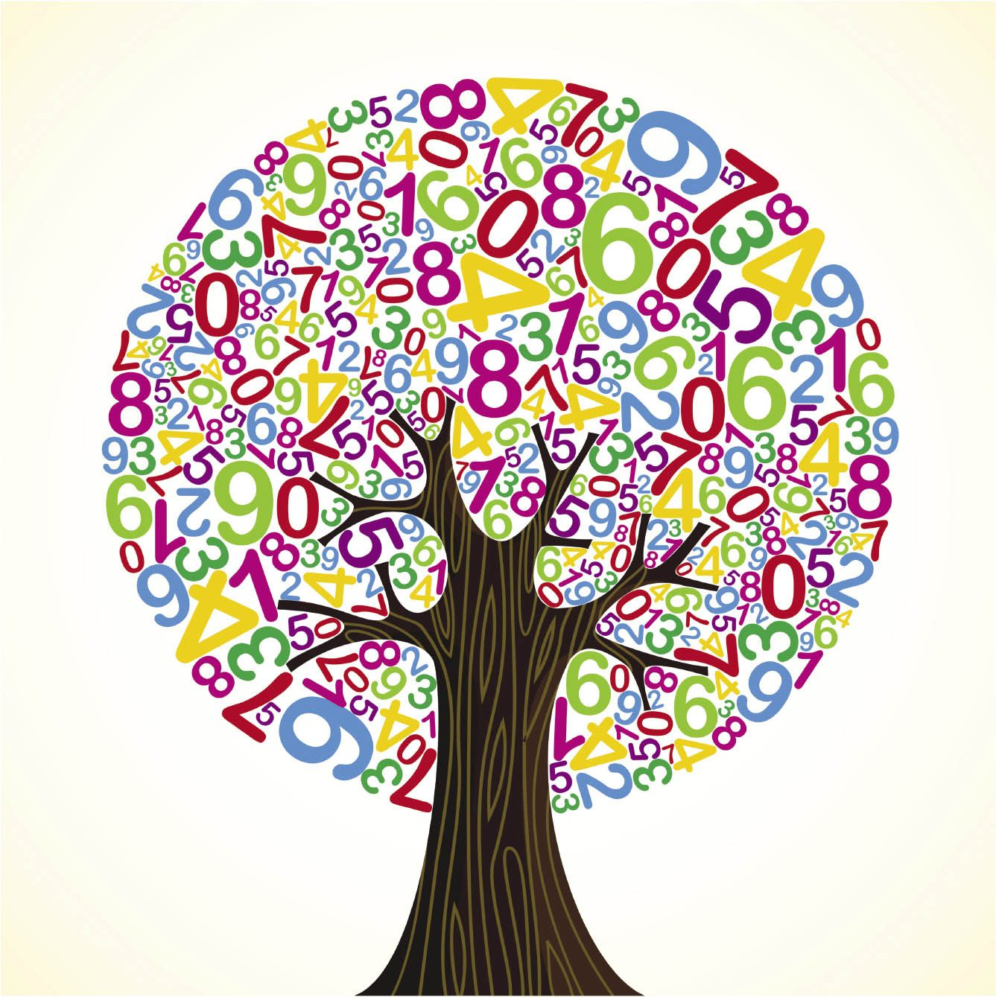

Fernwood Primary and Nursery School

Maths Intent

Subject Progression 2025-2026

At Fernwood Primary and Nursery school, we aim for all of our children to become successful mathematicians. Maths is seen as a vital and integral part of our school curriculum. We want children to develop the correct skills that will set them up for use in later life. We want our children to learn and develop a variety of strategies and concepts; both mental and written that will enable them to tackle a wide range of practical and investigative problems. Our children are encouraged to adopt and apply new vocabulary to explain their mathematical thinking. Arithmetic and basic maths skills are practised daily during Fluency fitness to ensure key mathematical concepts are embedded and children can recall their knowledge to see the links between topics in Maths. It is therefore our intent for every child to develop a sound understanding of Maths, equipping them with the skills of calculation, reasoning and problem solving that they need in life beyond school.

This document illustrates the progression of each Mathematical strand through school and the sequence in which the learning of objectives takes place, step by step from F2 to Year 6.

Calculation Policy
S:\FPNS Curriculum\Calculation Policy\addition-and-subtraction.pdf
..\..\..\FPNS Curriculum\Calculation Policy\multiplication-and-division.pdf

National Curriculum Progression
The aim of this progression document is to give an at-a-glance guide to how the WRM curriculum links to the Key Stage 1 and 2 national curriculum, and how it progresses through topics.
In each of the major topic areas (Number, Measurement, Geometry and Statistics), the curriculum has been broken down into key areas. For each of these areas, you can then see which NC objectives are covered that year, together with the term and block in which that objective is first met in V3 of the WRM scheme.
We have also included overviews for fluency from years one to four.

ready-to-progress criteria in the new DfE maths guidance for KS1 and KS2
https://www.ncetm.org.uk/classroom-resources/exemplification-of-ready-to-progress-criteria/

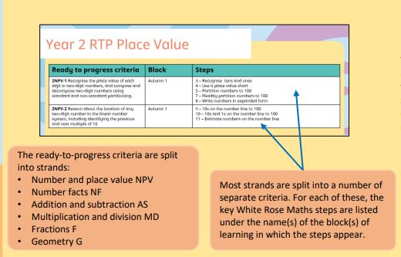
The ‘Ready to Progress’ RTP criteria is created by the DFE as part of their assessments of pupils’ learning. This document also lists the key steps in the White Rose Maths schemes of learning that support each of the ‘Ready to progress’ criteria, in the same sections as the national curriculum objectives.
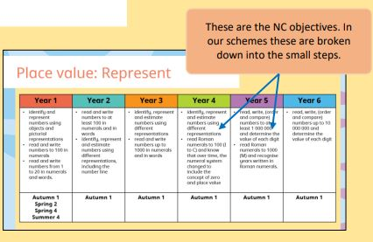

Place Value

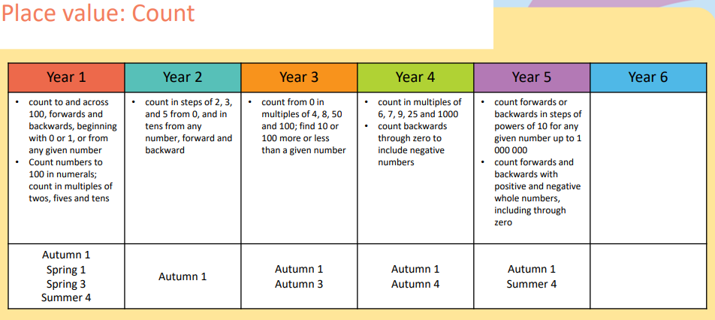
Note in the WRM scheme negative numbers are introduced in Year 5
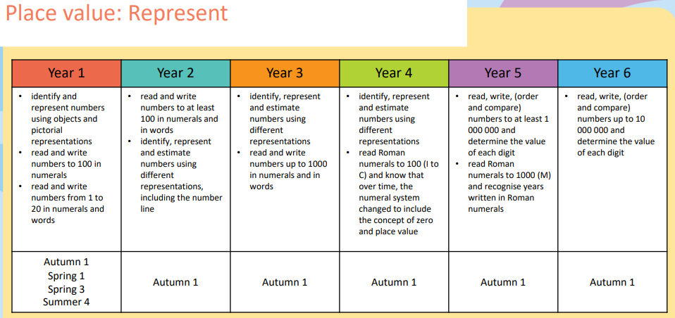

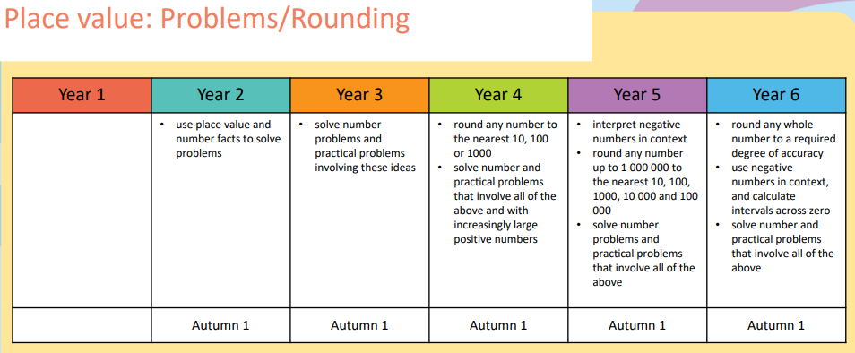
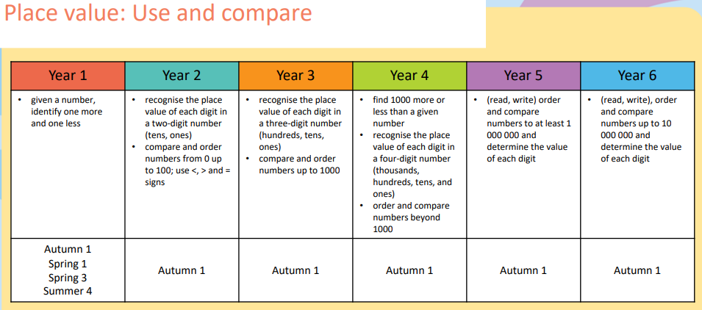

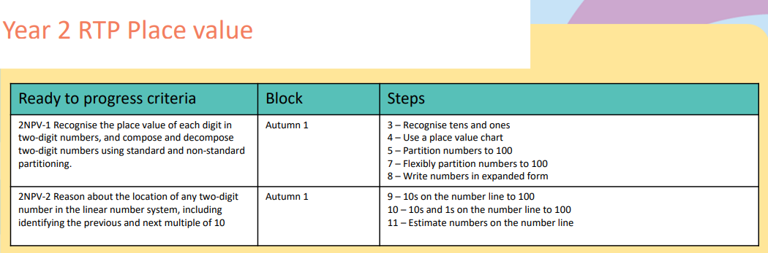
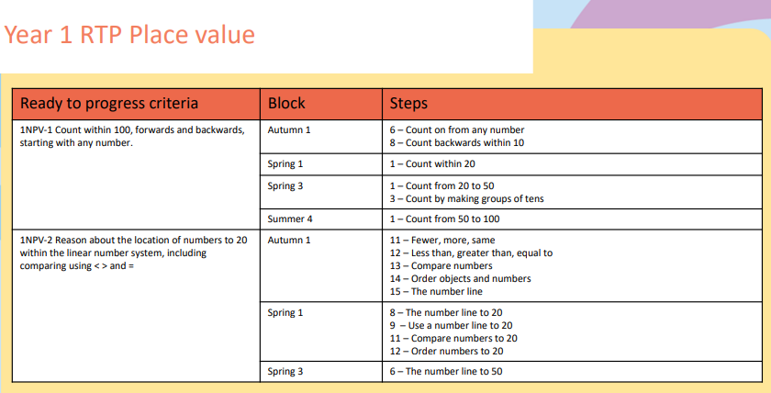

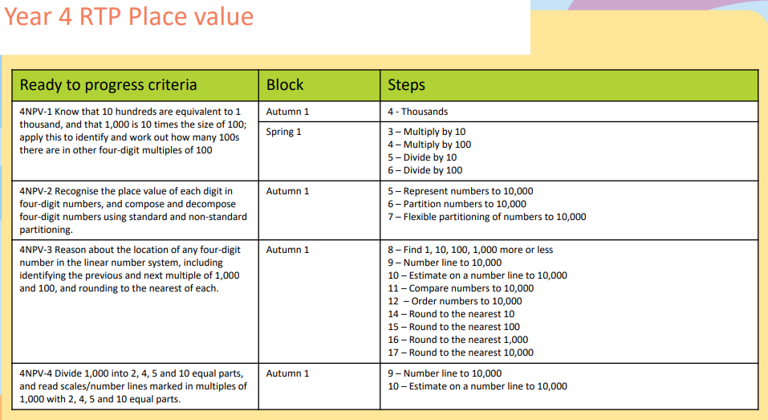
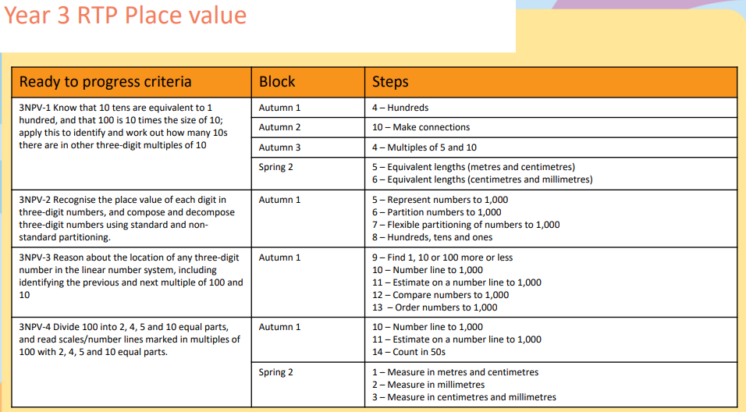

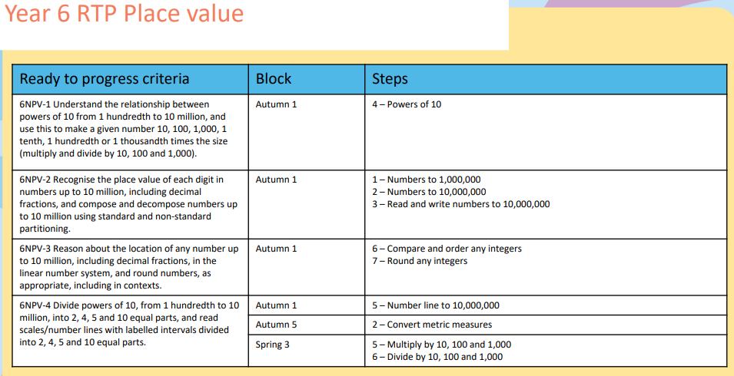
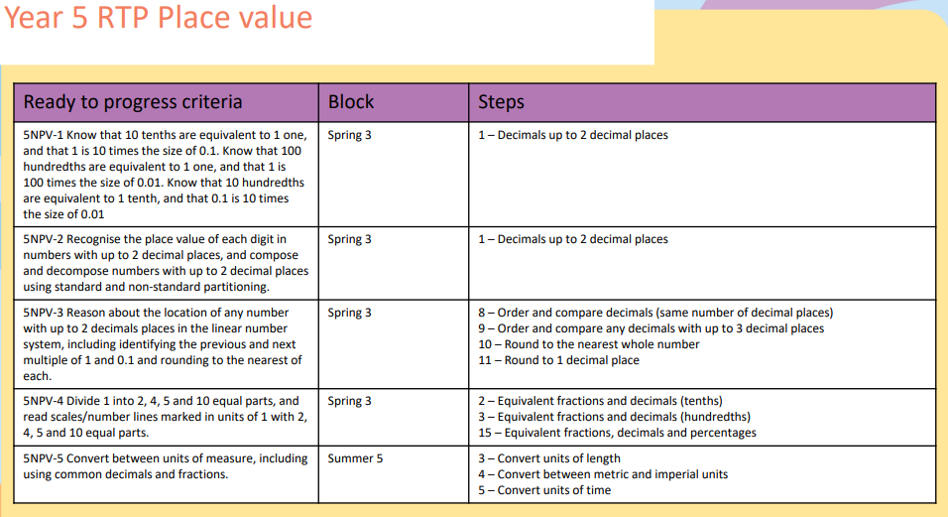

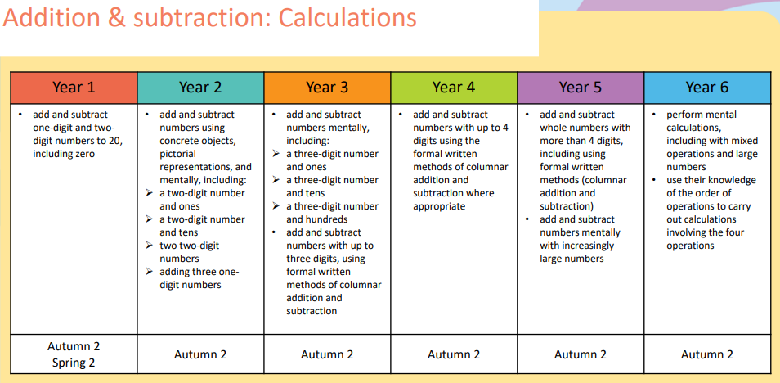
Addition and Subtraction
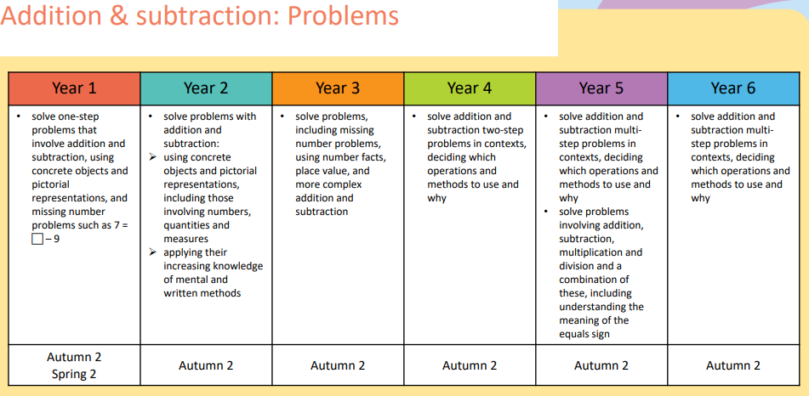

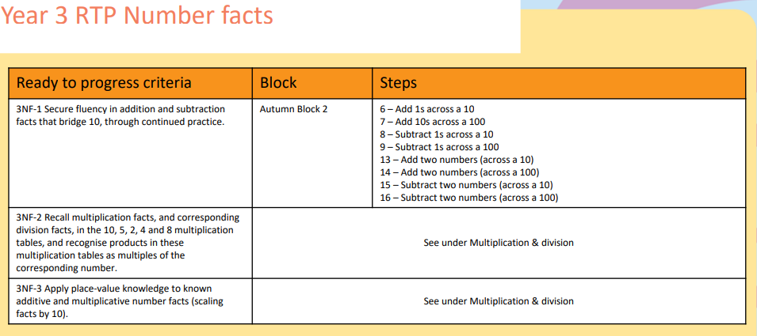
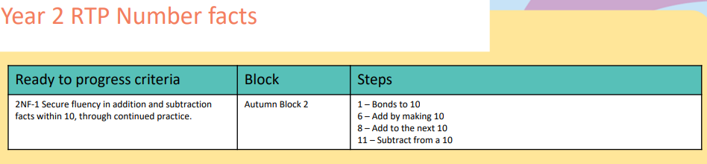
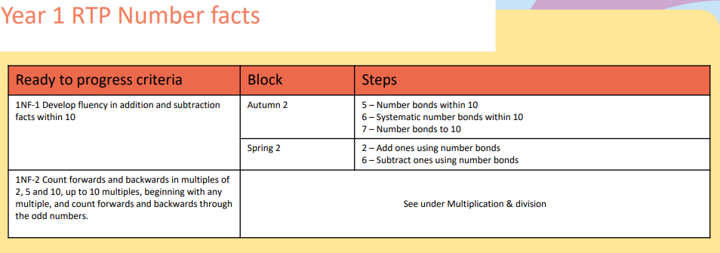

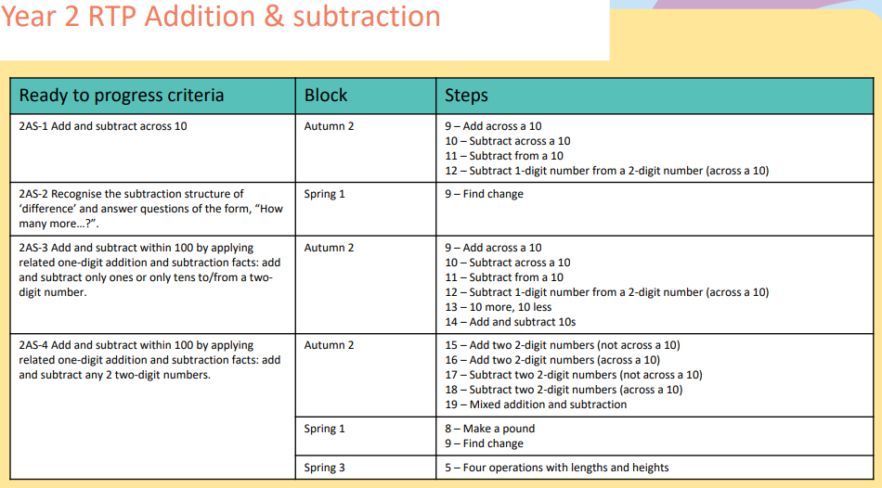
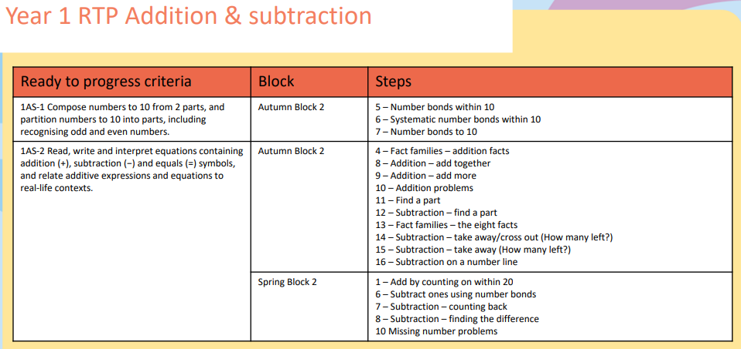
Note - In the WRM schemes odd and even numbers are explored both in Reception and Year 2 but there is no explicit step in Year 1.

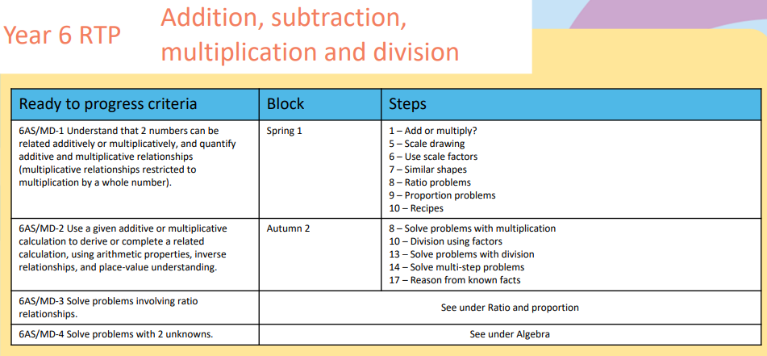
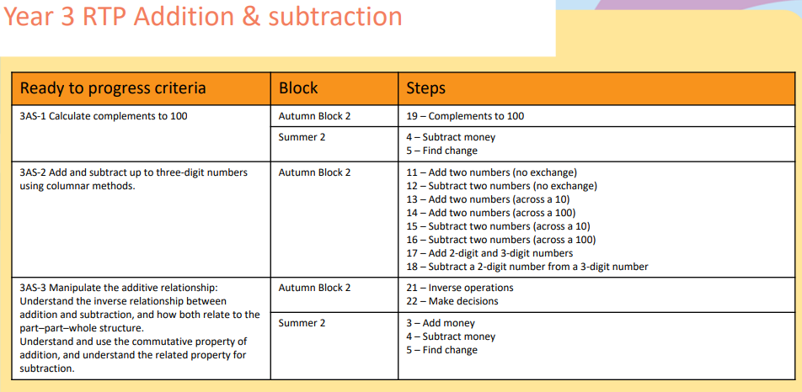

Multiplication and Division
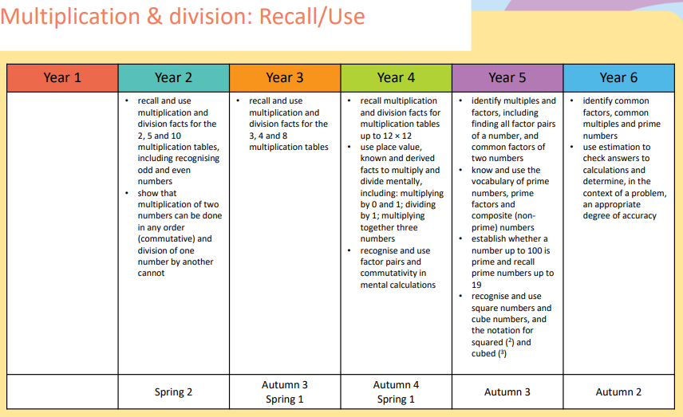
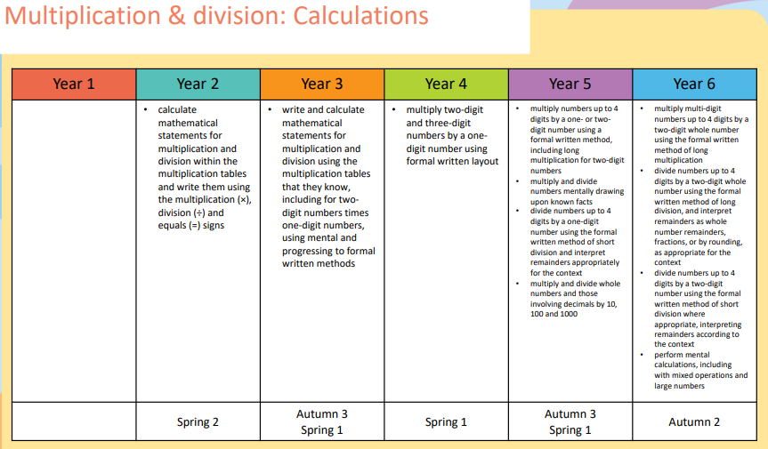
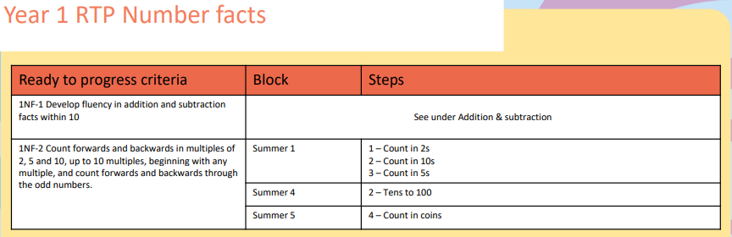
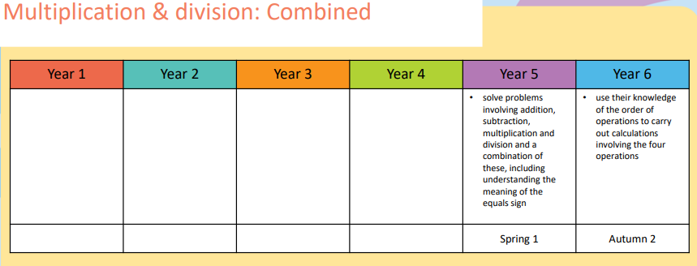
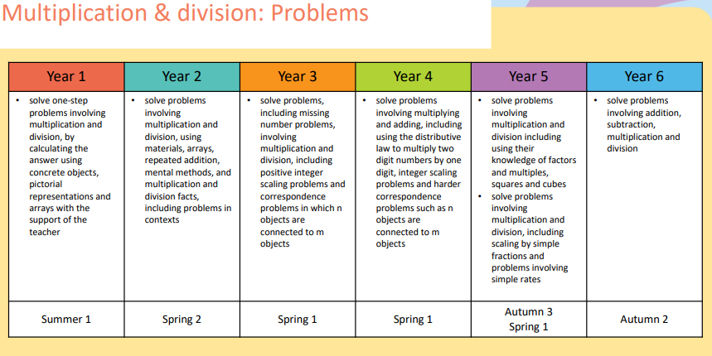
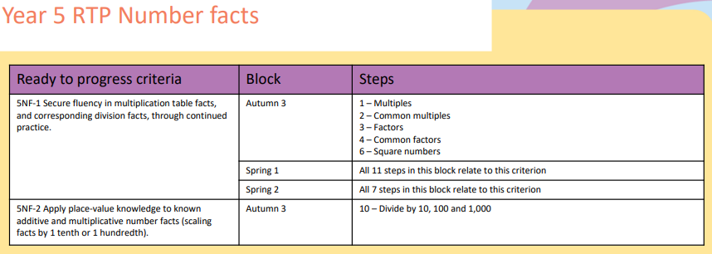
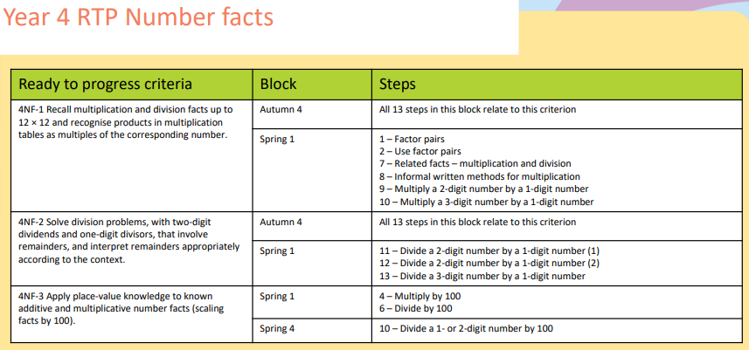
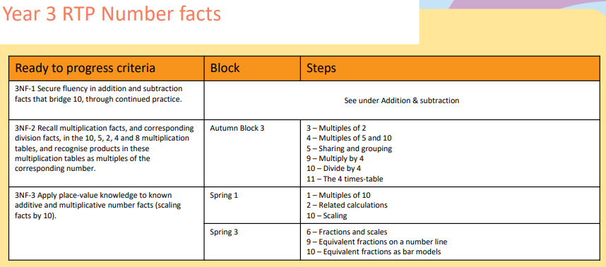
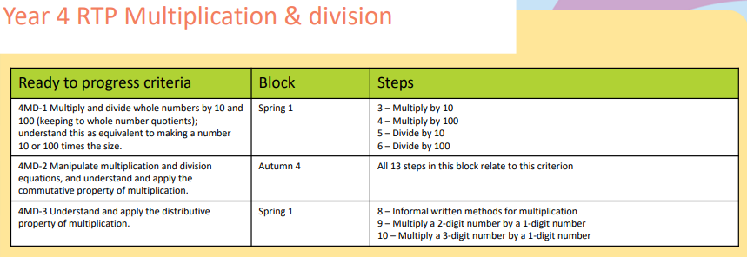
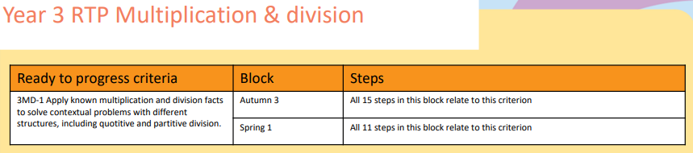
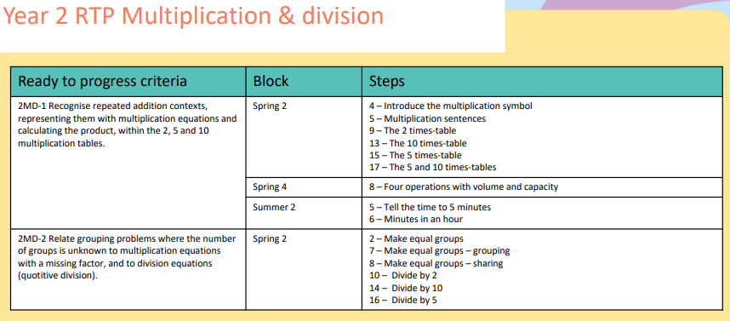

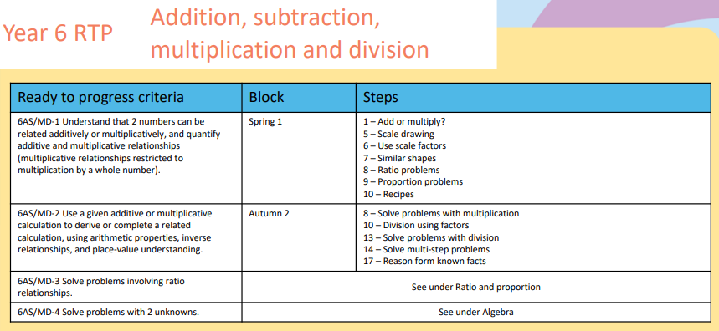
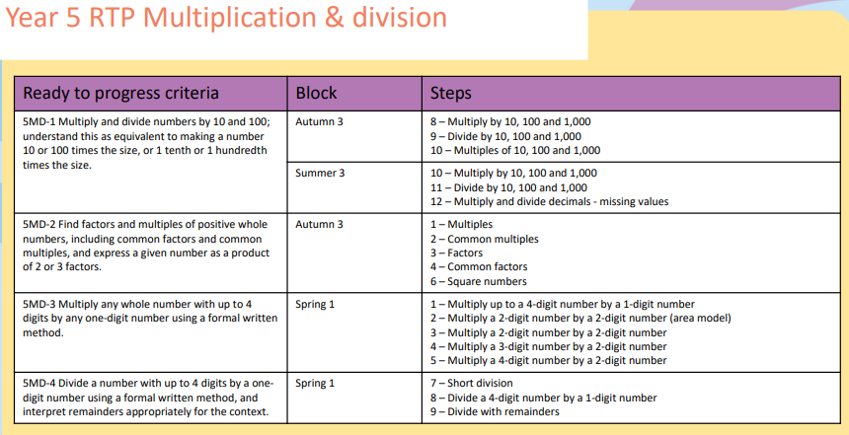

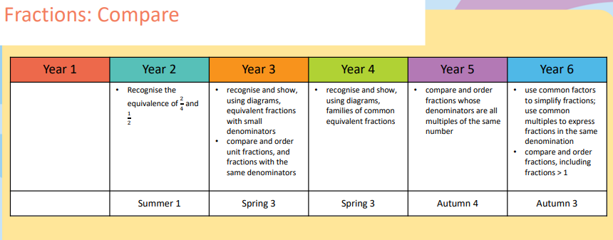
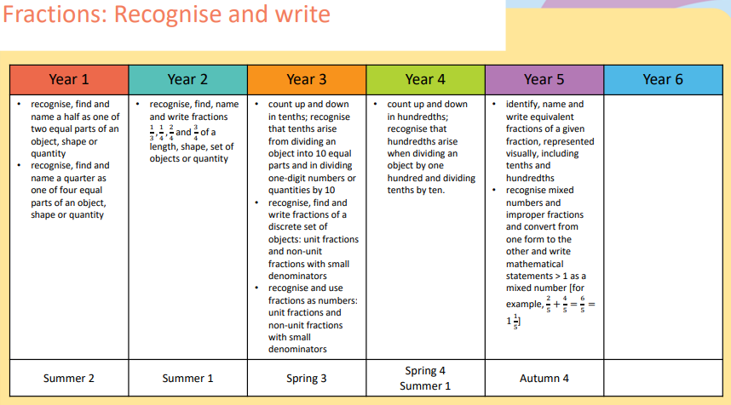
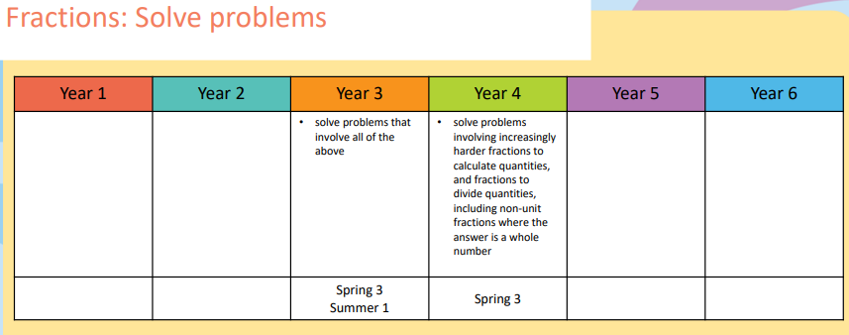
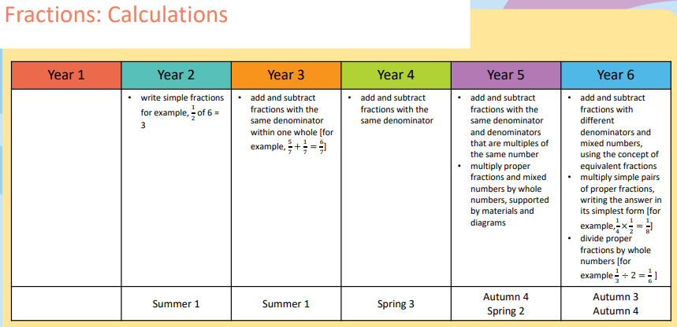

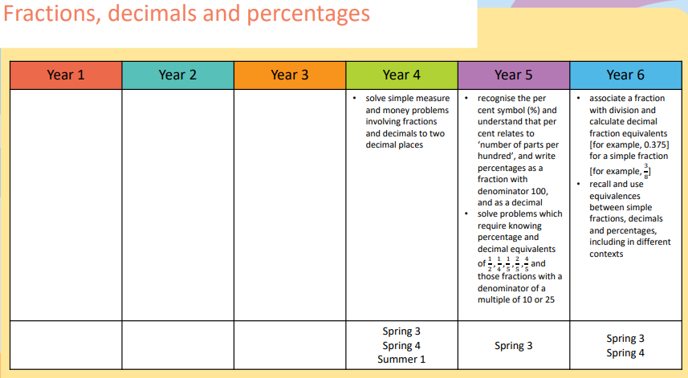
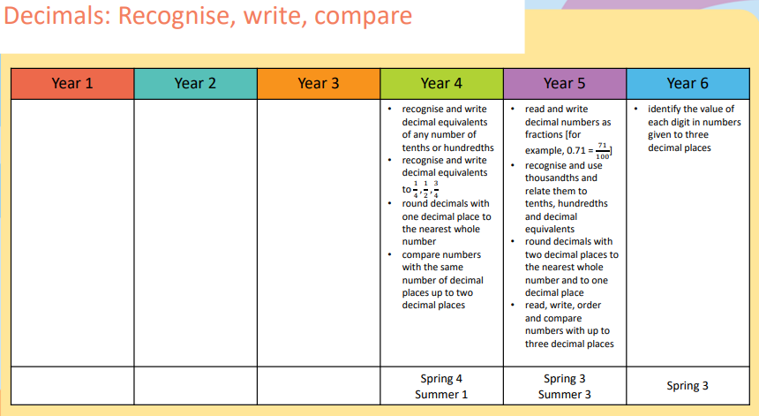

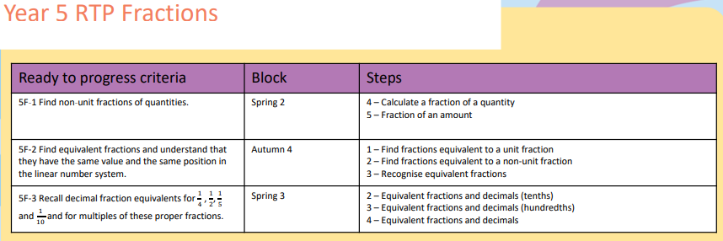
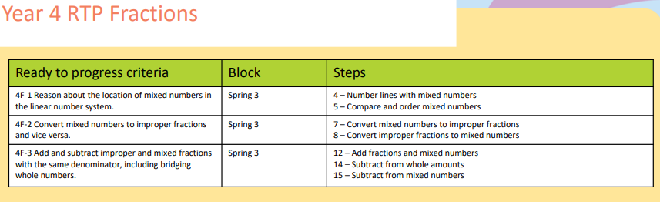
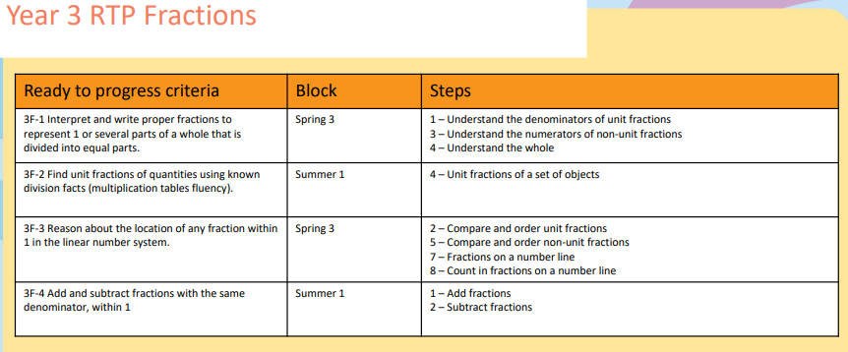

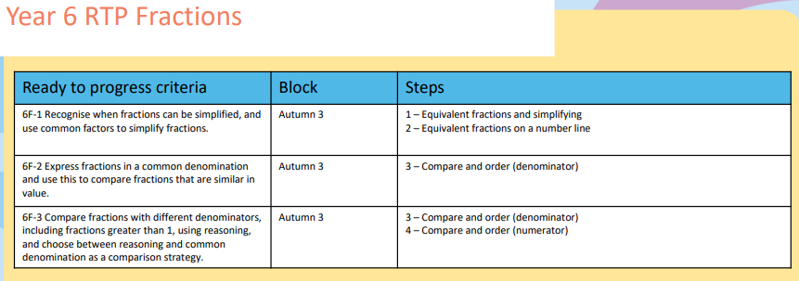

Ratio and Proportion, Algebra
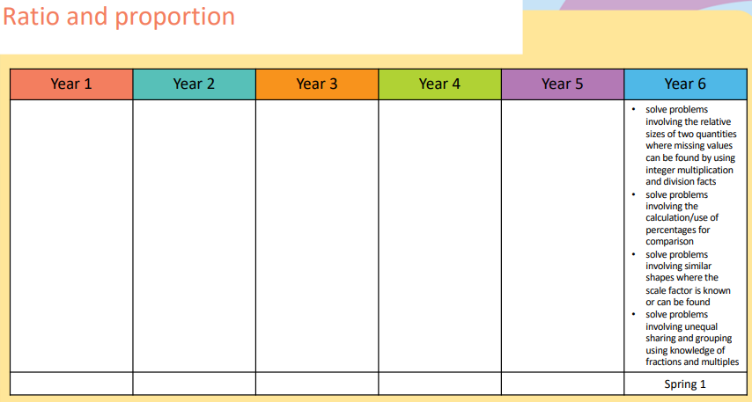

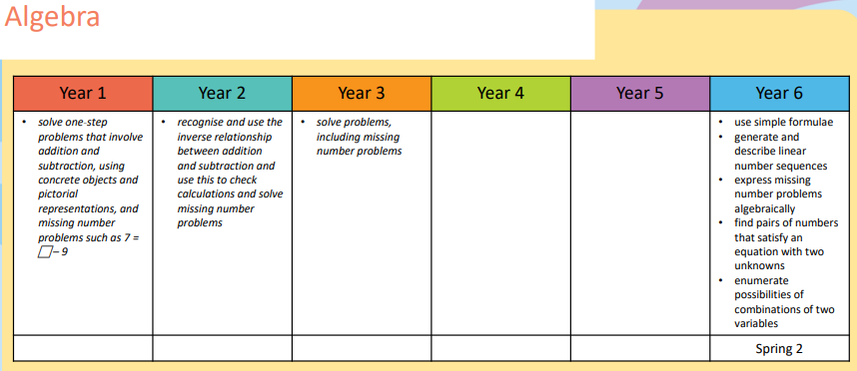
Note -although formal algebraic is not introduced until Year 6, algebraic thinking starts much earlier as exemplified by ‘missing number’ objectives from Year 1,2,3
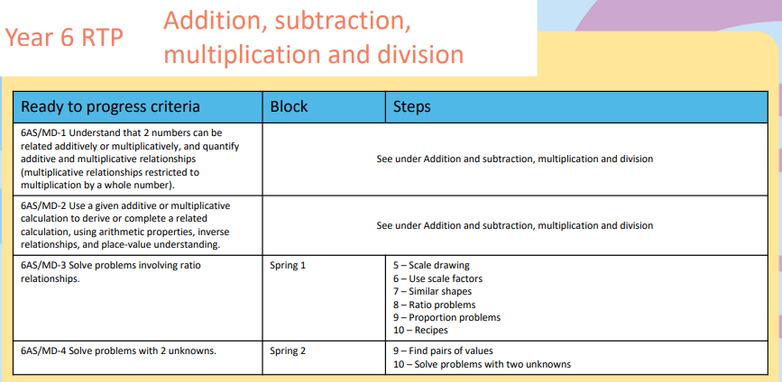
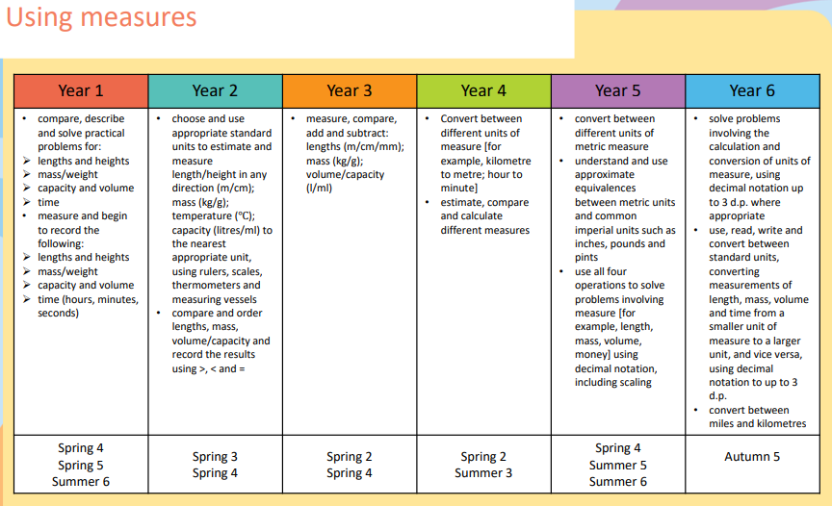
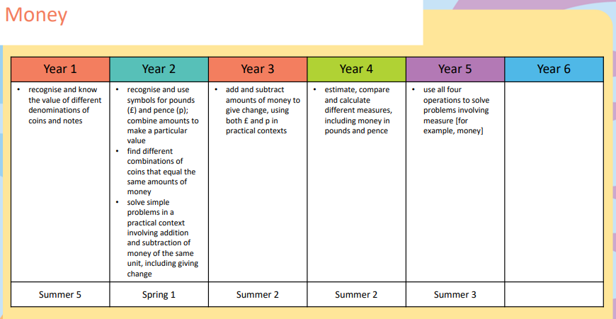
Measurement

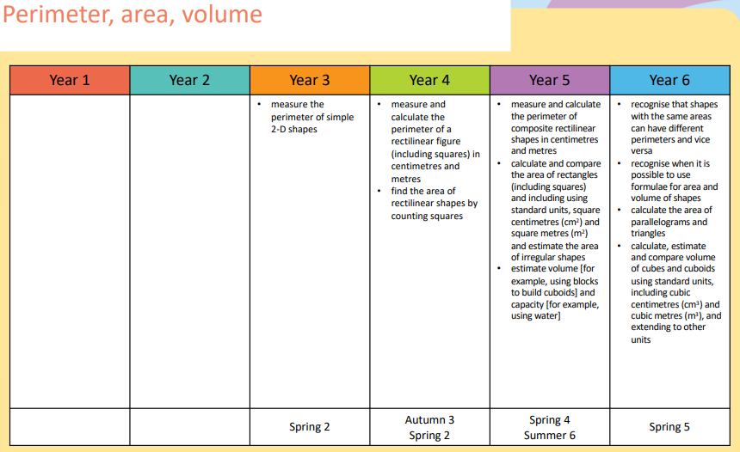
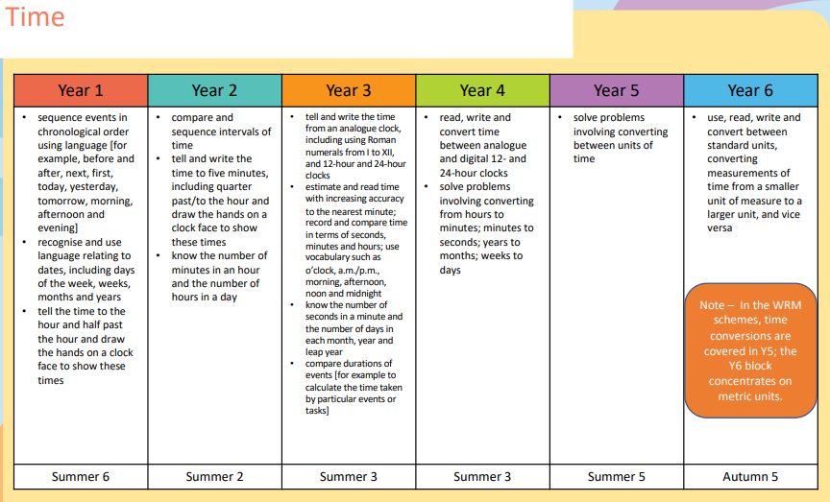
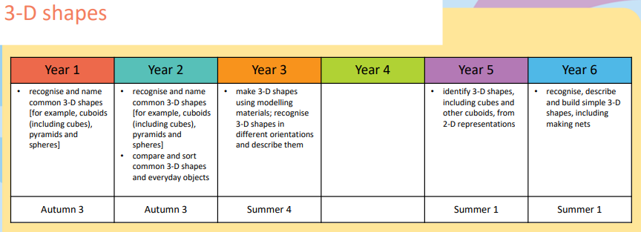
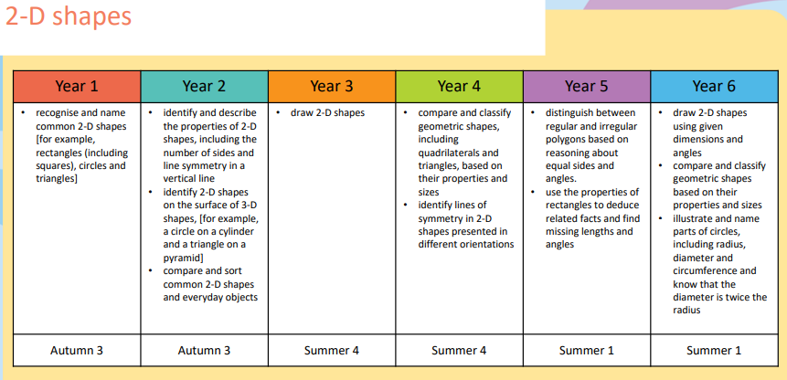
Geometry

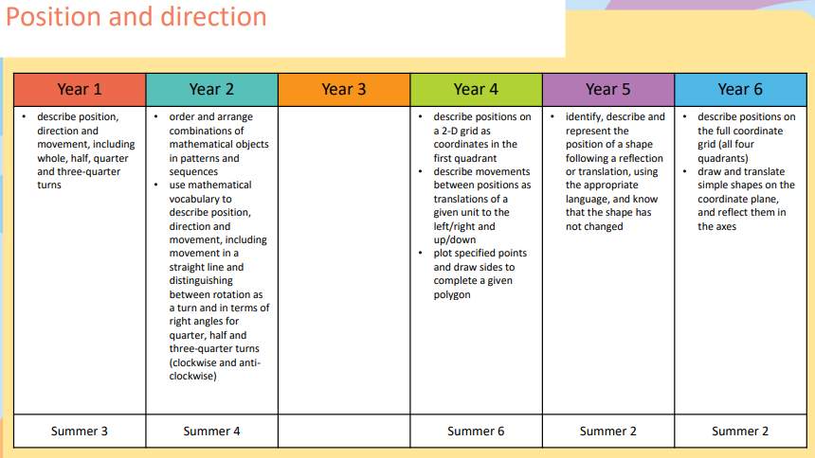
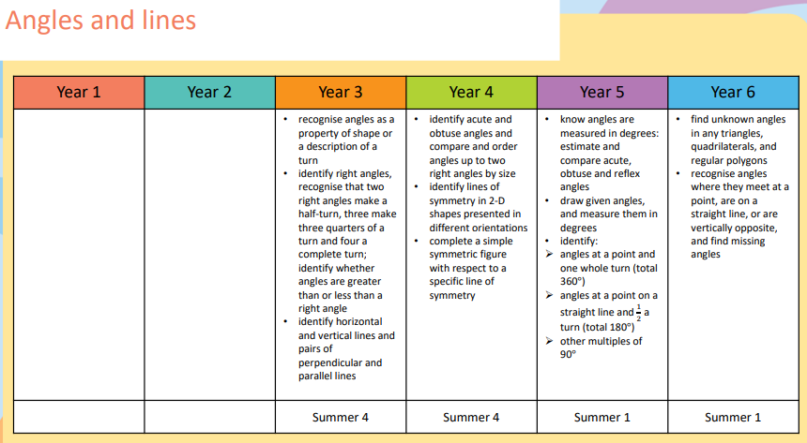

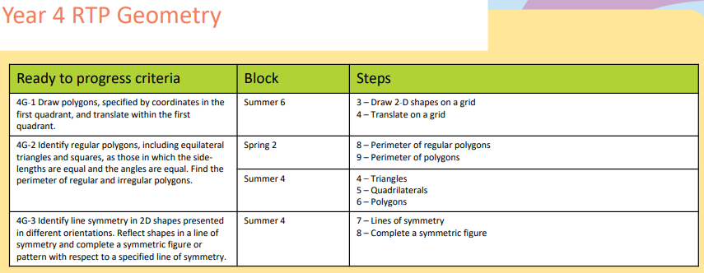
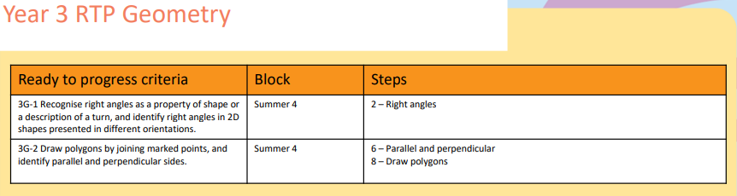
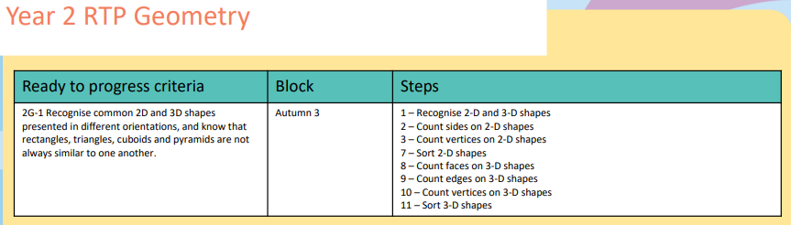
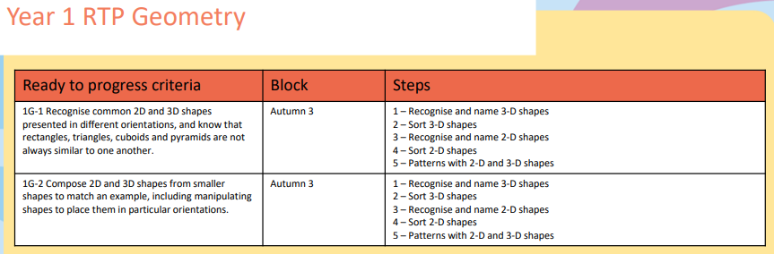
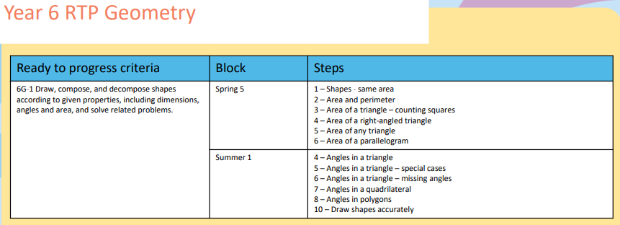
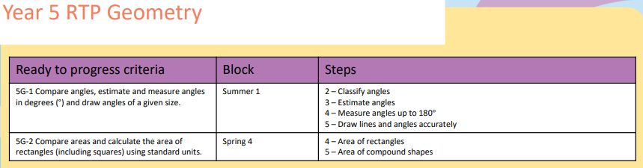
Statistics
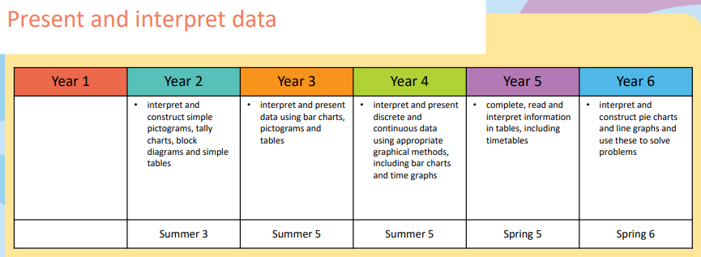
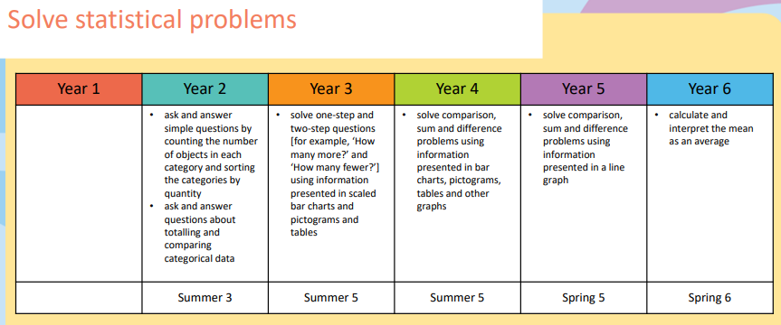

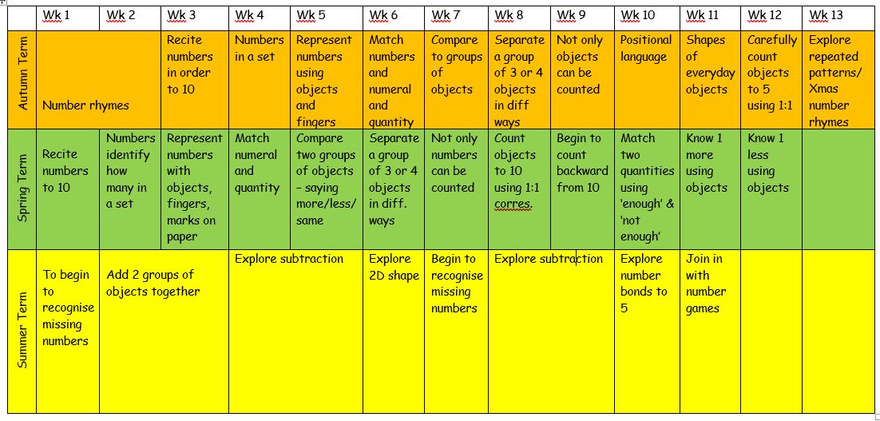
Nursery

Reception

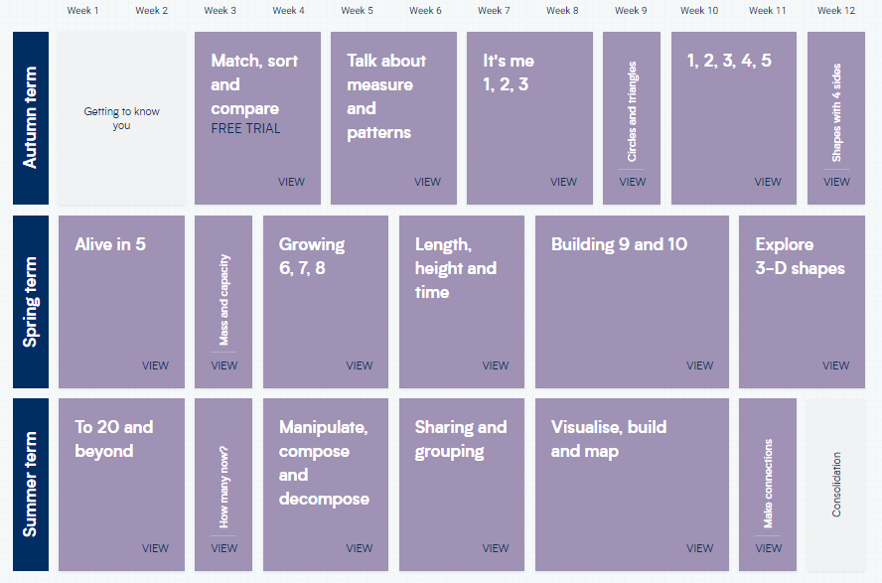

Year 1
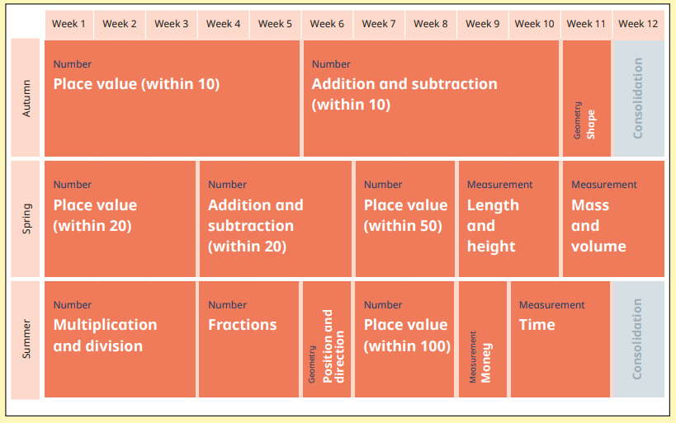

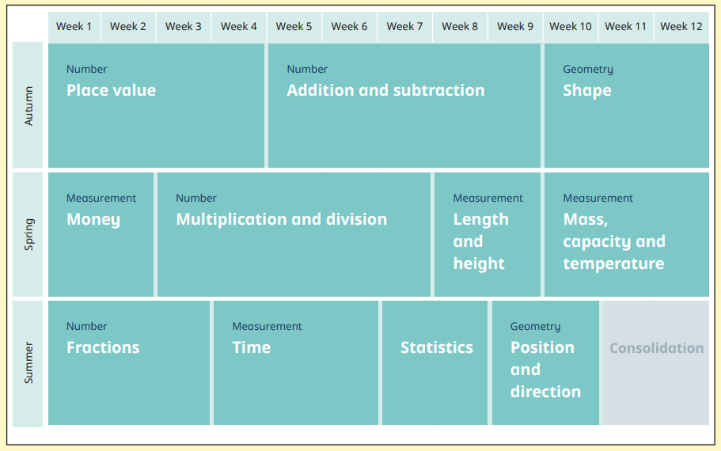
Year 2
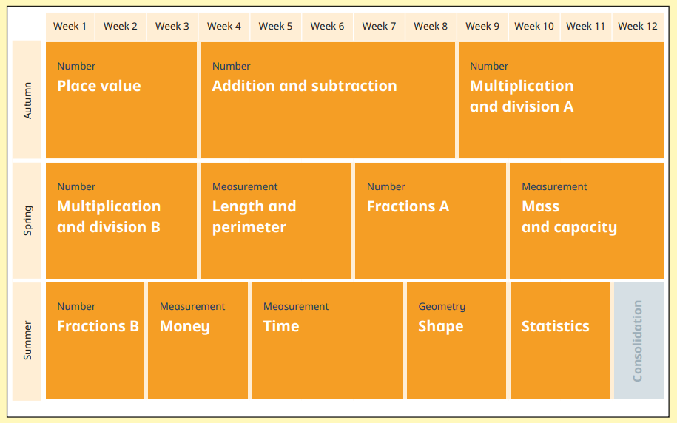
Year 3
Year 4
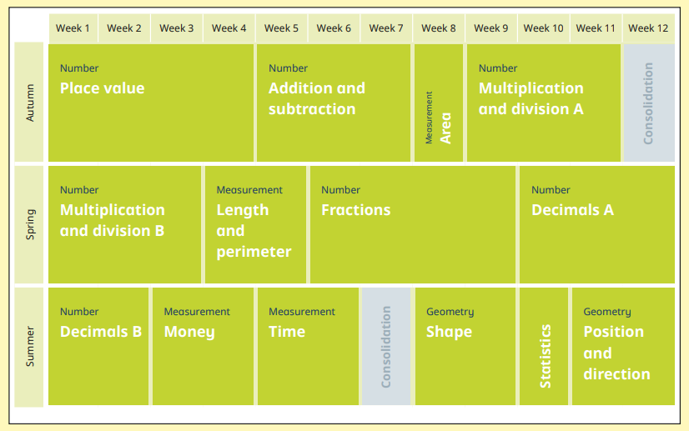
Year 5
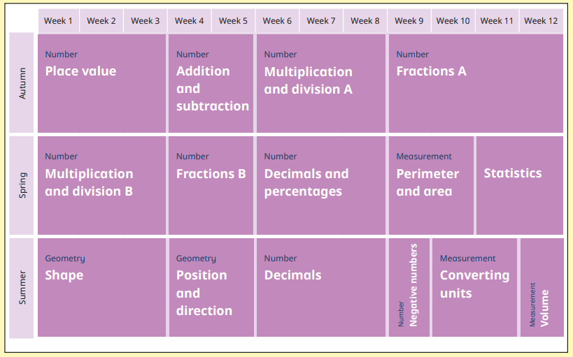

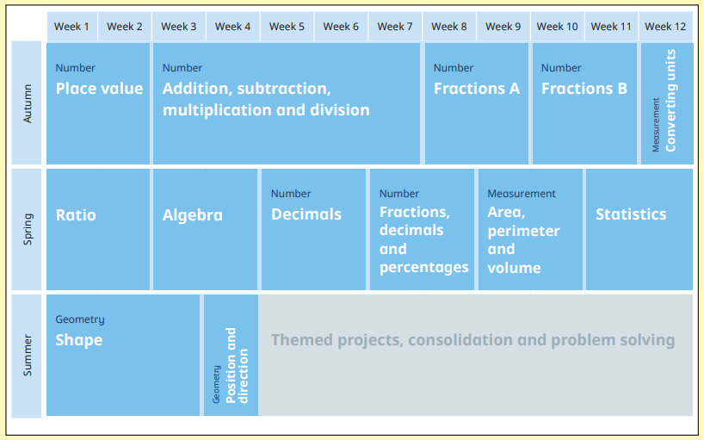
Year 6

Year Group Weekly Objectives
Nursery – Autumn

Week 1 | Number Rhymes | Week 2 | Number Rhymes
Week 3 | To recite numbers in order to 10 | Week 4 | To know that numbers identify how many objects are in a set
Week 5 | To begin to represent numbers using objects and fingers. | Week 6 | To begin to match numeral and quantity correctly
Week 7 | To compare two groups of objects, saying when they have the same amount.

Week 7 | Starters: Counting to 10 and number recognition to 5 To separate a group of three or four objects in different ways and begin to recognise the number is still the same. | Week 8 | To begin to understand that not only objects can be counted.
Week 9 | To begin to use positional language e.g. on top, underneath, next to, in front and behind | Week 10 | To begin to talk about shapes of everyday objects.
Week 11 | To careful count objects to 5 using 1:1 correspondence. | Week 12 | To explore repeated patterns.
Week 13 | To join in with Christmas number rhymes e.g. 12 days of Christmas.
Nursery – Autumn

Nursery - Spring
Week 1 | Starters: Counting to 10 and backwards and number recognition to 10  To recite numbers in order to 10. | Week 2 | To know that numbers identify how many objects are in a set.
Week 3 | To begin to represent numbers using objects, fingers and marks on paper | Week 4 | To begin to match numeral and quantity correctly.
Week 5 | To compare two groups of objects, saying when they have more, less or the same. | Week 6 | To separate a group of three or four objects in different ways and begin to recognise the number is still the same.

Nursery - Spring

Week 7 | To begin to understand that not only objects can be counted. | Week 8 | To careful count objects to 10 using 1:1 correspondence.
Week 9 | To begin to count backwards from 10 | Week 10 | To match two quantities saying when there is enough and not enough
Week 11 | To know 1 more than a number, using objects to support | Week 12 | To know 1 less than a number, using objects to support

Nursery – Summer
Week 1 | Starters: subitising to 10  To begin to recognise missing numbers | Week 2 | To add 2 groups of objects together.
Week 3 | To add 2 groups of objects together. | Week 4 | To explore subtraction.
Week 5 | To explore subtraction. | Week 6 | To explore 2D shapes.

Week 7 | Starters: number formation  Week 1: To begin to recognise missing numbers | Week 8 | To add 2 groups of objects together.
Week 9 | To add 2 groups of objects together. | Week 10 | To explore subtraction.
Week 11 | To explore subtraction. | Week 12 | To explore number bonds to 5.
Week 13 | To join in with number games. |  | no Maths planning.
Nursery – Summer

Year R - Autumn

Week 1 | Getting to know you  Take this time to play and get to know the children. Explore maths equipment around the classroom and outside. | Week 2 | Getting to know you  Take this time to play and get to know the children. Explore maths equipment around the classroom and outside.

Week 1 | Getting to know you  Take this time to play and get to know the children. Explore maths equipment around the classroom and outside. | Week 2 | Getting to know you  Take this time to play and get to know the children. Explore maths equipment around the classroom and outside.
Week 3 | Match, Sort and Compare  - Match objects  - Match pictures and objects  - Identify a set | Week 4 | Match, Sort and Compare  - Sort objects to a type  - Explore sorting techniques  - Create sorting rules  - Compare amounts
Week 5 | Talk about measure and pattern  - Compare size  - Compare mass  - Compare capacity | Week 6 | Talk about measure and pattern  - Explore simple patterns  - Copy and continue simple patterns  - Create simple patterns

Year R - Autumn

Week 7 | It’s me 1, 2, 3  - Find 1, 2 and 3  - Subitise 1, 2 and 3  - Represent 1, 2 and 3 | Week 8 | It’s me 1, 2, 3  - Step 4 1 more  - Step 5 1 less  - Step 6 Composition of 1, 2 and 3
Week 9 | Circles and triangles  - Identify and name circles and triangles  - Compare circles and triangles  - Shapes in the environment  - Describe position | Week 10 | 1, 2, 3, 4, 5  - Find 4 and 5  - Subitise 4 and 5  - Represent 4 and 5
Week 11 | 1, 2, 3, 4, 5  - 1 more  - 1 less  - Composition of 4 and 5  - Composition of 1−5 | Week 12 | Shapes with 4 sides  - Identify and name shapes with 4 sides  - Combine shapes with 4 sides  - Shapes in the environment  - My day and night

Week 1 | Alive in 5!  - Introduce zero  - Find 0 to 5  - Subitise 0 to 5  - Represent 0 to 5 | Week 2 | Alive in 5!  - 1 more  - 1 less  - Composition  - Conceptual subitising to 5
Week 3 | Mass and Capacity  - Compare mass  - Find a balance  - Explore capacity  - Compare capacity | Week 4 | Growing 6,7,8  - Find 6, 7 and 8  - Represent 6, 7 and 8  - 1 more  - 1 less
Week 5 | Growing 6,7,8  - Composition of 6, 7 and 8  - Make pairs – odd and even  - Double to 8 (find a double)  - Double to 8 (make a double) | Week 6 | Growing 6,7,8  - Combine 2 groups  - Conceptual subitising
Year R - Spring

Week 7 | Explore length and time  - Explore length  - Compare length  - Explore height  - Compare height | Week 8 | Explore length and time  - Talk about time  - Order and sequence time  Building 9 and 10  - Find 9 and 10  - Compare numbers to 10
Week 9 | Building 9 and 10  - Represent 9 and 10  - Conceptual subitising to 10  - 1 more  - 1 less | Week 10 | Building 9 and 10  - Composition to 10  - Bonds to 10 (2 parts)  - Make arrangements of 10  - Bonds to 10 (3 parts)  - Doubles to 10 (find a double)
Week 11 | - Doubles to 10 (make a double)  - Explore even and odd  Explore 3-D shapes  - Recognise and name 3-D shapes  - Find 2-D shapes within 3-D shapes | Week 12 | Explore 3-D shapes  - Use 3-D shapes for tasks  - 3-D shapes in the environment  - Identify more complex patterns  - Copy and continue patterns  - Patterns in the environment
Year R - Spring

Week 1 | To 20 and beyond  - Build numbers beyond 10 (10−13)  - Continue patterns beyond 10 (10−13)  - Build numbers beyond 10 (14−20) | Week 2 | To 20 and beyond  - Continue patterns beyond 10 (14−20)  - Verbal counting beyond 20  - Verbal counting patterns
Week 3 | How many more?  - Add more  - How many did I add?  - Take away  - How many did I take away? | Week 4 | Manipulate, compose and decompose  - Select shapes for a purpose  - Rotate shapes  - Manipulate shapes  - Explain shape arrangements
Week 5 | Manipulate, compose and decompose  - Compose shapes  - Decompose shapes  - Copy 2-D shape pictures  - Find 2-D shapes within 3-D shapes | Week 6 | Sharing and grouping  - Explore sharing  - Sharing  - Explore grouping
Year R - Summer

Week 7 | Sharing and grouping  - Grouping  - Even and odd sharing  - Play with and build doubles | Week 8 | Visualise, build and map  - Identify units of repeating patterns  - Create own pattern rules  - Explore own pattern rules  - Replicate and build scenes and constructions
Week 9 | Visualise, build and map  - Visualise from different positions  - Describe positions  - Give instructions to build  - Explore mapping | Week 10 | Visualise, build and map  - Represent maps with models  - Create own maps from familiar places  - Create own maps and plans from story situations
Week 11 | Make connections  - Deepen understanding  - Patterns and relationships | Week 12
Year R – Summer

Year 1 - Autumn
Week 1  Block 1: Place Value | - Sort objects  - Count objects  - Count objects from a larger group  Baseline fluency assessments  Fluency  Counting to 20 – forwards and backwards from any number -use a number line/square | Week 2  Block 1: Place Value | - Represent objects  - Recognise numbers as words  - Count on from any number  Baseline Fluency assessments  Fluency  Counting to 20 – forwards and backwards from any number – use a number line/square
Week 3  Block 1: Place Value | - 1 more  - Count backwards within 10  - 1 less  Fluency  Counting to 50 – forwards and backwards from any number – use hundred square | Week 4  Block 1: Place Value | - Compare groups by matching  - Fewer, more, same  - Less than, greater than, equal to  Fluency  Counting to 50 and up to 100 – forwards and backwards from any number -use hundred square
Week 5  Block 1: Place Value | - Compare numbers  - Order objects and numbers  - The number line  Fluency  Representing and recognising 1-10 on a 10 frame by filling each row | Week 6  Block 2: Addition and Subtraction | - Introduce parts and wholes  - Part-whole model  - Write number sentences  - Fact families - addition facts  Fluency  Adding 1 (7 + 1 and 1 + 7) adding 1 is counting!  Introduce ‘commutative’

Year 1 - Autumn

Week 7  Block 2: Addition and Subtraction | - Number bonds within 10  - Systematic number bonds within 10  - Number bonds to 10  Fluency  Odd and even numbers – initially up to 10 | Week 8  Block 2: Addition and Subtraction | - Addition - add together  - Addition - add more  - Addition problems  Fluency  Adding 2 to even numbers (2 + 4 and 4 + 2)  ‘commutative’
Week 9  Block 2: Addition and Subtraction | - Find a part  - Subtraction – find a part  - Fact families -the eight facts  Fluency  Adding 2 to even numbers (2 + 4 and 4 + 2)  ‘commutative’ | Week 10  Block 2: Addition and Subtraction | - Subtraction - take away/crossing out (How many left?)  - Subtraction - take away (How many left?)  - Subtraction on a number line  - Add or subtract 1 or 2  Fluency  Adding 2 to odd numbers (5 + 2 and 2 + 5)  ‘commutative’
Week 11  Block 3: Shape | - Recognise and name 3-D shapes  - Sort 3-D shapes  - Recognise and name 2-D shapes  - Sort 2-D shapes  - Patterns with 2-D and 3-D shapes  Fluency  Adding 2 to odd numbers (5 + 2 and 2 + 5)  ‘commutative’ | Week 12 | Consolidation Week/Assessment  Fluency  Adding 0 to a number (3 + 0 and 0 + 3)  ‘commutative’

Year 1 - Spring
Week 1  Block 1: Place Value | - Count within 20  - Understand 10  - Understand 11, 12 and 13  - Understand 14, 15, 16  Fluency  Number bonds to 10  commutative | Week 2  Block 1: Place Value | - Understand 17, 18, 19  - Understand 20  - 1 more and 1 less  - The number line to 20  Fluency  Number bonds to 10  (add and subtract -3+7=10 7+3=10 10-7=3 10-3=7 10=7+3 10=3+7)
Week 3  Block 1: Place Value | - Use a number line to 20  - Estimate on a number line to 20  - Compare numbers to 20  - Order numbers to 20  Fluency  Number bonds to 10  (add and subtract -3+7=10 7+3=10 10-7=3 10-3=7 10=7+3 10=3+7) | Week 4  Block 2: Addition and Subtraction | - Add by counting on within 20  - Add ones using number bonds  - Find and make number bonds to 20  Fluency  Near number bonds to 10  (6 + 3 = 9)
Week 5  Block 2: Addition and Subtraction | - Doubles  - Near doubles  - Subtract ones using number bonds  - Subtraction – counting back  Fluency  Near number bonds to 10  (6 + 3 = 9) | Week 6  Block 2: Addition and Subtraction | - Subtraction – finding the difference  - Related facts  - Missing number problems  Fluency  Doubles of numbers to 10

Year 1 - Spring

Week 7  Block 3: Place Value | - Count from 20 to 50  - 20, 30, 40 and 50  - Count by making groups of tens  - Groups of tens and ones  Fluency  Near doubles of numbers to 10 | Week 8  Block 3: Place Value | - Partition into tens and ones  - The number line to 50  - Estimate on a number line to 50  - 1 more, 1 less  Fluency  Retrieval – adding 2 to odd and even numbers
Week 9  Block 4: Length and Height | - Compare lengths and heights  - Measure length using objects  Fluency  Adding 3 to a number to 10  (2 + 1 more) | Week 10  Block 4: Length and Height | - Measure length in centimetres  Fluency  Adding 3 to a number to 10  (2 + 1 more)
Week 11  Block 5: Mass and Volume | - Heavier and lighter  - Measure mass  - Compare mass  Fluency  Counting to and across 100 – forwards and backwards from any given number | Week 12  Block 5: Mass and Volume | - Full and empty  - Compare volume  - Measure capacity  - Compare capacity  Fluency  Counting to and across 100 – forwards and backwards from any given number

Year 1 - Summer

Week 1  Block 1: Multiplication and Division | - Count in 2s  - Count in 10s  - Count in 5s  Fluency  Adding 10 to a number | Week 2  Block 1: Multiplication and Division | - Recognise equal groups  - Add equal groups  - Make arrays  Fluency  Adding 10 to a number
Week 3  Block 1: Multiplication and Division | - Make doubles  - Make equal groups - grouping  - Make equal groups – sharing  Fluency  Odd and even up to and over 100 | Week 4  Block 2: Fractions | - Recognise a half of an object or a shape  - Find a half of an object or a shape  - Recognise a half of a quantity  - Find a half of a quantity  Fluency  Doubles and halves up to 10  (Double 7 Half of 14)
Week 5  Block 2: Fractions | - Recognise a quarter of an object or a shape  - Find a quarter of an object or a shape  - Recognise a quarter of a quantity  - Find a of a quantity  Fluency  Count in 2’s | Week 6  Block 3: Position and Direction | - Describe turns  - Describe position – left and right  - Describe position – forwards and backwards  - Describe position – above and below  - Ordinal numbers  Fluency  Count in 5’s

Year 1 - Summer

Week 7  Block 4: Place Value | - Count from 50 to 100  - Tens to 100  - Partition into tens and ones  Fluency  Count in 10’s | Week 8  Block 4: Place Value | - The number line to 100  - 1 more, 1 less  - Compare numbers with the same number of tens  - Compare any two numbers  Fluency  Count in 2’s 5’s and 10’s from different starting points
Week 9  Block 5: Money | - Unitising  - Recognise coins  - Recognise notes  - Count in coins  Fluency  Count in 2’s 5’s and 10’s from different starting points | Week 10  Block 6: Time | - Before and after  - Days of the week  - Months of the year  Fluency  Empty box calculations  Solve one step problems up to 10  7 = 5 + ? 5 + ? = 10 10 = 7 + ?
Week 11  Block 6: Time | - Hours, minutes and seconds  - Tell the time to the hour  - Tell the time to the half hour  Fluency  Empty box calculations  Solve one step problems up to 20  7 = 5 + ? 15 + ? = 20 ? + 10 =15 | Week 12 | Consolidation/Assessment  Fluency  Empty box calculations  Solve one step problems up to 20  7 = 5 + ? 15 + ? = 20 ? + 10 =15

Year 2 -Autumn

Week 1  Block 1: Place Value | - Numbers to 20  - Count objects to 100 by making 10s  - Recognise tens and ones  - Use a place value chart  Baseline Fluency assessments bridging 10  Fluency  Retrieval - Counting to and across 100 – forwards and backwards from any given number  Adding 0 and 1 | Week 2  Block 1: Place Value | - Partition numbers to 100  - Write numbers to 100 in words  - Flexibly partition numbers to 100  - Write numbers to 100 in expanded form  Baseline Fluency assessments bridging 10  Fluency  Retrieval – Doubles to 10  (9+9 10+10)
Week 3  Block 1: Place Value | - 10s on the number line to 100  - 10s and 1s on the number line to 100  - Estimate numbers on a number line  - Compare objects  Fluency  Retrieval – Adding 2 to odd and even numbers up to 20 ) (12+2 2+12) commutative | Week 4  Block 1: Place Value | - Compare numbers  - Order objects and numbers  - Count in 2s, 5s and 10s  - Count in 3s  Fluency  Adding 10 to one and two digit numbers up to 20 (8+10 10+8 12+10 10+12) commutative
Week 5  Block 2: Addition and Subtraction | - Bonds to 10  - Fact families – addition and subtraction bonds within 20  - Related facts  - Bonds to 100 (tens)  Fluency  Adding 3 up to 20 | Week 6  Block 2: Addition and Subtraction | - Add and subtract 1s  - Add by making 10  - Add three 1-digit numbers  - Add to the next 10  Fluency  Near doubles to 10  ( 9+9=18 ((9+8= 18-1)) 8+9 )

Week 7  Block 2: Addition and Subtraction | - Add across a 10  - Subtract across 10  - Subtract from a 10  - Subtract a 1-digit number from a 2-digit number (across a 10)  - 10 more, 10 less  Fluency  Number bonds to 10  (add and subtract -3+7=10 7+3=10 10-7=3 10-3=7 10=7+3 10=3+7) | Week 8  Block 2: Addition and Subtraction | - Add and subtract 10s  - Add two 2-digit numbers (not across a 10)  - Add two 2-digit numbers (across a 10)  - Subtract two 2-digit numbers (not across a 10)  Fluency  Near number bonds to 10
Week 9  Block 2: Addition and Subtraction | - Subtract two 2-digit numbers (across a 10)  - Mixed addition and subtraction  - Compare number sentences  - Missing number problems  Fluency  Number bonds to 20 | Week 10  Block 3: Shape | - Recognise 2-D and 3-D shapes  - Count sides on 2-D shapes  - Count vertices on 2-D shapes  - Draw 2-D shapes  Fluency  Number bonds to 20  (add and subtract 13+7=20 17+3=20 20-7=13 20-13=7 20=17+3 20=13+7)
Week 11  Block 3: Shape | - Lines of symmetry on shapes  - Use lines of symmetry to complete shapes  - Sort 2-D shapes  - Count faces on 3-D shapes  Fluency  Near number bonds to 20 | Week 12  Block 3: Shape | - Count edges on 3-D shapes  - Count vertices on 3-D shapes  - Sort 3-D shapes  - Make patterns with 2-D and 3-D shapes  Fluency  Number in the middle -up to and bridging 10  (6+8 or 8+6 -double the number in the middle -double 7)
Year 2 - Autumn

Year 2 - Spring
Week 1  Block 1: Money | - Count money - pence  - Count money - pounds (notes and coins)  - Count money - pounds and pence  - Choose notes and coins  - Make the same amount  Fluency  Number in the middle -up to and bridging 10  (6+8 or 8+6 -double the number in the middle -double 7) | Week 2  Block 1: Money | - Compare amounts of money  - Calculate with money  - Make a pound  - Find change  - Two-step problems  Fluency  Doubles and near doubles to 15  (Doubles 14+14, near double 14+15. Double 14 add 1)
Week 3  Block 2: Multiplication and Division | - Recognise equal groups  - Make equal groups  - Add equal groups  Fluency  Bridging 10 –  (6+8, 8+6 - regroup to make a 10  6+4=10 4+10=14) | Week 4  Block 2: Multiplication and Division | - Introduce the multiplication symbol  - Multiplication sentences  - Use arrays  Fluency  Bridging 10 –  (6+8, 8+6 - regroup to make a 10  6+4=10 4+10=14)
Week 5  Block 2: Multiplication and Division | - Make equal groups – grouping  - Make equal groups – sharing  - The 2 times-table  Fluency  Counting in steps of 2’s,3’s, 5’s and 10’s from any number -forwards and backwards | Week 6  Block 2: Multiplication and Division | - Divide by 2  - Doubling and halving  - Odd and even numbers  - The 10 times-table  Fluency  Counting in steps of 2’s,3’s, 5’s and 10’s from any number -forwards and backwards

Week 7  Block 2: Multiplication and Division | - Divide by 10  - The 5 times-table  - Divide by 5  - The 5 and 10 times-tables  Fluency  Doubles and halves to 15 | Week 8  Block 3: Length and Height | - Measure in centimetres  - Measure in metres  Fluency  Number bonds to 20  (add and subtract 13+7=20 17+3=20 20-7=13 20-13=7 20=17+3 20=13+7)
Week 9  Block 3: Length and Height | - Compare lengths and heights  - Order lengths and heights  - Four operations with lengths and heights  Fluency  Number bonds to 20 -deriving facts to 100  (add and subtract 3+7=10, 10-7=3, and 7=10-3 to calculate 30+70=100; 100-70=30 and 70= 100-30) | Week 10  Block 4: Mass, Capacity and Temperature | - Compare mass  - Measure in grams  - Measure in kilograms  Fluency  Number bonds to 20 -deriving facts to 100  (add and subtract 3+7=10, 10-7=3, and 7=10-3 to calculate 30+70=100; 100-70=30 and 70= 100-30)
Week 11  Block 4: Mass, Capacity and Temperature | - Four operations with mass  - Compare volume and capacity  - Measure in millilitres  Fluency  Compensating –  7+9 – add 10 to 7 and subtract 1 | Week 12  Block 4: Mass, Capacity and Temperature | - Measure in litres  - Four operations with volume and capacity  - Temperature  Fluency  Compensating –  7+9 – add 10 to 7 and subtract 1
Year 2 - Spring

Year 2 - Summer
Week 1  Block 1: Fractions | - Introduction to parts and whole  - Equal and unequal parts  - Recognise a half  - Find a half  - Recognise a quarter  Fluency  Doubles and halves to 15 relate to multiply and divide by 2 | Week 2  Block 1: Fractions | - Find a quarter  - Recognise a third  - Find a third  - Find the whole  - Unit fractions  Fluency  2 times-table -counting and calculations to 12 x
Week 3  Block 1: Fractions | - Non-unit fractions  - Recognise the equivalence of a half and two-quarters  - Recognise three-quarters  - Find three-quarters  - Count in fractions up to a whole  Fluency  2 times-table – introduce division | Week 4  Block 2: Time | - O'clock and half past  - Quarter past and quarter to  Fluency  5 times-table – counting and calculations to 12 x
Week 5  Block 2: Time | - Tell time past the hour  - Tell time to the hour  Fluency  5 times-table – introduce division | Week 6  Block 2: Time | - Tell the time to 5 minutes  - Minutes in an hour  - Hours in a day  Fluency  10 times-table – counting and calculations to 12 x

Year 2 - Summer
Week 7  Block 3: Statistics | - Make tally charts  - Tables  - Block diagrams  - Draw pictograms (1-1)  Fluency  10 times-table – introduce division | Week 8  Block 3: Statistics | - Interpret pictograms (1-1)  - Draw pictograms (2, 5 and 10)  - Interpret pictograms (2, 5 and 10)  Fluency
Week 9  Block 4: Position and Direction | - Language of position  - Describe movement  - Describe turns  Fluency  Adding 3 one digit numbers – show this can be done in any order | Week 10  Block 4: Position and Direction | - Describe movement and turns  - Shape patterns with turns  Fluency  Adding two 2 digit numbers
Week 11 | - Consolidation week  Fluency  Adding two 2 digit numbers –  Show addition can be done in any order (commutative),subtraction cannot | Week 12 | Consolidation/Assessment  Fluency  Empty box calculations  Solve one step problems up to 100  70 = 50 + ? 30 + ? = 100 ? + 25 =75

Week 1  Block 1: Place Value | - Represent numbers to 100  - Partition numbers to 100  - Number line to 100  - Hundreds  - Represent numbers to 1,000  Fluency  Stage 1 Block 1 – How many? | Week 2  Block 1: Place Value | - Partition numbers to 1,000  - Flexible partitioning of numbers to 1000  - Hundreds, tens and ones  - Find 1, 10 or 100 more or less  - Number line to 1,000  Fluency  Stage 1 Block 1 – How many?
Week 3  Block 1: Place Value | - Estimating on a number line to 1,000  - Compare numbers to 1,000  - Order numbers to 1,000  - Count in 50s  Fluency  Stage 1 Block 2 – 100 | Week 4  Block 2: Addition and Subtraction | - Apply number bonds within 10  - Add and subtract 1s  - Add and subtract 10s  - Add and subtract 100s  - Spot the pattern  Fluency  Stage 1 Block 2 – 100
Week 5  Block 2: Addition and Subtraction | - Add 1s across a 10  - Add 10s across a 100  - Subtract 1s across a 10  - Subtract 10s across a 100  Fluency  Stage 1 Block 3 – Comparison to 100 | Week 6  Block 2: Addition and Subtraction | - Make connections  - Add two numbers (no exchange)  - Subtract two numbers (no exchange)  - Add two numbers (across a 10)  - Add two numbers (across a 100)  Fluency  Stage 2 Block 1 – Add and Subtract 1s
Year 3 - Autumn

Year 3 - Autumn
Week 7  Block 2: Addition and Subtraction | - Subtract two numbers (across a 10)  - Subtract two numbers (across a 100)  - Add 2-digit and 3-digit numbers  - Subtract a 2-digit number from a 3-digit number  Fluency  Stage 2 Block 2 – Add and Subtract 10s | Week 8  Block 2: Addition and Subtraction | - Complements to 100  - Estimate answers  - Inverse operations  - Make decisions  Fluency  Stage 2 Block 3 – Add through 10s
Week 9  Block 3: Multiplication and Division A | - Multiplication - equal groups  - Use arrays  - Multiples of 2  - Multiples of 5 and 10  Fluency  Stage 2 Block 3/4 – Add through 10s/Subtract through 10s | Week 10  Block 3: Multiplication and Division A | - Sharing and grouping  - Multiply by 3  - Divide by 3  - The 3 times-table  Fluency  Stage 2 Block 4 – Subtract through 10s
Week 11  Block 3: Multiplication and Division A | - Multiply by 4  - Divide by 4  - The 4 times-table  Fluency  Stage 3 Block 1 – Bonds to 100 | Week 12  Block 3: Multiplication and Division A | - Multiply by 8  - Divide by 8  - The 8 times-table  - The 2, 4 and 8 times-tables  Fluency  Stage 3 Block 2/3 – Compliments to 100/Doubles to 100.

Year 3 - Spring
Week 1  Block 1: Multiplication and Division B | - Multiples of 10  - Related calculations  - Reasoning about multiplication  - Multiply a 2-digit number by a 1 digit number – no exchange  Fluency  Stage 3 Block 3 –Doubles to 100. | Week 2  Block 1: Multiplication and Division B | - Multiply a 2-digit number by a 1-digit number – with exchange  - Link multiplication and division  - Divide a 2-digit number by a 1-digit number – no exchange  - Divide a 2-digit number by a 1-digit number –flexible partitioning  Fluency  Stage 4 Block 1 – The 2 times-tables
Week 3  Block 1: Multiplication and Division B | - Divide a 2-digit number by a 1-digit number – with reminders  - Scaling  - How many ways?  Fluency  Stage 4 Block 1 – The 2 times-tables | Week 4  Block 2: Length and Perimeter | - Measure in metres and centimetres  - Measure in millimetres  - Measure in centimetres and millimetres  - Metres, centimetres and millimetres  Fluency  Stage 4 Block 2 – The 10 times-tables
Week 5  Block 2: Length and Perimeter | - Equivalent lengths (metres and centimetres)  - Equivalent lengths (centimetres and millimetres)  - Compare lengths  - Add lengths  - Subtract lengths  Fluency  Stage 4 Block 2 – The 10 times-tables | Week 6  Block 2: Length and Perimeter | - What is perimeter?  - Measure perimeter  - Calculate perimeter  Fluency  Stage 4 Block 3 – The 5 times-tables

Year 3 - Spring
Week 7  Block 3: Fractions A | - Understand the denominators of unit fractions  - Compare and order unit fractions  - Understand the numerators of non-unit fractions  Fluency  Stage 4 Block 3 – The 5 times-tables | Week 8  Block 3: Fractions A | - Understand the whole  - Compare and order non-unit fractions  - Fractions and scales  Fluency  Stage 4 Block 4 – 2s, 5s and 10s
Week 9  Block 3: Fractions A | - Fractions on a number line  - Count in fractions on a number line  - Equivalent fractions on a number line  - Equivalent fractions as bar models  Fluency  Stage 4 Block 4 – 2s, 5s and 10s | Week 10  Block 4: Mass and Capacity | - Use scales  - Measure mass in grams  - Measure mass in kilograms and grams  - Equivalent masses (kilograms and grams)  Fluency  Stage 5 Block 1 – The 3 times-tables
Week 11  Block 4: Mass and Capacity | - Compare mass  - Add and subtract mass  - Measure capacity and volume in millilitres  - Measure capacity and volume in litres and millilitres  Fluency  Stage 5 Block 1 – The 3 times-tables | Week 12  Block 4: Mass and Capacity | - Equivalent capacities and volumes (litres and millilitres)  - Compare capacity and volume  - Add and subtract capacity and volume  Fluency  Stage 5 Block 1 – The 3 times-tables

Year 3 - Summer

Week 1  Block 1: Fractions B | - Add fractions  - Subtract fractions  - Partition the whole  Fluency  Stage 5 Block 2 – The 4 times-tables | Week 2  Block 1: Fractions B | - Unit fractions of a set of objects  - Non-unit fractions of a set of objects  - Reasoning with fractions of an amount  Fluency  Stage 5 Block 2 – The 4 times-tables
Week 3  Block 2: Money | - Pounds and pence  - Convert pounds and pence  Fluency  Stage 5 Block 2 – The 4 times-tables | Week 4  Block 2: Money | - Add money  - Subtract money  - Find change  Fluency  Stage 5 Block 3 – The 8 times-tables
Week 5  Block 3: Time | - Roman numerals to 12  - Tell the time to 5 minutes  - Tell the time to the minute  - Read time on a digital clock  Fluency  Stage 5 Block 3 – The 8 times-tables | Week 6  Block 3: Time | - Use am and pm  - Years, months and days  - Days and hours  - Hours and minutes – use start and end times  Fluency  Stage 5 Block 3 – The 8 times-tables

Year 3 - Summer
Week 7  Block 3: Time | - Hours and minutes – use durations  - Minutes and seconds  - Units of time  - Solve problems with time  Fluency  Stage 5 Block 4 – 3s, 4s and 8s | Week 8  Block 4: Shape | - Turns and angles  - Right angles  - Compare angles  - Measure and draw accurately  - Horizontal and vertical  Fluency  - Stage 5 Block 4 – 3s, 4s and 8s
Week 9  Block 4: Shape | - Parallel and perpendicular  - Recognise and describe 2-D shapes  - Draw polygons  - Recognise and describe 3-D shapes  - Make 3-D shapes  Fluency  Stage 5 Block 4 – 3s, 4s and 8s | Week 10  Block 5: Statistics | - Interpret pictograms  - Draw pictograms  - Interpret bar charts
Week 11  Block 5: Statistics | - Draw bar charts  - Collect and represent data  - Two-way tables | Week 12 | Consolidation/Assessment

Year 4 – Autumn
Week 1  Block 1: Place Value | - Represent numbers to 1,000  - Partition numbers to 1,000  - Number line to 1,000  - Thousands  Fluency  Stage 1 Block 1 – The 5 and 10 times-table | Week 2  Block 1: Place Value | - Represent numbers to 10,000  - Partition numbers to 10,000  - Flexible partitioning of numbers to 10,000  - Find 1, 10, 100, 1,000 more or less  Fluency  Stage 1 Block 1 – The 5 and 10 times-table
Week 3  Block 1: Place Value | - Number line to 10,000  - Estimate on a number line to 10,000  - Compare numbers to 10,000  - Order numbers to 10,000  - Roman numerals  Fluency  Stage 1 Block 2 – The 2,4 and 8 times-table | Week 4  Block 1: Place Value | - Round to the nearest 10  - Round to the nearest 100  - Round to the nearest 1,000  - Round to the nearest 10, 100 or 1,000  Fluency  Stage 1 Block 2 – The 2,4 and 8 times-table
Week 5  Block 2: Addition and Subtraction | - Add and subtract 1s, 10s, 100s and 1,000s  - Add up to two 4-digit numbers - no exchange  - Add two 4-digit numbers - one exchange  Fluency  Stage 1 Block 3 – The 2s,5s,10s,4s and 8s | Week 6  Block 2: Addition and Subtraction | - Add two 4-digit numbers– more than one exchange  - Subtract two 4-digit numbers - no exchange  - Subtract two 4-digit numbers - one exchange  Fluency  Stage 1 Block 3 – The 2s,5s,10s,4s and 8s

Year 4 – Autumn
Week 7  Block 2: Addition and Subtraction | - Subtract two 4-digit numbers – more than one exchange  - Efficient subtraction  - Estimate answers  - Checking strategies  Fluency  Stage 2 Block 1 – The 3 times-table | Week 8  Block 3: Area | - What is area?  - Counting squares  - Make shapes  - Compare area  Fluency  Stage 2 Block 1 – The 3 times-table
Week 9  Block 4: Multiplication and Division A | - Multiples of 3  - Multiply and divide by 6  - 6 times-table and division facts  - Multiply and divide by 9  - 9 times-table and division facts  Fluency  Stage 2 Block 1 – The 3 times-table | Week 10  Block 4: Multiplication and Division A | - The 3, 6 and 9 times-tables  - Multiply and divide by 7  - 7 times-table and division facts  - 11 times-table and division facts  Fluency  Stage 2 Block 2 – The 6 times-table
Week 11  Block 4: Multiplication and Division A | - 12 times-table and division facts  - Multiply by 1 and 0  - Divide a number by 1 and itself  - Multiply three numbers  Fluency  Stage 2 Block 2 – The 6 times-table | Week 12 | Consolidation/Assessment  Fluency  Stage 2 Block 2 – The 6 times-table

Year 4 – Spring

Week 1  Block 1: Multiplication and Division B | - Factor pairs  - Use factor pairs  - Multiply by 10  - Multiply by 100  - Divide by 10  Fluency  Stage 2 Block 2 – The 9 times-table | Week 2  Block 1: Multiplication and Division B | - Divide by 100  - Related facts – multiplication and division  - Informal written methods for multiplication  - Multiply a 2-digit number by a 1-digit number  - Multiply a 3-digit number by a 1-digit number  Fluency  Stage 2 Block 2 – The 9 times-table
Week 3  Block 1: Multiplication and Division B | - Divide a 2-digit number by a 1-digit number (1)  - Divide a 2-digit number by a 1-digit number (2)  - Divide a 3-digit number by a 1-digit number  - Correspondence problems  - Efficient multiplication  Fluency  Stage 2 Block 2 – The 9 times-table | Week 4  Block 2: Length and Perimeter | - Measure in kilometres and metres  - Equivalent lengths (kilometres and metres)  - Perimeter on a grid  - Perimeter of a rectangle  - Perimeter of rectilinear shapes  Fluency  Stage 2 Block 3 – 2s,5s,10s,4s,8s,3s,6s and 9s
Week 5  Block 2: Length and Perimeter | - Find missing lengths in rectilinear shapes  - Calculate the perimeter of rectilinear shapes  - Perimeter of regular polygons  - Perimeter of polygons  Fluency  Stage 2 Block 3 – 2s,5s,10s,4s,8s,3s,6s and 9s | Week 6  Block 3: Fractions | - Understand the whole  - Count beyond 1  - Partition a mixed number  Fluency  Stage 3 Block 1 – The 7 times-table

Year 4 – Spring

Week 7  Block 3: Fractions | - Number lines with mixed numbers  - Compare and order mixed numbers  - Understand improper fractions  - Convert mixed numbers to improper fractions  Fluency  Stage 3 Block 1 – The 7 times-table | Week 8  Block 3: Fractions | - Convert improper fractions to mixed numbers  - Equivalent fractions on a number line  - Equivalent fraction families  - Add two or more fractions  Fluency  Stage 3 Block 1 – The 7 times-table
Week 9  Block 3: Fractions | - Add fractions and mixed numbers  - Subtract two fractions  - Subtract from whole amounts  - Subtract from mixed numbers  Fluency  Stage 3 Block 2 – The 11 times-table | Week 10  Block 4: Decimals A | - Tenths as fractions  - Tenths as decimals  - Tenths on a place value chart  - Tenths on a number line  Fluency  Stage 3 Block 2 – The 11 times-table
Week 11  Block 4: Decimals A | - Divide a 1-digit number by 10  - Divide a 2-digit number by 10  - Hundredths as fractions  Fluency  Stage 3 Block 2 – The 11 times-table | Week 12  Block 4: Decimals A | - Hundredths as decimals  - Hundredths on a place value chart  - Divide a 1 or 2-digit number by 100  Consolidation/Assessment  Fluency  Stage 3 Block 3 – The 12 times-table

Year 4 – Summer
Week 1  Block 1: Decimals B | - Make a whole with tenths  - Make a whole with hundredths  - Partition decimals  - Flexibly partition decimals  Fluency  Stage 3 Block 3 – The 12 times-table | Week 2  Block 1: Decimals B | - Compare decimals  - Order decimals  - Round to the nearest whole number  - Halves and quarters as decimals  Fluency  Stage 3 Block 3 – The 12 times-table
Week 3  Block 2: Money | - Write money using decimals  - Convert between pounds and pence  - Compare amounts of money  Fluency  Stage 3 Block 4 – All the times tables | Week 4  Block 2: Money | - Estimate with money  - Calculate with money  - Solve problems with money  Fluency  Stage 3 Block 4 – All the times tables
Week 5  Block 3: Time | - Years, months, weeks and days  - Hours, minutes and seconds  Fluency  Stage 4 Block 1 – 1 and 0 | Week 6  Block 3: Time | - Convert between analogue and digital times  - Convert to the 24-hour clock  - Convert from the 24-hour clock  Fluency  Stage 4 Block 2 – Make Links

Year 4 – Summer

Week 7  Block 4: | - Consolidation  Fluency  Stage 4 Block 3 – Consolidation | Week 8  Block 4: Shape | - Understand angles as turns  - Identify angles  - Compare and order angles  - Triangles  Fluency  Stage 4 Block 3 – Consolidation
Week 9  Block 4: Shape | - Quadrilaterals  - Polygons  - Lines of symmetry  - Complete a symmetric figure  Fluency  Stage 4 Block 3 – Consolidation | Week 10  Block 5: Statistics | - Interpret charts  - Comparison, sum and difference  - Interpret line graphs  - Draw line graphs  Fluency  Stage 4 Block 3 – Consolidation
Week 11  Block 6: Position and Direction | - Describe position using coordinates  - Plot coordinates | Week 12  Block 6: Position and Direction | - Draw 2-D shapes on a grid  - Translate on a grid  - Describe translation on a grid  Consolidation/Assessment

Year 5 – Autumn
Week 1  Block 1: Place Value | - Roman numerals to 1,000  - Numbers to 10,000  - Numbers to 100,000  - Numbers to 1,000,000 | Week 2  Block 1: Place Value | - Read and write numbers to 1,000,000  - Powers of 10  - 10/100/1,000/10,000/100,000 more or less  - Partition numbers to 1,000,000  - Number line to 1,000,000
Week 3  Block 1: Place Value | - Compare and order numbers to 100,000  - Compare and order numbers to 1,000,000  - Round to the nearest 10, 100 or 1,000  - Round within 100,000  - Round within 1,000,000 | Week 4  Block 2: Addition and Subtraction | - Mental strategies  - Add whole numbers with more than four digits  - Subtract whole numbers with more than four digits  - Round to check answers
Week 5  Block 2: Addition and Subtraction | - Inverse operations (addition and subtraction)  - Multi-step addition and subtraction problems  - Compare calculations  - Find missing numbers | Week 6  Block 3: Multiplication and Division A | - Multiples  - Common multiples  - Factors  - Common factors

Year 5 – Autumn

Week 7  Block 3: Multiplication and Division A | - Prime numbers  - Square numbers  - Cube numbers | Week 8  Block 3: Multiplication and Division A | - Multiply by 10, 100 and 1,000  - Divide by 10, 100 and 1,000  - Multiples of 10, 100 and 1,000
Week 9  Block 4: Fractions A | - Find fractions equivalent to a unit fraction  - Find fractions equivalent to a non-unit fraction  - Recognise equivalent fractions  - Convert improper fractions to mixed numbers  - Convert mixed numbers to improper fractions | Week 10  Block 4: Fractions A | - Compare fractions less than 1  - Order fractions less than 1  - Compare and order fractions greater than 1  - Add and subtract fractions with the same denominator
Week 11  Block 4: Fractions A | - Add fractions within 1  - Add fractions with total greater than 1  - Add to a mixed number  - Add two mixed numbers | Week 12  Block 4: Fractions A | - Subtract fractions  - Subtract from a mixed number  - Subtract from a mixed number - breaking the whole  - Subtract two mixed numbers  Consolidation/Assessment

Year 5 – Spring
Week 1  Block 1: Multiplication and Division B | - Multiply up to a 4-digit number by a 1-digit number  - Multiply a 2-digit number by a 2-digit number (area model)  - Multiply a 2-digit number by a 2-digit number  - Multiply a 3-digit number by a 2-digit number | Week 2  Block 1: Multiplication and Division B | - Multiply a 4-digit number by a 2-digit number  - Solve problems with multiplication  - Short division  - Divide a 4-digit number by a 1-digit number
Week 3  Block 1: Multiplication and Division B | - Divide with remainders  - Efficient division  - Solve problems with multiplication and division | Week 4  Block 2: Fractions B | - Multiply a unit fraction by an integer  - Multiply a non-unit fraction by an integer  - Multiply a mixed number by an integer  - Calculate a fraction of a quantity
Week 5  Block 2: Fractions B | - Fraction of an amount  - Find the whole  - Use fractions as operators | Week 6  Block 3: Decimals and Percentages | - Decimals up to 2 decimal places  - Equivalent fractions and decimals (tenths)  - Equivalent fractions and decimals (hundredths)  - Equivalent fractions and decimals  - Thousandths as fractions

Year 5 – Spring

Week 7  Block 3: Decimals and Percentages | - Thousandths as decimals  - Thousandths on a place value chart  - Order and compare decimals (same number of  decimal places)  - Order and compare any decimals with up to 3  decimal places  - Round to the nearest whole number | Week 8  Block 3: Decimals and Percentages | - Round to 1 decimal place  - Understand percentages  - Percentages as fractions  - Percentages as decimals  - Equivalent fractions, decimals and percentages
Week 9  Block 4: Perimeter and Area | - Perimeter of rectangles  - Perimeter of rectilinear shapes  - Perimeter of polygons | Week 10  Block 4: Perimeter and Area | - Area of rectangles  - Area of compound shapes  - Estimate area
Week 11  Block 5: Statistics | - Draw line graphs  - Read and interpret line graphs  - Read and interpret tables | Week 12  Block 5: Statistics | - Two-way tables  - Read and interpret timetables  Consolidation/Assessment

Year 5 – Summer
Week 1  Block 1: Shape | - Understand and use degrees  - Classify angles  - Estimate angles  - Measure angles up to 180° | Week 2  Block 1: Shape | - Draw lines and angles accurately  - Calculate angles around a point  - Calculate angles on a straight line
Week 3  Block 1: Shape | - Lengths and angles in shapes  - Regular and irregular polygons  - 3-D shapes | Week 4  Block 2: Position and Direction | - Read and plot coordinates  - Problem solving with coordinates  - Translation
Week 5  Block 2: Position and Direction | - Translation with coordinates  - Lines of symmetry  - Reflection in horizontal and vertical lines | Week 6  Block 3: Decimals | - Use known facts to add and subtract decimals within 1  - Complements to 1  - Add and subtract decimals across 1  - Add decimals with the same number of decimal places

Year 5 – Summer
Week 7  Block 3: Decimals | - Subtract decimals with the same number of decimal places  - Add decimals with different numbers of decimal places  - Subtract decimals with different numbers of decimal places  - Efficient strategies for adding and subtracting decimals | Week 8  Block 3: Decimals | - Decimal sequences  - Multiply by 10, 100 and 1,000  - Divide by 10, 100 and 1,000  - Multiply and divide decimals - missing values
Week 9  Block 4: Negative Numbers | - Understand negative numbers  - Count through zero in 1s  - Count through zero in multiples  - Compare and order negative numbers  - Find the difference | Week 10  Block 4: Converting Units | - Kilograms and kilometres  - Millimetres and millilitres  - Convert units of length
Week 11  Block 4: Converting Units | - Convert between metric and imperial units  - Convert units of time  - Calculate with timetables | Week 12  Block 5: Volume | - Cubic centimetres  - Compare volume  - Estimate volume  - Estimate capacity  Consolidation/Assessment

Year 6 – Autumn
Week 1  Block 1: Place Value | - Numbers to 1,000,000  - Numbers to 10,000,000  - Read and write numbers to 10,000,000  - Powers of 10 | Week 2  Block 1: Place Value | - Number line to 10,000,000  - Compare and order any integers  - Round any integers  - Negative numbers
Week 3  Block 2: Addition, Subtraction, Multiplication and Division | - Add and subtract integers  - Common factors  - Common multiples  - Rules of divisibility | Week 4  Block 2: Addition, Subtraction, Multiplication and Division | - Primes to 100  - Square and cube numbers  - Multiply up to a 4-digit number by a 2-digit number  - Solve problems with multiplication
Week 5  Block 2: Addition, Subtraction, Multiplication and Division | - Short division  - Division using factors  - Introduction to long division | Week 6  Block 2: Addition, Subtraction, Multiplication and Division | - Long division with remainders  - Solve problems with division  - Solve multi-step problems

Year 6 – Autumn
Week 7  Block 2: Addition, Subtraction, Multiplication and Division | - Order of operations  - Mental calculations and estimation  - Reason from known facts | Week 8  Block 3: Fractions A | - Equivalent fractions and simplifying  - Equivalent fractions on a number line  - Compare and order (denominator)  - Compare and order (numerator)
Week 9  Block 3: Fractions A | - Add and subtract simple fractions  - Add and subtract any two fractions  - Add mixed numbers  - Subtract mixed numbers  - Multi-step problems | Week 10  Block 4: Fractions B | - Multiply fractions by integers  - Multiply fractions by fractions  - Divide a fraction by an integer  - Divide any fraction by an integer
Week 11  Block 4: Fractions B | - Mixed questions with fractions  - Fraction of an amount  - Fraction of an amount - find the whole | Week 12  Block 5: Converting Units | - Metric measures  - Convert metric measures  - Calculate with metric measures  - Miles and kilometres  - Imperial measures

Week 1  Block 1: Ratio | - Add or multiply?  - Using ratio language  - Introduction to the ratio symbol  - Ratio and fractions  - Scale drawing Week 2 | Week 2  Block 1: Ratio | - Using scale factors  - Similar shapes  - Ratio problems  - Proportion problems  - Recipes
Week 3  Block 2: Algebra | - 1-step function machines Eleanor  - 2-step function machines Eleanor  - Form expressions Eleanor  - Substitution Eleanor  - Formulae Eleanor | Week 4  Block 2: Algebra | - Form equations  - Solve 1-step equations  - Solve 2-step equations  - Find pairs of values  - Solve problems with two unknowns
Week 5  Block 3: Decimals | - Place value within 1  - Place value – integers and decimals  - Round decimals  - Add and subtract decimals  - Multiply by 10, 100 and 1,000 Fluency | Week 6  Block 3: Decimals | - Divide by 10, 100 and 1,000  - Multiply decimals by integers  - Divide decimals by integers  - Multiply and divide decimals in context
Year 6 – Spring

Year 6 – Spring

Week 7  Block 4: Fractions, Decimals and Percentages | - Decimal and fraction equivalents  - Fraction as division  - Understand percentages  - Fractions to percentages  - Equivalent fractions, decimals and percentages | Week 8  Block 4: Fractions, Decimals and Percentages | - Order fractions, decimals and percentages  - Percentage of an amount – one step  - Percentage of an amount – multi-step  - Percentages – missing values
Week 9  Block 5: Perimeter, Area and Volume | - Shapes – same area  - Area and perimeter  - Area of a triangle – counting squares  - Area of a right-angled triangle | Week 10  Block 5: Perimeter, Area and Volume | - Area of any triangle  - Area of a parallelogram  - Volume – counting cubes  - Volume of a cuboid
Week 11  Block 6: Statistics | - Line graphs  - Dual bar charts  - Read and interpret pie charts  - Pie charts with percentages  - The mean | Week 12  (Summer)  Block 1: Shape | - Measure and classify angles  - Calculate angles  - Vertically opposite angles  - Angles in a triangle  - Angles in a triangle – special cases

Year 6 – Summer
Week 1  Block 1: Shape | - Angles in a triangle – missing angles  - Angles in quadrilaterals  - Angles in polygons  - Circles  - Draw shapes accurately  - Nets of 3-D shapes | Week 2  Block 2: Position and Direction | - The first quadrant  - Read and plot points in four quadrants  - Solve problems with coordinates  - Translations  - Reflections
Week 3 | - Revision Week | Week 4 | - SATs
Week 5 | - Summer Holiday Planning  - Climate (handling data)  - Distance and conversions (units of measure)  - Flight costs (Money) | Week 6 | - Summer Holiday Planning  - Accommodation (Money and Percentages)  - Budget (Money)  - Time

Year 6 – Summer

Week 7 | - Bakery  - Best Value (Percentages and money problems)  - Profit Loss (Money)  - Packaging (Properties of shape -volume)  - Cooking Problems (Ratio) | Week 8 | - Conwy  - PS Stand-alone lesson  - PS Stand-alone lesson  - PS Stand-alone lesson
Week 9 | - Conwy  - PS Stand-alone lesson  - PS Stand-alone lesson  - PS Stand-alone lesson | Week 10 | - Production  - PS Stand-alone lesson  - PS Stand-alone lesson  - PS Stand-alone lesson
Week 11 | - Production  - PS Stand-alone lesson  - PS Stand-alone lesson  - PS Stand-alone lesson | Week 12 | - Leavers  - PS Stand-alone lesson  - PS Stand-alone lesson  - PS Stand-alone lesson

