
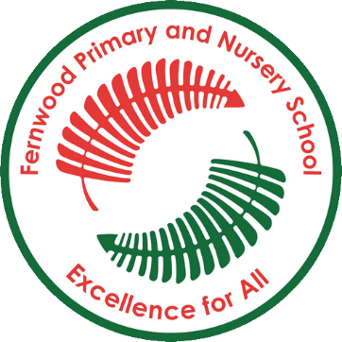

Fernwood Primary and Nursery School

English Intent & Implementation Overview

Our Reading Intent
Intent
At Fernwood Primary and Nursery School, we foster a love of language and reading; we attach great importance to enabling our children to become fluent readers. All staff at Fernwood Primary and Nursery school have a desire for children to be able to read fluently, confidently and with expression to achieve age-related expectation. We aspire to enthuse all children to read for pleasure – read to gain information, read to test out ideas, read to entertain, read to perform poetry, read to seek out new language and to have a love of books. Each year group has a carefully selected reading spine. This is the children’s entitlement for reading throughout the year and the texts are covered as part of shared reading, story time and English lessons.
Implementation
Phonics
Children are taught phonics from Nursery to Year 1 using the ‘Little Wandle Letters and Sounds revised' systematic synthetic programme. All children receive daily phonics lessons. Those children who require keep-up support are identified early and receive either small group or 1:1 interventions. At the beginning of Year 2, we review and consolidate, moving on to teaching the rules of spelling using phonetic knowledge. Children in Year 2 and KS2 who do not pass the phonics screener check remain on small group or 1:1 interventions, assessing their progress regularly.
Group Reading Sessions
Children in F2 and Year 1 receive two reading practice sessions per week, linked to the progression of the ‘Little Wandle Letters and Sounds Revised’ SSP. In Year 2, children receive a weekly guided reading session, focussing on fluency, prosody and comprehension. In KS2, children receive a small group (approximately 6 pupils) reading session, led by the teacher. During this time, children continue to build on their fluency and comprehension, discussing their reading choices.
Reading Lesson and Shared Reading
Children receive regular reading lessons based on quality fiction, non-fiction or poetry texts. These lessons focus on the teaching of the skills of reading including prediction, summarising, inference and vocabulary acquisition. In KS2, these lessons are weekly; a progression document for teaching the reading skills at KS2 can be found in Appendix 1 (KS2 Reading Lesson Progression). As part of reading lessons, shared reading takes place. This is when the teacher is reading the children a quality text to the whole class. During shared reading, discussions about genre, author’s approach and characterisation may take place.
Story Time
Story time takes place at the end of the day in all year groups; a teacher reads an age appropriate, high quality book or poem to the class. In KS1, story time takes place with the teacher reading a book to the children. In KS2, children and teachers share reading whole class reading of the same text. Each child has a copy of the text, led by the teacher. This models reading for pleasure and encourages children to engage with a wider range of books.

Reading for pleasure
We have many opportunities for reading for pleasure across the school. At the end of the school day, story time promotes reading for pleasure. Alongside this, a love of reading is fostered through World Book Day, reading/poetry competitions and reading sheds. To create a reciprocal reading community, children see school staff as readers with e.g. ‘Mrs Dorrington is reading…’ displayed outside all classrooms. Book talk between teachers and children enables discussions about book recommendations and behaviours. Many assemblies celebrate reading and poetry throughout the year. Annually, a group of Year 6 children are trained as Reading Buddies to listen to Year 3 and 4 children in KS2.
Reading books
In Nursery, children have a phonics reading book and choose a borrowed book to take home from the class library. In F2 and Year 1, children have a phonics reading book. Year 2 and 3 children have a banded book matched to their ability; some children will require a phonics reading book, if part of catch-up interventions. Children also choose a book from their class library to encourage reading for pleasure. Children in Year 4, 5 and 6 take home a borrowed book, monitored by their class teacher. Children in the lowest 20% are part of the Accelerated Reading Programme.
Reading Displays and Reading Areas
Reading displays in corridors celebrate the books on the reading spine of different year groups as well as work completed based on these books. Displays in the main entrance of both buildings celebrate the reading culture of Fernwood Primary and Nursery school and show the priority we give to reading. Welcoming reading areas in all classrooms reflect the children’s reading preferences and promote reading and its importance.
Our Writing Intent
The Writing Process
Children at Fernwood Primary and Nursery School develop their writing composition using following the writing process.
Hook
Engage and excite!

Read as a reader
Publishing
Children present their work for the target audience for another person to read or to be read aloud by themselves.
Editing & Improving
Children make changes to their writing, through self-evaluation and feedback given to ensure accurate spelling and grammar.
Drafting & Writing
Children follow their planning structure to write for their specific purpose and audience for writing.
Developing writing craft
Children learn the craft of writing for that purpose/audience.
Planning
Children identify audience and purpose of writing. Children use model texts to developing tool kits, generate ideas for writing and read as a writer.

Hook
Children are immersed into a writing unit using a hook (e.g. a crime scene, a letter from a character or an author visit). Children read as a reader to enjoy and familiarise themselves with the text. Story mapping is used as a tool to rehearse and embed the structure of a text and internalise vocabulary.
Planning
The use of a book-based writing curriculum allows children to engage with similar texts, look at and learn from their structures, presentation and vocabulary to help them gather ideas for their own writing. In KS1, children plan writing, focussing on sharing ideas orally and rehearsing sentences before writing using ‘think it, say it, write it, read it and check it’. In KS2, children plan their writing by discussing writing similar to which they are planning to learn from its structure and noting ideas for their writing. In Year 5 & 6, children draw on reading and research to help with the planning process. When planning writing, children write for four different purposes: writing to entertain (KS1 & KS2), writing to build a picture in the reader’s mind (KS1 & KS2), writing to inform (KS1 & KS2), writing to persuade (KS2) and writing to discuss (upper KS2). At the start of the planning process, collaboratively, a class will generate a writer’s tool kit using an expanded box plan.
Developing writing craft
Children are taught grammatical structures and writing crafts (e.g. show not tell character description) specific to the audience and purpose.
Drafting and Writing
When drafting and writing, children will compose and rehearse sentences, specific to the year group, described in the overview in this document.
Revising and Editing
In KS1, children begin to proof-read and check their writing with support from adults and peers. In Years 3 and 4, children edit and improve their writing, first by proof-reading for errors then developing the ability to assess the effectiveness of their own and others’ writing and suggesting improvements. In Year 5 and 6, children then develop the ability to ensure the consistent use of tenses throughout a piece of writing and propose changes to their writing that enhance effects and clarify meaning linked to the editing focus grid.
Publishing
Children perform their own compositions and read aloud their own writing as well as presenting writing to be read by others. In KS1, children begin by reading their writing aloud and develop the use of intonation to make the meaning of their writing clear. In Years 3 and 4, children also learn to control their tone and volume developing into using movement in Years 5 and 6. Children also present their work in written form, thinking specifically how to engage the audience that they are writing for.
Spelling
Children at KS1 follow the ‘Little Wandle Letters and Sounds Revised’ programme. Following from phonics, children at Fernwood Primary and Nursery School learn the spelling rules from the National Curriculum. See individual year group progression for the rules taught.
Handwriting
Children start their handwriting journey by practice pre-writing skills focusing on fine and gross motor in both the nursery and in reception. Once the children have developed their pincer grip and correct sitting posture they begin the letter joins handwriting scheme.
This is how handwriting is taught progressively from reception up to year 6 -
Reception
Year 1
Year 2
Year 3
Year 4
Year 5
Year 6

The Importance of Oracy
Oracy is the ability to articulate ideas, develop understanding and engage with others through spoken language. In school, oracy is a vital tool for learning; by teaching students to become more effective speakers and listeners we empower them to better understand themselves, each other and the world around them. At Fernwood Primary and Nursery School, we believe that it is important for children to learn to communicate effectively and creatively through spoken language to equip them with the skills to be lifelong learners. Purposeful talk is modelled and practised in the classroom to support and enhance learning to enable all learners to develop the skills needed to talk effectively and with confidence. We make use of sentence stems displayed in each classroom to support classroom discussion and promote a talk-rich environment.
Spoken Language
From Years 1 to 6, children are taught to:
- listen and respond appropriately to adults and their peers
- ask relevant questions to extend their understanding and knowledge
- use relevant strategies to build their vocabulary
- articulate and justify answers, arguments and opinions
- maintain attention and participate actively in collaborative conversations, staying on topic and initiating and responding to comments
- use spoken language to develop understanding through speculating, hypothesising, imagining and exploring ideas
- speak audibly and fluently with an increasing command of Standard English
- participate in discussions, presentations, performances, role play/improvisations and debates
- gain, maintain and monitor the interest of the listener(s)
- consider and evaluate different viewpoints, attending to and building on the contributions of others

Nursery
Autumn 1
Week 1 | Week 2 | Week 3 | Week 4 | Week 5 | Week 6 | Week 7
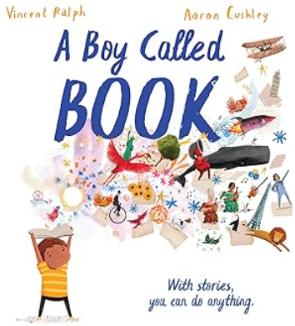  A boy called book  (Supported by Non-Fiction Books) | 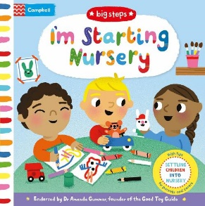  I’m Starting Nursery (Campbell: 2018) | 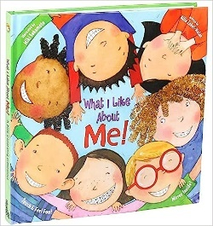What I Like About Me (Allia Zobel-Nola: 2005) | 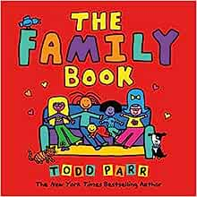  The Family Book (Todd Parr: 2003) (Supported by Non-Fiction Books) | 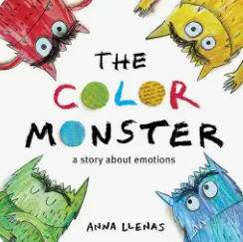The Colour Monster  (Supported by Non-Fiction Books) | 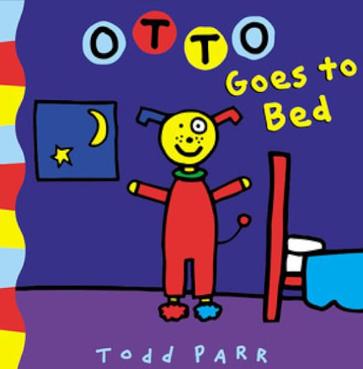  Otto goes to bed  (Supported by Non-Fiction Books) |   The best Diwali ever  (Supported by Non-Fiction Books)
Objectives taught each week | - To listen to and enjoy the story  - To understand key words from the story  - To say what happened in the text by looking at the pictures  - To contribute to a share sentence based on the text  - To talk about their favourite part of the story

Phonics progression
Week 1  Sounds in the environment | Week 2  Sounds in the environment | Week 3  Sounds in the environment | Week 4  Rhyme time – 1,2,3,4,5 once I caught a fish alive | Week 5  Rhyme time – A sailor went to sea sea sea | Week 6  Rhyme time – Baa baa black sheep | Week 7  Rhyme time – Down at the station

Autumn 2
Week 1 | Week 2 | Week 3 | Week 4 | Week 5 | Week 6 | Week 7
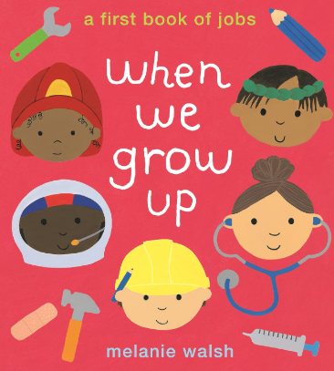When we grow up  (Melanie Walsh 2020) (Supported by Non-Fiction Books) | 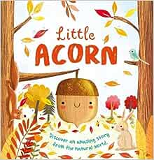  Little Acorn (Nature Stories: 2020) (Supported by Non-Fiction Books) | 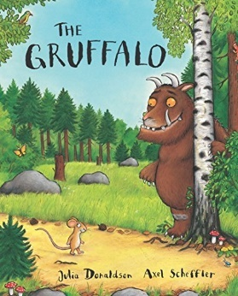  The Gruffalo (Julia Donaldson: 1999) (Supported by Non-Fiction Books) | 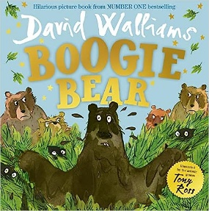  Boogie Bear by David Walliams | 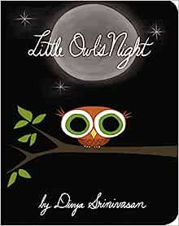  Little Owls Night (Divya Srinivasan: 2011) (Supported by Non-Fiction Books) | 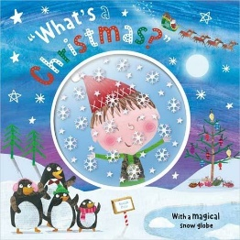  What’s A Christmas (Hayley Down: 2015) (Supported by Non-Fiction Books) | 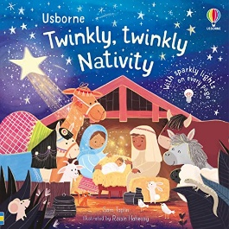  Twinkly, Twinkly Nativity (Sam Taplin: 2021) (Supported by Non-Fiction Books)
Objectives taught each week | - To listen to and enjoy the story  - To understand key words from the story  - To say what happened in the text by looking at the pictures  - To contribute to a share sentence based on the text  - To talk about their favourite part of the story

Phonics progression
Week 1  Sound – s  Rhyme time – Hey diddle diddle | Week 2  Sound – a  Rhyme time – Hickory dickory dock | Week 3  Sound – t  Rhyme time – Humpty dumpty | Week 4  Sound – p  Rhyme time – Incy Wincy spider | Week 5  Sound – i  Rhyme time – Jack and Jill | Week 6  Sound – n  Rhyme time – Mary mary quite contrary | Week 7  Sound – m  Rhyme time – Miss Molly had a dolly

Spring 1
Week 1 |  | Week 2 | Week 3 | Week 4 | Week 5 | Week 6
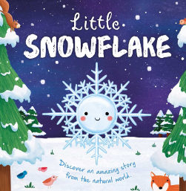  Little Snowflake (Nature Stories: 2020) (Supported by Non-Fiction Books) |  | 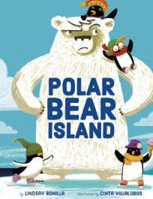  Polar Bear Island (Lindsay Bonilla: 2018) (Supported by Non-Fiction Books) | 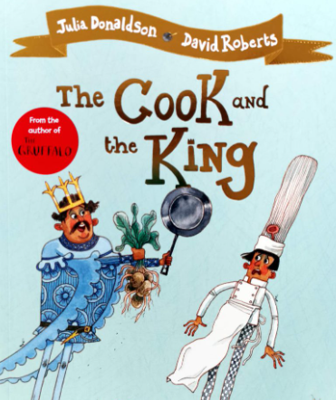  Little Chefs  The cook and the king | 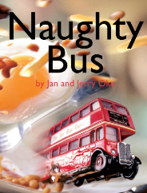  The Naughty Bus (Jan Oke: 2004)  (Supported by Non-Fiction Books) | 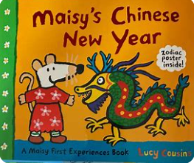Maisy’s Chinese new year  (Supported by Non-Fiction Books) | 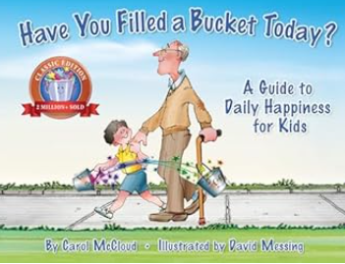  Have you filled a bucket today? (Carol McCloud) (Supported by Non-Fiction Books)
Objectives taught each week | - To listen to and enjoy the story  - To understand key words from the story  - To say what happened in the text by looking at the pictures  - To contribute to a share sentence based on the text  - To talk about their favourite part of the story

Phonics progression
Week 1  Sound – d  Rhyme time – 1, 2 buckle my shoe | Week 2  Sound – g  Rhyme time – Pat-a-cake | Week 3  Sound – o  Rhyme time – ring a ring of roses | Week 4  Sound – c  Rhyme time – Round and round the garden | Week 5  Sound – k  Rhyme time – Row row row your boat | Week 6  Sound – e  Rhyme time – The grand old duke of York

Spring 2
Week 1 | Week 2 | Week 3 | Week 4 | Week 5
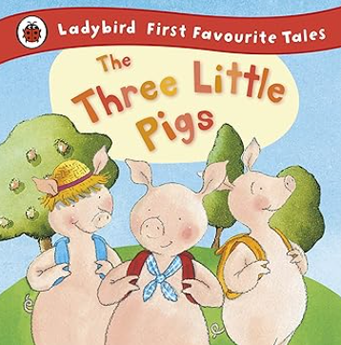  The three little pigs | 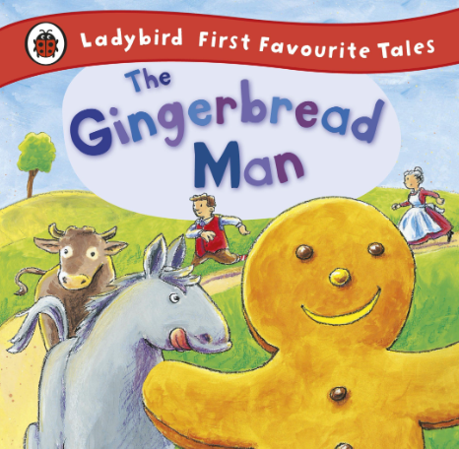  The Gingerbread Man | 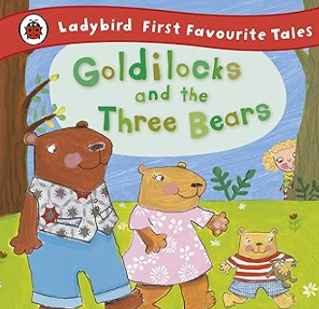 Goldilocks and the three bears | World Book Day – interactive stories | 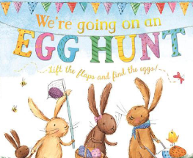  We’re Going On An Egg Hunt (Laura Hughes: 2016)  (Supported by Non-Fiction Books)
Objectives taught each week | - To listen to and enjoy the story  - To understand key words from the story  - To say what happened in the text by looking at the pictures  - To contribute to a share sentence based on the text  - To talk about their favourite part of the story

Phonics progression
Week 1  Sound – u  Rhyme time – Wheels on the bus | Week 2  Sound – r  Rhyme time – Twinkle Twinkle | Week 3  Sound – h  Rhyme time – Wind the Bobbin | Week 4  Sound – b  Rhyme time – 1,2,3,4,5 once I caught a fish alive | Week 5  Sound – f  Rhyme time – A sailor went to sea sea sea

Summer 1
Week 1 |  | Week 2 | Week 3 | Week 4 | Week 5 | Week 6
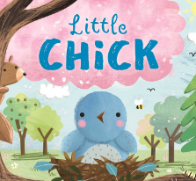  Little Chick (Nature Stories: 2020) |  | 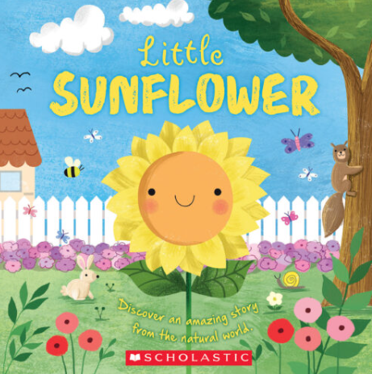  Little Sunflower (Nature stories: 2020) | 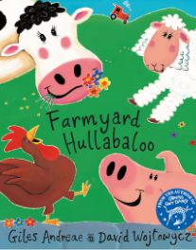  Farmyard Hullabaloo (Giles Andreae: 1999) | 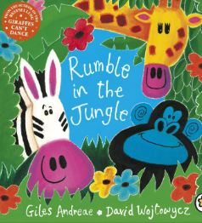  Rumble in the Jungle (Giles Andreae: 1996) | 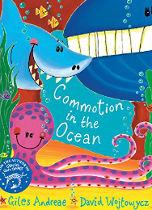  Commotion in the Ocean (Giles Andreae: 1996) | 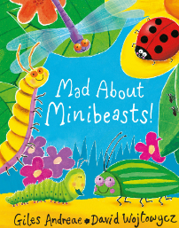  Mad About Mini-Beasts (Giles Andreae: 2011) (Supported by Non-Fiction Books)
Objectives taught each week | - To listen to and enjoy the story  - To understand key words from the story  - To say what happened in the text by looking at the pictures  - To contribute to a share sentence based on the text  - To talk about their favourite part of the story

Phonics progression
Week 1  Sound – l  Rhyme time – Baa baa black sheep | Week 2  Sound – j  Rhyme time – Down at the station | Week 3  Sound – v  Rhyme time – Hey diddle diddle | Week 4  Sound – w  Rhyme time – Hickory dickory dock | Week 5  Sound – y  Rhyme time – Humpty dumpty | Week 6  Sound – z  Rhyme time – Incy wincy spider

Summer 2
Week 1 | Week 2 |  | Week 3 | Week 4 | Week 5 | Week 6 | Week 7 | Week 8
Summer | 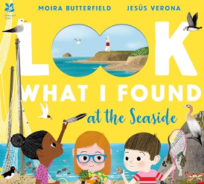  Look What I Found (Moira Butterfield: 2021) |  | 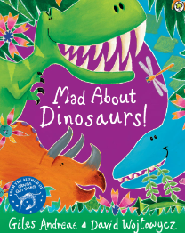  Mad About Dinosaurs  (Giles Andreae: 2014) | 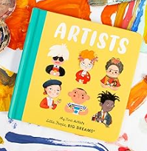  My First Artists (Sanchez Vagara: 2021) | 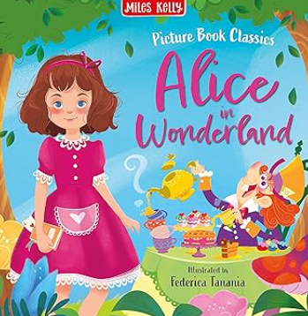Alice in Wonderland (Big arts) | 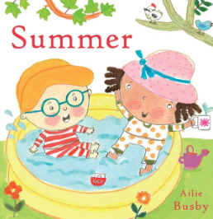  Summer (Ailie Busby: 2015) | 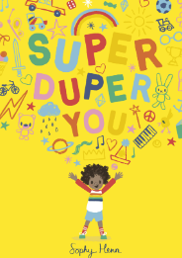  Super Duper You (Sophy Henn: 2019) | 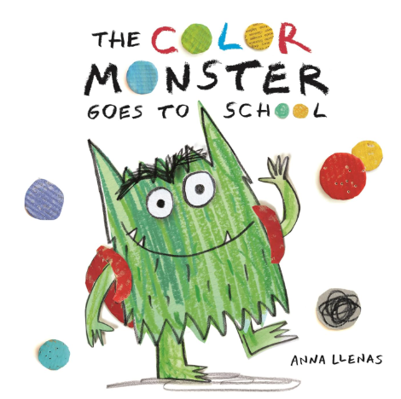  The colour monster goes to school
Objectives taught each week |  | To listen to and enjoy the story  To understand key words from the story  To say what happened in the text by looking at the pictures  To contribute to a share sentence based on the text  To talk about their favourite part of the story

Phonics progression
Week 1  Sound – qu  Rhyme time – Jack and Jill | Week 2  Sound – ch  Rhyme time – The wheels on the bus | Week 3  Sound – ck  Rhyme time – Mary mary quite contrary | Week 4  Sound – x  Rhyme time – Miss Molly had a dolly | Week 5  Sound – sh  Rhyme time – 1,2 buckle my shoe | Week 6  Sound – th  Rhyme time – Pat-a-cake | Week 7  Sound – ng  Rhyme time – Ring a ring of roses | Week 8  Sound – nk  Rhyme time – Round and round the garden

Reception
Additional English objectives are developed within different workshop areas.
 | Autumn 1 – Drawing club
 |  | Week 1 |  | Week 2 |  |  | Week 3 | Week 4 |  | Week 5 | Week 6 |  | Week 7
Stimulus for Writing |  | 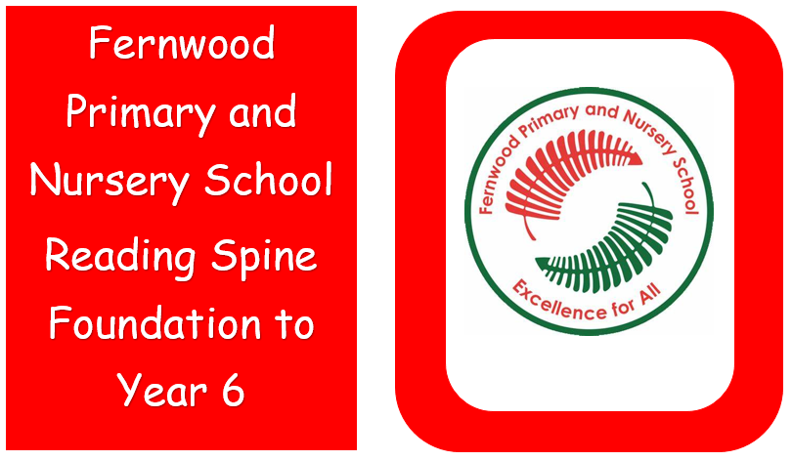Reading spine books |  |  | Reading spine books |  | 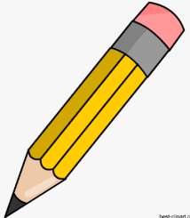Name writing | 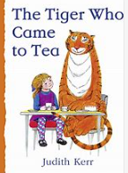  The Tiger who came  to tea |  | 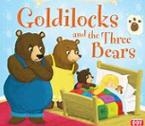Goldilocks | 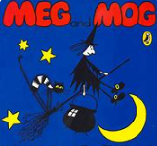  Meg and Mog |  | 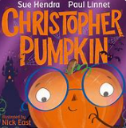Christopher pumpkin
Writing purpose and genre |  | Writing to entertain  - Fiction |  |  |  |  | Writing to inform  -Non-fiction | Writing to entertain  - Fiction |  | Writing to entertain  - Traditional tale | Writing to entertain  - Fiction |  | Writing to entertain  - Fiction
Reading and comprehension  Objectives |  | To listen to and enjoy the story  -To be able to talk about a favourite part of the story  -To recognise words with the same initial sounds | -To listen to and reflect on the story  - To begin to hear the initial sounds of words  -To begin to say a simple sentence orally  -To say which part of the story is their favourite |  |  |  | -To listen to and enjoy a story  -To make links to their own lives  -To say what letters are in their name  -To say their name in a sentence | -To listen to a story and name the main character  -To retell a story through play  -To use newly learnt vocabulary  -To begin to ask questions about the story |  | -To begin to recognise words with the same initial sounds  -To match taught phonemes and graphemes  -To begin to blend cvc words using taught letter sounds  To wonder about and share ideas about the story. | - To listen to and enjoy the story  -To be able to talk about the key events in the story  -To say a sentence orally  -To verbally join simple phrases using ‘and’ |  | -To repeat and use new vocabulary  To identify the characters in the story  -To recognise words with the same initial/middle/end sounds  -To begin to blend sounds into words made up of known letter-sound correspondence
Writing objective |  | -To make marks and share their meaning | -To make marks and give meaning to them |  |  |  | -To begin to write their own name | - To begin to write the initial sounds of words |  | -To begin to write some lower case letters correctly | -To write initial sounds for identified words |  | -To write some lowercase letters correctly
Phonics |  | Week 1  s a t p | Week 2  I n m d |  |  |  |  | Week 3  g o c k |  | Week 4  ck e u r | Week 5  h b f l |  | Week 6 – consolidation
Handwriting |  |  |  |  |  | Fine and gross motor activities to develop skills for writing |  |  | Fine and gross motor activities to develop skills for writing |  |  | Fine and gross motor activities to develop skills for writing
Autumn 2
 | Week 1 | Week 2 | Week 3 | Week 4 | Week 5 | Week 6 | Week 7
Stimulus for Writing | 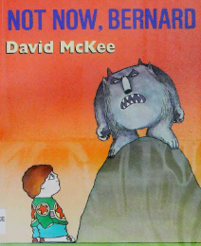Not now Bernard | 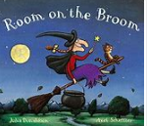Room on the Broom | 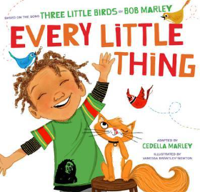Every little thing by Cedella Marley | Roadrunner | 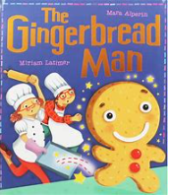  Gingerbread Man | 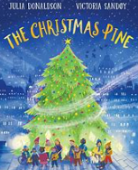  The Christmas Pine | Consolidation of all drawing club skills
Writing purpose and genre | Writing to entertain  -Fiction | Writing to entertain  -Fiction | Writing to entertain  -Animation | Writing to entertain  - Animation | Writing to entertain  -Traditional tale | Writing to entertain  - Fiction | Writing to entertain  -Narrative
Reading and comprehension  objectives | To recognise words with the same initial sounds  To wonder about the characters in the story  To begin to say a simple sentence orally and count the words  To begin to verbally join sentences using ‘and’ | -To listen to and enjoy the story  -To match an action to newly learnt vocabulary  -To wonder what might happen in the story  -To be able to talk about the key events in the story | -To use newly learnt vocabulary when talking about the story  -To say a sentence using and  -To talk about the characters and setting of the clip  -To spell words by identifying the sounds | -To be able to hear the initial sound of a word  -To say what will happen next in the story  -To begin to read some tricky words  - To repeat and use newly learnt vocabulary in the story | -To say a simple sentence orally and then count the words  -To match taught graphemes and phonemes  -To repeat new vocabulary in the context of a story  -To predict what might happen in the story | -To talk about the main events in the story  -To recognise words with the same initial sounds  -To verbally join two simple sentences using ‘and’  -To say what will happen next in the story | - To write about a character  -To describe a setting  -To write what will happen next  -To write a sentence using ‘and’
Writing objectives | -To hear and write the initial sound of a word | -To draw and write about their favourite part of the story | -To begin to spell words by identifying the sounds and graphemes | -To be able to write their own name | -To write some lowercase letters correctly | -To begin to blend and write some sounds into words using known letter-sounds correspondence | To use new vocabulary in a sentence
Phonics | Week 1 - ff ll ss j | Week 2 - v w x y | Week 3 - z zz qu s added to words, ch | Week 4 - sh th ng nk | Week 5 - words with s added and words ending with s/z | Week 6 and 7 – consolidation and assessment
Handwriting | Lesson  1 – 3 – i, l | 4, 5 and 6  u, w, t and e | 7, 8, 9  u w t and e | 10, 11, 12  C and o | 13, 14, 15  C and o | 16, 17, 18  A and d

Spring 1
 | Week 1 | Week 2 | Week 3 | Week 4 | Week 5 | Week 6
Stimulus for Writing | 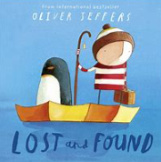  Lost and Found | 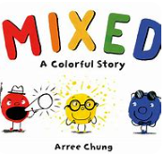 Mixed | 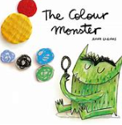 The Colour Monster | 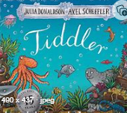  Tiddler | 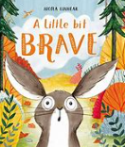  A little bit brave | 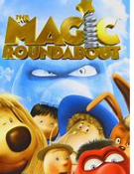  The magic roundabout
Writing purpose and genre | Writing to entertain  - Fiction | Writing to entertain  - Fiction | Writing to entertain  - Fiction | Writing to entertain  - Journey story | Writing to entertain  - Fiction | Writing to entertain  - Fiction
Reading and comprehension objectives | -To identify the characters in the story  -To wonder what will happen next  -To blend sounds into words  -To explain their understanding using ‘because’ | -To listen to and enjoy the story  --To read simple sentences containing known letter sounds  -To predict what will happen  -To make marks and give meaning to those marks | -To read and reflect on the story  -To read sentences back to check  -To say and write words with the same initial sound for phase 2 phonemes  -To ask questions about the story | -To read and spell some high frequency tricky words  -To share read sentences  -To name and talk about the setting of the story  -To wonder about their ideas | -To begin to use sound buttons to identify how many sounds are in a word  -To talk about the story in correct order  -To talk about the characters in the story  -To blend sounds into words | -To use newly learnt vocabulary in context  -To read short sentences using known letter sounds  -To read sentences back to check  -To begin to predict what will happen next
Writing objective | -To write shared sentences about the story | -To write cvc words and labels using previously taught sounds | -To write cvc words | -To begin to use capital letters, finger spaces and full stops | -To write simple sentences including tricky words | -To form lower-case letters correctly
Phonics | Week 1 – ai, ee, igh, oa | Week 2 – oo, oo, ar, or | Week 3 – ur, ow, oi, ear | Week 4 – air, er, double letters dd mm tt bb rr gg ff | Week 5 – longer words | Week 6 – consolidate and assessment
Handwriting | Recap  Lessons 19 and 20 – Loopies and waves | Lessons 21-23 – i, l, t | Lessons 24 and 25 – i, l, t  Lesson 26 – u,w,e | Lessons 27-29 – u,w,e | Lessons 30 – u,w,e  Lesson 31 and 32 – c and o | Lessons 33-35 – c and o
Spring 2
 | Week 1 | Week 2 | Week 3 | Week 4 | Week 5
Stimulus for Writing | 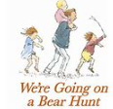  We’re going on a bear hunt | 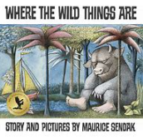  Where the wild things are | 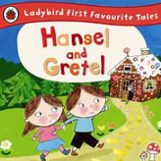  Hansel and Gretel | 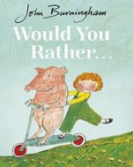 Would you rather? | 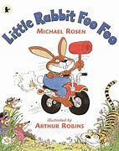  Little Rabbit Foo Foo
Writing purpose and genre | Writing to entertain  -Traditional tale | Writing to entertain  -Fiction | Writing to entertain  -Traditional tale | Writing to entertain  -Narrative | Writing to entertain  -Narrative
Reading and Comprehension Objectives | -To use sounds buttons to identify how many sounds in a word  - To blend sounds into short words  -To answer questions about the characters  -To retell the story using repeated phrases | -To read words back to check  -To use talk in play to practice new vocabulary  -To blend sounds into words  -To imagine what would happen next | -To supply words with the same initial sounds for phase 2 phonemes  -To listen to and talk about a story  - To blend sounds into longer words  -To share read code from the story | -To predict what might happen next in a story  - To read simple sentences about the story containing known letter sounds  -To match actions to correct vocabulary  -To answer questions about the story | -To say a simple sentence about the story  -To ask and questions about the character  -To talk about the setting of the story  -To use newly learnt vocabulary in context
Writing Objectives | -To write shared sentences about the story | -To spell some high frequency tricky words | -To write short sentences using capital letters, spaces and full stops | -To write cvc words and spell some high frequency tricky words | -To write some uppercase letters correctly
Phonics | Week 1 - review phase 3 ai ee igh oa oo ar or ur oo ow oi ear | Week 2 - review phase 3 er air, words with double letters, longer words | Week 3 - words with two or more digraphs | Week 4 - longer words, words ending in -ing, compound words | Week 5 - longer words, words with s in the middle, words ending with s, words with es at the end
Handwriting | Lessons 36-38 – a and d | Lessons 39 and 40 – a d  Lessons 41 – n,m,h | Lessons 42-44 – n, m, h | Lesson 45 – n, m, h  Lesson 46 and 47 – j and y | Lessons 48-50 – j and y

Summer 1
 | Week 1 | Week 2 |  | Week 3 | Week 4 | Week 5 | Week 6
Stimulus for Writing | 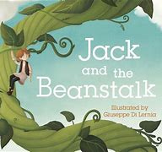  Jack and the beanstalk | 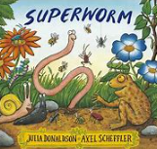 Superworm |  | 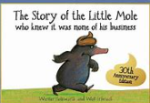 The story of the little mole | 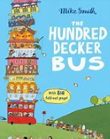  The hundred decker bus | 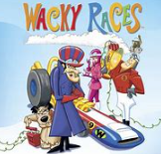 Wacky Races | 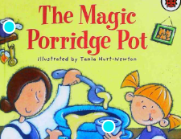  The Magic Porridge Pot
Writing purpose and genre | Writing to entertain  -Traditional tale |  | Writing to entertain  -Fantasy | Writing to entertain  -journey story | Writing to entertain  -Fiction | Writing to entertain  -Animation | Writing to entertain  -Traditional tale
Reading and Comprehension  Objectives | -To share a favourite book with a peer  -To read and reflect on the story  -To wonder what will happen next in the story  -To identify words containing the same graphemes | -To listen to and enjoy a story  -To name the characters in the story  -To name and talk about the setting  -To retell a story in their own way repeating known phrases from the text |  | -To listen to and talk about the story  -To say their own sentences about the story  - Use sound buttons to segment and read words  -To use newly learnt vocabulary in the correct context | -To talk about the settings in the story using learnt vocabulary  - To re-tell the story to show understanding  -To answer questions about the characters  -To read their sentence to check it makes sense | -To join phrases with ‘and’ or ‘but’  -To ask questions.  -To wonder about ideas.  -To use ‘because’ to develop their ideas. | - To listen to and talk about the story  -To talk about the characters in the story  -To share their opinion of the story using because  -To use newly learnt vocabulary in the correct context
Writing objective | - To write shared extended sentences about the story | -To write recognisable letters, most of which are correctly formed |  | -To form letters correctly following handwriting scheme | -To write sentences using capital letters and full stops | -To write a repetitive phrase | -To write a sentence about the beginning, middle and end
Phonics | Week 1 – short vowel cvcc | Week 2 – short vowels cvc ccvc |  | Week 3 – short vowels ccvcc, cccvc, cccvcc, longer words | Week 4 – longer words, compound words | Week 5 – root words ending in ing, ed/t, ed/id, ed, est | Week 6 – consolidation and assessment
Handwriting | Lessons 51-53 – g and q Recap, Lessons 54 and 55 – g and q | Lessons 56-58 – b, p, k |  | Lessons 59 and 60 – b, p, k  Lessons 61 – v, s, r | Lessons 62-64 – v, s, r | Lessons 65 – v, s, r  Lesson 66 and 67 – f, x, z | Lessons 68 - 70 – f, x, z
Summer 2
 | Week 1 | Week 2 | Week 3 | Week 4 | Week 5 | Week 6 | Week 7 | Week 8
Stimulus for Writing | 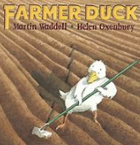 Farmer Duck | 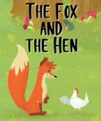 Hen and the fox | Big Arts Week | 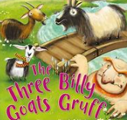 Three Billy Goats gruff | 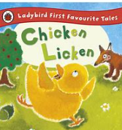 Chicken Licken | 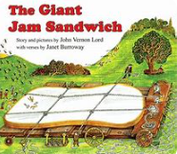  The Giant Jam sandwich | 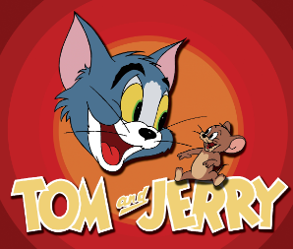  Tom and Jerry | 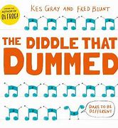The diddle that dummed
Writing purpose and genre | Writing to entertain  -Narrative | Writing to entertain  -Traditional tale | No English lessons this week | Writing to entertain  -Traditional tale | Writing to entertain  -Traditional tale | Writing to entertain  -Journey story | Writing to  -Animation | Writing to  -Narrative
Reading and Comprehension  Objectives | -To listen to and talk about the story  -To read newly learnt vocabulary  -To read words consistent with their phonic knowledge by sound blending,  -To use because to develop their ideas | -To verbally join two sentences using ‘and’  -To read some common exception words  - To verbally sequence the beginning, middle and ending of the story  -To say a sound for each letter in the alphabet and at least 10 digraphs |  | -To identify the main characters  -To re-read a sentence to check  -To spell words by identify sounds in them and representing the sounds with a letter/s,  -To name the main events of the story | - To read the names of the characters  - To read and blend newly learnt graphemes  -To anticipate the key events in the story  -To read aloud simple sentences that are consistent with their phonic knowledge | -To listen to and talk about the story  -To read some common exception words in a sentence  -To use and understand newly learnt vocabulary  - To read and blend newly learnt graphemes | -To say a sentence orally for writing and count the words  - To repeat new vocabulary in the context of a story  -To read and reflect on the story  -To answers questions about the story | -To say what they think might happen next in the story  -To ask questions about the story  -To answer questions about the story  -To read aloud simple sentences linked to the story
Writing objective | -To write a sentence including key vocabulary | -To write sentences including capital letters and full stops | -To write a sentence for the beginning, middle and end | -To write phrases by identify sounds within | -To write newly learnt vocabulary within a sentence | -To write sentences using capital letters and full stops | -To write phonetically plausible sentences | -To write a sentence to match an image
Phonics | Week 1 – long vowel sounds cvcc ccvc | Week 2 – long vowel sounds ccvc, cccvc, ccv, ccvcc | Week 3 – phase 4 words ending –s/s, -s/z, -es, longer words | Week 4 – root words ending in ing, ed/t, ed/id, ed/d, ed | Week 5 – Phase 4 words ending in s/s, s/z, es and longer words | Week 6 – assessment | Week 7 – assessment/consolidation for year 1 | Week 8 – consolidation for year 1
Handwriting | Consolidation of | previously learnt | letters across | the | half term | -------------------- | ----------------------------------- | ------------------

Early learning goals
Writing – Write recognisable letters, most of which are correctly formed, spell words by identify sounds in them and representing the sounds with a letter/s, write simple phrases and sentences that can be read by others, to hold a pencil effectively in preparation for fluent writing using the tripod grip in almost all cases (fine motor).
Reading – To say a sound for each letter in the alphabet and at least 10 digraphs, read words consistent with their phonic knowledge by sound blending, read aloud simple sentences and books that are consistent with their phonic knowledge, including some common exception words.
Comprehension – Demonstrate an understanding of what has been read to them by retelling stories and narratives using their own words and recently introduced vocabulary, to anticipate, where appropriate, key events in the story, to use and understand recently introduced vocabulary during discussions about stories, non-fiction, rhymes and poems during role-play.

Implementation Overviews Years 1 - 6
Year 1 National Curriculum Objectives
Reading
National Curriculum – Word reading | Pupils are taught to:  - apply phonic knowledge and skills as the route to decode words  - ▪ respond speedily with the correct sound to graphemes (letters or groups of letters)  - for all 40+ phonemes, including, where applicable, alternative sounds for graphemes  - ▪ read accurately by blending sounds in unfamiliar words containing GPCs that have  - been taught  - ▪ read common exception words, noting unusual correspondences between spelling  - and sound and where these occur in the word  - ▪ read words containing taught GPCs and –s, –es, –ing, –ed, –er and –est endings  - ▪ read other words of more than one syllable that contain taught GPCs  - ▪ read words with contractions [for example, I’m, I’ll, we’ll], and understand that the  - apostrophe represents the omitted letter(s)  - ▪ read aloud accurately books that are consistent with their developing phonic  - knowledge and that do not require them to use other strategies to work out words  - ▪ re-read these books to build up their fluency and confidence in word reading.
Year 1 National Curriculum - Reading comprehension | Pupils are taught to:  - develop pleasure in reading, motivation to read, vocabulary and understanding by:  - listening to and discussing a wide range of poems, stories and non-fiction at a level beyond that at which they can read independently  - being encouraged to link what they read or hear read to their own experiences  - becoming very familiar with key stories, fairy stories and traditional tales, retelling them and considering their particular characteristics  - recognising and joining in with predictable phrases  - learning to appreciate rhymes and poems, and to recite some by heart  - discussing word meanings, linking new meanings to those already known  - ▪ understand both the books they can already read accurately and fluently and those they listen to by:  -▪ drawing on what they already know or on background information and vocabulary provided by the teacher  -▪ checking that the text makes sense to them as they read and correcting inaccurate reading  - discussing the significance of the title and events  - making inferences on the basis of what is being said and done  - predicting what might happen on the basis of what has been read so far  - ▪ participate in discussion about what is read to them, taking turns and listening to what others say  - ▪ explain clearly their understanding of what is read to them.

Writing
National Curriculum – Transcription and Handwriting | Pupils are taught to:  - spell:  - words containing each of the 40+ phonemes already taught  - common exception words  - the days of the week  - name the letters of the alphabet:  - naming the letters of the alphabet in order  - using letter names to distinguish between alternative spellings of the same sound  - add prefixes and suffixes:  - using the spelling rule for adding –s or –es as the plural marker for nouns and the third person singular marker for verbs  - using the prefix un–  - using –ing, –ed, –er and –est where no change is needed in the spelling of root words [for example, helping, helped, helper, eating, quicker, quickest]  - write from memory simple sentences dictated by the teacher that include words using the GPCs and common exception words taught so far  Pupils are taught to:  - sit correctly at a table, holding a pencil comfortably and correctly  - begin to form lower-case letters in the correct direction, starting and finishing in the right place  - form capital letters  - understand which letters belong to which handwriting ‘families’ (ie letters that are formed in similar ways) and to practise these
National Curriculum – Composition | Pupils are taught to:  - write sentences by:  - saying out loud what they are going to write about  - composing a sentence orally before writing it  - sequencing sentences to form short narratives  - re-reading what they have written to check that it makes sense  - discuss what they have written with the teacher or other pupils  - read their writing aloud, clearly enough to be heard by their peers and the teacher
National Curriculum – Vocabulary, grammar and punctuation | Pupils are taught to develop their understanding of the concepts set out in English appendix 2 by:  - leaving spaces between words  - joining words and joining clauses using ‘and’  - beginning to punctuate sentences using a capital letter and a full stop, question mark or exclamation mark  - using a capital letter for names of people, places, the days of the week, and the personal pronoun ‘I’  - learning the grammar for year 1 in English appendix 2  - and using the grammatical terminology in English English appendix 2 in discussing their writing
English Appendix 2 | - Use -s or -es for the suffix of plural nouns.  - Add suffixes -ing -ed and -er when no change is needed to the root word  - Use the prefix un- to change the meaning of verbs and adjectives  - Join words and clauses using and  - Sequence sentences to form short narratives  - Separate words with spaces  - Use capital letters, full stops, question marks and exclamation marks to demarcate sentences.  - Use capital letters for names and ‘I’

Autumn 1 – Drawing club
 |  | Week 1 |  | Week 2 |  | Week 3 |  | Week 4 |  | Week 5 | Week 6 and 7
Stimulus for Writing |  | 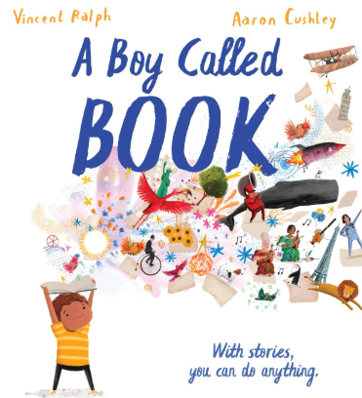  A boy called book  School text |  | 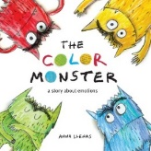  The Colour Monster by Anna Llenas  Drawing club |  | 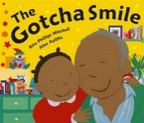  Gotcha Smile by Rita Philips  Drawing club |  | 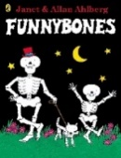  Funny Bones by Janet and Alan Ahlberg  Drawing club |  |  | 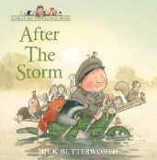  After the storm By Nick Butterworth  Drawing club |  |  | 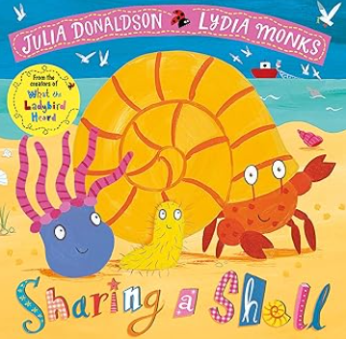 Sharing a shell by Julia Donaldson  Drawing club
Writing purpose.  Genre |  | Writing to entertain  Genre: Fiction - Story |  | Writing to entertain  Genre: Fiction - Story |  | Writing to entertain  Genre: Journey Story |  | Writing to entertain  Genre: Descriptive narrative |  |  | Writing to entertain |  |  | Genre: Descriptive narrative
Writing Objectives |  | - To leave spaces between words.  - To begin to punctuate sentences with a full stop and capital letter.  - To say out loud what they are going to write about. |  | - To leave spaces between words.  - To write sentences by saying out loud what they are going to write about  - To sequence sentences to retell short narratives  - To read and write common exception words in a sentence. |  | - To use drama  - To begin form lower case correctly, starting and finishing in the correct place.  - To sequence sentences to for a short narrative  - To use adjectives to describe |  | - To make a story plan to stimulate writing ideas.  - To say out loud what they are going to write about  - To begin to punctuate sentences with a full stop and capital letter.  - To write sentences by saying out loud what they are going to write about |  | - -To use the suffix -ed for verbs that need to change needed to the root word.  - -To begin to punctuate sentences with a full stop and capital letter.  - -To add suffix –ed and know that it happened in the past  - To use a capital letter correctly | - To use the suffix -ing to verbs that need no change to the root word.  - To begin to punctuate sentences with a question mark.  - To recognise a verb and a suffix  - To write common exception words within a sentence |  | - To identify the main events and characters in a story  - To use drama and drawings as a stimulus for writing  - To use adjectives to describe.  - To join words and clauses using ‘and’
Reading Objectives |  | - To link what they read or hear read to their own experiences. |  | - To discuss word meanings, linking new meanings to those already known |  | - To recognise and join in with predictable phrases. |  | - To discuss the significance of the title and events. |  | - To make inferences on the basis of what is being said and done | - To discuss the significance of the title and events in a book. |  |  | - To orally retell the main events in order
Phonics |  | LW- review Phase 3 GPCs ai ee igh oa oo ar or ur oo ow oi ear |  | LW - air er /z/ s –s –es words with two or more digraphs e.g. queen thicker |  | LW - Phase 4: CVCC CCVC CCVCC CCCVC Phase 4 with long vowels |  | LW - Phase 5 /ai/ ay play /ow/ ou cloud /oi/ oy toy /ee/ ea each |  | LW – To review longer words | Autumn 1 consolidation and assessments
Handwriting |  | Lessons 1 -3 |  | Lessons 4 – 6 |  | Lessons 7 – 9 |  | Lessons 10 – 12 |  | Lessons 13 – 15 | Lessons 16 – 18
Autumn 2 – Drawing club and curious quests
 | Week 1 |  | Week 2 |  | Week 3 |  | Week 4 |  | Week 5 |  | Week 6 | Week 7
Stimulus for Writing | 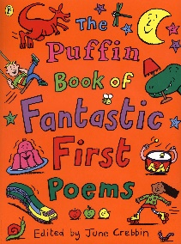  Animal poems  Drawing club |  | 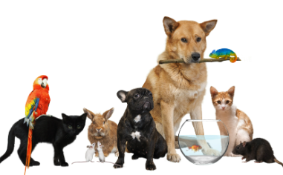  Animal’s  Non fiction writing  Drawing club |  | 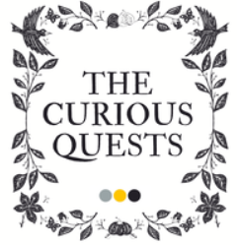  Curious quests context week |  | 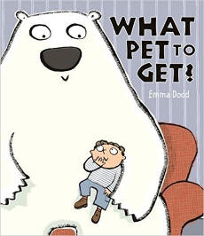  What Pet To Get? by Emma Dodd |  | 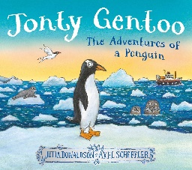  Jonty Gentoo by Julia Donaldson |  | 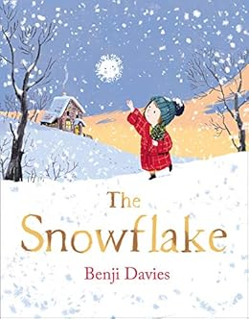The Snowflake by Benji Davies |   Rudolf is missing (Topic too)
Writing purpose and genre | Writing to entertain  - Poetry |  | Writing to inform  - List and labels |  | Writing to inform  - Setting the context for curious quests |  | Writing to entertain  Fiction  Writing to entertain  - Descriptive narrative |  | Writing to entertain  - Descriptive narrative |  | Writing to entertain  - Fiction | Writing to entertain  - Informative poster
Writing Objectives | To write using rhyme in poetry  To find rhyming words  To use verbs to describe  To write a sentence  To write in a poem structure |  | To list different types of animals  To write sentences (about an animal) by saying out loud what they are going to write about  To join words and clauses using ‘and’  To write labels for the pictures  To link that they have read to their own experiences. |  | To introduce the idea of Professor Klunk and give purpose  To introduce Noodle and Titch and add to purpose for writing  To introduce concept of exploring time and link with N, T and PK  To introduce Noodle and Titch’s joy in sentence writing  To introduce how children will use the space and explore |  | Which adjective describes the character?  How do use finger spaces?  To use capital letters  To use full stops  To use the word ‘but’  How can we describe the character? |  | When do we need to use a capital letter?  When do we use a full stop?  How can we describe the setting? (adjectives)  What happened next in the story? |  | Who are the main characters?  Describe how the snowflake moves (verbs)  Adjectives to describe what's happening  How are the characters the same? Different?  How do we write a sentence? | Describe a character using adjectives  Where is the setting?  How to write a sentence  Predict what will happen next  Edit and improve a sentence
Reading Objectives | - To recognise and join in with predictable phrases. |  | - To listen to and discuss a wide range of non-fiction texts |  | - -To appreciate rhymes and poems and recite some from heart. |  | - To retell key stories and explain their characteristics. |  | - To explain clearly an understanding of what has been read to them. |  | - To be encouraged to link what they read or hear read to their own experiences | - To draw on what they already know and vocabulary provided.
Phonics | Phase 5 graphemes - ur/ ir bird /igh/ ie pie /oo/ /yoo/ ue blue rescue /yoo/ u unicorn |  | Phase 5 graphemes - oa/ o go /igh/ i tiger /ai/ a paper /ee/ e he |  | Phase 5 graphemes - ai/ a-e shake /igh/ i-e time /oa/ o-e home /oo/ /yoo/ u-e rude cute |  | Phase 5 graphemes - ee/ e-e these /oo/ /yoo/ ew chew new /ee/ ie shield /or/ aw claw |  | Phase 5 graphemes - oa/ o go /igh/ i tiger /ai/ a paper /ee/ e he |  | Phase 5 grapheme consolidation | Phase 5 graphemes autumn 2 assessment
Handwriting | Lessons 21-23 |  | Lessons 24 – 26 |  | Lessons 27 – 29 |  | Lessons 30 – 32 |  | Lessons 33-35 |  | Lessons 36-38 | Lessons 39 – 40
Spring 1 – Curious Quests
 | Week 1 | Week 2 | Week 3 | Week 4 – Reading checks |  | Week 5 |  | Week 6
Stimulus for Writing | 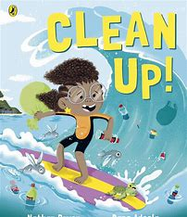  Clean up by Nathan Bryon | 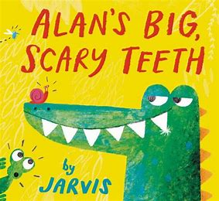  Alan’s big scary teeth by Jarvis | 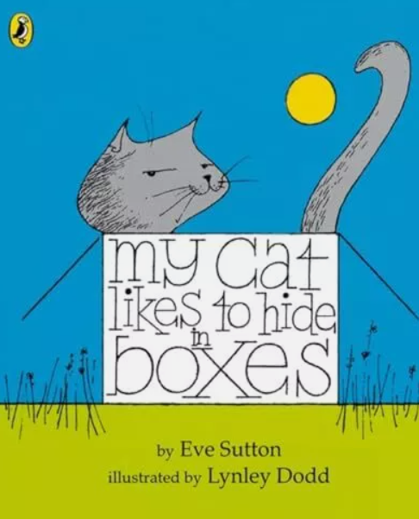  My Cat likes to hide in boxes by Eve Sutton | 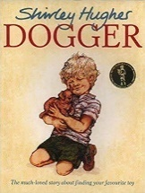  Dogger by Shirley Hughes |  | 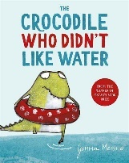  The Crocodile who didn’t like water by Gemma Merino |  | 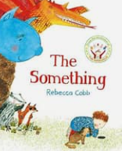  The something Rebecca Cobb
Writing purpose and genre | Writing to: inform | Writing to: entertain | Writing to entertain | Writing to entertain |  | Writing to entertain |  | Writing to entertain
Writing Objectives | Who is the main character?  Where is the setting in the story?  Which adjectives describe your invention?  What will happen next in the story?  How to write a sentence. | Which adjectives describe the character?  What does the setting look like?  To compose a sentence orally before writing.  When do we need finger spaces?  Where should you put capital letters and full stops? | To begin to form lower-case letters  To compose a sentence orally before writing it  To re-read what they have written to check that it makes sense  When do we need to leave a space?  to leave spaces between words  to use and to join words |  | How will you describe Dogger?  Where will the story happen?  How will your invention help?  How does the story end?  NFER |  | To use adjectives to describe the main character  How is the setting different?  To predict what would happen next  How will your invention change the story?  To compare characters |  | Describe how the character feels  Where is the story happening?  Which adjectives describe your new invention?  To spell common exception words correctly  (4 lessons due to Faith and Culture day)
Reading Objectives | - To listen to and enjoy new stories | - To re-read familiar books to build fluency and confidence | -To explain clearly their understanding of what is read to them | -To discuss word meanings and link new meanings. |  | - To make inferences on the basis of what is being said and done. |  | To listen to and discuss a wide range of non-fiction texts
Phonics | ee/ y funny /e/ ea head /w/ wh wheel /oa/ oe ou toe shoulder | /igh/ y fly /oa/ ow snow /j/ g giant /f/ ph phone | /l/ le al apple metal /s/ c ice /v/ ve give | u/ o-e o ou some mother young /z/ se cheese /s/ se ce mouse fence /ee/ ey donkey |  | Grow the code: /oo/ u ew ue u-e ui ou oo fruit soup /ee/ ea e e-e ie ey y ee /s/ c se ce ss /z/ se s zz /oa/ ow oe ou o-e o oa |  | Phase 5 grapheme consolidation and assessment
Handwriting | 41 42 43 a b c d e | 44 45 46 a b c d e | 47 48 49 f g h I j | 50 51 52 k l m n o |  | 53 54 55 k l m n o |  | 56 57 58 p q r s t

Spring 2 – Curious Quests
 | Week 1 | Week 2 | Week 3 |  | Week 4 | Week 5
Stimulus for Writing | 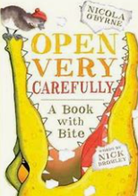  Open very carefully | 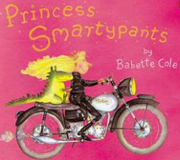Princess Smartypants Babette Cole | 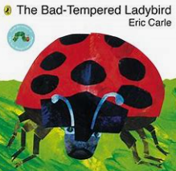  The bad tempered ladybird Eric Carle |  | 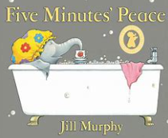  Five minutes peace Jill Murphy | 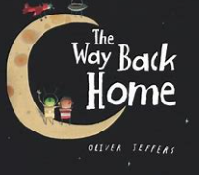  The way back home Oliver Jeffers  PLAY RECOUNT NEXT YEAR
Writing purpose and genre | Writing to entertain – fiction | Writing to entertain – adventure | Writing to entertain - fiction |  | Writing to entertain – ficton | Writing to entertain – action fiction
Writing objectives | What do you think will happen next to the character?  Which word will join your sentences?  To use ‘and’ to join words and phrases  What did you invent this week for Professor Klunk?  To use ‘because’ in the sentence | To chose adjectives to describe the character  Where does the Princess live?  What do we put at the end of a sentence?  How can you use ‘but’ in your sentence?  (4 lessons due to World Book Day) | Who is the main character?  Where is the story happening?  How will you start your sentence? (oral composition)  How do you write capital letters?  How could you improve your writing? (re-read to make sense) |  | To describe the main character using because  To use and to join descriptive phrases  To use newly learnt vocabulary in their writing  To join two phrases using ‘so’  To predict what they think will happen next | To create a word bank to describe the character  To use newly learnt vocabulary in their writing  To plan a new character for the story  To join two sentences using so  To spell common exception words correctly
Reading objectives | -To participate in discussions about what is being read and listening to others. | To link what I have read to my own experiences | -To discuss word meanings. |  | -To learn to appreciate rhymes and poems | -To draw on background knowledge and vocabulary.
Phonics | Week 1 ur/ or word /oo/ u oul awful would /air/ are share /or/ au aur oor al author dinosaur floor walk | Week 2 ch/ tch match /ch/ ture adventure /ar/ al half* /ar/ a father* |  | Week 3 /or/ a water schwa in longer words: different /o/ a want /air/ ear ere bear there | Weel 4 /ur/ ear learn /r/ wr wrist /s/ st sc whistle science schwa at the end of words: actor | Week 5 c/ ch school /sh/ ch chef /z/ ze freeze
Handwriting | 59 60 61 p q r s t | 62 63 64 u v w x y z |  | 65 66 67 numbers 0-9 | 68 69 70 numbers 0-9 | 71 72 73 punctuation and maths symbols 74 75 76
 |  | Summer 1 – Curious Quests
 | Week 1 |  | Week 2 | Week 3 | Week 4 | Week 5 | Week 6
Stimulus for Writing | 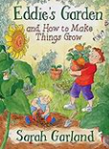  Eddie’s Garden by Sarah Garland |  | 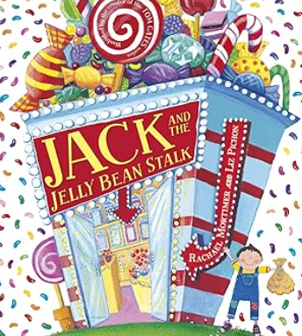  Jack and the jelly beanstalk | 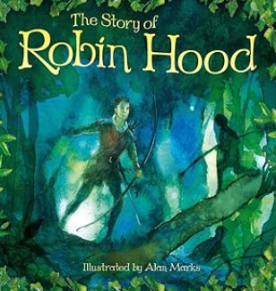  Robin Hood | 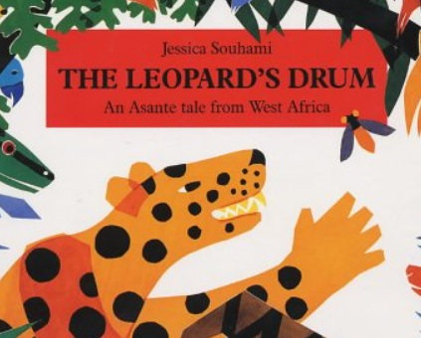Leopard’s drum | 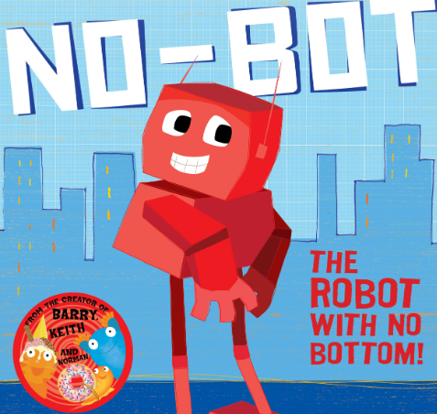  No Bot the Robot | 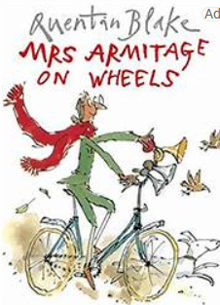  Mrs Armitage on Wheels
Writing purpose and genre | Writing to entertain – fiction |  | Writing to entertain - fiction | Writing to entertain – adventure fiction | Writing to entertain – adventure fiction | Writing to entertain – fictional | Writing to entertain – fiction
Writing objectives | To use because to join clauses - character  To use adjectives to describe a setting  To punctuate sentences using a capital letter and a full stop – adventure 1  To begin to punctuate sentences using question mark/exclamation mark – adventure 2  To write common exception words (dictation) adventure 3 |  | To compose a sentence orally before writing it - Character  To use because to join words and clauses - setting  To plan and write what will happen next in the story – adventure 1  To use ‘so’ to join clauses – adventure 2  (4 days due to bank holiday) | To say what the character will do next – character  To explore the setting and describe different parts – setting  To use because to join events that have happened – adventure 1  To decode vocabulary to write in a sentence – adventure 2  To write common exception words (dictation) adventure 3 | To form capital letters – character  To begin to form lower-case letters – setting  To compose a sentence orally before writing it – adventure 1  To re-read what they have written to check that it makes sense – adventure 2  (4 days due to bank holiday) | To compose a sentence orally before writing it – character  To answer a range of questions about the text including setting  To decode words/sentences using phonetic knowledge  To re-read a sentence to make sure it makes sense | -What happens in the story? To verbally retell a story  -What do you know about the story? To freeze frame to show understanding of a story  -How can you describe the story/character? To create a word bank of descriptive words and phrases  -Who will your character be? To plan and describe a character  To write sentences from dictation
Reading Objectives | To infer what is going to happen next in the story |  | To answer questions about a story | To make inferences on the basis of what is being said and done. | To retell familiar stories. | To predict what might happen next | To link what they have read to their own experiences
Phonics | Week 1 ay play a-e shake ea each e he |  | Week 2 ie pie i-e time o go o-e home | Week 3 ue blue rescue ew chew new u-e rude cute aw claw | Week 4 ea head ir bird ou cloud oy toy | Week 5 i tiger a paper ow snow u unicorn | Consolidation
Handwriting | 74 75 76 other symbols |  | 77 78 79 other symbols | Repeat letter families pre-cursive | Repeat letter families pre-cursive | Repeat letter families pre-cursive | Repeat letter families pre-cursive

Summer 2 – Curious Quests
 | Week 1 | Week 2 | Week 3 | Week 4 | Week 5 |  | Week 6 | Week 7 | Week 8
Stimulus for Writing | 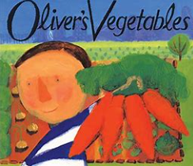Oliver's Vegetables | 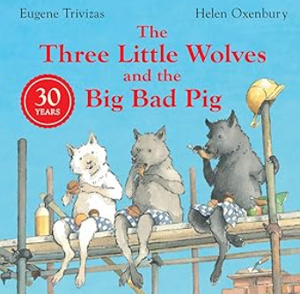Three Little Wolves | Big Arts Week | 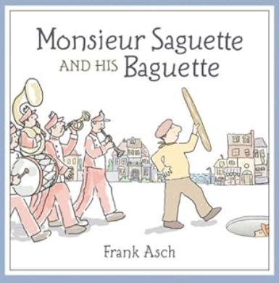  Monsieur Saguette | 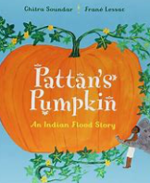  Pattan’s pumpkin by Chitra Soundar |  | 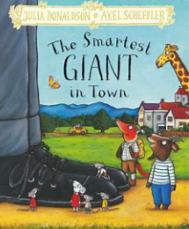  The Smartest Giant in Town | 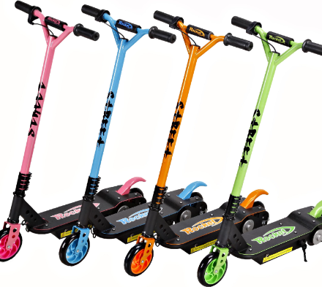Scootering | 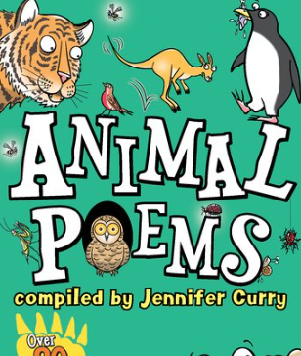Poetry
Writing purpose and genre | Writing to entertain  Genre: Narrative | Writing to entertain  Genre: Alternative traditional tale | No lessons due to big arts week | Writing to entertain  Genre: Alternative traditional tale | Writing to entertain – cultural fiction |  | Writing to entertain  Genre: Alternative traditional tale | Writing to inform: non-fiction | Writing to entertain Genre: Poetry
Writing objective | To act out part of the story in the role of the character  -To sequence sentences to form short narratives - setting  To punctuate sentences using a question mark – adventure 1  - To write sentences using the conjunction ‘and’ – adventure 2 | -To assign sentences to different characters  --To use suffixes to spell words adding suffixes -ing – setting  - To write sentences using the conjunction ‘but’ - adventure 1  -To choose options from pictures to write about – adventure 2  -To include newly taught vocabulary in sentences – adventure 3 | No lessons  due to big  arts week | - To write sentences through dictation - character  -To write sentences to sequence a short narrative – setting  - To use conjunction ‘so’ to compare sentences – adventure 1  -To punctuate sentences correctly – adventure 2  -To include newly taught vocabulary in sentences – adventure 3 | To use adjectives to describe - character  To use newly learnt vocabulary - Setting  To use ‘and’ to join phrases - Adventure 1  To start a sentence with ‘so’ - adventure 2  To describe an invention - Adventure 3 |  | To describe characters using adjectives  -- To use suffixes to spell words adding suffixes -er – setting  - To make links between parts of the story – adventure 1  -To write sentences to sequence key events – adventure 2  To punctuate sentences correctly – adventure 3 | -To decode speech bubbles  -To write their own speech bubbles  -To review and make changes to their writing  -To write labels to inform  -To use suffixes to spell verbs adding suffixes -ing | -To orally rehearse sentences  -To write descriptive sentences using capital letters and full stops  -To compose a simple patterned poem.  -To write poetry using adjectives to describe.  -To use rhyme in their writing
Reading Objectives | To discuss word meanings and link new meanings. | To retell familiar stories (traditional tales). | To discuss the significance of the title and events. | To say out loud what they are going to write about | To make links between what they’ve read and their own experiences |  | To listen to and discuss a wide range of poems. | To answer questions about what I have read. |  | To recognise and join in with predictable phrases
Phonics | Week 1  Phonic screening prep and revision | Week 2  Phonics screening check | Week 3  Summer 1 assessment | Week 4  Bridging the gap – phonics screening gaps | Week 5  Summer 1 assessment |  | Week 6  Summer 2 wk 1 | Week 7  Summer 2 wk 2 |  | Summer 2 wk 1 and 2 consolidation
Handwriting | Repeat letter families pre-cursive | Days of the week | Tricky words | Tricky words | Months of the year | Months of the year |  | Consolidation |  | Consolidation

Year 2 National Curriculum Objectives
Reading
National Curriculum – Word reading | Pupils are taught to:  - continue to apply phonic knowledge and skills as the route to decode words until automatic decoding has become embedded and reading is fluent  - read accurately by blending the sounds in words that contain the graphemes taught so far, especially recognising alternative sounds for graphemes  - read accurately words of two or more syllables that contain the same graphemes as above  - read words containing common suffixes  - read further common exception words, noting unusual correspondences between spelling and sound and where these occur in the word  - read most words quickly and accurately, without overt sounding and blending, when they have been frequently encountered  - read aloud books closely matched to their improving phonic knowledge, sounding out unfamiliar words accurately, automatically and without undue hesitation  - re-read these books to build up their fluency and confidence in word reading.
National Curriculum - Reading comprehension | Pupils are taught to:  - develop pleasure in reading, motivation to read, vocabulary and understanding by:  -listening to, discussing and expressing views about a wide range of contemporary and classic poetry, stories and non-fiction at a level beyond that at which they can read independently  - discussing the sequence of events in books and how items of information are related  - becoming increasingly familiar with and retelling a wider range of stories, fairy stories and traditional tales  - being introduced to non-fiction books that are structured in different ways  - recognising simple recurring literary language in stories and poetry  - discussing and clarifying the meanings of words, linking new meanings to known vocabulary  - discussing their favourite words and phrases  - continuing to build up a repertoire of poems learnt by heart, appreciating these and reciting some, with appropriate intonation to make the meaning clear  - understand both the books that they can already read accurately and fluently and those that they listen to by:  -drawing on what they already know or on background information and vocabulary provided by the teacher  - checking that the text makes sense to them as they read and correcting inaccurate reading  - making inferences on the basis of what is being said and done  - answering and asking questions  - predicting what might happen on the basis of what has been read so far  - participate in discussion about books, poems and other works that are read to them and those that they can read for themselves, taking turns and listening to what others say  - explain and discuss their understanding of books, poems and other material, both those that they listen to and those that they read for themselves.
Writing
National Curriculum – Transcription and Handwriting | Pupils are taught to:  - spell by:  - segmenting spoken words into phonemes and representing these by graphemes, spelling many correctly  - learning new ways of spelling phonemes for which one or more spellings are already known, and learn some words with each spelling, including a few common homophones  - learning to spell common exception words  - learning to spell more words with contracted forms  - learning the possessive apostrophe (singular) [for example, the girl’s book]  - distinguishing between homophones and near-homophones  - add suffixes to spell longer words, including –ment, –ness, –ful, –less, –ly  Pupils are taught to:  - form lower-case letters of the correct size relative to one another  - start using some of the diagonal and horizontal strokes needed to join letters and  - understand which letters, when adjacent to one another, are best left unjoined  - write capital letters and digits of the correct size, orientation and relationship to one  - another and to lower case letters  - use spacing between words that reflects the size of the letters
National Curriculum – Composition | Pupils are taught to:  - develop positive attitudes towards and stamina for writing by:  - writing narratives about personal experiences and those of others (real and fictional)  - writing about real events  - writing poetry  - writing for different purposes  - consider what they are going to write before beginning by:  - planning or saying out loud what they are going to write about  - writing down ideas and/or key words, including new vocabulary  - encapsulating what they want to say, sentence by sentence  - make simple additions, revisions and corrections to their own writing by:  - evaluating their writing with the teacher and other pupils  - re-reading to check that their writing makes sense and that verbs to indicate time are used correctly and consistently, including verbs in the continuous form  - proof-reading to check for errors in spelling, grammar and punctuation [for example, ends of sentences punctuated correctly]  - read aloud what they have written with appropriate intonation to make the meaning clear
National Curriculum – Vocabulary, grammar and punctuation | Pupils are taught to:  - develop their understanding of the concepts set out in English Appendix 2 by:  - learning how to use both familiar and new punctuation correctly (see English Appendix 2), including full stops, capital letters, exclamation marks, question marks, commas for lists and apostrophes for contracted forms and the possessive (singular)  - learn how to use:  - sentences with different forms: statement, question, exclamation, command  - expanded noun phrases to describe and specify [for example, the blue butterfly]  - the present and past tenses correctly and consistently including the progressive form  - subordination (using when, if, that, because) and co-ordination (using or, and, but)  - the grammar for year 2 in English Appendix 2  - some features of written Standard English  - use and understand the grammatical terminology in English Appendix 2 in discussing their writing.
English Appendix 2 | - Form nouns using the suffixes e.g. -ness -er  - Form adjectives using the suffixes e.g. -ful and -less  - Use suffixes -er and -est in adjectives and -ly to turn adjectives to adverbs  - Use subordination (when, if, that, because) and coordination (or, and, but)  - Use expanded noun phrases to describe  - Write sentences as statements, questions, exclamation and commands.  - Use the present tense and past tense consistently throughout writing.  - Use capital letters, full stops, questions marks and exclamation marks to punctuate sentences.  - Use commas separate items in a list  - Use apostrophes to mark where letters are missing

Year 2 Autumn 1
 | Week 2 | Week 3 | Week 4 | Week 5 | Week 6 | Week 7
Stimulus for Writing | Poetry:  The Moon’s Gorgonzola by Debra Bertulis  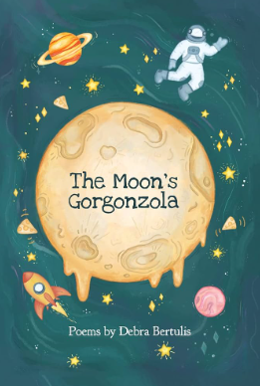  Week 3 – NFER Reading tests |  | Mavis the Bravest by Lu Fraser  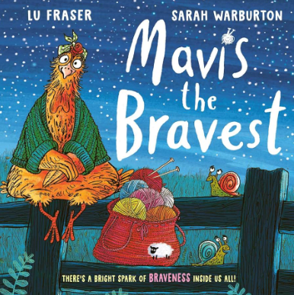  Week 4: History Day |  | Amazing Grace by Mary Hoffman  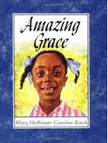  Week 7: Careers Week
Writing purpose:  Genre | Poetry  To entertain |  | To entertain  Fiction |  | To entertain the reader  Fiction
Writing Objectives  Writing craft lessons (Toolkit) | To write poetry in different forms (adverb poem, acrostic poem).  To recognise simple recurring literary language in poems.  To continue to build up a repertoire of poems learnt by heart  To write down ideas and/or key words, including new vocabulary  To identify word classes – adjectives and verbs |  | What is the moral of the story?  To write a simple retell of a story  To identify rhyme  To identify word classes – What is a noun? What is an adjective? What is a verb? |  | To retell the story  To use time words as sentence openers to add detail for the reader.  To learn how to use subordination (because) to describe (why Grace is so amazing!)
Reading Objectives | To learn about some poets.  To participate in discussions about poems.  To continue to build up a repertoire of poetry, learnt by heart, appreciating these and reciting some with appropriate intonation.  To listen to, discuss and express views about a wide range of contemporary and classic poetry, at a level beyond that at which they can read independently  To recite some of the rhyming language by heart.  To develop pleasure in reading poetry.  To explain and discuss their understanding of poems both those that they listen to and those that they read for themselves. |  | To explain and discuss their understanding of books.  To discuss their favourite words and phrases |  | To answer and ask questions

Year 2 Autumn 2
 | Week 1 | Week 2 | Week 3 | Week 4 | Week 5 | Week 6 | Week 7
Stimulus for Writing | Aliens Love Underpants by Claire Freedman  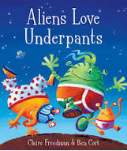 |  | 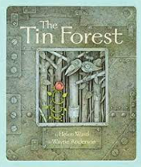  The Tin Forest  By Helen Ward and Wayne Anderson |  | The Pea and the Princess by Mini Grey  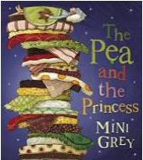 |  | Harvey Slumfenburger by John Burningham.  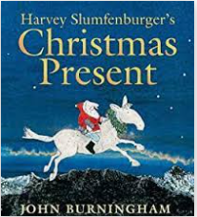
Writing purpose and genre | To entertain.  Fiction – an adventure story with a focus on Characterisation. |  | To entertain.  Fiction – focus on characterisation |  | To entertain  Genre: traditional tale |  | To entertain.  Genre: Journey Story
Writing Objectives  Writing Craft objectives (toolkit) | To write a character description.  To say out aloud what they are going to write about.  To compose a sentence orally before writing it.  To punctuate a sentence accurately using a full stop and a capital letter.  To use expanded noun phrases to describe  To choose adjectives carefully to help the reader picture the character.  To look at the spelling patterns of the rhyming words. |  | To use expanded noun phrases to describe.  To use conjunctions to compare.  To identify persuasive features of a poster, leaflet and a letter.  To design a persuasive poster.  To us persuasive features e.g slogan, eye-catching images, commands.  To edit and improve writing. |  | To write a traditional tale from a different perspective.  To write sentences as statements, questions, exclamation and commands.  To use the correct choice and consistent use of the past tense throughout writing.  Use apostrophes to mark where letters are missing |  | To write a thank you letter.  To understand the layout of a simple letter.  To use subordination (when, if).
Reading Objectives | To develop pleasure in reading. |  | To begin to predict what might happen. To identify phrases that add a storytelling voice to the narrative. Discuss meaning and what they add to the story (e.g. only if you happened to look…slippers that made no sound as she walked… Down the stairs, sly as steam, she crept…) |  | To ask and answer questions. |  | To use inference.  To give my thoughts and opinions about a story and characters.

Year 2 Spring 1
 | Week 1 | Week 2 | Week 3 | Week 4 | Week 5 | Week 6
Stimulus for Writing | 2023-24: 2 days  Vlad and the Great Fire of London  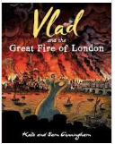 | Vlad and the Great Fire of London | Vlad and the Great Fire of London | The Day the Crayons Quit by Drew Daywalt.  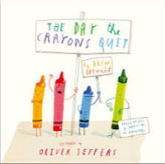 | The Day the Crayons Quit by Drew Daywalt. | Non-fiction  My First Book of Wildlife by Mike Unwin  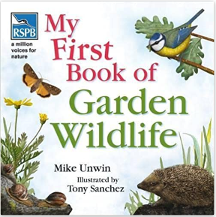
Writing purpose and genre | Fiction  To entertain |  |  | Fiction  To inform (letter). |  | Non-fiction  To inform.
Writing Objectives | To write a diary  To plan or say aloud what they are going to write about.  To use drama to understand what makes a diary a diary.  To explore the writing craft of a diary (rhetorical questions, informal language, chronological order, adverbs).  What makes a diary a diary?  To use drama to explore different perspectives  What is an adverb? How can I use them?  What are time words? How can I use them?  To make simple additions, revisions and corrections. |  |  | To write an informal letter.  To know the layout and structure of a letter.  What makes a letter a letter?  What different kinds of letters are there?  To explore the writing craft of a letter.  To use informal language.  To add suffixes to words  To read aloud what they have written with appropriate intonation to make the meaning clear.  To make simple additions, revisions and corrections.  NFER test – 2 days |  | What is non-fiction?  What makes a good non-fiction books?  To write sentences as statements, questions, exclamation and commands.  To plan a non-fiction piece of writing  To engage a younger reader  To edit and improve my work
Reading Objectives | To discuss the sequence of events in books  To understand both the books that they can already read accurately and fluently and those that they listen to by answering and asking questions. |  |  | To participate in discussions about books.  To discuss their favourite words and phrases. |  | To be introduced to non-fiction books that are structured in different ways

Year 2 Spring 2
 | Week 1 | Week 2 | Week 3 | Week 4 | Week 5 | Week 6
Stimulus for Writing | The Disgusting Sandwich by Gareth Edwards  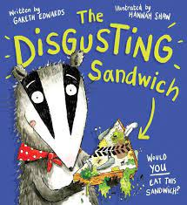 |  | World Book Day.  Christopher Nibble  By Charlotte Middleton  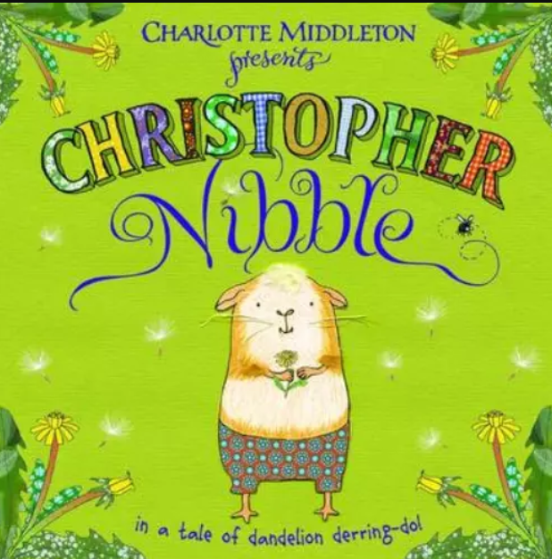 |  | The Magic Paintbrush by Julia Donaldson  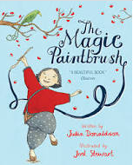
Writing purpose and genre | Fiction.  To entertain. |  | Fiction  To persuade  Poetry – Roger McGough ‘The Sound Collector’ |  | To entertain  Genre: an action story. (Story from another culture.)
Writing Objectives | To use subordination (when if that because) and coordination (or and but).  To form nouns using suffixes (e.g. ful, ness and er).  Form adjectives using the suffixes (ful and less).  To use expanded noun phrases to describe  To orally rehearse their writing.  To write a new event for the story  To write in the style of the author |  | World Book Day – Visiting author.  To orally rehearse sentences.  To use interesting sentences openers.  To write sentences as statements, questions, exclamation and commands.  To begin to learn about simple persuasive language  2 days – Poetry. Based on The Sound Collector by Roger McGough and Christopher Nibble. Write a poem in the style of The Sound Collector as if you are in Dandeville (Christopher Nibble). |  | To plan or say aloud what they are going to write about.  What makes a good action story?  To retell a story.  To learn to use subordination (using when, if, that, or because) and co-ordination (using or, and, or but)  To use the present tense and past tense consistently throughout writing.  To make simple additions, revisions and corrections.
Reading Objectives | Discussing and clarifying the meanings of words linking new meanings to known vocabulary. |  | To learn about some poets.  To participate in discussions about poems. |  | Explain and discuss their understanding of books.  To become increasingly familiar with and retell a wider range of stories, fairy stories and traditional tales

Year 2 Summer 1
 | Week 1 | Week 2 | Week 3 | Week 4 | Week 5
Stimulus for Writing | 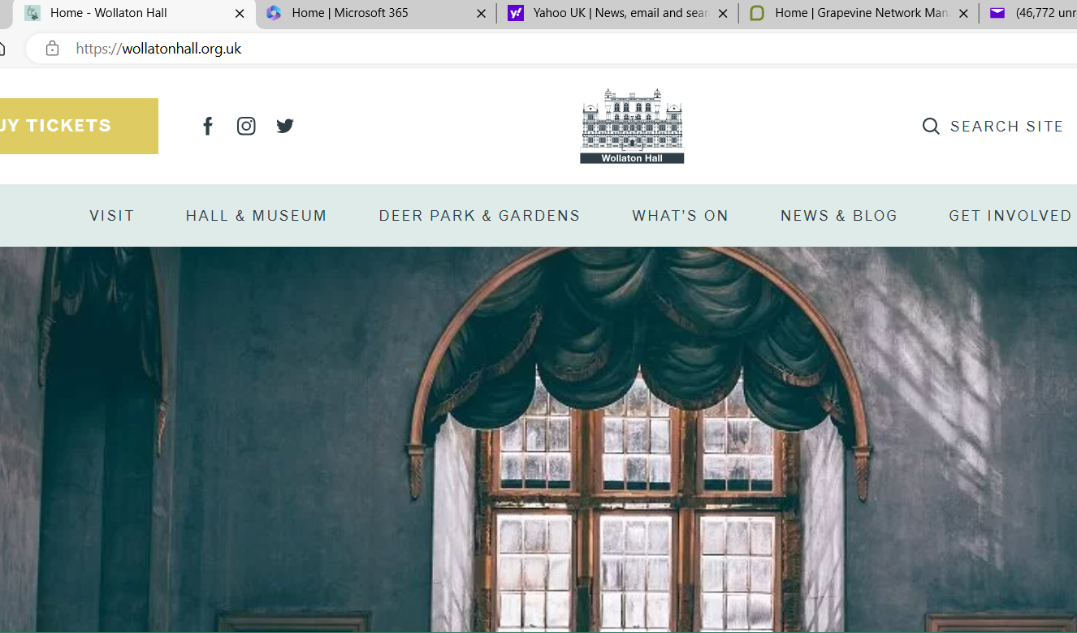  Wollaton Hall and Park website  http://wollatonhall.org.uk |  | Traction Man  By Mini Grey  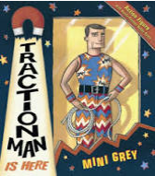 |  | Gorilla  by Anthony Browne  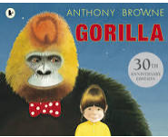
Writing purpose and genre | Non-fiction.  To inform |  | Fiction:  To entertain (video his new adventure) |  | Fiction  To entertain
Writing Objectives | What are exclamations. statements and questions?  To research a topic by answering key questions.  To create a poster ‘Come to Wollaton’. |  | To orally rehearse a story.  To plan their writing.  To write a new adventure for Traction Man in the style of Mini Grey.  To discuss and clarify the meaning of words, linking new meanings to known vocabulary. (To discuss the meanings of new vocabulary)  To use adjectives to describe a character.  To use verb tenses in the style of Mini Grey.  To video my new adventure! |  | To use commas in a list.  (SATs papers)
Reading Objectives | Listening to, discussing and expressing views about a wide range of non-fiction at a level beyond that at which they can read independently. |  | To make inferences on the basis of what is being said and done. |  | To make inferences based on what you have read.

Year 2 Summer 2
 | Week 1 | Week 2 | Week 3 | Week 4 | Week 5 | Week 6 | Week 7 | Week 8
Stimulus for Writing | The Tear Thief by Caroline Duffy  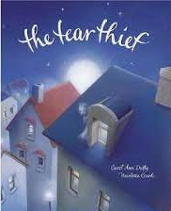 |  | 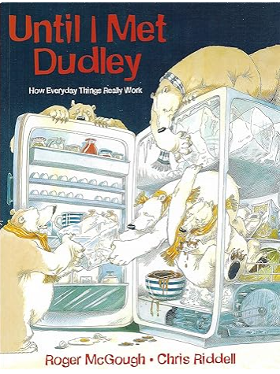  Until I met Dudley  By Roger McGough |  | Nim’s Island by Wendy Orr  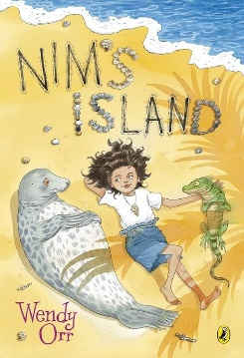
Writing purpose and genre | Fiction.  To entertain. |  | Non-fiction and fiction book  To entertain |  | Fiction  To entertain.  To inform.
Writing Objectives | To write a description of the Tear Thief.  To punctuate a sentence accurately using a full stop and a capital letter.  To build up description using sentences of three (e.g. The forest was cold, dark and silent). Use commas.  To use simple similes to describe.  To use the present and past tenses correctly and consistently including the progressive form: e.g. She crept along the rooftops, silent as smoke, listening, listening, until she heard the crying again. (past tense then progressive)  To use the suffix –ly to turn adjectives into adverbs (silent – silently; careful – carefully) to add deatil to description |  | To discuss a book.  To plan my writing.  To practise my sentences orally.  To write an explanatory text.  To practise using subordination in sentences. |  | To orally describe a setting of a story  To discuss and clarify the meanings of words.  To make ask questions and make inferences. (hotseating Nim)  To know the format of and tone of an informal letter.  To write an email/letter.  To use and understand imperative verbs. (bossy verbs)  To plan and write instructions.
Reading Objectives | To make predictions as to what might happen.  To discuss and clarify the meanings of words, linking new meanings to known vocabulary. |  |  |  | To predict what might happen on the basis of what has been read so far

