


Fernwood Primary and Nursery School

English Intent & Implementation Overview

Year 3
Autumn 1
 | Week 2 and 3 |  | Week 4 and 5 |  | Week 6 and 7
Stimulus for Writing | 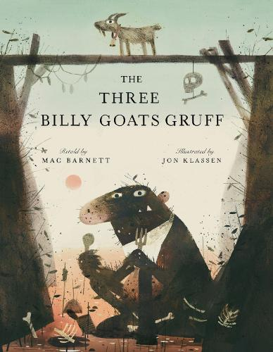  The Three Billy Goats Gruff by Mac Barnett and Jim Klassen |  |   The Lion and the Mouse by Jerry Pinkey |  | 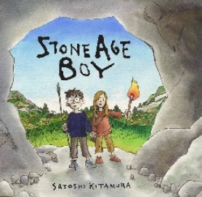  Stone Age Boy by Satoshi Kitamura
Writing purpose and genre | Writing to entertain  - Character description (the troll)  - Characterisation  Hook – mystery boxes of fairy tales, to include The Three Billy Goats Gruff. |  | Writing to entertain  - Setting description  Hook – sounds of The Savannah. |  | Writing to entertain  - Portal story  - Settings and characters  Hook – letter from The Stone Age Boy.
Writing Objectives  Grammar objectives | - To identify different types of nouns (proper and common nouns)  Lesson 1 - To story map a traditional tale.  Lesson 2 – To explore the writing craft of character description.  Lesson 3 – What makes a good sentence? (EF1 teach) using dictation  Lesson 4 – What is an expanded noun phrase? using dictation  Lesson 5 – What is a simile? using dictation | - To identify different types of nouns (concrete and abstract nouns).  Lesson 1 - To use adverbs to describe how a character moves. Using dictation.  Lesson 2 – To plan my own troll character.  Lesson 3 – To choose vocabulary for a troll description.  Lesson 4 and 5 – To write a description of a troll (one lesson for appearance and one for personality) use dictation to begin this. | - To identify adjectives.  Lesson 2 – To explore a wordless fable book. (build a class word bank)  Lesson 3 – To explore the writing craft of a setting description. (use model texts for picture books)  Lesson 4 – To choose vocabulary to describe using the senses.  Lesson 5 – To use alliteration to create an atmosphere. Using dictation | - To identify noun phrases.  Lesson 1 – To use expanded noun phrases to describe. Using dictation  Lesson 2 – To choose similes to describe a setting. Using dictation.  Lesson 3 – To sequence sentences for a description.  Lesson 4 – To write a setting description. | - To use a and an to correctly introduce nouns.  Lesson 2 – To explore the writing craft of a portal story.  Lesson 3 – To plan a Stone Age portal story (use story mapping). ONLY CHANGE THE CHARACTER)  Lesson 4 – To use conjunctions to join two main clauses. Using dictation.  Lesson 5 – INSET. | - To find conjunctions that join main clauses.  Lesson 1 – To write an opening to a portal story.  Lesson 2 – To write a middle of a portal story.  Lesson 3 – To write an end to a portal story.  Lesson 4 – To publish a portal story for my peers/th  - HISTORY DAY?
Reading Objectives | No reading lesson. | No reading lesson | Lesson 1 - To use dictionaries to check the meaning of words. (Vocabulary) | Lesson 5 - To use a contents page and subheadings to locate information in a non-fiction text. (retrieval) | Lesson 1 - NTS testing | Lesson 5 - To summarise the key points in one paragraph (using the 5Ws).
Spelling objectives  Words from the Year 3 / 4 list | To spell common homophones correctly. (e.g. there/their/they’re, here/hear, quite/quiet)  accident, accidentally, address | To spell common homophones correctly (e.g. (to/too, be/bee blue/blue). answer, appear, arrive | To double consonants when adding the suffix -ing, -er or -ed (e.g. Forget, forgetting, forgotten, begin, beginner)  believe, bicycle | To spell words with the /i/ sound written as ‘y’ (e.g. myth, gym, Egypt, pyramid, mystery).  busy, business, calendar, caught, centre | To add the prefix dis- to root words to add a negative meaning (e.g. disappointment, disagree, disobey).  century, certain | To add the prefix in- to root words to add a negative meaning (e.g. inactive, incorrect, indecent, indefinite).  consider, continue

Autumn 2
 | Week 1 and 2 |  | Week 3 and 4 |  | Week 5 and 6
Stimulus for Writing | 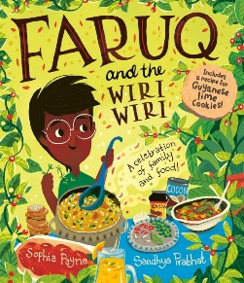  Faruq and the Wiri Wiri by Sophia Payne and Sandhya Prabhat |  | 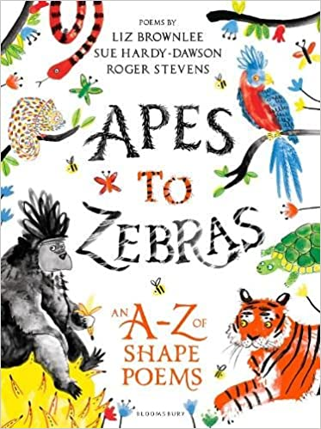 |  | 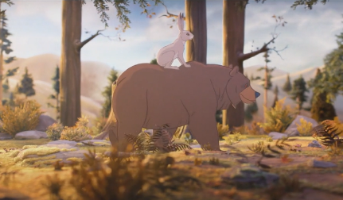  The bear and the hare animation
Writing purpose and genre | Writing to entertain  - Writing a description of food |  | Writing to entertain  - Poetry |  | Writing to entertain  - Dialogue
Writing Objectives  Grammar objectives | To identify fragments in sentences.  Lesson 2 – To explore the writing craft of food description.  Lesson 3 – To explore vocabulary linked to Guyanese ingredients.  Lesson 4 – To design a Guyanese soup, focussing on ingredients and purpose.  Lesson 5 - Careers Day | To identify prepositions.  Lesson 1 – To use personification to describe food.  Lesson 2 – To develop expanded noun phrases, alliteration, adverbs and similes for my soup description.  Lesson 3 and 4 – To write a description of a Guyanese soup.  To write a description of how a soup will change someone’s life. | To identify word families.  Lesson 2 - To explore language in animal poetry.  Lesson 3 - To plan a calligram poem.  Lesson 4 - To write a calligram poem.  Lesson 5 - To perform a poem (poetry slam). | To understand present and past tense for to be.  Lesson 1 - To explore word families.  Lesson 2 - To explore colour poetry.  Lesson 3 - To plan a colour poem.  Lesson 4 - To write a colour poem. | To understand present and past tense for to have.  Lesson 2 - To use speech bubble to show dialogue.  Lesson 3 - To use inverted commas to show dialogue.  Lesson 4 - To use synonyms for said.  Lesson 5 - To write a short conversation. | To identify dialogue.  Lesson 1 – To plan a conversation.  Lesson 2 and 3 – To write a conversation with a short narrative opening.  Lesson 4 - To perform a conversation (oracy).
Reading  Objectives | Lesson 1 - To make predictions about what will happen next using an image (prediction). What did the Wiri Wiri bush tell him? Read the rest of the book at the end of the lesson. | Lesson 5 - To infer characters thoughts and feelings from images (inference).  Reading the rest of the Wiri Wiri | Lesson 1 - To explore the features of calligram poems (explore and compare). | Lesson 5 - To perform a poem learned by heart (fluency). | Lesson 1 - To infer characters’ thoughts and feelings from an animation (inference). |  | Lesson 5 - To retrieve information from a non-fiction text (retrieval)
Spelling objectives  Words from the Year 3 / 4 list | To add the prefix im- to root words that start with m or p. (e.g. immature, immortal, impossible).  different, guard, notice, sentence | To spell words with split vowel digraphs. (e.g. hated, coped, cube, spine)  earth, eight | To use the prefix sub- to mean underneath or lower (e.g. subtract, subject, subside, subway).  eighth, heard, often | To add the prefix inter- to root words to mean between (e.g. interact, international, interval).  experience, ordinary, special | To add the prefix super- to root words to mean over and above (e.g. supervise, supersonic, supernatural).  height, peculiar, strange |  | To add the prefix ‘anti-‘, meaning against (e.g. anticlockwise, antibiotics).  famous, favourite, imagine, increase, popular, suppose

 | Spring 1
 | Week 1 | Week 2 |  |  | Week 3 | Week 4 | Week 5 | Week 6
Stimulus for Writing | 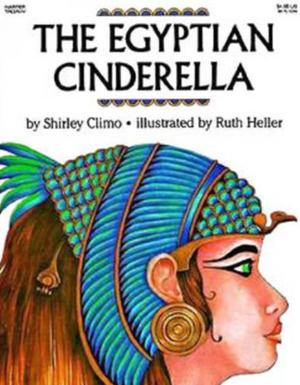  The Egyptian Cinderella by Shirley Climo |  |  |  | Animation – Marshmallows  https://www.literacyshed.com/en-us/resource/marshmallows  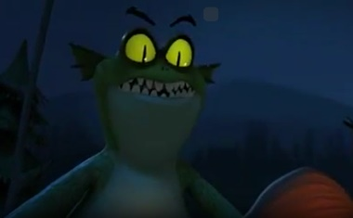 |  | 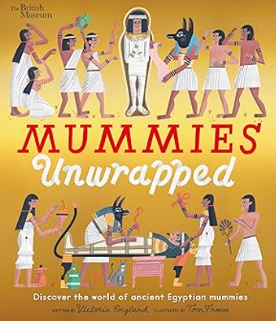  Mummies unwrapped by Tom Froese and model texts
Writing purpose and genre | Writing to entertain  - Character description |  |  |  | Writing to entertain  - Writing a suspense extract. |  | Writing to inform  Information text - create own information sheet about mummifying an animals
Writing Objectives  Grammar objectives | To form adjectives using suffixes (e.g. ful and less)  Lesson 2 - Explore the text and compare between modern and traditional  Lesson 3 - Identify features of a character description  Lesson 4 - Design a new Egyptian Queen  Lesson 5 - Use show not tell to show character emotions |  | To identify features of setting and character description  Lesson 1 - Write expanded noun phrases for the New Queen  Lesson 2 - Use prepositional phrases as fronted adverbials  Lesson 4 - Improve writing, focusing on looking for fragments and run ons (EF2)  Lesson 5 - Write a character description about the Egyptian Queen | To identify coordination and subordination within sentences.  Lesson 2 - Compare different suspense extracts.  Lesson 3 - Writing craft of a suspense text (Mysterious Door by Pie Corbett)  Lesson 4 - Explore show don’t tell.  Lesson 5 - Create rhetorical questions and short sentences to build suspense. |  | To explore word families based on common words  Lesson 1 - Powerful adjectives to create atmosphere (setting)  Lesson 2 - Create an escape plan for the character (story map)  Lesson 3 - Write a short suspense extract.  Lesson 4 - Publish suspense extract. | To identify fronted adverbials.  Lesson 1 - Compare structure and features of information texts (oracy)  Lesson 2 - What makes a good information text?  Lesson 3 - Create facts about chosen animal to mummify  Lesson 5 - Research technical vocabulary linked to topic | To identify nouns, adjectives, verbs, adverbs and conjunctions within a sentence  Lesson 1 - Plan the structure of the information text (envelope)  Lesson 2 & 3 - Writing and editing the information text  Lesson 4 - Publish and finalise information text
Reading Objectives | Lesson 1 - To create a story board to re-tell the story orally (summarising) |  | Lesson 3 - To infer characters thoughts and feelings from their actions in the text. (inference) | Lesson 1 - Make predictions based on an animation (prediction) |  | NTS testing (one day) | Lesson 4 - To find the meaning of words using clues in the text (vocabulary). | Faith and Culture day
Spelling objectives  Words from the Year 3 / 4 list | To spell further homophones (e.g.  reign, material |  | To spell words ending with ‘gue’ (e.g. league, tongue, fatigue).  island library early | To spell words with the /s/ sound spelt ‘sc’ (e.g. science, scene, discipline).  build decide describe |  | To spell words with the /ai/ sound – ei, eigh or ey (e.g. they, sleigh, veil).  breath breathe | To spell words using the plural possessive apostrophe (e.g. girls’, boys’, babies’)  imagine history | To spell homophones and near homophones (e.g. ball/bawl, grown/groan).  February natural

 |  | Spring 2
 |  | Week 1, 2 and 3 |  |  |  |  | Week 4 and 5
Stimulus for Writing |  | 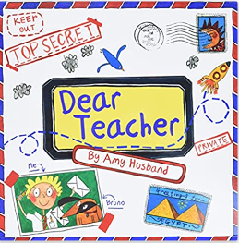  Dear Teacher by Amy Husband |  |  |  |  | 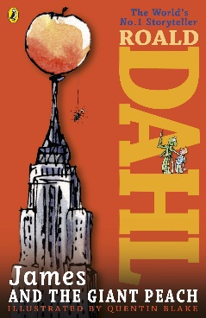  James and the Giant Peach by Roald Dahl
Writing purpose and genre |  | Writing to inform  - Informal letter to Miss Brooks from story. |  | Writing to persuade  - Formal email to Fernwood SLT. |  |  | Writing to inform  - Instruction writing – How to grow an enchanted fruit (doesn’t have to be a peach)
Writing Objectives  Grammar objectives |  | To identify personal and possessive pronouns.  Lesson 1 - To explore the craft of informal letters.  Lesson 2 - To explore informal language to plan an informal letter.  Lesson 3 - To write an informal letter.  INSET DAY |  | To identify conjunctions to link ideas.  Lesson 1 - To explore the writing craft of a persuasive letter.  Lesson 2 - To discuss persuasive arguments for a formal letter.  Lesson 3 - To explore persuasive openers, formal language and rhetorical questions.  Lesson 4 - To plan a persuasive letter. | To identify the present perfect tense.  Lesson 1 – To check for checking for improvements in punctuation (EF3 teach).  Lesson 2 & 3 - To write a formal persuasive letter (two days).  Lesson 4 - To publish a formal letter. (Write up as email on laptops using improvements). |  | To identify adverbs for time and cause (e.g. next, soon, then).  Lesson 2 - To explore the writing craft of instructional writing.  Lesson 3 - To use commas to indicate separate adjectives, or nouns, in a list.  Lesson 4 - To explore vocabulary used in instruction writing. (create word bank)  Lesson 5 - To explore sentence openers used in instruction writing |  | To use commas in a list.  Lesson 1 - To plan a set of instructions.  Lesson 2 & 3 - To write a set of instructions using simple organisational devices (two days).  EXPLORER DAY
Reading  Objectives |  | Lesson 4 - To find the meaning of words using a dictionary (vocabulary). |  | World Book Day | Lesson 5 - To read non-fiction books that are structured in different ways. (exploring and comparing) (standalone) |  | Lesson 1 – To explore and compare different model texts of instruction writing (explore and compare) |  | Lesson 4 - To use quotations from the text when retrieving information (retrieval) (standalone)
Spelling objectives  Words from the Year 3 / 4 list | To spell homophones (e.g. here hear)  knowledge, learn, quarter, weigh, families |  | To spell homophones (e.g. missed and mist)  Experiment, medicine, disappear, tongue |  | Common misconception words.  Surprise, particular, confusion, mixture | g grapheme that sounds like /j/ (e.g. giant).  hought, various, incorrect, gym |  | Words with the /oo/ sound that are spelt ui (e.g. fruit)  regular, probably, heart, ascend, grey

 | Summer 1
 | Week 1 and 2 |  | Week 3 and 4 |  | Week 5 and 6
Stimulus for Writing | James and the Giant Peach by Roald Dahl |  | 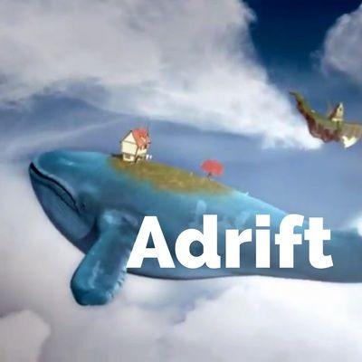  Adrift video – Literacy Shed |  | 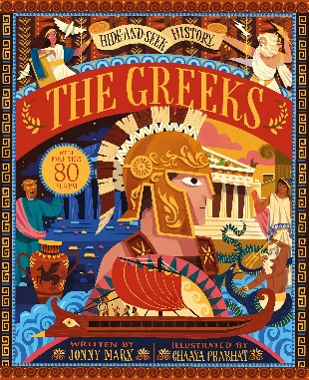  The Greeks by Jonny Marx
Writing purpose and genre | Writing to reflect  - Recount (diary entry) |  | Writing to entertain  - Fantasy narrative (Fantasy stories - child lives on back of chosen animal) |  | Writing to persuade  • Persuasive writing – Visit Ancient Greece!
Writing Objectives  Grammar objectives | To identify coordinating conjunctions (and, for, but, or and so).  Lesson 1 - To explore the writing craft of a diary entry.  Lesson 2 - To use the present perfect tense to describe past actions that still affect the present.  Lesson 3 - To use fronted adverbials to indicate time for a diary entry.  Lesson 4 - To explore informal language for a diary entry. | To identify the present perfect tense.  Lesson 1 - To plan a diary entry, organising paragraphs around a theme.  Lesson 2 & 3 -To write a diary entry (two days).  Lesson 4 - To edit and improve my writing using EFs 1, 2 & 3 | To identify subordinating conjunctions (because, although, when and if).  Lesson 2 – To explore the writing craft of a fantasy story.  Lesson 3 – To choose a fantasy setting and animal for story. (e.g. an elephant that swims underwater in the sea)  Lesson 4 - To story map a fantasy story.  Lesson 5 - To use show not tell to describe a character and their emotions. | To identify the features of direct speech.  Lesson 1 - To use dialogue to show character’s feelings.  Lesson 2 & 3 – To write a fantasy narrative.  Bank holiday | To use a or an correctly to introduce nouns.  Lesson 1 - To explore the writing craft of a persuasive advert.  Lesson 2 - To use conjunctions to explain a point (coordinating and subordinating).  Lesson 3 - To use interesting adjectives to persuade.  Lesson 4 – To explore persuasive openers. | To use a or an correctly to introduce nouns.  Lesson 1 - To plan a persuasive advert.  Lesson 2 & 3 - To write a persuasive advert (two days)  Lesson 4 - To present and publish a persuasive advert.
Reading  Objectives | SCIENCE DAY | Lesson 5 - To infer a character’s motives from their actions in the text (inference – using J&GP) | Lesson 1- To infer characters thoughts and feelings using details from the text. (inference) (based on video) | Lesson 4 - To make predictions based on what is stated in a text (prediction). | NTS assessment | INSET day
Spelling objectives  Words from the Year 3 / 4 list | To spell words using the prefix auto-, meaning self (e.g. autobiography, automatic, autograph)  forward, important, mention, position | To spell words using the suffix -ation to turn verbs into nouns (e.g. prepare, preparation)  fruit, length | To turn adjectives into averbs using the suffix -ly (e.g Sad, sadly, complete completely). | To spell words ending in sure (e.g. measure, treasure, pleasure)r  group | To spell words ending in ture (e.g. Creature, furniture, picture)  minute, possible | To spell words using the -sion suffix to turn verbs into nouns (e.g, division, invasion, confusion)  island, potatoes, purpose, therefore

 | Summer 2
 | Week 1 and 2 |  | Week 3 and 4 |  | Week 5 | Week 6 and 7
Stimulus for Writing | 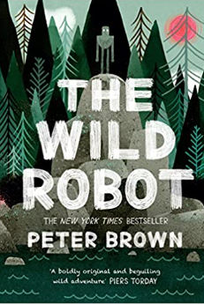  The Wild Robot by Peter Brown |  | Using Once Upon a Picture/Literacy Shed, choose an appropriate picture to use as inspiration for a narrative. |  | BIG  ARTS  WEEK | 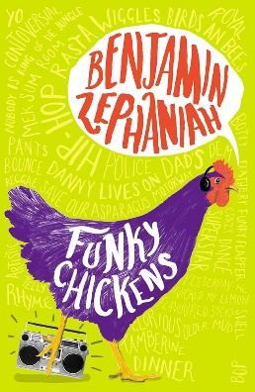  Funky Chickens by Benjamin Zephaniah
Writing purpose and genre | Writing to entertain  Setting Description (using chapter 1 and 2)  - Settings |  | Writing to entertain  - Narrative with dialogue |  | BIG  ARTS  WEEK | Writing to entertain  - Poetry
Writing Objectives  Grammar objectives | To identify conjunctions.  Lesson 1 - To explore the writing craft of a setting description.  Lesson 2 - To choose vocabulary to describe using the senses. (include power of three)  Lesson 3 - To write similes and alliteration to describe.  NEXT YEAR – to use prepositional phrases as fronted adverbials?  Lesson 4 - To use when, where and how fronted adverbials. | To identify conjunctions.  Lesson 1 - To plan a setting description from a character’s perspective.  Lesson 2 & 3 - To write a setting description (two days)  Lesson 4 - To publish setting description. | To identify fronted adverbials.  Lesson 1 - To explore and unpick chosen picture.  Lesson 2 – To explore the writing craft of narrative.  Lesson 3 - To extend the range of sentences using a fronted adverbials and conjunctions  Lesson 4 - To use show not tell for a character’s emotions. | To identify prepositions.  Lesson 1 - To use repetition and rhetorical questions to build tension.  Lesson 2 - To use inverted commas to punctuate dialogue, including action (WRITE THE BIT THEY WILL USE).  Lesson 3 – To plan a narrative from a character’s point of view. (use story mapping).  Lesson 4 & 5 - To write narrative building suspense and tension (three days). | BIG  ARTS  WEEK | Features of poetry.  Lesson 1 - To explore and compare performance poetry.  Lesson 2 – To explore the writing craft of performance poetry.  Lesson 3 – To practise using voice and expression when performing poetry.  Lesson 4 – To plan a free-verse poem. | Lesson 1 – To create similes, alliteration and onomatopoeia for performance poetry.  Lesson 2 – To write repeated phrases to create rhythm.  Lesson 3 - To write a free-verse poem.  Transition morning
Reading  Objectives | Lesson 5 - To justify inferences using evidence from the text. (inference) | Lesson 5 - To justify predictions using evidence from the text (prediction). | Lesson 5 - To discuss words and phrases that capture the reader’s interest and imagination (vocabulary) |  | N/A | INSET Day | Fernwood Festival
Spelling objectives  Words from the Year 3 / 4 list | Words with the /r/ sound that are spelt ‘wr; (e.g. write, wrapper).  through, history division, preferred | To spell homophones.  Here/hear, heel/heal/he’ll, knot/not  knowledge, learn, quarter | To spell homophones.  Missed/mist, peace/piece, plain/plane, scene/seen  experiment, medicine | To spell common exception words.  Because, improve, people, water, Christmas, beautiful, sure, clothes  surprise, particular | To spell words where the ‘g’ grapheme is used for the /j/ sound.  giant, ginger, genius, danger, emergency, imagine, intelligent, tragic  thought, various | To spell words using the ‘ui’ grapheme for the /oo/ sound.  juice, recruit, suitable, build, guide, fruit, suitcase regular, probably, heart | To spell words using the ‘wr’ grapheme for the /r/ sound. write wrapper, wreck, wrestle, wrinkle, wrong, wriggle, wrist  through, history

Year 4
Autumn 1
 | Week 2 and 3 |  | Week 4 and 5 |  | Week 6 and 7
Stimulus for Writing | 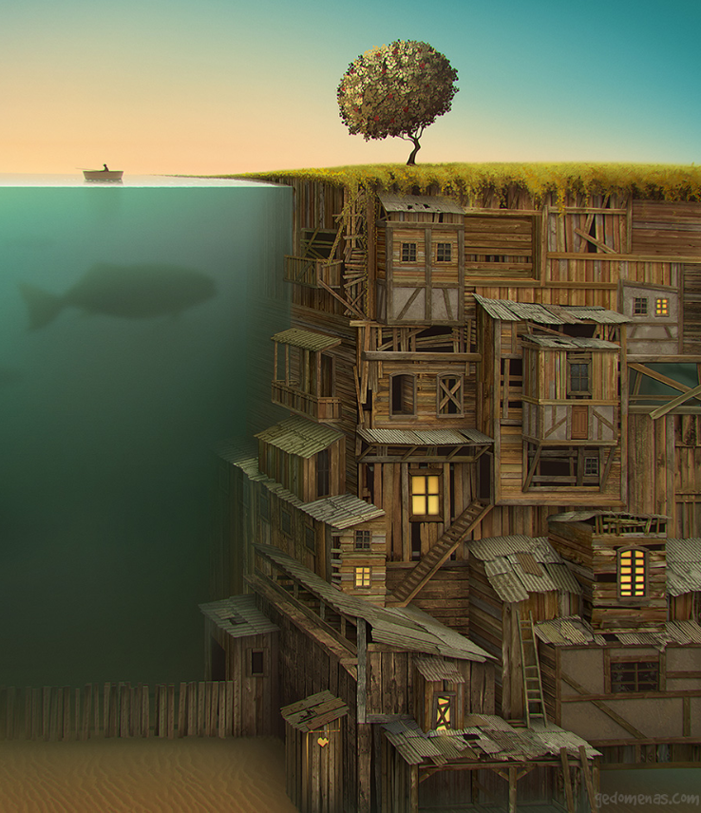  Subterranean - Once Upon a Picture |  | 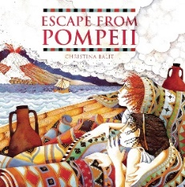  Escape from Pompeii by Christina Balit |  | 
Writing purpose and genre | Writing to paint a picture in the reader’s mind  - Setting description  Hook – Have picture up and make predictions | Writing a short narrative – what happens next? | Writing to entertain  - Re-written section of historical suspense narrative, including dialogue |  | Writing to entertain  - Dialogue  - Suspense story (based on a different natural disaster)  - Openings/endings  Add to previous week’s toolkit
Writing Objectives  Retrieval objectives | To use the determiners a and an correctly to introduce nouns.  Lesson 2 - To explore the writing craft of setting description.  Lesson 3 - To explore vocabulary used to describe the setting.  Lesson 4 - To use expanded noun phrases, similes and personification.  Lesson 5 – To write a setting description. | To identify prepositions and prepositional phrases.  Lesson 2 – To story map what happens next in the picture (max 5 pics)  Lesson 3 – To use coordination to join main clauses (and, but, so and yet).  Lesson 4 – To explore sentence length for suspense.  Lesson 5 – To write a short narrative. | To understand the rules of punctuating direct speech.  Lesson 2 - To explore the writing craft of suspense narrative with dialogue.  Lesson 3 - To use direct speech to show how a character feels.  Lesson 4 - To add on what the character is doing after a piece of dialogue to advance action.  Lesson 5 - To use subordination in a sentence (because, when, before, after and while). | To identify different types of adverbs (time, frequency and manner).  Lesson 1 - To choose verbs and adverbs effectively to show how a character is feeling.  Lesson 2 – To explore and use suspense features (revisit sentence length, repetition and moving the threat closer)  Lesson 3 and 4 - To write a section of narrative with dialogue (two days). | To recap editing focuses 1-3.  Lesson 1 – To research natural disasters and story map for a suspense narrative  Lesson 2 – To use adverbs and prepositional phrases as fronted adverbials.  Lesson 3 - To build suspense in writing by using repetition, varied sentence length and rhetorical questions to make the reader worried.  INSET DAY | To identify personal and possessive pronouns.  Lesson 1 – To explore different openings for my suspense story.  Lesson 2 and 3 - To write a suspense story  ROMAN DAY
Reading Objectives | Lesson 1 – To use a dictionary to check the meaning of words, checking the correct word class and definition (vocabulary) | Lesson 1 - To make predictions based on a picture. (prediction) | Lesson 1 - To use skim and scan to retrieve information from a text (retrieval). | Lesson 5 - To highlight key information in a text and record it in diagrams (summarising) (standalone) | NTS testing | HISTORY DAY
Spelling objectives  Words from the Year 3 / 4 list | To spell homophones (e.g. see/sea, bear/bare).  consider continue | To use the il- prefix to have a negative meaning (e.g. illegal, illogical).  century certain position | To add suffixes to words than begin with a vowel (e.g. garden gardener gardening).  breath breathe build | To spell words with the /u/ sound spelt ‘ou’ (e.g. young).  busy calendar caught centre | To spell words with the mis- prefix (e.g. misbehave, mislead)  believe bicycle | To use the ir- prefix (e.g. irregular, irrelevant)  accident accidentally address

Autumn 2
 | Week 1 and 2 |  | Week 3 and 4 |  | Week 5 and 6
Stimulus for Writing | 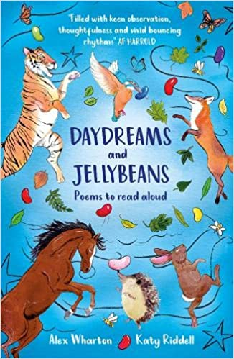  Daydreams and Jellybeans by Alex Wharton |  | 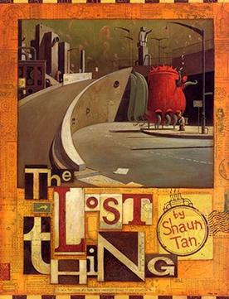  The Lost Thing by Shaun Tan |  | 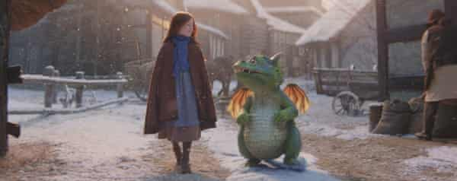  Edgar – video animation
Writing purpose and genre | Writing poetry  Hook – Sending to Wollaton Library. |  | Writing to entertain  - Settings  - Characterisation |  | Writing to reflect  - Diary entry (recount)
Writing Objectives  Retrieval objectives | To identify adjectives  Lesson 1 - Explore a range of poetry.  Lesson 2 - To explore the writing craft of free-verse poetry.  Lesson 3 - To explore figurative language for poetry.  Careers Fair | To use precise nouns to describe (e.g. sparrow not brown bird).  Lesson 1 - To write a free-verse poem, following a familiar structure.  Lesson 2 – To plan a free verse or rhyming poem.  Lesson 3 - To write a free-verse or rhyming poem (free writing).  Lesson 4 – To publish my poetry for the library. | To identify verbs and adverbs  Lesson 2 - To explore the writing craft of a dystopian/science fiction narrative.  Lesson 3 – To design a narrator and creature for my dystopian story.  Lesson 4 - To plan a first-person narrative as a story map  Lesson 5 - To use dialogue to advance action. | To use the present and past perfect form of verbs.  Lesson 1 - To edit and improve an action scene (EF4 teach).  Lesson 2 and 3 - To write a first- person narrative.  Lesson 4 - To publish a first-person dystopian narrative (two days). | To use coordinating conjunctions to join words, phrases and clauses.  Lesson 1 - To explore the writing craft of a diary entry.  Lesson 2 - To explore vocabulary to show facts, opinion and feelings in a diary entry.  Lesson 3 - To use adverbials of time, duration and location as fronted adverbials.  Lesson 4 - To explore the use of rhetorical questions and informal language. | To use subordinating conjunctions to add a subordinate clause to a sentence.  Lesson 2 - To plan a diary entry.  Lesson 3 and 4 - To write a diary entry.  Lesson 5 – To publish my diary entry.
Reading Objectives | Lesson 4 - To use a thesaurus to find synonyms (vocabulary). | Lesson 5 - To perform a poem (poetry slam) (fluency). | Lesson 1 - To use prior knowledge and details from the text to make predictions (prediction). | Lesson 5 - To infer characters’ motives using evidence from the text (inference) (standalone). | Lesson 5 - To use quotes to support answers to questions about the text (retrieval). | Lesson 1 – To summarise a short animation in pictures (summarising)
Spelling objectives  Words from the Year 3 / 4 list | To spell words using the re- prefix (e.g. redo, refresh).  early guide occasion occasionally separate | To spell words, using split vowel digraphs (e.g. excuse, spite).  enough | To use the prefix sub- (e.g. subheadings, submarine)  exercise heart opposite | To use the prefix inter-, meaning between.  straight particular | To use the prefix super-, meaning over and above (e.g. superficial, superimpose)  experiment extreme history perhaps strength | To use the prefix anti-, meaning against (e.g. antifungal, antifreeze)  February surprise medicine

Spring 1
 | Week 1 and 2 |  | Week 3 | Week 4 and 5 |  |  | Week 6
Stimulus for Writing | 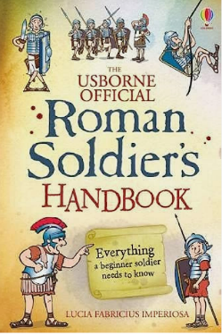  Roman Soldier’s Handbook by Lucia Fabricius Imperoisa |  | 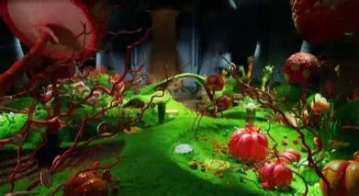  Charlie and the Chocolate Factory – movie clip |  | 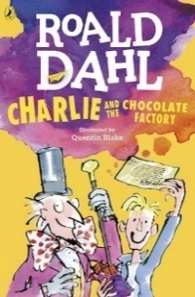  Charlie and the Chocolate Factory by Roald Dahl |  | 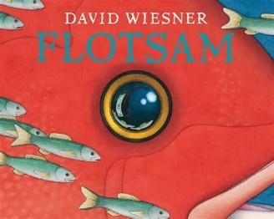  Flotsam by David Wiesner
Writing purpose and genre | Writing to inform  - Instruction writing (how to be a Roman soldier) |  | Writing to build a picture in the reader’s mind  - Setting description (based on film clip of the chocolate room) | Writing to persuade  - Persuasive letter (to Mr Willy Wonka)  - Chapter 3 and 4 |  |  | Writing to entertain  - Describing their own imagination – What’s can they see in the camera?
Writing Objectives  Retrieval objectives | To identify imperative verbs and adverbs used to instruct.  Lesson 2 - To explore the writing craft of instructional writing.  Lesson 3 - To explore vocabulary to entertain the reader.  Lesson 4 - To use fronted adverbials to create cohesion between instructions.  Lesson 5 - To plan a set of instructions using a planning web. | To identify determiners that quantify (three, many, some).  Lesson 1 - To choose simple organisational devices in non-narrative material (captions, pictures and diagrams).  Lesson 2 - To write a introduction to an instructional text.  Lesson 3 & 4 - To write instructions ‘how to be a roman soldier’ (two days). | To identify the present perfect form of verbs.  Lesson 1 - To design own magical room and show the setting through the character’s eyes.  Lesson 2 - To use adverbs, similes and prepositional phrases as fronted adverbials.  Lesson 3 - To use powerful and precise vocabulary (nouns, adjectives, verbs and adverbs) to match the atmosphere.  Lesson 4 - To write a setting description of their own magical room. | To understand and use the plural possessive apostrophe.  To explore the writing craft of a persuasive letter.  To use coordinating conjunctions to join words, phrases and clauses (and, but, so, or and yet) to link ideas.  To explore appealing adjectives and compliments to persuade.  To explore persuasive openers and rhetorical questions to persuade. |  | To use coordinating conjunctions to join words, phrases and clauses (and, but, so, or and yet).  To plan a persuasive letter.  To edit to check for pronouns (EF5 teach)  To write a persuasive letter (two lessons). | To distinguish between adverbs of time, frequency and manner.  Lesson 2 – To design a picture from the camera.  Lesson 3 – To explore sentence openers linked to magical world.  Lesson 4 – Write a short description of their picture world  FAITH & CULTURE DAY
Reading Objectives | Lesson 1 - To discuss how language, structure and presentation contribute to meaning in a non-fiction text (explore and compare). | Lesson 5 (standalone) - To highlight key information in a text and record in bullet points (summarising). | Pantomime | To find the meaning of new words using the context of a sentence (vocabulary). |  | NTS testing | Lesson 1 - To make predictions based on the pictures in the book. (predictions)
Spelling objectives  Words from the Year 3 / 4 list | - To spell words using the prefix dis-, meaning apart (e.g. disorder, disbelief)  learn recent | - To spell words using ation to change words from verbs into nouns (e.g. determine determination)  grammar library | - To spell using the suffix -ily to change adjectives into adverbs (e.g. happily angrily)  interest which | - To spell words with the /k/ sound spelt using ‘ch’ (e.g. scheme chorus)  natural quarter |  | - To spell words using the suffix -ture to turn verbs into nouns (e.g. signature departure)  possess possession

Spring 2
 | Week 1 and 2 |  | Week 3, 4 and 5
Stimulus for Writing |   Taking Flight – Literacy Shed |  | 
Writing purpose and genre | Writing to entertain  - Dialogue  - Action |  | Writing to entertain  - Characterisation, settings, suspense and tension  - Wishing tale  - Writing using a made-up character and their journey to get something that they really want.
Writing Objectives  Retrieval objectives | To identify similes and personification used to create an atmosphere.  Lesson 1 - To explore the writing craft of an action scene.  Lesson 2 - To design imaginary setting.  Lesson 3 - To use inverted commas to punctuate direct speech, including using the reporting clause at the beginning.  Lesson 4 - To use varied sentence length and repetition to build pace and tension. | To use pronouns and to create cohesion across sentences.  Lesson 1 - To show how a character is feeling through their actions and reactions to the setting or other characters (verbs).  Lesson 2 - To edit and improve vocabulary choices (EF6 teach)  Lesson 3 & 4 - To write an action scene, including dialogue. (over two lessons) | - York (x3 days)  Writing linked to York – no pressure. Can link to memory booklets.  E.g. guide, postcard, recount, speech about York, guided tour (chn choose, allow freedom). | To use prepositional phrases, similes and adverbs as fronted adverbials.  Lesson 1 - To explore a wishing tale.  Lesson 2 - To create character, with a name to suggest something about them and reveal their desire or wish (short-burst writing).  Lesson 3 - To plan a wishing tale.  Lesson 4 - To use conjunctions to add subordination to a sentence (because, when, before, after, although, if and while) | To identify features of character and setting descriptions.  Lesson 1 - To build suspense and tension by showing the reader how my character is feeling rather than telling (actions and reactions).  Lesson 2 & 3 - To write a wishing tale (three days).  Lesson 4 - To publish, edit and design a front cover.  EXPLORER DAY
Reading Objectives | INSET DAY | World Book Day |  | Lesson 5 - To compare two characters, discussing author’s choice (explore and compare) (standalone)
Spelling objectives  Words from the Year 3 / 4 list | - To spell words using the -ous suffix (our changes to or) e.g. humour humorous.  material regular | - To spell word with the ‘ous’ ending (e.g. curious hideous)  probably reign thought | - To spell words with the suffix -tion to change verbs into nouns (e.g. operate operation).  weight | - To spell words using the -ssion suffix (e.g. possess possession)  through various | To spell words using the suffix -sion when a verb ends in ‘de or se’ (e.g. collide collision).  accident accidentally

Summer 1
 | Week 1 | Week 2 and 3 |  | Week 4 | Week 5 and 6
Stimulus for Writing | Using Once Upon a Picture/Literacy Shed, choose an appropriate picture to use as inspiration for a character description. | 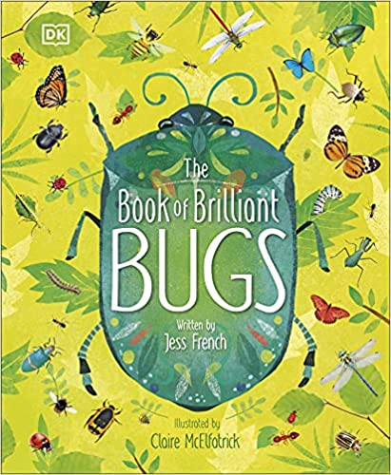  The Book of Brilliant Bugs by Jess French |  | 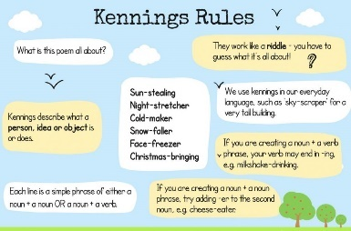  Kenning Poems | 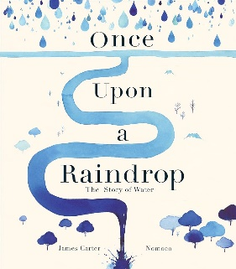  Once Upon a Raindrop by James Carter
Writing purpose and genre | Writing to entertain  - Character description | Writing to inform  - Information Text (minibeast) |  | Writing to entertain  - Poetry (Kenning) | Writing to entertain  - Journey story (narrative)
Writing Objectives | To use apostrophes to mark singular possession.  Lesson 2 – To explore the writing craft of a character description.  Lesson 3 – To explore physical and personality traits of a character.  Lesson 4 – To write a character description  SCIENCE DAY | To identify plural apostrophes.  Lesson 2 - To explore the writing craft of information texts  Lesson 3 - To research and make notes (focus on technical vocabulary).  Lesson 4 - To explore literary devices in an information text.  Lesson 5 - To use coordinating and subordinating conjunctions to link information. | To identify a variety of determiners.  Lesson 1 - To plan the structure of an information text, including pictures/diagrams.  Lesson 2 & 3 - To write an information text (two days)  Lesson 4 - To publish an information text. | To identify word families.  Lesson 1 - To explore the writing craft of a Kenning poem.  Lesson 2 - To explore technical vocabulary to plan a poem.  Lesson 3 - To follow a similar structure to write poetry.  Lesson 4 – To perform a poem, using intonation, volume and correct tone. | To identify the difference between the plural and possessive ‘s’.  Lesson 1 - To explore non-fiction as poetry.  Lesson 2 - To explore how a poet engages the reader (onomatopoeia, RQ alliteration, repetition etc).  Lesson 3 – To plan journey story (story map) (each child’s story faces a different obstacle e.g. raindrop lands in different places)  Lesson 4 – To create a bank of figurative language linked to journey | To identify possessive pronouns.  Lesson 2 & 3 - To write a journey of a raindrop (2 days)  Lesson 4 - To publish journey of a raindrop with illustrations. (integrated)  INSET day
Reading Objectives | Lesson 1 - To make and justify predictions using evidence from the text (prediction) (based on picture) | Lesson 1 - To explore and discuss how language, structure and presentation contribute to meaning in a non-fiction text (explore and compare). | Lesson 5 - To summarise information from a non-fiction text orally (summarising) | Bank holiday | NTS testing | Lesson 1 - To explain how words and phrases capture the interest of the reader (vocabulary).
Spelling objectives  Words from the Year 3 / 4 list | To spell homophones and near homophones (e.g. precede and proceed).  pressure | To spell words ending with the /k/ sound with the que grapheme (e.g. antique) with a French origin.  century group popular | To spell words with the /s/ sound using the sc grapheme (e.g. muscle) with a Latin origin.  bicycle famous favourite | To spell words using the /ey/ sound spelt using the graphemes ei eight or ey (e.g. neighbour).  heard peculiar | To spell words using the plural possessive apostrophe (e.g. parents’).  complete | To spell words using the /sh/ sound, spelt using the grapheme ch (e.g. chef).  answer appear arrive believe

Summer 2
 | Week 1 and 2 |  | Week 3 and 4 |  | Week 5 | Week 6 and 7
Stimulus for Writing | 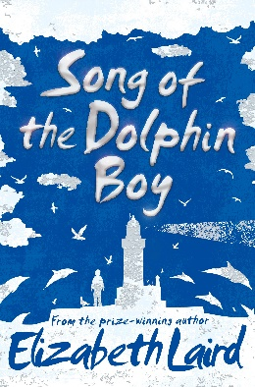  Song of the Dolphin Boy by Elizabeth Laird |  | 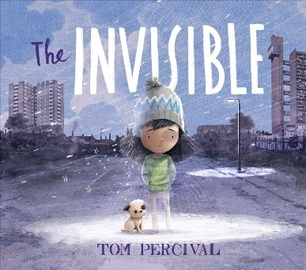  The Invisible by Tom Percival |  | BIG ARTS WEEK |   The Tibicena extract (see KG)
Writing purpose and genre | Writing to entertain  - Setting description |  | Writing to recount  - Diary entry |  | BIG ARTS WEEK | Writing to entertain  - Narrative with dialogue  - Characterisation and Settings  - Beat the monster narrative from perspective of the character
Writing Objectives | To identify fronted adverbials.  Lesson 2 - To explore the writing craft of setting descriptions.  Lesson 3 – Design own magical setting within a magical town  Lesson 4 - To begin sentences with more than one fronted adverbial.  Lesson 5 - To bring a setting to life using similes, metaphors and the senses to describe. | To identify adverbs for describing location and manner.  Lesson 1 – To explore atmosphere to create mood (e.g. what type of land have they created – fairy land, mysterious woodland etc)  Lesson 2 – To explore different endings to create atmosphere.  Lesson 3 & 4 – To write and edit a setting description. | To identify persuasive techniques  Lesson 2 – To describe a feeling using figurative language  Lesson 3 – To recap the writing craft of a diary entry (see Autumn 2 week 6)  Lesson 4 – To compare ‘the old home’ vs. ‘the new area’ in the book (annotate and explore)  Lesson 5 – To describe a setting using sensory detail (both settings). | To improve similes to describe  Lesson 1 – To describe emotions of the character in the story.  Lesson 2 – To story map Isabel’s emotional journey.  Lesson 3 & 4 – To write a diary entry from Isabel’s perspective. | INSET day  BIG ARTS WEEK | To improve sentence openers.  Lesson 2 – To explore character, settings and motives.  Lesson 3 – To design a monster for the narrative (must have idea for main character).  Lesson 4 – To design a setting (keep in mind a goal/obstacle for character)  Lesson 5 - To create a story map of monster narrative. | To identify word classes within sentences.  Lesson 1 & 2 – To write a beat the monster narrative (two days)  Lesson 3 – To publish a short narrative.  Transition morning
Reading Objectives | Lesson 1 - To write a brief summary of the main point of a chapter, using important information (summarising). | To retrieve information from a text (use SoaDb) (retrieval) | Lesson 1 - To infer a character’s feelings using clues from illustrations (Isabel from story) | Lesson 5 - To make predictions by asking questions (prediction) (use poetry one already there – standalone) | BIG ARTS WEEK | Lesson 1 - To discuss and define new and unusual vocabulary (vocabulary) (using extract) | Fernwood Festival
Spelling objectives  Words from the Year 3 / 4 list | To spell homophones and near homophones (e.g. meet and meat).  ordinary consider | To spell homophones and near homophones (e.g. there their they’re).  eighth eleven | To spell words ending in -ar (e.g. familiar).  calendar | To spell words using cy at the start and end of words (e.g. cylinder accuracy).  imagine sentence | To spell words using the -cian suffix (e.g. beauty beautician).  accident address | To spell words using the oy and oi graphemes for the /oi/ sound.  woman women

Year 5 and 6 National Curriculum Objectives
Reading
Word Reading | - To apply their growing knowledge of root words, prefixes and suffixes (morphology and etymology), as listed in English Appendix 1, both to read aloud and to understand the meaning of new words that they meet.
Year 5 National Curriculum Statements - Reading comprehension | - To maintain positive attitudes to reading and understanding of what they read by:  - continuing to read and discuss an increasingly wide range of fiction, poetry, plays, non-fiction and reference books or textbooks  - reading books that are structured in different ways and reading for a range of purposes  - increasing their familiarity with a wide range of books, including myths, legends and traditional stories, modern fiction, fiction from our literary heritage, and books from other cultures and traditions  - recommending books that they have read to their peers, giving reasons for their choices  - identifying and discussing themes and conventions in and across a wide range of writing  - making comparisons within and across books  - learning a wider range of poetry by heart  - preparing poems and plays to read aloud and to perform, showing understanding through intonation, tone and volume so that the meaning is clear to an audience  - To understand what they read by:  - checking that the book makes sense to them, discussing their understanding and exploring the meaning of words in context  - asking questions to improve their understanding  - drawing inferences such as inferring characters’ feelings, thoughts and motives from their actions, and justifying inferences with evidence  - predicting what might happen from details stated and implied  - summarising the main ideas drawn from more than one paragraph, identifying key details that support the main ideas  - identifying how language, structure and presentation contribute to meaning  - discuss and evaluate how authors use language, including figurative language, considering the impact on the reader ♣ distinguish between statements of fact and opinion  - retrieve, record and present information from non-fiction  - participate in discussions about books that are read to them and those they can read for themselves, building on their own and others’ ideas and challenging views courteously  - explain and discuss their understanding of what they have read, including through formal presentations and debates, maintaining a focus on the topic and using notes where necessary  - provide reasoned justifications for their views.

Writing
National Curriculum – Transcription and Handwriting | Pupils should be taught to:  - use further prefixes and suffixes and understand guidance to add them.  - spell some words with ‘silent’ letters (for example knight, psalm and solemn).  - Continue to distinguish between homophones and other words which are often confused.  - use knowledge of morphology and etymology in spelling and understand that the spelling of some words ned to be learnt specifically, a listed in English Appendix 1.  - use dictionaries to check the spelling and meaning of words.  - use the first three or four letters of a word to check selling, meaning or both of these in a dictionary.  - use a thesaurus.  Pupils are taught to:  - write legibly, fluently and with increasing speed by:  - choosing which shape of a letter to use when give choices and deciding whether or not to specific letters  - choosing the writing implement that is best suited for a task.
National Curriculum – Composition | Pupils are taught to:  - plan their writing by:  - identifying the audience for and purpose of the writing, selecting the appropriate form and using other similar writing as models for their own.  - noting and developing initial ideas, drawing on reading and research where necessary.  - in writing narratives, considering how authors have developed characters and what pupils have read, listened to or seen performed.  - draft and write by:  - selecting appropriate grammar and vocabulary, understanding how such choices can change and enhance meaning.  - in narratives, describing settings, characters, and atmosphere and integrating dialogue to convey character and advance the action.  - précising longer passages.  - using a wide range of devices to build cohesion within and across paragraphs.  - using further organisational and presentational devices to structure text ad to guide the reader (for example headings, bullet points and underlining).  - evaluate and edit by:  - assessing the effectiveness of their own and others’ writing.  - proposing changes to vocabulary, grammar and punctuation to enhance effects and clarify meaning.  - ensuring the consistent and correct use of tense throughout a piece of writing.  - ensuring correct subject and verb agreement when sing singular and plural, distinguishing between the language of speech and choosing the appropriate register.  - proof-read for spelling and punctuation errors.  - perform their own compositions, using appropriate intonation, volume, and movement so that meaning is clear.
National Curriculum – Vocabulary, grammar and punctuation | Pupils are taught to:  - develop their understanding of the concepts in English Appendix 2 by:  - recognising vocabulary and structures that are appropriate for formal speech, and writing, including subjunctive forms.  - using passive verbs to affect the presentation of information in a sentence.  - using the perfect form of verbs to mark relationships of time and clause.  - use expanded noun phrases to convey complicated information concisely.  - using modal verbs and adverbs to indicate degrees of possibility.  - using relative clauses beginning with who, which, where, when, whose, that or an implied (i.e. omitted) relative pronoun.  - indicate grammatical and other features by:  - using commas to clarify meaning or avoid ambiguity in writing.  - using hyphens to avoid ambiguity.  - using brackets, dashes or commas to mark boundaries between independent clauses.  - using colons to introduce a list.  - punctuating bullet points consistently.  - use and understand the grammatical terminology in English Appendix accurately and appropriately when discussing their writing and reading.
English Appendix 2 | Year 5  - convert nouns or adjectives into verbs using suffixes (e.g. -ate, -ise, -ify)  - use prefixes for verbs (dis-, de-, mis-, over- and re-)  - use relative clauses beginning with who, which, where, when, whose and that.  - indicate degrees of possibility using adverbs or modal verbs.  - link ideas across paragraphs using adverbials of time, place, and manner.  - Use brackets, dashes or commas to indicate parenthesis.  - Use commas to clarify the meaning or avoid ambiguity. | Year 6  - know the difference between vocabulary for formal and informal.  - know how words are related by meaning as synonyms and antonyms.  - use the passive tense to affect the presentation of information in a sentence.  - use the subjunctive forms (e.g. ‘If I were…’)  - link ideas across paragraphs using a wider range of cohesive devise (repetition, adverbials, ellipsis)  - use semi-colons, colons and dashes to mark the boundary between independent clauses.  - to use colon to introduce lists and use semi-colons in lists.  - punctuate bullet point to list information.  - know how hyphens can be used to avoid ambiguity.

Year 5
 | Autumn 1
 | Week 2 and 3 |  | Week 4 and 5 |  | Week 6 and 7
Stimulus for Writing | 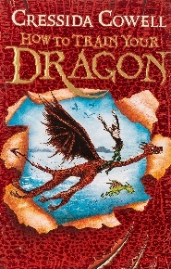  How to Train your Dragon by Cressida Cowell |  | 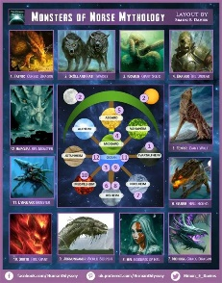  How to care for a Norse mythical creature |  | 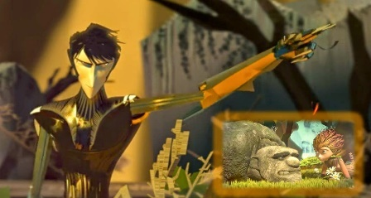  Broken; Rock, Paper, Scissors – Literacy Shed animation
Writing purpose and genre | Writing to paint a picture in the reader’s mind  - Characterisation (create a dragon)  - Setting description (where your dragon lives – cave and forest setting. |  | Writing to inform  - Instruction writing |  | Writing to entertain  - Dialogue with narrative (at about 2 minutes 30 seconds)
Writing Objectives  Grammar objectives | To identify adverbials of time, place and manner.  Lesson 2 - To explore the writing craft of a character description.  Lesson 3 – To design a dragon and choose figurative language techniques (similes, abstract similes and metaphors).  Lesson 4 - To use expanded noun phrases and repetition to add detail about a character.  Lesson 5 – To write a description of a dragon. | To identify a range of adverbs in writing to indicate manner (‘how’).  Lesson 1 – To explore the writing craft of a setting description.  Lesson 2 – To begin sentences with more than one fronted adverbial to zoom in in or out of a setting.  Lesson 3 – To choose vocabulary and figurative language to appeal to the reader’s senses.  Lesson 4 – To write a setting description. | To identify coordinating conjunctions to join words, phrases and clauses.  Lesson 1 - To explore the writing craft of instructions.  Lesson 2 – To choose and research a Norse mythical creature.  Lesson 3 - To use modal verbs to indicate degrees of possibility.  Lesson 4 - To use brackets to add parenthesis to a sentence. | To identify adverbs and modal verbs that define possibility.  Lesson 1 - To use adverbials for time to create cohesion in writing.  Lesson 2 - To plan an instructional text on how to look after a mythical creature. (Intro, Safety and Handling, Training, Basic needs e.g. food and environment)  Lesson 3 and 4 - To write and publish an instructional text (over double page) | To identify the rules of punctuating dialogue.  Lesson 1 - To explore the writing craft of using dialogue to advance action in narrative.  Lesson 2 – To hot seat characters from a video to improvise dialogue.  Lesson 3 – To punctuate dialogue, including split speech to advance the action and show character’s feelings.  INSET day |  |  | To identify relative clauses and relative pronoun within a sentence.  Lesson 1 – To plan a short conversation, interspersed with short narrative.  Lesson 2 and 3– To write a short section of narrative with dialogue.  HISTORY DAY
Reading Objectives | Lesson 1 - To read a section of text before and after to retrieve information (retrieval). | Lesson 5 - To discuss and evaluate the author’s use of language, including figurative language, and the impact on the reader (explore and compare). | Lesson 5 - To explore the meaning of words in context using a dictionary (vocabulary). | Lesson 5 - To infer a character’s personality, using their behaviours as evidence (inference). | NTS testing | Lesson 4 - To summarise the main ideas drawn from a section of text, identifying key details (summarising)
Spelling objectives  Year 5/6 words | To spell words /∫es/. If the root ends in -ce, then /∫/ sound is spelt as -c (e.g. gracious)  accommodate available cemetery familiar necessary | To spell words using -ant, -ance, -ancy and -ation (e.g. observant, observation).  according awkward | To turn adjectives ending in -able to abverbs ending in -ably (e.g. adorable and adorable).  sufficient aggressive  bruise community | To add suffixes beginning with vowels to words ending in -fer. (e.g. refer and referring)  ancient competition | To spell words using ‘ough’ (e.g. nought, enough).  appreciate conscious guarantee |  | To spell nouns ending in -ce and verbs ending is -se (e.g. practice and practise).  convenience hindrance occur

Autumn 2
 | Week 1 and 2 |  | Week 3 and 4 |  | Week 5 and 6
Stimulus for Writing | 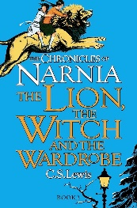  The Lion, the witch and the wardrobe by C S Lewis |  | Making schools phone-free is 'near impossible'. Do parents even want it? - BBC News  Should children have smartphones? |  | 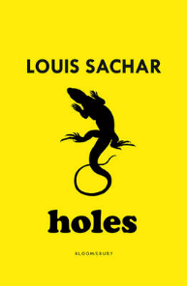  Holes by Louis Sachar
Writing purpose and genre | Writing to entertain  - Narrative  - Characterisation  - Dialogue |  | Writing to discuss  - Balanced argument |  | Writing to persuade  Formal letter
Writing Objectives  Retrieval objectives | To identify commas for clarity.  Lesson 2 - To explore the writing craft of fantasy narrative.  Lesson 3 - To create a setting beyond the wardrobe, choosing suitable vocabulary.  Lesson 4 - To explore characterisation, mirroring the character’s feelings to the atmosphere.  Careers Day | To identify different types of subordination (relative clause, non-finite clause and adverbial clause).  Lesson 2 – To story map Lucy’s journey through the wardrobe.  Lesson 3 - To use non-finite clauses to begin sentences.  Lesson 4 and 5 – To write a section of fantasy narrative. | To identify the present and past perfect tense.  Lesson 2 – To explore the writing craft of a balanced argument.  Lesson 3 – To compare model balanced arguments (make notes).  Lesson 4 – To discuss ideas for and against smartphones for children (oracy).  Lesson 5 – To choose modal verbs and formal vocabulary for a balanced argument. | To understand commas for clarity to clarify meaning.  Lesson 1 – To choose effective sentence starters for a balanced argument.  Lesson 2 – To plan a balanced argument.  Lesson 3 and 4 – To write a balanced argument. | To identify conjunctive adverbs.  Lesson 2 – To explore the writing craft of a persuasive letter.  Lesson 3 –To use a range of coordinating conjunctions to join words, phrases and clauses (and, but, so, or, yet, for and nor).  Lesson 4 – To explore formal, persuasive language to persuade the reader.  Lesson 5 – To use the rule of three for cohesion to persuade. | To identify adverbial clauses at the beginning and end of sentences.  Lesson 1 – To plan a persuasive letter.  Lesson 2 and 3 – To write a persuasive letter.  Lesson 4 – To publish a persuasive letter (type up).
Reading Objectives | Lesson 1 - To retrieve information from a classic narrative (retrieval). | Lesson 1 - To explore themes in fantasy writing (explore and compare). | Lesson 1 - To summarise the main ideas drawn from a whole text, identifying key details (summarising news article). | Lesson 5 – To take part in a balanced debate (oracy). | Lesson 1 - To read around a word to explore its meaning n a section or paragraph of text (vocabulary). | Lesson 5 - To infer a character’s feelings and thoughts from a text using their actions (inference).
Spelling objectives  Year 5/6 words | To spell further homophones (e.g. guessed and guest).  critic criticise | To spell adjectives with the suffix -able where the root word does not change. (e.g. comfort and comfortable).  curiosity lightning signature | To spell adjectives with the -ible suffix and adverbs with the -ibly suffix. (e.g. possible and possibly).  develop parliament | To spell words using the rule ‘I before e except afte c’ (e.g. friend).  embarrass interfere relevant symbol | To spell words using the rule ‘I before e except afte c’ (e.g. receipt)  equip equipped equipment | To spell homophones and near homophones (e.g. dessert and desert).  existence privilege thorough

 | Spring 1
 | Week 1 and 2 |  |  | Week 3 | Week 4 and 5 |  | Week 6
Stimulus for Writing |   Inspired by Yellow-Spotted-Lizard from Holes |  |  | 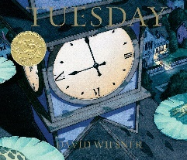  Tuesday by David Wiesner |   Inspired by Holes |  | William Shakespeare
Writing purpose and genre | Writing to inform  - Information text about deadly creature found in a desert |  |  | Writing to recount  - Diary entry | Writing to entertain  - Characterisation  - Settings  - Flashback |  | Performing playscripts
Writing Objectives  Retrieval objectives | To identify brackets used for parenthesis within a sentence  Lesson 1 – To explore different non-fiction texts.  Lesson 2 - To explore the writing craft of an information text.  Lesson 3 – Design deadly creature (does not have to be real)  Lesson 4 - To use hyphens to create compound adjectives. |  | To identify simple organisational devices (subheadings, headings and bullet points).  Lesson 1 – To plan an information text.  Lesson 2 - To structure a topic themed paragraph.  Lesson 3 & 4 - To write an information text (two days). | To identify hyphenated compound adjectives.  Lesson 1 – Writing craft of a diary entry.  Lesson 2 – Plan diary entry from perspective of frog.  Lesson 3 – To write a diary entry from the perspective of a frog.  Pantomime | To identify wide range of fronted adverbials, including more than one to begin a sentence.  Lesson 1 - To explore the writing craft of narrative with a flashback (look at variety of example texts)  Lesson 2 - To explore characterisation, adding an embedded -ing or relative clause to suggest about the character.  Lesson 3 - To ensure that word choices earn their place in description. | To identify subordinate (adverbial, relative and non-finite) clauses embedded within a sentence.  Lesson 1 - To plan a flashback narrative, mirroring the character’s feelings with the setting.  Lesson 2 & 3 - To write a flashback narrative (two days).  Lesson 4 - To publish a flashback narrative | To understand an author from our literary heritage (William Shakespeare).  FAITH & CULTURE DAY
Reading Objectives | Lesson 5 - To investigate alternative word choices that could be made (vocabulary). |  | Lesson 5 (standalone) - To distinguish between fact and opinion in a text (explore and compare). | To infer characters feelings, thoughts from a text and motives for their actions (inference). (use the news reporter page in the book) | NTS papers  Space centre visit | Lesson 5 - To make predictions about details implied, using evidence from the text (prediction). | To discuss themes and conventions from a chapter of text (summarising).  To explore archaic language in a text.  To prepare a play to perform, showing understanding through intonation, tone and volume so that the meaning is clear to an audience.  To compare and discuss themes across two playscripts (modern vs Shakespearean)
Spelling objectives  Year 5/6 words | To spell further homophones and near homophones (e.g. accept and except).  explanation profession | To spell words using split vowel (e.g. extreme).  leisure programme |  | To turn adjectives to adverbs by adding -ly or -lly when the word end in an l. (e.g. wonderful wonderfully).  pronunciation restaurant | To add the suffix -ly to words with more than one syllable (e.g. shabbily).  muscle | To use -cial (after vowel) and -tial (after consonant) endings (e.g. partial and facial).  rhyme accompany definite guessed | To use ‘ph’ digraph for the /f/ sound (e.g. paragraph).  achieve average

 | Spring 2
 | Week 1 and 2 |  |  | Week 3 | Week 4 and 5
Stimulus for Writing |  |  |  | Once Upon a Picture (teacher choose from website for year group)  https://www.onceuponapicture.co.uk/ | 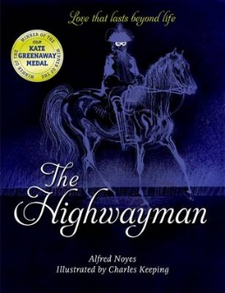  The Highwayman by Alfred Noyes
Writing purpose and genre | Writing to inform  - Biography about someone who inspires them |  |  | Writing to entertain  - Character description | Writing to entertain  - Narrative poetry (from a character’s perspective)
Writing Objectives  Grammar l objectives | To identify the perfect tense within a sentence.  Lesson 1 - To explore and compare the writing craft of a biography (look at different model extracts)  Lesson 2 – Research information about chosen person. (graphic organiser)  Lesson 3 - To understand how to write quotes and direct reported speech. (role play)  INSET DAY | To identify parenthesis embedded within a sentence (semicolons)  Lesson 1 - To explore adding detail to description using dashes, brackets commas to add parenthesis to sentences.  Lesson 2 – To plan the different sections/layout of biography.  Lesson 3 & 4 – To write and edit a biography. |  | To identify singular and plural apostrophes for possession.  Lesson 2 – To explore personality and traits of the character.  Lesson 3 – To show not tell the character’s traits through actions and body language.  Lesson 4 – To explore sentence types (focussing on fronted adverbials, complex and compound sentences and clauses to add detail)  Lesson 5 – To write a character description | To identify adverbs for time, place and manner.  Lesson 1 - To re-tell a narrative poem (story map).  Lesson 2 - To practise using punctuation for parenthesis (commas and dashes)  Lesson 3 - To use figurative language and sentence starters.  Lesson 4 - To re-tell a narrative poem in the first person (one day) (choose character from story to tell it from different perspectives) | To identify different types of fronted adverbials.  Lesson 2 & 3 - To re-tell a narrative in the first person (two days).  Lesson 4 - To publish a narrative.  EXPLORER DAY
Reading Objectives | Lesson 5 - To make connections between information across a text to write a summary (summarising). | World Book Day |  | Lesson 1 - To infer from a picture (infer) (same picture being used for writing) | Lesson 1 - To discuss how the author’s choice of language impact the reader (vocabulary). | Lesson 5 - To perform poetry with intonation (fluency) (discuss and analyse text with focus on characters)
Spelling objectives  Year 5/6 words | To spell words with ‘xc’ (e.g. exceptional).  amateur neighbour nuisance |  | To spell words ending in -ious (e.g. conscientious).  bargain category | To spell words adjectives the prefix un- to demonstrate a negative meaning (e.g. uncomfortable).  apparent exaggerate | To spell words ending in -ary (e.g. stationary).  committee frequently | To spell words using the suffix -ible (e.g. sensible).  controversy foreign

Summer 1
 | Week 1 and 2 |  |  | Week 3 and 4 |  | Week 5 and 6
Stimulus for Writing |   Alma video – The Literacy Shed |  |  |  |  | 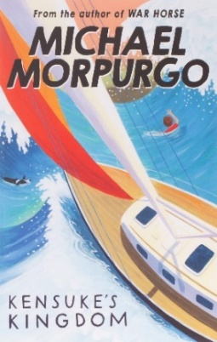  Kensuke’s Kingdom by Michael Morpurgo
Writing purpose and genre | Writing to entertain  - Narrative  - Settings  - Building suspense and action |  |  | Writing to persuade  - Writing an email to a celebrity to come to school (could link to biography earlier in year) |  | Writing to reflect  - Recount (ship’s log)
Writing Objectives | To use commas and dashes to indicate parenthesis embedded in a sentence.  To use semi colons correctly  Lesson 1 – To explore the writing craft of suspense and tension narratives (compare clip with written ex  Lesson 2 - To choose figurative language and punctuation techniques (similes, metaphors, personification, ellipsis)  Lesson 3 - To use a wide range of fronted adverbials to indicate when, where and how, including non-finite clauses.  SCIENCE DAY | To identify relative clauses to add subordination using who, which, whose and that.  Lesson 1 – To explore sentence structures to build tension (sentence of three with action, varied sentence length.  Lesson 2 - To explore repetition to build tension (anadiplosis and beginning and end of sentence.  Lesson 3 - To plan a narrative, building suspense.  Lesson 4 & 5 - To write a narrative, building suspense (two days). |  | To identify hyphenated compound words.  Lesson 1 – To explore the writing craft of persuasive extracts.  Lesson 2 – To use persuasive language in a sentence.  Lesson 3 – To explore formality of persuasive letters.  Lesson 4 – To create persuasive sentence openers. | To identify word classes within sentences (nouns and adjectives).  Lesson 1 – To write a conclusion, summarising reasons.  Lesson 2 – To plan a persuasive email (include reason they are writing to celeb)  Lesson 3 & 4 – To write a persuasive email. | To identify word classes within sentences (determiners and pronouns).  Lesson 1 - To explore the writing craft of diary/journal writing.  Lesson 2 - To research ideas for writing.  Lesson 3 - To explore the use of different tenses in journal writing.  Lesson 4 -To plan a ship’s log (and begin writing). | To identify word classes within sentences (conjunctions and prepositions).  Lesson 1 & 2 - To write a ship’s log.  Lesson 3 - To publish a ship’s log.  INSET day
Reading Objectives | Lesson 4 - To look at an author’s use of figurative language (vocabulary). | N/A |  | Lesson 5 - To support predictions with more than one piece of evidence (prediction). | Bank holiday | NTS testing | Lesson 4 - To draw evidence from more than one place in a text to make an inference (inferences).
Spelling objectives  Year 5/6 words | To spell adjectives ending in -al (e.g. sensational).  government persuade. | To spell adverbs using the -ally suffix (e.g. annually).  correspond dictionary desperate | To spell adverbs using the suffix -fully (e.g. spitefully).  disastrous embarrass environment |  | To spell nouns ending in the suffix -ment (e.g. encouragement).  excellent forty harass | To spell progressive verbs with the suffix -ing where the l is doubled first (e.g. patrolling).  identity immediate immediately | To spell simple past tense verbs ending in the suffix -ed when the l is doubled first (e.g. appalled).  individual rhythm suggest

Summer 2
 | Week 1 and 2 |  | Week 3 and 4 |  | Week 5 and 6 |  | Week 7
Stimulus for Writing | 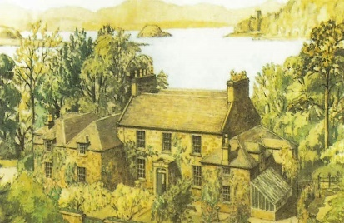  The Manor House by Joe Pearce (Pie Corbett) |  | Kensuke’s Kingdom by Michael Morpurgo |  | 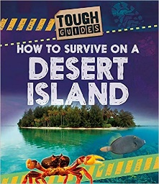  How to Survive on a Desert Island by Jim Pipe |  | 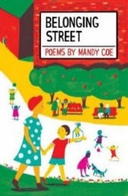  Belonging Street by Mandy Coe
Writing purpose and genre | Writing to entertain  - Writing an action scene (with elements of suspense) |  | Writing to entertain  - Setting description |  | Writing to inform  - Explanation (survival guide) |  | Writing to entertain  - Poetry
Writing Objectives  Grammar objectives | To identify dashes, commas and brackets for parenthesis within a sentence.  Lesson 1 – To explore the writing craft of an action scene.  Lesson 2 – To compare different action scenes and analyse features.  Lesson 3 – To explore mood and tension to build suspenseful action.  Lesson 4 – To explore vocabulary to build suspenseful action. | To identify relative pronouns and relative clauses within a sentence.  Lesson 1 – To design own setting to base their scene.  Lesson 2 – To plan an action scene  Lesson 3 & 4 – To write an action scene. | To use semicolons to link two main clauses.  Lesson 1 - To explore the writing craft of setting description.  Lesson 2 - To design their own deserted island.  Lesson 3 - To choose figurative language techniques.  Lesson 4 – To use the five senses to make the scene vivid. | To improve sentence openers using fronted adverbials.  Lesson 2 – To use the rule of three and sentences with more than one fronted adverbial to describe.  Lesson 3 - To plan a setting description.  Lesson 4 & 5 - To write a setting description (two days). | To use modal verbs to indicate degrees of possibility.  Lesson 1 - To explore the writing craft of an explanation text.  Lesson 2 – To explore and use technical vocabulary.  Lesson 3 – To use a variety of punctuation to develop different sentence structures (include bullet points)  Lesson 4 – To explore the passive voice. | To use colons to introduce lists.  Lesson 2 - To plan a survival guide.  Lesson 3 & 4 - To write a survival guide (two days)  Lesson 5 -To publish a survival guide. | To identify word classes within sentences.  Lesson 1 - To explore figurative language in poetry.  Lesson 2 - To write a colour poem  Lesson 3 - To publish a poem (red book and  perform).  Transition morning  Fernwood Festival
Reading Objectives | Lesson 5 - To identify themes across a wide range of writing (summarising). | Lesson 5 - To find fact and opinion within a non-fiction text (retrieval). | Lesson 5 - To draw evidence from more than one place in a text to make an inference (inference). | Lesson 1 - To evaluate the author’s use of language (vocabulary). | INSET day | Lesson 1 - To compare and explore different explanation texts (explore and compare) |  | To begin to challenge others’ point of view (explore and compare).
Spelling objectives  Year 5/6 words | To spell progressive verbs using the suffix -ing (e.g. accelerating).  communicate conscience temperature | To spell adjectives using ‘ci’ for the /sh/ phoneme (e.g. suspicious).  determined mischievous twelfth | To spell words with letters that are not stressed (e.g. business).  occupy physical variety | To spell words using the dis- prefix to have a negative meaning (e.g. dishearten).  prejudice queue sincere | To spell words using the prefix circum from the Latin ‘round’ (e.g. circumference). To spell words using the prefix hypo- from Greek ‘under’ (e.g. hypothesis). recognise recommend | To spell words with the prefix audi-, from the Latin to har (e.g. audible

Year 6
Autumn 1
 | Week 1 and 2 |  |  | Week 3 and 4 |  | Week 5 | Week 6 and 7
Stimulus for Writing | A range of pictures from One Upon A Picture (could be a different a stimulus for each |  |  | 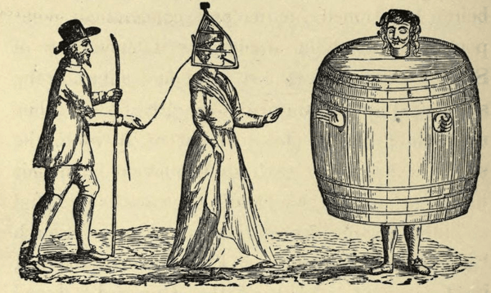 |  |  | 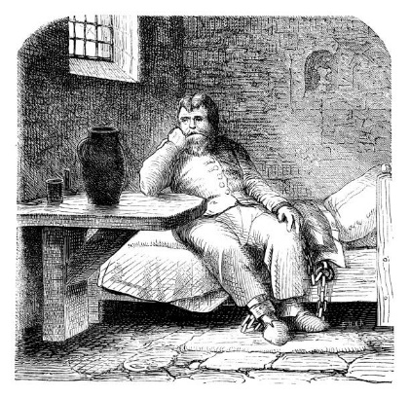
Writing purpose and genre | Year 6 Writing Toolkit |  |  | Writing to inform/explain  - Balanced argument about whether Tudor punishments were fair. |  |  | Writing to reflect  - Diary entry based on the someone’s first day in a Victorian prison.
Writing Objectives  Grammar objectives | To recap EF1-EF6  Lesson 1 - To understand main and subordinate clauses.  Lesson 2 - To use and punctuate a range of fronted adverbials.  Lesson 3 - To use apostrophes to show singular and plural possession. | To use pronouns to avoid repetition.  Lesson 1 - To use inverted commas to punctuate dialogue.  Lesson 2 - To use punctuation (brackets, dashes and commas) for parenthesis.  Lesson 3 - To use semicolons to join to main clauses.  Lesson 4 - Short burst writing (use all the skills) |  | To identify modal verbs.  Lesson 2 – To explore the writing craft of a balanced argument.  Lesson 3 – To discuss arguments for and against Tudor punishments (pick some specific punishments).  Lesson 4 – To use formal language and tone to develop arguments.  Lesson 5 – To create sentence openers to guide a reader through a balanced argument. | To identify apostrophes for singular and plural possession.  Lesson 1 – To plan a balanced argument, supporting arguments with evidence.  Lesson 2 and 3 – To write a balanced argument.  Lesson 4 – To take part in a balanced argument. | NO OTHER LESSONS THIS WEEK – BIKEABILITY | To identify noun phrases and expanded noun phrases in a sentence.  Lesson 1 - To explore the writing craft of a diary entry.  Lesson 2 - To create a Victorian prisoner (their background, crime, personality and attitude towards prison).  Lesson 3 - To choose vocabulary for informal, reflective writing.  Lesson 4 - To use parenthesis to add thoughts and reflections. | To identify synonyms.  Lesson 1 - To plan the structure of a diary entry.  Lesson 2 and 3 - To write a diary entry.  Lesson 4 - To publish a diary entry.  History day
Reading Objectives | Lesson 4 - To make predictions (prediction and vocabulary) | Lesson 5 - To summarise the main ideas from a text, identifying key details (summarising). |  | Lesson 1 - To read around a word to explore its meaning of words in context (vocabulary). | Lesson 5 - To make inferences to help compare characters (inference). | SATs paper testing | INSET day
Spelling objectives  Year 5/6 words | To spell words /∫es/ ending it -tious (e.g. infectious).  accompany average committee foreign neighbour stomach |  | To spell words ending in -ent, -ence and -ency (e.g. decent decency).  achieve bargain communicate forty nuisance | To turn adjectives ending in -ible to adverbs ending in -ibly (e.g. forcible and forcibly).  amateur category frequently | To spell words using hyphens, joining prefixes to words beginning with a vowel (e.g. co-ordinate).  apparent conscience government occupy suggest | To spell words with silent letters, where the letters used to be pronounced historically (e.g. thistle).  attached controversy harass | To spell homophones and near homophones (e.g. effect and affect).  correspond identity opportunity

Autumn 2
 | Week 1 and 2 |  | Week 3 and 4 |  | Week 5 and 6
Stimulus for Writing | 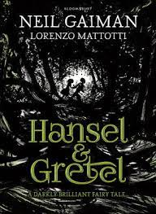  Hansel and Gretel by Neil Gaiman |  | 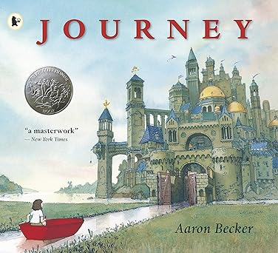  The Journey by Aaron Becker |  | 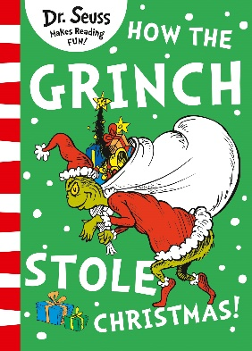  The Grinch by Dr. Seuss
Writing purpose and genre | Writing to entertain  Contrasting setting description (creepy setting of forest own planned wondrous place) |  | Writing to entertain  Fantasy narrative with dialogue (meet a character through the red door that has a problem) |  | Writing to explain  - Instructional writing
Writing Objectives  Grammar objectives | To identify relative pronouns and relative clauses.  Lesson 2 – To explore the writing craft of setting description.  Lesson 3 – To design a wondrous setting inspired by Hansel and Gretel.  Lesson 4 – To use repetition to make a setting seem mysterious (focus on the woods).  Lesson 5 – To choose punctuation to build tension in a contrasting description. | To identify adverbs to indicate manner, time and frequency and place.  Lesson 1 – To create contrasting examples of figurative language (personification, metaphors, similes).  Lesson 2 – To create atmosphere, developing ideas to transition from one setting to the other.  Lesson 3 and 4 – To write a contrasting setting description. | To identify conjunctions used to introduce a subordinate clause.  Lesson 1 – To explore the writing of fantasy narrative  Lesson 2 - To design a fantasy object and setting and explore figurative language to describe it.  Lesson 3 – To create a character to meet beyond the door and explore dialogue to advance the action.  Lesson 4 – To explore a variety of sentence structure for effect. | To punctuate dialogue.  Lesson 1 – To story map a short fantasy narrative.  Lesson 2 and 3 – To write a short fantasy narrative with dialogue.  SPaG paper in pairs and as a class | To identify antonyms.  Lesson 2 - To explore the writing craft of an instructional text.  Lesson 3 - To use semicolons to join two main clauses.  Lesson 4 - To plan and structure an instructional text.  Lesson 5 - To use a variety of sentence openers. | To identify a range of pre-fixes.  Lesson 1 – To choose vocabulary suitable for my instructional text.  Lesson 2 and 3 - To write an instruction text on how to steal Christmas  Lesson 4 - To publish an instructional text.
Reading Objectives | Lesson 1 - To discuss and evaluate the author’s use of language, including figurative language, and the impact on the reader (explore and compare). READ THE BOOK | Lesson 5 - To use more than one piece of evidence to support an inference made about a character’s thoughts, feelings or motive (inference). | Lesson 1 - To make predictions based on a picture book (prediction). | Reading assessment | Lesson 1 - To summarise an event as a storyboard (summarising – read the book). | Lesson 5 – To retrieve information from a non-fiction text (retrieval).
Spelling objectives  Year 5/6 words | To spell homophones and near homophones (e.g. morning and mourning).  dictionary individual secretary | To spell words with a + double consonant (e.g. assembly , anniversary).  desperate language rhythm | To spell words endng in -ance, -an and -ation using root words (e.g. expectant expectation).  determined temperature | To spell adjectives ending in -able (e.g. reasonable).  especially marvellous interrupt persuade | To spell adverbs ending in -ably (e.g. believably).  definite environment | To use the rule ‘I’ before ‘e’ except after ‘c’ and some exceptions (e.g. conceit).  excellent prejudice system

Spring 1
 | Week 1 and 2 |  | Week 3 | Week 4 and 5 |  | Week 6
Stimulus for Writing | Range of advertisements for hotels |  | 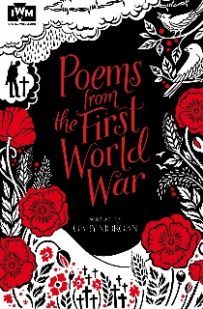  Poems from the first World War | Gas Mask! Portal Story  Lee Enfield rifle from the WW1 history box as a hook |  | 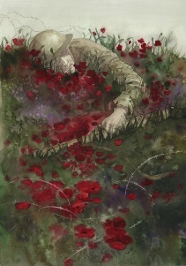  The Thinking Collection - Once Upon a Picture
Writing purpose and genre | Writing to persuade  - Hotel advert |  | Writing to paint a picture in the reader’s mind  - Settings | Writing to entertain  - Portal narrative  - Settings  - Characterisation |  | Writing to entertain  - Writing an ending
Writing Objectives  Grammar  objectives | Lesson 1 - To explore the writing craft of a persuasive advert.  Lesson 2 - To identify persuasive devices.  Lesson 3 - To use the subjunctive form to persuade.  Lesson 4 -To explore language for a persuasive hotel advert. | Lesson 1 - To plan a persuasive advert.  Lesson 2 & 3 - To write a persuasive advert (two days).  Lesson 4 - To publish a persuasive advert. | To identify different types of figurative language  Lesson 2 - To explore vocabulary in war time poetry.  Lesson 3 - To write figurative language for poetry.  Lesson 4 - To write and perform a wartime poem.  Pantomime | To identify and use semicolons.  Lesson 2 - To explore the writing craft of a portal story.  Lesson 3 - To practise using a range of sentence lengths in narrative.  Lesson 4 - To develop characters using a range of techniques  Lesson 5 - To plan a portal story | To identify the subject and object of a sentence  Lesson 1 - To develop two contrasting settings.  Lesson 2 - To explore, compare and analyse openings of model texts (extra reading lesson).  Lesson 3 & 4 -To write a portal story (UP TO PORTAL MOMENT). | To identify a range of fronted adverbials.  SPaG paper – use data to inform lessons.  Lesson 2 – To make links back to earlier events (echoes, moments, clues or themes – what happened to the character before this picture?) (hot seating)  Lesson 3 – To create mood and voice. (through short and complex sentences and fronted adverbials for impact and detail)  Lesson 4 – To write an ending to match the picture.
Reading Objectives | Lesson 5 - To discuss and compare inferences made with peers and justify my views (inference). | Lesson 5 - To make give recommendations to my peers, giving reasons for my choices (explore and compare). | Lesson 1 - To compare poems (explore and compare) | Lesson 1 - To make impressions about characters using evidence from the text (inference) (using Jonathan’s Journey through time) | Reading paper | Lesson 1 – To compare different endings of texts (variety of genres) (explore and compare).  e.g. fairy tale, adventure, action, tragedy. Create toolkit of features.
Spelling objectives  Year 5/6 words | To spell words using the ‘ough’ letter string (e.g. afterthought).  aggressive necessary leisure | To turn adjectives to adverbs by using the -ly suffix to words ending with a consonant (e.g. vivid vividly).  queue variety | To turn adjectives to adverbs by using the -ly suffix to words ending with -ble, -ple, -tle, -gle (e.g. reasonable reasonably).  sacrifice | To spell words part of word families, showing words related in meaning (e.g. vary, variety, variation, variable).  soldier vegetable | To add suffixes beginning with vowel letters to words ending in -fer (e.g. confer conferred).  recognise recommend vehicle | To spell words with the /s/ phoneme spelt with the c grapheme (e.g. cemetery).  yacht accommodate community

Spring 2
 | Week 1 and 2 |  |  | Week 3 and 4 |  |  | Week 5
Stimulus for Writing | 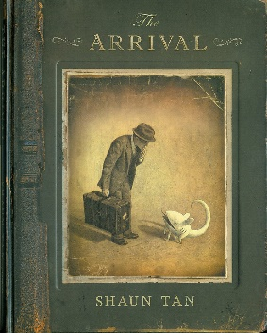  The Arrival by Shaun Tan |  |  | 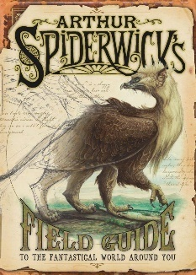  Arthur Spiderwick’s Field Guide |  |  | REVISION WEEK FOR SATs
Writing purpose and genre | Writing to reflect  - Diary entry (recount)  - Children don’t have to base their diaries on the same picture from the book. |  |  | Writing to inform  - Information text based on a made-up creature |  |  | REVISION WEEK FOR SATs
Writing Objectives  Grammar objectives | Revise grammar you think children need.  Lesson 1 – To compare different diary entries.  Lesson 2 - To explore the writing craft of diary writing.  Lesson 3 – To explore time conjunctions to move the diary forward.  Lesson 4 – To show not tell emotions and feelings in a diary.  INSET DAY – no reading lesson |  | Revise grammar you think children need.  Lesson 1 – To explore description and detail in a diary entry.  Lesson 2 & 3 – To write edit and publish a diary entry.  World Book Day | Revise grammar you think children need.  Lesson 1 – To explore the pages of Arthur Spiderwick’s Field Guide.  Lesson 2 - To explore the writing craft of an information text.  Lesson 3 – To design a made-up creature.  Lesson 4 – To explore vocabulary linked to the character made-up creature. (linked to different sections of information text) |  | Revise grammar you think children need.  Lesson 1 – To create facts based on made-up creature.  Lesson 2 – To plan the structure and presentation of an information text.  Lesson 3 & 4 – To write an information text based on a made-up animal (publish as writing) | Revise grammar you think children need.  - Reading paper  - SPaG paper  REVISION WEEK FOR SATs
Reading Objectives | Application of reading skills to practise and develop skills in comprehension questions involving retrieval, inference, prediction, summarising and exploring and comparing short extracts of text.
Spelling objectives  Year 5/6 words | To spell words using the ending in -cial (e.g. artificial).  according ancient appreciate available | To spell words ending in -tial (e.g. potential).  bruise awkward cemetery |  | To spell words with the long ‘o’ sound using the graphemes ou and ow. (e.g. smoulder).  competition convenience curiosity conscious | To spell words that can be used as nouns and verbs (e.g. challenge).  develop existence explanation |  | To spell words part of word families (e.g. accrue , accomplish).  muscle signature | To spell words part of word families (e.g. assign assignment).  relevant restaurant

Summer 1
 | Week 1 | Week 2 and 3 |  | Week 4 and 5 | Week 6
Stimulus for Writing |   Road’s End – Literacy Shed | 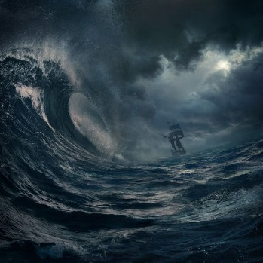  Sea storm description |  | SATS revision and KS2 SATs tests | WW2 historical sources  (more lessons this week due to SATs being finished)
Writing purpose and genre | Writing to entertain  - Mystery story | Writing to entertain  - Setting description  - Dialogue |  |  | Writing to reflect/inform  - Letter from an evacuee
Writing Objectives | Revise grammar you think children need.  Lesson 1 – To explore a range of literary techniques to build mystery (short sentences, cliff-hangers, slow build up)  Lesson 2 – To create clues and red-herrings to move the story forward and mislead.  Lesson 3 – To story map their mystery story (including figurative ideas)  Lesson 4 – To write a short mystery extract.  SCIENCE DAY | To identify the progressive tense.  Lesson 1 - To explore the writing craft of sea storm narrative  Lesson 2 - To choose vocabulary for a sea storm setting.  Lesson 3 - To use dialogue to advance the action. | Revise grammar you think children need.  Lesson 1 - To plan a sea storm description.  Lesson 2 & 3 - To write a sea storm description (two days). |  | To identify parenthesis  To identify conjunctions  Lesson 1 - To explore the writing craft of an informal letter.  Lesson 2 - To explore emotional language to use in an informal letter.  Lesson 3 - To plan an informal letter.  Lesson 4 - To write an informal letter.
Reading Objectives | Application of reading skills to practise and develop skills in comprehension questions involving retrieval, inference, prediction, summarising and exploring and comparing short extracts of text. |  |  |  | INSET day
Spelling objectives  Year 5/6 words | To spell words part of word families (e.g. telegram hologram).  occur parliament privilege profession | To spell words part of word families (e.g. digest congestion).  thorough symbol rhyme pronunciation

Summer 2
 | Week 1 and 2 |  | Week 3 | Week 4 | Week 5 | Week 6 and 7
Stimulus for Writing | Pet Peeves Blog Entries |  |  | 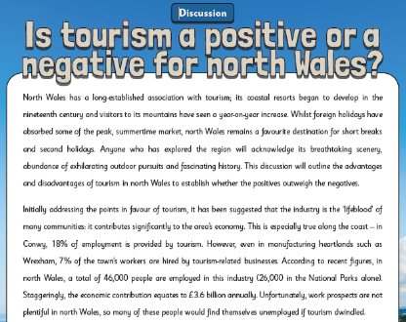 | BIG ARTS WEEK |   Research using fernwoodprimary.co.uk
Writing purpose and genre | Writing to inform/entertain  - Blog entry writing |  |  | Writing/Speaking to discuss (oracy focus week)  - Should tourism be allowed in North Wales? | BIG ARTS WEEK | Writing to reflect  - Newsletter all about Fernwood Primary School  - Leavers memory poems
Writing Objectives | To identify modal verbs to indicate degrees of possibility.  Lesson 1 - To explore the writing craft of a blog entry.  Lesson 2 - To explore formal and informal language.  Lesson 3 -To understand how to use semicolons in a list.  Lesson 4 - To use the active and passive voice. | To identify nouns and noun phrases.  Lesson 2 - To plan a blog entry  Lesson 3 & 4 - To write a blog entry (two days)  Lesson 5 - To publish a blog entry. |  | Lesson 1 - To explore the craft of a discussion text.  Lesson 2 - To consider what makes a good orator.  Lesson 3 - To speak from bullet points.  Lesson 4 - To present views on an important topic. | BIG ARTS WEEK | Lesson 1 - To interview to find record quotes.  Lesson 2 - To plan a newsletter.  Lesson 3 - To write a newsletter.  Transition morning
Reading Objectives | Lesson 5 - To explore the meaning of words in context (vocabulary). | Lesson 1 – To compare and analyse different blog posts. (explore and compare) |  | Lesson 5 - To speak fluently to discuss my ideas (standalone). | BIG ARTS WEEK | Fernwood Festival
Spelling objectives  Year 5/6 words | To spell words that can be used as nouns and verbs (e.g. produce).  criticise identity  To spell words that are synonyms and antonyms (e.g. elated forlorn).  embarrass  To spell words that are synonyms and antonyms (e.g. ambled sauntered).  interfere

