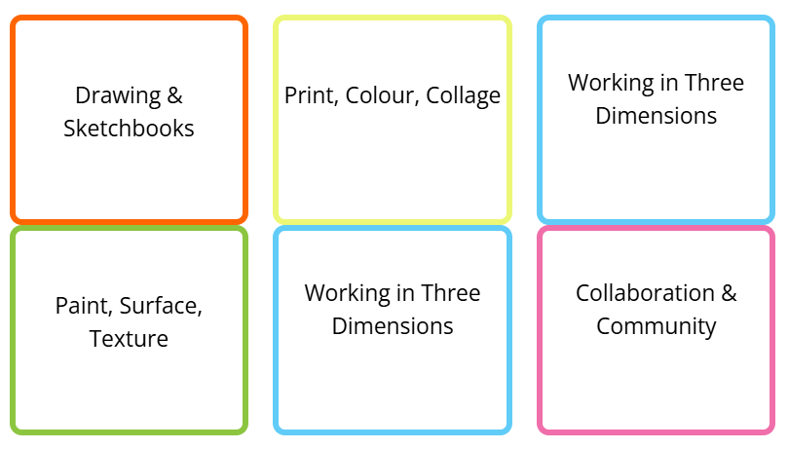

Nursery
Autumn 1 | Spring 1 | Summer 1
EAD- CWM  Access Art: What can we see?  Can you find a circle?  Finding Circles (accessart.org.uk)  Access Art: How can we use our imagination?  What marks can you make when you listen to music?  Mark Making & Sound: Part Two (accessart.org.uk) | EAD- CWM  Access Art: How can we explore materials and marks?  How do you paint with string?  Printing with String (accessart.org.uk) | EAD- CWM  Access Art: How can we use our bodies to make art?  What art can you make when you dance?  Talking Points: Dancing to Art (accessart.org.uk)
Autumn 2 | Spring 2 | Summer 2
Access Art: How can we explore colour?  What colours can you see around you?  (No obvious lesson idea in Access Art that links to colours around us). | EAD- CWM  Access Art: How can we build worlds?  What will you use to make a bug house?  Insect Hotels (accessart.org.uk) | EAD- CWM  Access Art: How can we explore 3d materials?  How can you make a fruit or vegetable head?  Fruit and Veg Head (accessart.org.uk)  EAD- CWM  Artists  To explore different pieces of art.  To explore creating art work inspired by famous artists such as, Matisse.

Foundation 2- Reception
Autumn 1 | Spring 1 | Summer 1
Painting  EAD: Safely use and explore a variety of materials, tools and techniques, experimenting with colour, design, texture, form and function.  Access Art: How can we use our bodies to make art?  How can I paint using my hands and fingers?  Hands, Feet and Flowers (accessart.org.uk) | Colours  EAD: Safely use and explore a variety of materials, tools and techniques, experimenting with colour, design, texture, form and function.  Access Art: How can we explore colour?  How can I create a colourful nature wax rubbing?  Collaging with Wax Crayon Rubbings (accessart.org.uk) | Drawing  EAD Share their creations, explaining the process they have used.  Access Art: How can we explore materials and marks?
Autumn 2 | Spring 2 | Summer 2
Patterns  EAD: Share their creations, explaining the process they have used.  Linked to BV: Tolerance, Mutual Respect  Access Art: How can we use our imagination  How do I make a collage?  Let’s Start With… Collage (accessart.org.uk) | Artists  EAD: Safely use and explore a variety of materials, tools and techniques, experimenting with colour, design, texture, form and function.  Why is Yahyoi Kusama famous?  Why is Vincent Van Gogh famous?  Access Art: What can we see?  What is a still life?  Still Life Compositions: Inspired by Cezanne (accessart.org.uk) | Make and Create  EAD: Safely use and explore a variety of materials, tools and techniques, experimenting with colour, design, texture, form and function.  Access Art: How can we build worlds?  Can we make props for our cuddly toys?  Prop Making for Toys (accessart.org.uk)  Access Art: How can we explore 3D materials?  Can you make a printing roller?  Repeat Pattern Printing Roller (accessart.org.uk)

Y1
Autumn 1 | Spring 1 | Summer 1
Spirals – Drawing, Collage, Sketchbooks  - Making spiral drawings  - Develop your drawings (make snail drawings)  - Drawing Exercises (Observational Drawing: Continuous Line)  - Drawing Exercises (Experimental Mark-Making with Water Soluble Pens)  - Celebrate (Share, reflect, discuss) | Making birds – sculpture, drawing  - Drawing from a photograph  - Drawing from observation and experimental mark making  - Manipulating paper from 2D to 3D  - 4) Explore sculpture  - 5) Celebrate (Share, reflect, discuss) | Simple Printmaking – printmaking, collage, drawing  - Printing with your body  - Making rubbings  - Explore Plasticine printing  - Explore foam printing  - Celebrate (Share, reflect, discuss)
Autumn 2 | Spring 2 | Summer 2

Y2
Autumn 1 | Spring 1 | Summer 1
Exploring the World through Mono printing – drawing, collage, printmaking  - Explore – Draw from Stills and Film  - Drawing small  - Introduce Mono Printing  - Mono Printing – Change, Grow, Live  - Display and Reflect (Present, Talk, Share and Celebrate) | Expressive painting – painting, sketchbooks  - Introduce  - Explore – Painting and colour mixing  - Explore - Brush work of Van Gogh and Cezanne  - Explore and Create – Gestural Mark Making with Acrylic Paint  - Present and Share (Share, Reflect, Discuss) | Stick transformation Project – making, drawing, sketchbooks  - Making and Playing  - Introduce and Create – Stick People (3 weeks)  - Present and Celebrate (Share, Reflect, Discuss)
Autumn 2 | Spring 2 | Summer 2

Y3
Autumn 1 | Spring 1 | Summer 1
Cloth, thread and paint - Painting, Sewing, Drawing, Sketchbooks  - Introduce Artists  - Develop mark making  - Find your focus – canvas  - Find your focus – stitch  - Share and Celebrate (Share, reflect, Discuss) | Making animated drawings - Drawing, Animation, Sketchbooks  - Introduce and explore - What is animation?  - Explore – paper cut puppets  - Make your moveable drawings (2 weeks)  - Create a background  - Present Work (Share, reflect and celebrate) | Telling Stories through drawing and Making – Drawing, sculpture, sketchbooks  - Introduce – artists and illustrators  - Explore Drawing  - Find your focus (3 weeks)  - Reflect and Discuss (Share and celebrate the outcomes)
Autumn 2 | Spring 2 | Summer 2

Y4
Autumn 1 | Spring 1 | Summer 1
The Art of Display - Sculpture, Creative Thinking Sketchbooks  - Introduce - What is a plinth?  - Introduce – An artist  - Find your focus – Explore and Make (3 weeks)  - Celebrate (Share, Reflect, Discuss) | Exploring Still Life – drawing, collage, painting, relief, sketchbooks  - Introduce an artist/ Drawing Exercises  - Explore contemporary and traditional still life artists  - Paint and collage (3 weeks)  - Present and celebrate (Share, reflect, discuss) | Festival feasts – sculpting, drawing, painting, sketchbooks  - Be Inspired - Explore and draw (2 weeks)  - Feast from clay (2 weeks)  - Communal Picnic drawing  - Share and discuss (Share, Reflect and Celebrate)
Autumn 2 | Spring 2 | Summer 2

Y5
Autumn 1 | Spring 1 | Summer 1
Making Monotypes - Printmaking (Monotype), Drawing, Painting, Collage, Sketchbooks  - Introduce - Monotype printing and artist  - Mark making inspired by artists  - Create a visual poetry zine with monotype (3 weeks)  - Talk (Share, reflect, discuss) | Set design - Set Design, Making, Drawing, Sketchbooks  - Introduce – set design for theatre  - Create – set design for theatre (4 weeks)  - Reflect and discuss (present, talk and celebrate) | Fashion design - Fashion, Painting, Collage, Sketchbooks  - Introduce designers and artist  - Brief – working in sketchbooks  - Explore and Make – Fashion  - Present and Share (Share, reflect, discuss)
Autumn 2 | Spring 2 | Summer 2

Y6
Autumn 1 | Spring 1 | Summer 1
Brave colour - Drawing, Sculpture, Graphic Design, Collage, Sketchbooks  - Explore colour- Brave sketchbook  - Be inspired- Visual notes (choose a couple of artists to explore)  - Exciting colour- Create moodboard  - Create- Dream big by working small- Option 1 Mini world light boxes (2 weeks)  - 5 Share, reflect, discuss | Shadow puppets - Making, Drawing, Sketchbooks  - Introduce – discover artists and approaches  - Explore and create – making shadow puppets (3 weeks)  - Present and Share (Share, Reflect, Discuss) | Exploring identity - Collage, Drawing, Sketchbooks, painting  - Introduce – discover artists and approaches  - Sketchbook work – portrait club  - Explore and Create - making layered portraits (3 weeks)  - Present and Share (Share, Reflect, Discuss)
Autumn 2 | Spring 2 | Summer 2

